Answer Either Question 9 Or Question 10

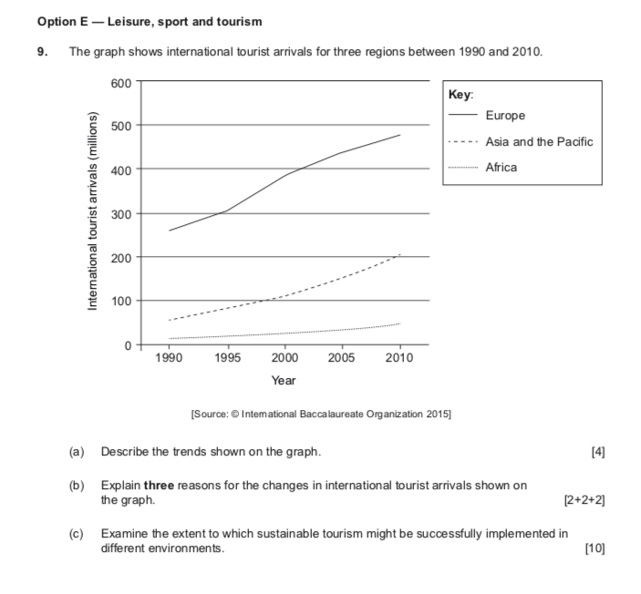

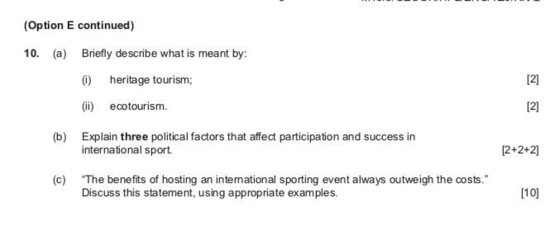

Mark-scheme:

Option E — Leisure, sport and tourism
9. (a)
Describe the trends shown on the graph.
Award [1] for recognition that arrivals are increasing in all three regions. Award [1] for quantification (use of data).
Award up to [2] for any two of the following:
- Europe is always the highest
- steep increase in Europe between 1995 and 2000
- Asia and the Pacific have seen recent steep increase, especially after 2000, from about 100 million to about 200 million
- high relative increase in Africa but still low overall (from about 10 million to about 50 million)
- the rates of growth might be compared; for example, the growth rate in Africa has been much greater as a % of the starting point than elsewhere.
(b) Explain three reasons for the changes in international tourist arrivals shown on the
graph. [2+2+2] Award [1] each for a valid reason, that relates to international tourism growth, and a
further [1] for development or exemplification of the reason.
For example:
- the cost of air travel has reduced in recent years [1], so that more tourists can travel cheaply eg from Europe to Asia [1]
- increased tourism advertising in Africa has been heavily promoted in the media [1], so that tourists are increasingly attracted to new/more exotic destinations eg The Gambia from China [1].
A wide variety of reasons could be given, including:
- increased affluence and leisure time for travel [1] and may provide details of changing employment patterns
- growth of package holidays/TNCs [1] and gives specific details of eg Thomas Cook
- development of tourist infrastructure at destinations [1] and gives specific detail eg Hamad (Doha) airport in Qatar [1]
- credit cards/Visa Cash make travel easier [1]
- online booking/ICT make planning/booking easier [1].
– 21 – M15/3/GEOGR/BP2/ENG/TZ0/XX/M (c) Examine the extent to which sustainable tourism might be successfully implemented
in different environments. [10] Sustainable tourism aims to meet economic social and environmental goals and to
preserve tourist resources for future generations.
Possible ways/strategies of implementing sustainable tourism might include:
- protection of the natural environment
- managing resources to prevent depletion
- reducing the ecological footprint of tourism
- managing visitor numbers
- involvement of local people in the tourist activities
- economic and social benefits to local people and the nation
- development of infrastructure.
Negative impacts of tourism which might detract from the success of sustainability strategies could include over-exploitation of the environment, economic “leakage” of tourist revenues, or cultural dilution.
“Environments” could be interpreted as different places/cities/rural locations/ecosystems or biomes.
Good answers may provide a structured examination of what is meant by sustainable tourism (economic/social/environmental strands) and the extent to which these different goals have been met. Another approach might be to provide a structured examination of differing approaches to managing tourism in different geographical environments/contexts (levels of development, scale, etc).
For band D, expect some description of the outcomes of relevant/sustainable tourism strategies in one or two environments/places.
At band E, expect either more detailed explanation of the outcomes of tourism strategies in two places (do not expect balance) or an examination of the extent to which different sustainability goals have actually been achieved.
At band F expect both of these elements.
Marks should be allocated according to the markbands.

10. (a)
Briefly describe what is meant by: (i) heritage tourism;
Heritage tourism is tourism based on a historic legacy [1] (landscape feature, historic building or event) as its major attraction [1].
[1] may alternatively be awarded for naming a valid example such as the Taj Mahal or Machu Picchu.
(b)
(ii) ecotourism. [2] Ecotourism is tourism focusing on the natural environment [1] and respecting local communities [1].
[1] may alternatively be awarded for naming a valid example such as Monteverde cloud forest in Costa Rica.
Explain three political factors that affect participation and success in international sport. [2+2+2] Award [1] for each factor identified, and [1] for further development or exemplification.
For example:
- Government spending on specific/internationally-orientated sport facilities such
as swimming pools and stadiums [1] thereby increasing chance of success in
Olympic Games[1].
- The government’s hosting of an international sporting event, such as the
Olympics [1], has promoted national pride and encouraged people to participate
more widely in sport [1].
- The government’s role promoting sport in education, eg in national curricula, to
promote sport in schools and colleges [1] enables elite athletes to reach global
potential [1].
- Political initiatives to promote sport / government advertising [1] with emphasis
on “world-beating” potential [1].
- Government support in the hosting of an international sporting event.
- Political isolation of North Korea or other countries [1] so North Korea under- represented in many global competitions [1].
- Specific political values may encourage or deter participation [1] eg Islamic states’ attitudes to female participation or Soviet-era gymnastics, etc [1]. Credit other valid political factors.
(c) “The benefits of hosting an international sporting event always outweigh the costs.”
Discuss this statement, using appropriate examples. [10]
Likely benefits and costs might include issues arising from:
- building infrastructure – stadiums, accommodation, and transport facilities
- international reputation
- impacts on the economy of the host country
- regeneration of urban areas
- sporting legacy
- encouragement of participation in sporting activities.
Good answers are likely to provide a structured discussion of different kinds of costs/benefits. Another approach would be to discuss how perspectives may differ on what constitutes a benefit (or cost). Another approach would be to choose examples which allow a discussion of whether the veracity of the statement is place- specific (may provide contrasts for countries at different levels of development, for instance).
For band D, expect some description of some costs and benefits for one or two international sporting events.
At band E, expect either more detailed explanation of costs and benefits for one or more events (do not expect balance) or a structured discussion (may discuss the cost-benefit balance for different groups of people in different kinds of place).
At band F expect both of these elements.
Marks should be allocated according to the markbands.

