The Impact Of Genghis Khan’s Leadership Qualities 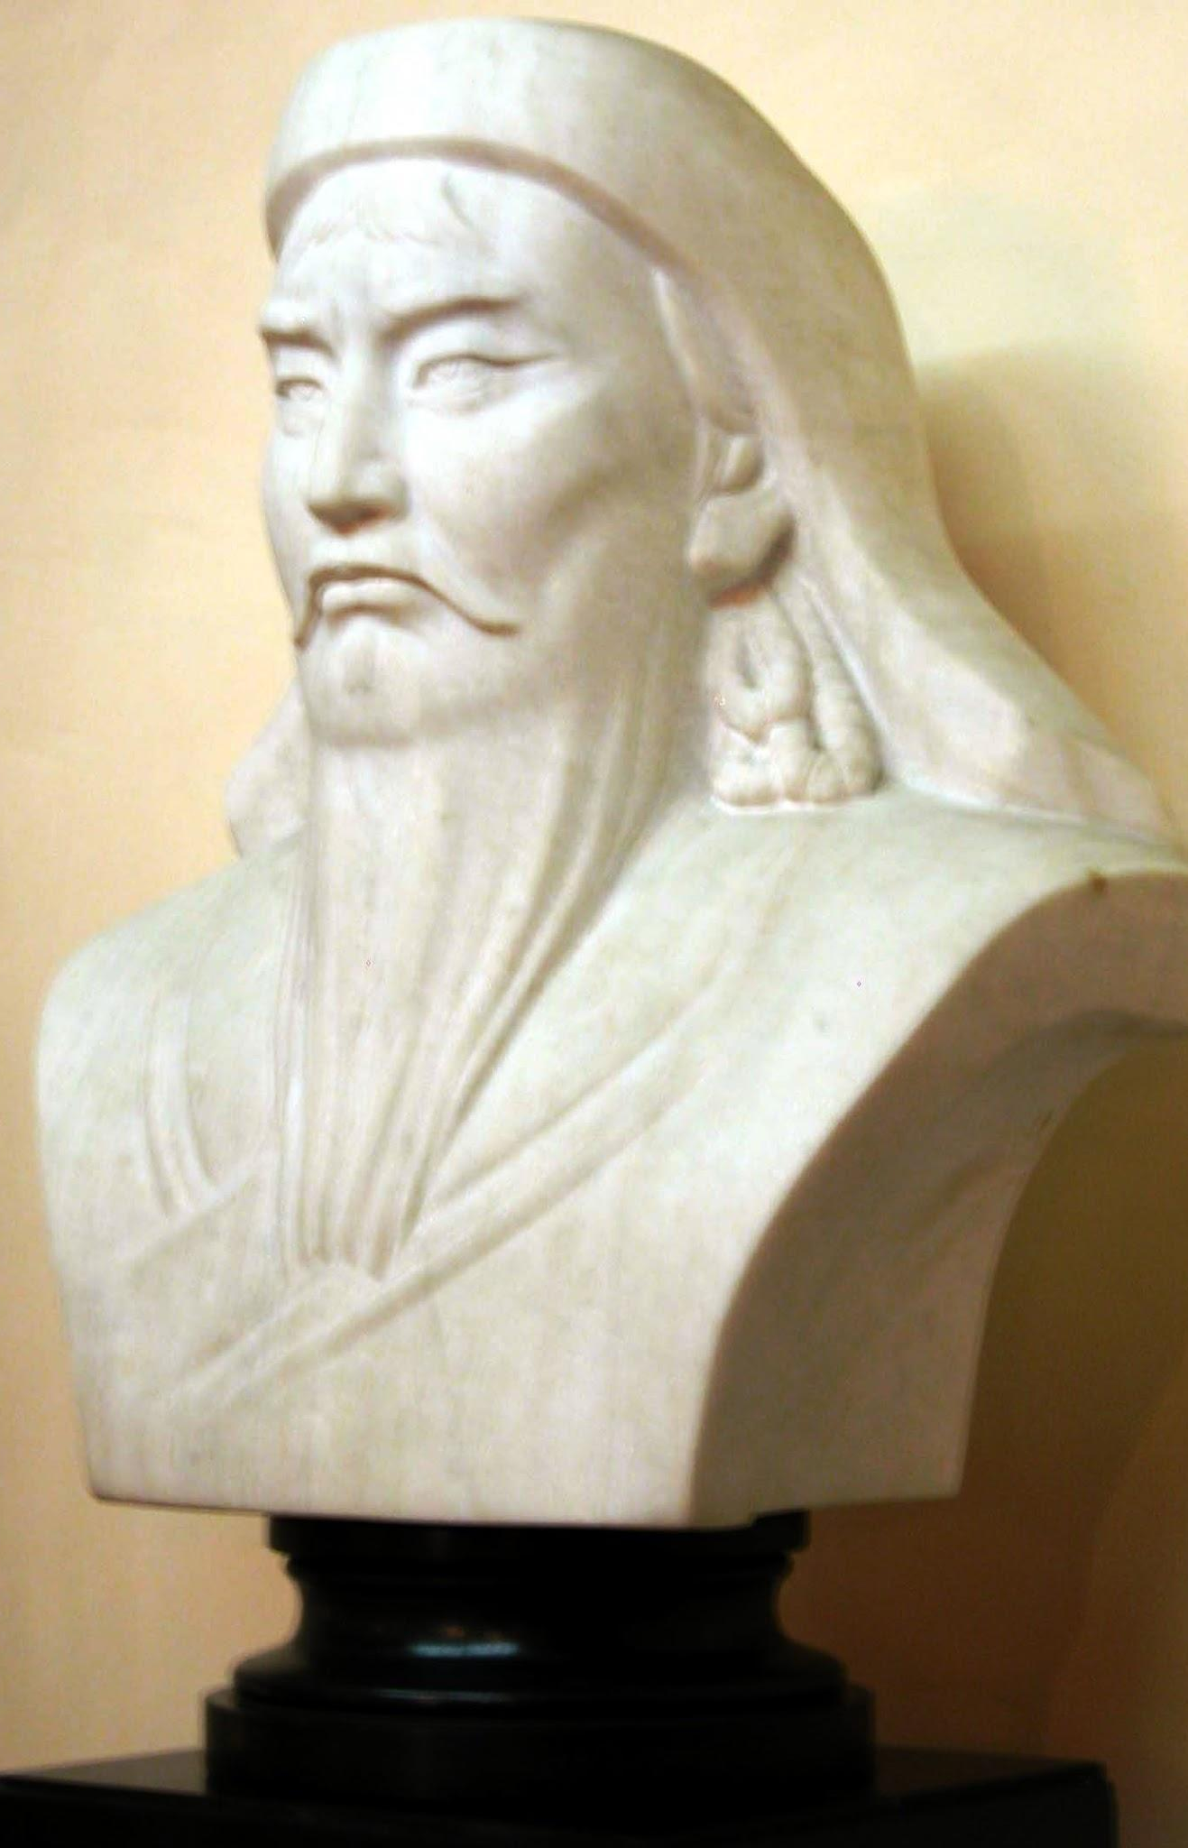

Personality
- Ruthless
- Determined and wants the best for his people.
- Campaigns not motivated by greed.
- Political genius - ‘Superb imagination’, in both conceiving vision of world empire and foreseeing the problems that could occur doing so.
- Took advice from others, such as his generals
- Had charm and Charisma
Strategies
Used abstract tactics and was able to adapt said methods to different kinds of warfare (when called for)

Impact of having these qualities
- Made it more likely that people would trust him and follow him.
- Made uniting the tribes and gathering support during his campaigns easier and more effective.
- Made his enemies/opposition fearful of him, since he believed he was the only leader.
- Military reputation gave the tribal soldiers faith they would survive.
- Gave soldiers reassurance that their families would be taken care of and receive some of the loot taken during the raids

