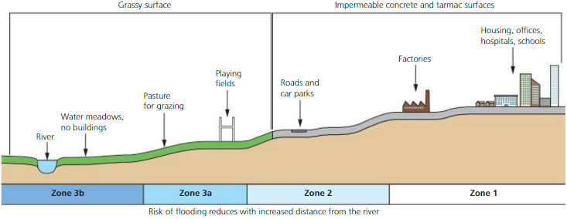
COSTS AND BENEFITS OF SOFT ENGINEERING
ACTIVATE

Explain what flood plain zoning is.
__________________________________________________________________________________________________________________________________________________________________________________________________________________

BENEFITS | COSTS
__________________________________________________________________________________________________________________________________________________________________________________________________________________

Explain how planting trees helps.
BENEFITS
COSTS

How do flood warnings and preparation work?

__________________________________________________________________________________________________________________________________________________________________________________________________________________

BENEFITS | COSTS
Explain how river restoration works.
__________________________________________________________________________________________________________________________________________________________________________________________________________________

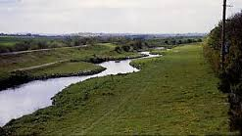

BENEFITS | COSTS

