What are the most important aspects of development?
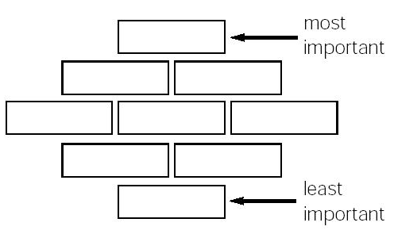

What are the most important aspects of development?

