00000 – 0000
$15 minimum wage backed by Joe Biden would cost 1.4 million Jobs
Source: CNBC: https://www.cnbc.com/2021/02/08/raising-minimum-wage-to-15-would-cost-1point4-million-jobs-cbo-says.html
Date Written:
Date of Article: February 8th, 2021
Word count: 785
Section 2: Microeconomics

the concept to this essay is government intervention, Government intervention is a regulatory measure performed by the government to influence the social and economic decisions made by people, groups, and organizations. The minimum wage is a basic price regulation imposed by the government. Price controls establish a minimum price that must be paid for a certain commodity or service. Governments impose price controls to ensure that people are paid fairly in a variety of jobs.

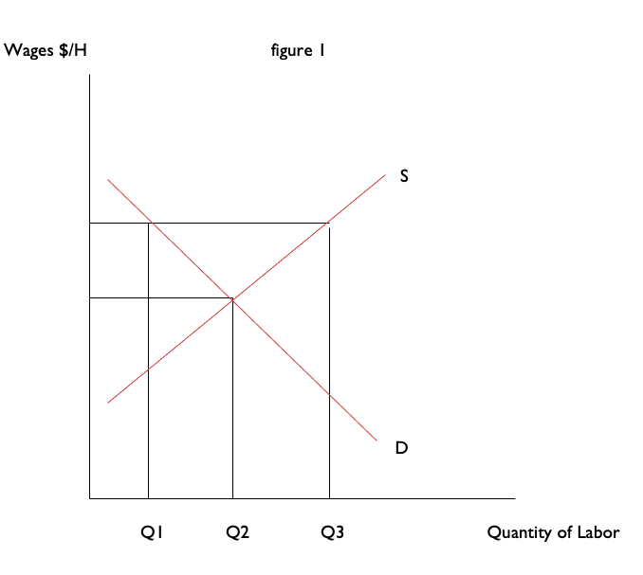
Welfare loss
US economy
Minimum wage
E2
E
E1
W
W1

Government intervention: the concept to this essay is government intervention, Government intervention is a regulatory measure performed by the government to influence the social and economic decisions made by people, groups, and organizations. The minimum wage is a basic price regulation imposed by the government. Price controls establish a minimum price that must be paid for a certain commodity or service. Governments impose price controls to ensure that people are paid fairly in a variety of jobs.

The minimum wage graph shows the effect, with demand dropping from e to e1 and supply expanding from e to e2. As a result, there is a good chance that there will be more labor supply than demand. This diagram explains the demand and supply for minimum wage in the United States. A minimum wage is the lowest wage per hour that a worker may be paid, as mandated by federal law. It is a legally mandated price floor on hourly wages, below which non-exempt workers may not be offered or accept a job. When the government imposes a minimum wage, firms are not permitted to pay less than the amount that the government mandates. Suppose we are again in the base year, so the price level is 1. The market equilibrium wage is $7.25 per hour, but the government may now pass legislation stating that all firms must pay at least $15 per hour. At this wage, supply does not equal demand. Markets are based on voluntary trades. In figure 1, we see that seller (the workers who supply labor) would like to sell 50,000 hours of labor to the market at the set minimum wage—that is, 250 more people would like to have a 40-hour-a-week job when the wage increases from $7.25 to $15. But firms wish to purchase only 32,000 hours of labor. In a market with voluntary trade, no one can force firms to hire workers. As a result, the equilibrium quantity of labor traded in the market will be determined by how much the firms wish to buy, not how much workers want to sell. The current wage in the US is dependent on state within the country. In Texas, the current minimum wage is $7.25 an hour. President Biden has announced the plan of increasing All minimum wages in the US to an hourly rate of $15 USD. Raising the minimum wage increases consumer spending and boosts the economy. A study by Doug Hall and David Cooper estimated that a $2.55 increase in the minimum wage would increase the earnings of low-wage workers by $40 billion and result in a significant increase in GDP and employment. When the price charged is greater than or less than the equilibrium price set by market forces of demand and supply, it is referred to as a price floor. Lower price floors have been demonstrated to be unsuccessful via observation.

Increasing the EITC, or Earned Income Tax Credit, is a popular alternative to raising the minimum wage. This federal program helps low- and middle-income families. The maximum amount a family could receive annually through this program, according to the IRS website, it currently sits around $6,000. Supporters of increasing the Earned Income Tax Credit argue that it would help low-income families more effectively than raising the minimum wage. Furthermore, as with other tax-based solutions to help low-income workers, the burden falls on the federal government, not on businesses, which argue that having to pay higher minimum wages would put them out of business. As demand falls, employment declines, but unemployment rises as supply expands. Minimum wage regulations (government intervention) are used by federal governments to ensure a baseline standard of living for all citizens within their borders. These laws aim to improve a person's place in the economic income scale. Rather than having a large number of underpaid or impoverished persons, minimum wage regulations aim to achieve economic equality. In some cases, minimum wage regulations have unforeseen consequences. One of the most significant consequences is an increase in an individual's tax liability. In a free market economy, price regulations can distort supply and demand theory. The supply and demand idea is frequently used by businesses to make choices.

00000 – 0000
UK economic growth slows as supply problems hit the recovery
Source: BBC news: https://www.bbc.com/news/business-59244988
Date Written:
Date of Article: November 12th, 2021
Word count: 779
Section 1: Macroeconomics

the concept of this essay is economic well-being, Economic well-being is a multifaceted concept that refers to a country's level of prosperity and the quality of its citizens' living standards. Improved output is the result of increased productivity. As the ratio of capital expenditures per worker rises, labor becomes more productive. A rise in worker productivity boosts the economy's growth rate.

Economic growth is defined as an increase or improvement in the inflation-adjusted market value of an economy's products and services through time. Statisticians commonly use the percent rate of rise in real gross domestic product, or real GDP, to assess such growth. Economic development generates more tax income, reducing the need to spend money on benefits like unemployment compensation. As a result, economic growth aids in the reduction of government borrowing. Economic growth is also important in lowering debt-to-GDP ratios. Economic growth boosts governmental capacity and the delivery of public goods; it also generates income, some of which finds its way into the wallets of employers and employees, boosting their well-being. People can escape poverty and improve their living conditions by earning better wages and spending more money. According to an estimate by the independent Office for Budget Responsibility, Britain's GDP would increase 6.5 percent in 2021, after contracting nearly 10% last year. This is up from an earlier forecast of 4%, and it's the highest increase since at least the 1980s.

Consumer spending climbed as Britain started to emerge from lockdown, but this was offset by decreases in other sections of the economy, leaving three-month growth at 1.3 percent, according to the Office for National Statistics. The economy is now 2.1 percent lower than it was in the final three months of 2019, before the coronavirus outbreak struck. A slowing economy has a negative impact on the labor market because firms are less likely to recruit additional people when the economy is weak. Debt collection, mediation, and job search services are among the businesses that enjoy increased demand during difficult economic times. There are various measures, both supply and demand side, that have proven useful in combating high unemployment. One of them is fiscal policy expansion. By lowering taxes and boosting government expenditure, expansionary fiscal policy boosts aggregate demand and the pace of economic growth. A rise in Real GDP can be achieved through boosting aggregate demand (AD). This means that businesses will create more and, as a result, their need for workers will rise, lowering unemployment rates.

The UK economy grew 1.3% quarterly in the third quarter of 2021, below 5.5% in the second quarter and below the forecast of 1.5%. The UK economy grew 5.5% quarterly in the second quarter of 2021, well above the initial forecast of 4.8% and recovered from the 1.4% decline in the previous quarter, home consumption was the number one factor in the rise after the coronavirus restrictions were relaxed. On the manufacturing side, the biggest contributions to GDP growth came from wholesale and retail, accommodation and catering activities, education and human health, and social work activities.
Increasing capital goods, labor, technology and human capital can all contribute to economic growth. Economic growth is usually measured in terms of increasing the total market value of additional goods and services produced using estimates such as GDP. The influence of expansionary fiscal policy on aggregate demand (AD) along the aggregate supply (AS) curve is depicted in the diagram below.

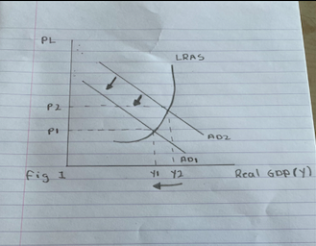
£
UK Economy

The increase in firm output may be seen in this shift in real GDP from (Y1) to (Y2). They will be willing to hire more people as a result of the increased output, cutting unemployment rates. However, there is a temporal lag associated with this. That means that when the government implements an expansionary fiscal policy, it will be months, if not years, before the economy noticeably changes. With this increase in employment and newly obtained production, the government may spend even more in the economy, extend the market, and perhaps build infrastructure to cut living expenses and increase productivity. Although this policy will not be inexpensive, it has a significant long-term potential return.

Economic growth boosts governmental capacity and the delivery of public goods; it also generates income, some of which finds its way into the wallets of employers and employees, boosting their well-being. This is up from an earlier forecast of 4%, and it's the highest increase since at least the 1980s. By lowering taxes and boosting government expenditure, expansionary fiscal policy boosts aggregate demand and the pace of economic growth. A rise in Real GDP can be achieved through boosting aggregate demand (AD). Increasing capital goods, labor, technology and human capital can all contribute to economic growth.

00000 – 0000
U.S. Imposes 266% Duty on Some Chinese Steel Imports
Source: BBC news: https://www.wsj.com/articles/u-s-imposes-266-duty-on-some-chinese-steel-imports-1456878180
Date Written: December 14th, 2021
Date of Article: March 1st, 2021
Word count: 783
Section 3: International
Concept: Efficiency

Cold-rolled steel is used to manufacture vehicle parts, appliances, and shipping containers. The Department of Commerce announced preliminary levies on imports of cold-rolled steel from seven countries, including China, whose steelmakers were hit with a huge penalty. Customs taxes on Chinese steelmakers have been set at 265.79 percent. The penalties will be imposed within the next week, but they must still be confirmed in a final determination anticipated for later this summer. They are intended to penalize those that engage in dumping, or selling below cost, to improperly acquire market share. Officials in China have categorically refuted the practice. After suffering through one of the worst downturns in their history, American steelmakers are now relying on tariff protection to help them survive a difficult market. Steel prices have been deflated over the world because of a downturn in the steel and heavy oil and gas industries, along with a surge in Chinese exports.

In 2015, the benchmark hot-rolled coil index plunged 35% to under $400 a ton, causing U.S. Steel to lose $1.5 billion and ArcelorMittal to lose almost $8 billion. Trade protection, according to analysts, will support prices but won't save distressed enterprises or stimulate market demand, particularly in the oil and gas sector. Despite the fact that China is only the seventh largest steel exporter to the United States, behind Canada, Brazil, Russia, Mexico, South Korea, and Turkey, Chinese steelmakers have drawn the greatest attention due to their potential to disrupt the American market. Steel traders claim that their prices are often 20 percent to 50 percent lower than everyone else's. And because of the sheer volume of its exports, Chinese steel is found all over the world. Except for Japan, China shipped more steel (100.4 million tons) last year than any other country.

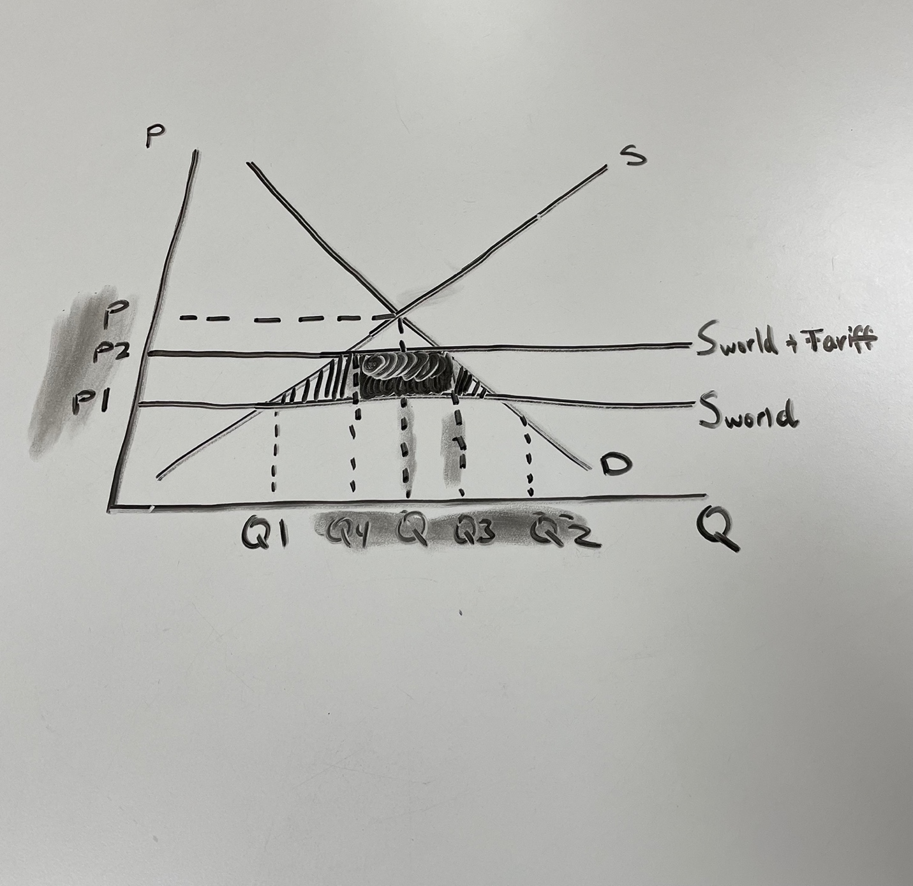
Chinese steel
¥¥

In Q3, the new output is at Q3, and the price has increased to P2. The percentage of the market held by domestic producers increased to the fourth quarter, while imports decreased from the fourth quarter to the third quarter. Consequently, domestic producers have been shielded from being undercut by cheaper imports from other parts of the world. Because domestic consumers are paying higher costs, they are also experiencing a reduction in consumer surplus. Domestic producers, on the other hand, see an increase in their producer surplus because of receiving a greater price than they would have received otherwise. Increased market share also means that jobs in the domestic sector will be protected because of the expansion. However, the drop in consumer surplus outweighs the gain in producer surplus by a significant margin. Even after including in the tariff revenue, the net result is a loss of money.

When simplified to its most basic definition, a tariff is a tax levied on commodities or services as they are transported from one jurisdiction to another. In some cases of protective tariffs, a greater tax on imported items is levied so that locally made copies of the same commodities can be sold at a more competitive price than their imported counterparts. A tariff is a sort of tax levied by a country on an imported commodity at the border that is collected by the government. The imposition of tariffs has long been a tool for governments to raise income, but they are also a means for them to attempt to safeguard native producers. Tariffs, when used as a protectionist tactic, raise the pricing of imported goods. Tariffs provide domestically produced items a pricing edge over imported goods, while also increasing government revenue.

Dumping is a scenario of international price discrimination in which the price of a product sold in the importing country is less than the price of that product offered in the exporting country's market. Dumping is defined as follows: A country or firm exports a product at a price that is lower in the foreign importing market than the price at which the product is sold in the exporter's own domestic market. The most significant advantage of dumping is the capacity to flood a market with products at prices that are frequently regarded as unjustified by consumers. In accordance with World Trade Organization (WTO) standards, dumping is permitted unless the foreign country can demonstrate with reasonable certainty that the exporting firm has caused harm to its local producers. Dumping allows consumers in the importing country to receive items at a lower cost than they would otherwise be able to afford. However, it has the potential to devastate the domestic market of the importing country, resulting in layoffs and the collapse of firms in that country. The World Trade Organization and the European Union prohibit dumping by imposing duties and levies on trading partners.

