Jinnah Vs. Gandhi
By FPJ Bureau
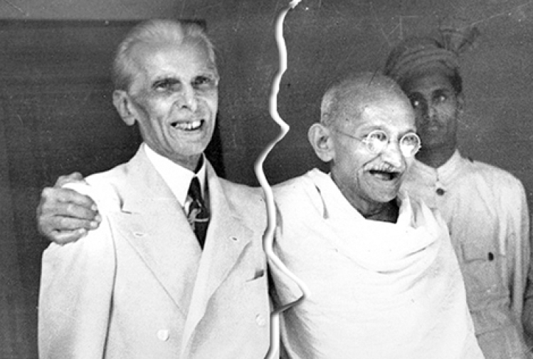

The modern history of South Asia is shaped by the personalities of its two most prominent politicians and ideologues – Mohammad Ali Jinnah and Mahatma Gandhi. This book skilfully chronicles the incredible similarities and ultimate differences between the two leaders.
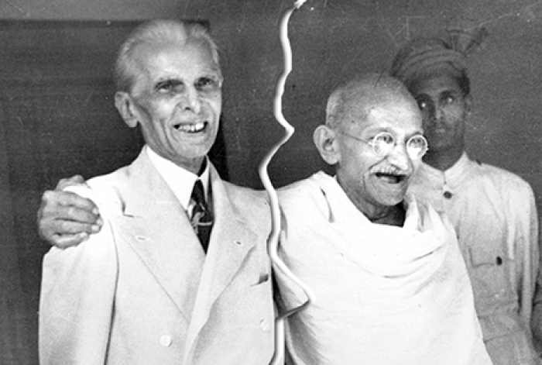
There are scores of books on Mahatma Gandhi that could fill several shelves, but Mohammad Ali Jinnah had apparently few admirers, considering that his biograph-ers are few and far between.
The most notable among them are Stanley Wolpert (‘Jinnah of Pakistan’), Ayesha Jalal (‘The Sole Spokesman’), Stephen Cohen (‘The Idea of Pakistan’), M.A.H Ispahani (‘Quaid-I-Axam: Jinnah As I Knew Him’), Salima Karim (‘Secular Jinnah…as Expressed’), Rafiq Zakaria (‘The Man Who Divided India’) and above all, Jaswant Singh (‘Jinnah, India, Partition’).
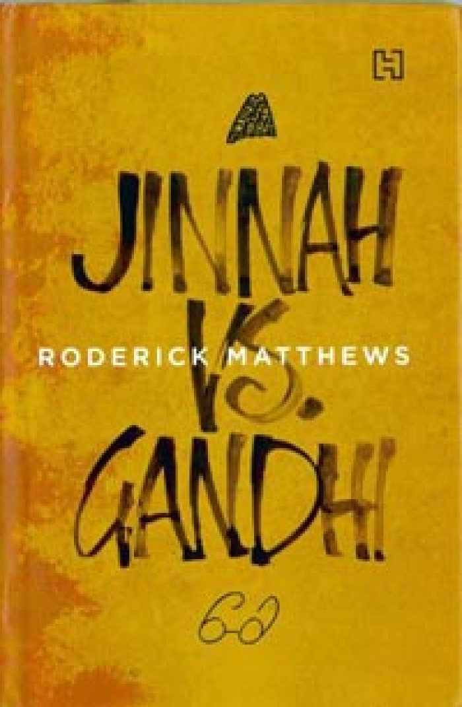
Many have sought to compare Jinnah with Mahatna Gandhi, often peripherally, but Roderick Matthews book is almost the first attempt, which focuses only on a comparative study of the two leaders. Scholars on the Mahatma may not be too happy with some of the author’s conclusions, but at least Matthews has the courage to present them for what they are worth.
It is somewhat intriguing; that Matthews has given too little attention to the Nagpar Congress session of 1920 when Jinnah was literally booed out. He does concede that Jinnah was indeed ‘booed’ out, but fails to give the background.

Many to this day believe that it was at Nagpur that Jinnah and the Congress emotionally parted company. However, Matthews says: “The Nagpur session clearly demonstrated that the Congress was going to be a mass-based party and a mass-based party had to be a Hindu party, Gandhi or no Gandhi.”
But it was in an emotional context at Nagpur that Jinnah turned his face away from the Congress to ultimately form the Muslim League and push for the acceptance of the Two-Nation Theory.
Think of the following remarks Matthews makes of Jinnah and Gandhi: “Gandhi’s optimism gave India a broad and inclusive conception of nationhood whereas Jinnah’s pessimism bequeathed to Pakistan a narrow and defensive brand of nationalism” or “Gandhi was prolific and self-critical, Jinnah was reticent and defensive” or “Jinnah was committed to ends without great regard to means.
For Gandhi, no good thing could grew out of bad and truth is indivisible” or “Gandhi excelled as an active protestor, Jinnah was the most skilful of passive opponents” and again, “Gandhi was a leader by example, Jinnah, was leader by inspiration”.
Matthews also quotes others like for example, Rafiq Zakaria, who believed Jinnah was a godless, ruthless, self-centred man who had nothing but contempt for the Muslim masses, who hated Gandhi “yet loved to be equated with him”.
Matthews, however, describes Gandhi as “a renunciate pilgrim” and Jinnah as “the apple that shrivelled on the tree, the milk that soured in the bottle, the favoured son who never inherited a promised bequest”. Also, according to Matthews, “Gandhi had the right kind of virtues to found a nation which Jinnah, ultimately, did not”.
Matthews is sensible enough to say that Pakistan was a “complex process” and not an easy story to tell and refers to “a long list of writers who are prepared to accept that it was the Congress that pressed for partition in the final days and that Jinnah was reluctant to accept the reality he had brought about”.
Matthews quotes Penderell Moon as saying that Jinnah had confided to a few friends in Lahore that the Pakistan demand was just a “tactical move”, a “bargaining counter”. Kanji Dwarkadas who knew Jinnah well is quoted as saying that Jinnah did not imagine “Pakistan would come into being” and was prepared to settle for loss. And Matthews quotes liberally from Ayesha Jalal’s book that said Jinnah was “all in favour” of accepting the Cabinet Mission plan and didn’t want Pakistan.
But Matthews himself is quite clear that the respon-sibility for the creation of Pakistan lies squarely on Jinnah and nobody else. As he puts it: “He (Jinnah) asked for Pakistan much too often to deny his central role in the process” and “can still correctly be seen as the main instigator in the process that led to partition”.
Is it possible that Jinnah wanted partition because he could also not get along with Vallabhbhai Patel and Jawaharlal Nehru, especially the latter? That Jinnah hated Hinduism is evi-dent.
In December 1938, at the League Conference in Patna, Jinnah made what Matthews calls “one of his least conciliatory, most revealing speeches”. He told the League that Congress was nothing but a ‘Hindu body’ and that Gandhi was planning a Hindu Raj, and he couldn’t have made a more silly statement.
In-cidentally, Matthews is of the view that the British really did not want partition as a solution and “to insist that they did is to believe that mountains of official documents were no more than a smokescreen for some deeper purpose, and that officials spent literally years lying to each other in private”.
However, he also adds that “tragically, the British did not have enough concern to deny partition to Indians if they said they wanted it”. Who are these ‘In-dians’? Surely not from the Congress? Matthews should also study some correspondence between Jinnah and
Winston Churchill, and he may then revise his views.
The British had no great respect for the Congress. As Matthews himself notes, “the British equated mass popularity with manipulation and hysteria” and he recalls many political observers of making “direct parallels between Gandhi and European fascists”.
Obviously Matthews hasn’t given much thought to the Quit India Movement that Gandhi inaugurated in 1942. Gandhi was not in league with the Axis Powers whatever British ‘political observers’ might have thought. He had his own strong views, which he expressed at the meeting of the AICC held in Mumhai on August 7 and 8, 1942.
But it in intriguing that, of all people, Britain’s Prime Minister Clement Attlee once remarked – and Matthews quotes him – that “Jinnah was the only fascist he had ever met”.
Matthews has his own views on Jinnah, whose leadership, he feels “is the leadership of momentum, not of foresight”. Summarising Jinnah’s obsessive demands for Pakistan he says in the end: “Pakistan had serious problems of insecurity…that Jinnah was reluctant to acknowledge and did not address. He missed the large point for the lesser one. The result was a paranoid country, too small to sustain its own defence without compromising its other obligations…Gandhi had the right kind of virtues to found a nation. Jinnah, ultimately, did not.” And that says it all.
Whatever anybody may say, in the end Jinnah has proved himself to be a disaster even for the very Muslims whose larger interests he felt he was trying to protect by demanding partition. As a study of two great contemporary leaders this book has few compeers.

