Is there a pattern of world development?

What: A scatter graph to decide the correlation between 2 development indicators
Why: so that we can use geographical skills to analyse the pattern of world development
How:
- Collect and treat appropriate data
- Present the data in a geographically appropriate way
- Describe and explain data
- Analyse route to enquiry

The route to enquiry (the learning cycle)
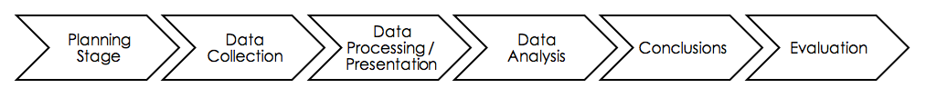

1: Planning stage:

Which development indicators will you use? Why these?
Which 20 countries will you pick? Have you a good spread of countries from different levels of development?

Geographical Enquiry Focus

Enquiry Question:

Hypotheses:
Step 1:

2: Data collection

- Use a reliable geographical source to collect the data for your 2 development indicators for your 20 chosen countries.
Rank
- For each set of data you need to decide which figure shows the lowest level of development- this will be rank 1.
- Rank the data for each set from 1 being lowest to 20 being most developed.

Country | Indicator | rank | indicator 2 | rank

- Data processing/ presentation

Using the data collected complete a scatter graph showing rank v rank. The graph should have axis clearly labelled, plotted countries labeled in some way and a clear and descriptive title.

- Data analysis/ conclusion

Describe data- what is the general trend- use scatter graph relationship terminology
Explain why you may have got the patterns you have found (i.e. why may there be a relationship between your two indicators)
Use specific examples from the graph to back up your explanation. Use your own knowledge and some research to explain why these countries may have had the positions on your graph.
Are there any anomalies in your data? Why may you have this anomaly?

What conclusions can we draw from this?

- Analysis

Did you choose good sets of data to show a relationship?
Why do you think you received these results?
Would you have obtained a similar pattern with different data? Why/ why not? Give examples.
How could we extend this study?

Level 4 | Level 5
- Formulates/chooses a clear and focused research question and describes its relevance in detail  - Formulates and somewhat follows a partial action plan to investigate a research question  - Uses methods to collect and record mostly relevant information  - Evaluates some aspects on the research process and results of the investigation | - Formulates/chooses a clear and focused research question and explains its relevance  - Formulates and follows a partial action plan to investigate a research question  - Uses method(s )to collect and record appropriate, relevant information  - Evaluates the process and results of the investigation
Level 6 | Level 7
- Formulates/chooses a clear and focused research question and justifies its relevance  - Formulates and effectively follows a comprehensive action plan to investigate a research question  - Uses methods to collect and record appropriate, varied and relevant information  - Thoroughly evaluates the investigation process and results | - Independently, formulates/chooses a clear and focused research question and fully evaluates its relevance  - Independently, formulates and effectively follows a comprehensive action plan to investigate a research question  - Independently, can identify methods to collect and record appropriate, varied relevant information  - Thoroughly evaluates the investigation process and results and independently seeks ideas for extensions
I can….

Interpret if there are geographical similarities, differences and links between places

Use sources such as maps, graphs, tables, atlases, photographs and statistics, in a critical manner, represent information using maps, models and diagrams, including use of scale, graphs and tables.

Analyse and interpret information from a wide range of sources

