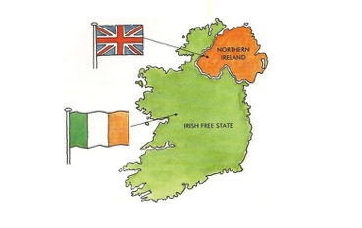
Ireland
Challenge | Explanation | Examples | Response | Success?
Political Challenges
- Constitution
- Political Rule
- Racial and separatist movements
Ethnic and Religious Challenges
- Ethnic division
- Religious division
- Language
- Nationalism
Economic Challenges
Social and cultural Challenges
Interaction with neighbours and the wider world

