What was the most important invention of the Industrial Revolution?

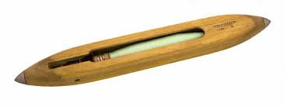
Invention - Flying Shuttle
Invented by - John Kay
Date invented - 1733
Importance at the time - This invention doubled the output of weavers and was the first major textile breakthrough of all our inventions. It also meant only one person was now required to work a loom machine to make cloth (previously it had taken two people).
Profundity of the invention's impact - A group calling itself 'the shuttle club' set up - members would ignore the patent, steal Kay's design, and pay the legal costs of one another. This almost bankrupted Kay and he later moved to France.
Quantity - The mule was so popular that weavers in Colchester, worried they couldn't compete, even petitioned the King to ban it!
Durability - Today Kay is seen as a local hero in Bury where there are statues and pubs named after him. His invention laid the foundations for those that followed him such as Hargreaves and Arkwright.
Relevance - How many items of clothing do you own? What would happen to the price if two people were required to work producing each piece rather than one?

Invention - Refrigerator
Invented by - William Cullen
Date invented - 1755
Importance at the time - The poisonous gases vaporised to cool air put a lot of people off this new invention which was discovered in Glasgow.
Profundity of the invention's impact - By 1800 meat from places such as Argentina reached Europe. This provided cheaper food and a richer diet for the poor but it did have a negative impact on some local farmers. It also improved health because less salt was used (salt had previously been used as a preservative).
Quantity - Early models were for industrial use only and domestic models didn't become available until 1913 (even then they cost nearly twice the price of a car!)
Durability - Today most people in our country have a refrigerator (or two) in their home.
Relevance - Next time you eat look closely at where your food has come from. New Zealand lamb? Filipino bananas? Korean strawberries? Malaysian jackfruit? English chocolate?

Invention - Spinning Jenny
Invented by - James Hargreaves
Date invented - 1764
Importance at the time - This machine had 8 spindles (later increasing to 40, then 120) which meant they could produce much more yarn than before. In turn this meant the wool industry grew.
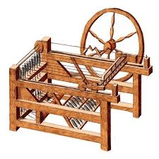
Profundity of the invention's impact - Named after Hargreave's daughter, Jenny, this device impacted upon the workforce and was labour saving. He did not get a patent for his invention though and it was widely copied.
Quantity - Because they cost only £6 they were affordable and popular. By the time he died there were over 20,000 replicas in Britain.
Durability - The Spinning Jenny inspired other inventions by people like Richard Arkwright but Hargreaves invention was the earlier of the two.
Relevance - Are you wearing wool today? What items do you have at home that are made of wool?

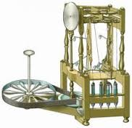
Invention - Water frame
Invented by - Richard Arkwright
Date invented - 1769
Importance at the time - Arkwright teamed up with a man called John Kay to invent this machine, which meant four threads of cotton could be spun into yarn at one time. Later devices could spin 96 threads at once causing production to boom.
Profundity of the invention's impact - Arkwright could now employ unskilled labourers on his frames.
Quantity - Arkwright made about £30,000,000 in today's money. Not bad for a man who used to make wigs.
Durability - The water frame produced a much stronger thread than the Spinning Jenny.
Relevance - Manchester became a booming industrial town, nicknamed 'Cottonopolis'. Without Arkwright Manchester United might therefore not be the big football club it is today. More importantly, that cotton shirt you're wearing would cost your parents a lot more money!

Invention - Steam engine
Invented by - James Watt
Date invented - 1775
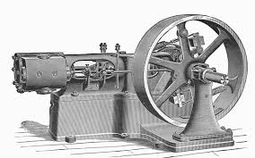
Importance at the time - Thomas Newcomen had already invented a steam engine back in 1712. However it was James Watt who made the first reliable external combustion engine. It meant factories could locate away from sources of water which had previously been a requirement for machines using water wheels as their primary source of power.
Profundity of the invention's impact - Watt's steam engine powered the locomotives which covered the country and also powered many of the new inventions in the textile industry such as spinning mules and power looms. Without this invention these would have not been possible!
Quantity - Steam engines were one of the most significant driving forces in making the Industrial Revolution possible and became commonplace in many big factories.
Durability - In 1781 Watt's engine had a force of 10 horse power but by 1883 they could provide 10,000 horse power.
Relevance - There are now many alternatives to steam power such as solar, wind and nuclear energy sources.

Invention - Spinning mule
Invented by - Samuel Crompton
Date invented - 1779
Importance at the time - It was called a mule because it was a mix of two earlier inventions, the Spinning Jenny and the power loom.
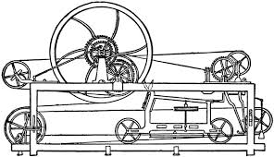
Profundity of the invention's impact - By the 1790s machines had as many as 400 spindles and productivity was greater than ever in the textile industry.
Quantity - Crompton was too poor to apply for a patent so sold his idea to a factory in Bolton. It became very popular although he didn't benefit hugely from it himself.
Durability - The mule had a moveable carriage which made it different to earlier inventions and ensured its longevity.
Relevance - Textiles were crucial to the Industrial Revolution. How many individual items of clothing are you wearing while reading this?

Invention - Power Loom
Invented by - Edmund Cartwright
Date invented - 1785
Importance at the time - This invention was steam powered and helped the textile industry flourish. The idea had been inspired by a visit to Arkwright and relied on Watt's steam engine although at first it did not work very well.
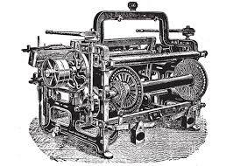
Profundity of the invention's impact - Inventions like this created a big demand for cotton which in turn caused Europeans to kidnap more and more Africans to work as enslaved people on the plantations of the Americas.
Quantity - It increased the output of cloth weaving 40-fold. By 1850 there were 250,000 power looms in England most of which (177,000) were in Lancashire.
Durability - The power loom was improved upon by later inventors and meant a 13 or 14 year old could operate two machines at once where previously this could only be done by skilled adults.
Relevance - Is the school shirt / blouse you are wearing right now cotton? How much more would it cost if the power loom had not been invented and it had to be made by hand?

Invention - Davy Lamp
Invented by - Humphry Davy
Date invented - 1815
Importance at the time - Coal mining was a very dangerous job because of highly flammable methane gas which would cause explosions when in contact with miners' candles. The Davy Lamp worked without igniting any gases and was intended to save many miners' lives.
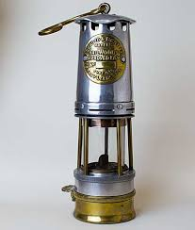
Profundity of the invention's impact - Oddly the Davy Lamp actually increased the number of deaths from coal mining. This was because pit owners opened up more dangerous seams thinking miners were now safe.
Quantity - From 1700 to 1750 coal production had increased by 50% This rate of increase soared by 500% after 1850.
Durability - Coal is still used today but is increasingly being replaced by renewable energies such as solar, wind and even nuclear power.
Relevance - Coal was a major reason in the Industrial Revolution, perhaps even the major factor for such rapid growth. Your teacher, Mr. Guiney, comes from near the Black Country - an area named because of how black it looked on account of all the coal and soot commented on by the Queen, Victoria.

Invention - Cadbury's chocolate
Invented by - John Cadbury
Date invented - 1824
Importance at the time - Drinking chocolate became a very popular leisure activity. The Cadbury family became very wealthy but because of their religion (Quakers) also developed a reputation for looking after their workers, building them 314 cottages and houses on the estate.
Profundity of the invention's impact - Cadbury's generated a big multiplier effect, giving jobs to shopkeepers, drivers, construction workers, and of course factory workers. Today the factory features a museum called Cadbury World which provides a history of the company thanks to some helpful cocoa beans!
Quantity - By 1893 the business had expanded enough for it to move to new 120 ha premises in Bourneville.
Durability - The average person today eats 11.7 pounds of chocolate per year.
Relevance - How many Cadbury adverts can you remember? And which is your favourite Cadbury chocolate bar?

Invention - Stephenson's Rocket
Invented by - Robert Stephenson
Date invented - 1829
Importance at the time - This was an early form of steam-powered Locomotive which won the Rainhill Trials to design a Locomotive for the Liverpool and Manchester Railway.
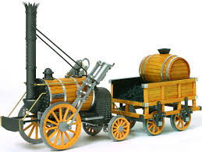
Profundity of the invention's impact - It could reach a speed of 28mph and became the template for Locomotives for the next 150 years.
Quantity - Between 1845-47 alone 8,000 miles of track were laid with £200 million of government funding.
Durability - Today there are 21,000 miles of railway track in the U.K. and locomotives account for about 8% of all travel. Railways meant the growth of the seaside, movement of fresh produce became more efficient, and GMT was introduced so that Britain only had one time zone. Above all it aided industry and allowed for efficient movement of heavy goods, like coal and steel. It benefited though from Bessemer steel, Watt steam, and Davy Lamp coal.
Relevance - For those of you who are fans of Thomas the Tank Engine (also known as Thomas & Friends) you might be interested to know that the character Stephen is based on this invention!

Invention - Camera
Invented by - William Henry Fox Talbot
Date invented - 1835
Importance at the time - The camera was very popular and quickly replaced drawings. Soon many people had photographs on their mantelpieces.
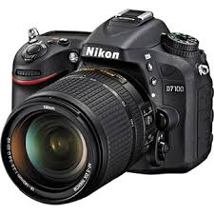
Profundity of the invention's impact - People could see Royals and famous people for the first time - this gave birth to the rise of celebrity culture! Also though policing changed thanks to photography and important moments in History could be recorded for posterity.
Quantity - By 1900 a company called Kodak had made photography affordable, at around $25. Interestingly many camera enthusiasts were women.
Durability - Photography is an art form and has changed History. Famous powerful photos include My Lai, doctored Soviet pictures, and pictures of the First Would War.
Relevance - How many photographs do you have on you right now? This includes selfies. How much duller would life be without such images?

Invention - Difference and analytical engines
Invented by - Charles Babbage
Date invented - 1837
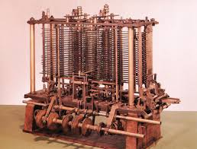
Importance at the time - Babbage argued with his chief engineer, Joseph Clement, and did not have the funding to see his plans through to completion - as a result they were not put into action until a hundred years later. They did however create the world's first computer - even if it had no screen or keyboard! Instead it operated by cranking a handle from which a series of mathematical data would be printed. Great idea but not carried out at the time.
Profundity of the invention's impact - These were the world's first plans for computers and were designed by a mathematician. A working model - assembled in the 1990s - can be seen in London's Science Museum.
Quantity - None were ever sold during the Industrial Revolution.
Durability - Computers have grown in importance over time and Babbage laid the foundations for what was to come later. Today the world would struggle to operate without computers.
Relevance - How long ago did you last use a computer? Will your answer be in days, hours, or even minutes I wonder?

Invention - Telegraph
Invented by - Samuel Morse
Date invented - 1837
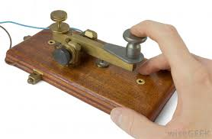
Importance at the time - This transformed communication and meant people could contact each other much more easily. This machine pre-dated the telephone and meant people could instantly send messages to one another using Morse Code - a series of dots and dashes. Morse was given a $30,000 loan to develop his Telegraph.
Profundity of the invention's impact - People living far apart could now communicate for the first time without having to be face to face or by writing a letter. It could transmit 30 characters per minute.
Quantity - Telegraphy was expensive but received lots of government funding. By 1852 there were 23,000 miles of telegram lines in the USA and 2,200 miles in Britain.
Durability - The Telegraph remains the basis for rhythmic communication today. Without this it is unlikely the telephone would have been invented.
Relevance - How different would your life be if you could not send or receive SMS messages? Is Morse Code still used? Where and by whom?

Invention - Bicycle
Invented by - Kirkpatrick Macmillan
Date invented - 1839
Importance at the time - Bicycles gave people the opportunity to travel to the countryside. Cycling clubs were formed and cycling became the latest craze. They were a very popular invention at the time.
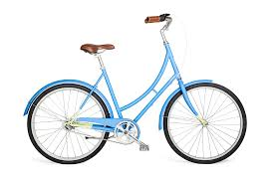
Profundity of the invention's impact - Bicycles improved health, increased leisure opportunities, and made it easier for people to travel thus encouraging them to live further from their place of work. They were much more affordable than later motor vehicles although they were very heavy and it took considerable effort to ride until the invention of the pneumatic tyre in 1887.
Quantity - Kirkpatrick did not patent his invention and for about 50 years the man who did patent it was wrongly considered its inventor. Many bicycles were produced and there were popular publications such as Bicycling News.
Durability - Today there are over one billion bicycles in the world, approximately 65% of which are made in China.
Relevance - Can you ride a bicycle? How much have they really changed since 1839?

Invention - Portable sewing machine
Invented by - Isaac Singer
Date invented - 1851
Importance at the time - People could now make and repair their own clothes cheaply and easily. The invention won first place in Paris at the World's Fair in 1855.
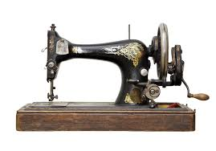
Profundity of the invention's impact - Along with other items designed to be labour saving domestic appliances the sewing machine meant women had more time which in turn encouraged them to enter the workforce more. In this sense inventions like this helped women's rights in the long term.
Quantity - 4 million machines were sold in the first 20 years.
Durability - Many people tend to buy clothing 'off the peg' in our 'throwaway society'. They are still used widely however in production of the clothes you are wearing right now.
Relevance - Sewing machines have long been used industrially but are presently enjoying a revival. This year sales rocketed 500%.

Invention - Bessemer's Steel converter
Invented by - Henry Bessemer
Date invented - 1856
Importance at the time - For the first time pig iron could be cheaply converted into quality steel on a large scale. Instead of it costing £40 per ton it now cost £6-7 per ton.
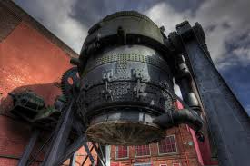
Profundity of the invention's impact - Steel railway lines lasted ten times longer than iron ones and railway carriages could be twice as heavy. Building structures are made with steel girders. Bridges were previously made from wrought iron because steel was too costly but this now changed.
Quantity - Bessemer licensed his invention to four manufacturers for a substantial sum of £27,000. It was a huge success and an example can still be seen at Kelham Island Museum in Sheffield.
Durability - The Forth Rail Bridge, the Royal Albert Hall, and the Oval Cricket ground are all made with Victorian steel.
Relevance - When you eat your dinner today do you use a knife and fork? If so, what are they made of? When your dad or big brother shaves what is his razor made of? Yes, steel. Can you research other items you use daily that are made from steel?

Invention - Telephone
Invented by - Alexander Graham Bell
Date invented - 1876
Importance at the time - Although it appeared an instant success Bell made more money from lecturing than the telephone up to 1897. Early telephones required a 'telephone exchange' so there would be 3 or 4 people on the line. This meant conversations included less gossip than today because people didn't like to spill their secrets.
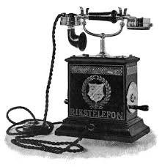
Profundity of the invention's impact - Bell had a deaf mother and wife which explains his interest in listening devices. From the moment the first words - "Mr Watson - come here - I want to talk to you" were uttered by Bell the invention of the telephone changed the world profoundly.
Quantity - When Edison's patent ran out (there was some controversy with some believing he stole the idea from Elisha Gray) there were immediately 300 other patents filed from competitors.
Durability - Today politicians, businessmen, and families make millions of calls per day. Today there are 900 billion cell phone calls each year in the USA alone.
Relevance - How many times per day do you use your cell phone? Who do you phone the most? How different would your life be without it?

Invention - Phonograph
Invented by - Thomas Edison
Date invented - 1877
Importance at the time - Recording and hearing sounds caused an uproar at the time. It worked by a needle which scratched a tin foil drum.
Profundity of the invention's impact - In 1877 Emile Berliner improved upon this further with a gramophone which could play records on vinyl discs.
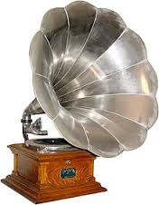
Quantity - Whilst early phonographs were a sensation they remained expensive items for the privileged until the Twentieth Century.
Durability - The phonograph paved the way for records, CDs, MP3s, and indeed whatever will follow these. No Thomas Edison, no Lady Gaga!
Relevance - Who is your favourite singer or band? How would you feel having to listen to mum or dad or your teacher instead?

Invention - Motor vehicle
Invented by - Karl Benz
Date invented - 1886
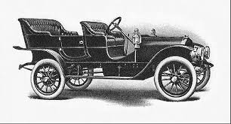
Importance at the time - The first car with a petrol engine had in fact been built by a Belgian called Lenoir in 1863 but this was improved upon significantly by Benz and also Daimler. They were however very expensive at the time and in the U.K. were allowed to travel only at a speed of 4mph and had to have someone walk in front of them with a red flag to warn people.
Profundity of the invention's impact - Today there are 1.2 billion vehicles in the world and the motor card led to significant changes in culture, morals, living habits, and economics.
Quantity - Benz sold only 25 cars between 1888-1893.
Durability - Cars have evolved significantly over time and became cheaper later on in the 1920s when Henry Ford introduced cars made on a conveyor belt - this was, however, after the Industrial Revolution.
Relevance - Can you imagine a world without cars? No pollution, car crashes, and accidents. But also no suburbs, no F1 circuits, no Top Gear, and no drive-time music. How different would your life be?

Invention - Pneumatic tyre
Invented by - John Dunlop
Date invented - 1887
Importance at the time - The pneumatic tyre encouraged the bicycle and motor vehicle industries.
Profundity of the invention's impact - Cycling became a huge Victorian craze thanks to the Scotsman Dunlop's invention. Cars also became faster.
Quantity - In 1896 the business was sold for an astonishing £3,000,000.
Durability - Sir Chris Hoy, Bradley Wiggins and Victoria Pendleton are some of your teacher's heroes. Without Dunlop you would not have heard of these Olympians. You probably also wouldn't know about Lewis Hamilton, and car chases in your favourite Hollywood action movies would be very different!
Relevance - Did you arrive at school today on a bike? A car? A bus? If so it is thanks to Dunlop that you are enjoying this wonderful History lesson!

