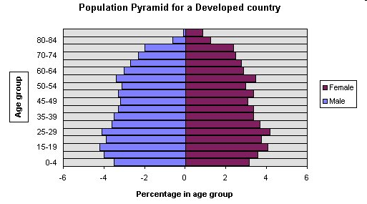
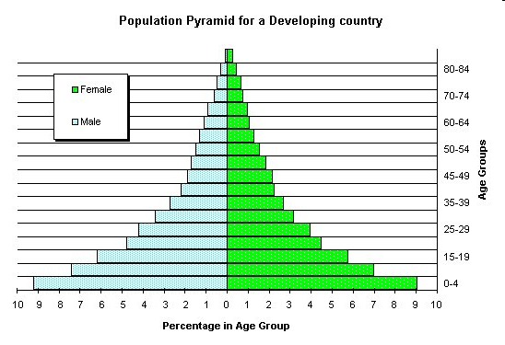

Instructions
- Decide which graph each of the statements relates to and add the label to the graph.
- Extension: what other information could you annotate onto these population pyramids?
This pyramid is typical of a country such as Gambia or Vietnam. | Narrower at the base which means that birth rates are lower.
Developing Country | Wide at the base which means there are a large proportion of young people in the country.
Wide at the top because there is longer life expectancy. | 4% of the population is female aged 25-29.
Narrow at the top which shows that there is a small proportion of elderly people. | Wider in the middle which means that people are living longer, less infant mortality.
Developed Country | This pyramid is typical of a country such as Italy and Japan.

