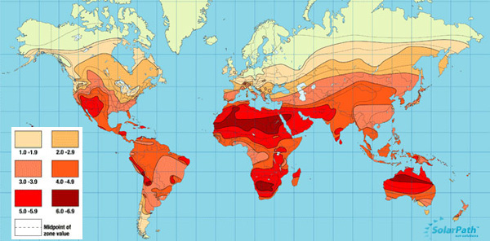
How do insolation & atmospheric cells work together to give a tropical climate?

The map above shows insolation levels over the land surface of planet earth. The darker reds indicate a higher level of solar radiation. Insolation refers to the level of solar radiation received by the earth. Insolation is greatest nearer the equator. Solar radiation is absorbed by the surface and then radiated out as heat, heating the air above. You know what happens to warm air …..
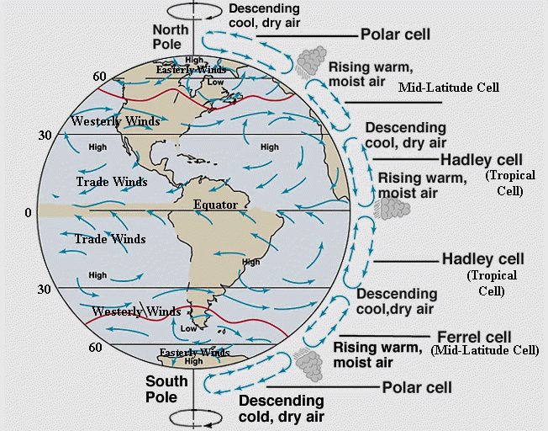
The model to the right shows a series of air cells that exist in our atmosphere. Air generally rises where there is a source of heat and then circulates (cools, condenses, precipitates, cools further, sinks, travels back over the surface of the earth, heats rises etc).
Task 1 – Mark on the location of Belem in Brazil onto both maps.
Task 2 – What is the name of the air cell that affects Belem, Brazil and what happens at this location?

Task 3 – In the space below, explain how insolation causes the formation of the Hadley cell (think high levels of radiation, warming air etc) and how this then causes convectional rainfall (click link for YouTube video)

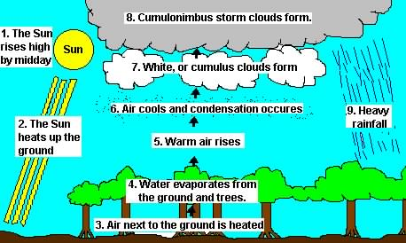
Task 4 – Using what you learnt in the YouTube video and the diagram to the right, explain how convectional rainfall influences total rainfall in rainforest areas (see your climate graph).

Task 5 -How does the constant rainfall influence the flora (vegetation) and fauna (animals & insects) in rainforest biomes?

