IB Inquiry Title:

Does technology create more perfect or imperfect market structures?

IB Concepts:

Choice-Efficiency-equity-Economic well-being

Change-Interdependence-Intervention

* Scarcity
* Efficiency
* Equity
* Intervention

IB Content:

Economic theories, models, ideas and tools

* Perfect competition
* Imperfect competition
* monopolistic competition, oligopoly, monopoly
* Market outcome; allocative and productive efficiency
* Is government intervention required and if so what sort of intervention

Contexts:

Real world issues and examples

Growth of online market places

social media. Technological justifications for

natural monopolies. Sharing apps such as Uber.

Outcome:

1. Create a market structures overview diagram demonstrating how technology affects the degree of competition in each market structure.
2. Evaluate using different examples whether technology is making market structures more or less competitive. Demonstrate that there are many possible answers depending on how the market structure has changed with technology.

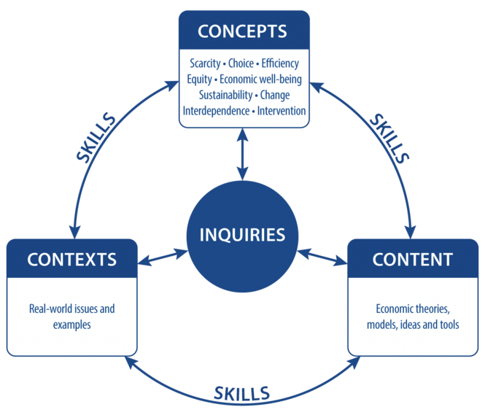

Concepts

Context

Inquiry

Content