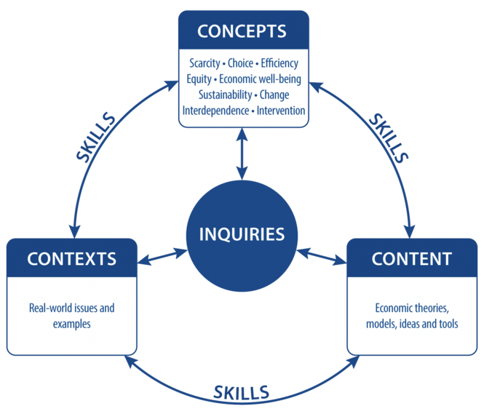

IB Inquiry Title:

To what extent is the American Healthcare market an example of Market Failure?

IB Concepts:

Scarcity-Choice-Efficiency-equity-Economic well-being

Sustainability - Change-Interdependence-Intervention

* Scarcity
* Efficiency
* Equity
* Intervention

IB Content:

Economic theories, models, ideas and tools

* MSB≠MSC
* Externalities
* Merit goods
* Private goods
* Public goods
* Common pool resources
* Government approaches
* Asymmetric Information

Contexts:

Real world issues and examples

* American Healthcare Market – Private v Public – Employee Based Insurance - Emergency Rooms - Obamacare – Subsidy - Mandate

Outcome:

1. Justification for 5 safety improvements that could be presented to SLT

2. Write a report for presentation

Concepts

Context

Inquiry

Content