Inflation

In this chapter we will be covering the following

- Definition of the terms: inflation, deflation and disinflation
- The measurement of inflation
- Costs of inflation & deflation
- Causes of inflation
- Solutions to inflation
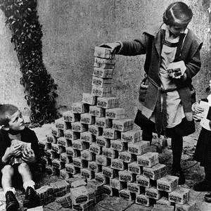
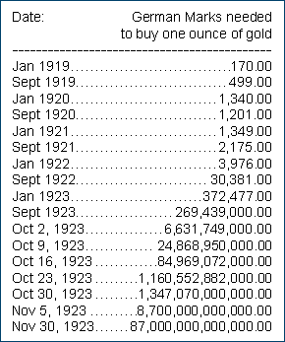
- Use the graph below to identify the following terms and write definitions in the table
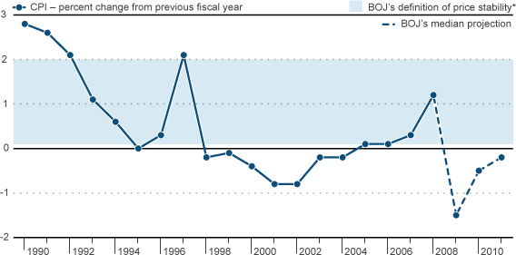

Inflation
Deflation
Disinflation

- Governments measure the rate of inflation using the ‘Consumer Price Index’.

- The prices of goods and services have to be measured in an economy from one year to the next in order to calculate the rate of inflation.

Why is it necessary for the government to compile a ‘representative basket of consumer goods and services?

- The 650 items contained within the basket of goods and services are grouped into different categories.

- The prices of the items are measured to calculate the average price change of the goods and services in the basket.

- The average change in the price of goods and services is reflected by a change in the

.

- Consumers spend a larger proportion of their income on some items than others. Therefore some categories are given a than others.

Larger weight every month consumer price index

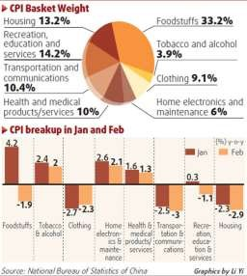
- In the table below, please complete the following:-

  - – Arrange the different categories into descending order by importance/weighting.
  - – Identify the weighting of each category.
  - - Give examples of the different goods and/or services that would be found in each category.

The figures in the table are for the UK (2011)

Costs of Inflation

Lesson Objectives
To look at the different costs of inflation for different groups in society. To look at how inflation may effect the macro economy.

The following are all costs of inflation:-

- Shoe-leather costs
- Menu Costs
- Psychological and political costs
- Redistribution costs
- Unemployment and Growth

Cost | Explanation
1. Shoe-leather costs
2. Menu Costs

3. Psychological costs
4. Redistributional costs

5. Unemployment

- Using your own knowledge say how inflation would have a negative/positive effect upon the following groups of people answers should be in sentence format and not one word answers.

Politicians in power

A pensioner on a fixed income

A Restaurant owner

A saver who receives a rate of interest of 4% on her savings when inflation is running at 6%.

A borrower who borrowed money at 5% when inflation is 6%. (income rises in line with inflation)

A worker whose tax allowance did not rise in 1999 when the rate of inflation was 6%.(income rises in line with inflation)

A factory owner who manufactures rubber ducks for export. (U.K. inflation 6%; E.U. average 4%)

A saver who receives a rate of interest on her savings of 4% when inflation is at 3%.

A worker whose personal income tax allowance is £4000 in 1997, inflation is running at 2% and his allowance increases to £4500 the next year. (income rises in line with inflation)

A Marketing Director whose salary increases by 10% in response to an increase in the rate of inflation of 3%

- Complete the example below when the rate of inflation is 10% per year

 | Year 1 | Year 2
Income | $100,000 | $110,000
Allowance | $10,000 | $10,000
Tax Rate | 25% | 25%
Taxable Income | $90,000 | $100,000
Tax Paid | $22,500 | $25,000
Tax Paid as a % of Gross  Income | 22.5%  (average tax rate) | 22.7%  (average tax rate)

The allowance should increase in line with inflation to avoid people paying more tax.

- Give three/four reasons why inflation might have a negative impact upon the whole economy. Use the notes you have been given to help you.

Unemployment
Lower rate of economic growth Less money from exports

Complete the flow chart below.

There is a sustained rise in the price level of an
economy
Do people become more confident or less confident about the future?

If people are less confident,
what happens to the amount of money they spend?
What impact will this
have on businesses and how will they react?

What happens to the rate of unemployment?

- If less people are working and less people are spending money then what will be the impact upon the level of Real G.D.P. (National Income) in the economy?

Look at the diagram below and imagine that there are just two nations in the world and that they trade with each other.
Country A Average Price of Exports: $10
Country B Average Price of Exports: $10
Now imagine that country A experiences inflation at a rate of 5% and country B experiences inflation at a rate of 8%.

Calculate the new average price of exports for country A and the new average price of exports for country B. Mark this on the diagram below.
Country A Average Price of Exports:
Country B Average Price of Exports

What will happen to the level of exports in both nations and how can this be linked to the rate of inflation?

Deflation – Causes and Costs

  - Generally speaking, deflation can occur due to one of two reasons. The first type of deflation is known as ‘bad deflation’ (Blink and Dorton 2007) and is a result of a fall in aggregate demand. Illustrate and explain this below.

Price Level

Real G.D.P.

- However, ‘good deflation’ can also occur due to improvements in the supply-side of the economy. Illustrate this below and give some examples of the type of policies that may lead to a fall in the average price level.

Price Level

Real G.D.P.

- The IB has set essay questions in the past asking students to consider the ‘costs of deflation’. The negative aspects of deflation are much more likely to occur when it has resulted from a fall in aggregate demand (‘bad deflation’)

Using the table below, explain the costs of deflation in more detail.

Factor | Explanation
Unemployment
Investment

Debtors (think consumers and firms)

Causes of Inflation
Cost-push inflation Demand-pull inflation
The Monetarist explanation

Cost-push inflation occurs due to an increase in the costs of production of firms.

- How might a firm respond to an increase in its costs so that it maintains its profit margins?

- In the table below identify why a firm might experience an increase in its costs of production.

Increase in cost | Reason
Petrol/oil
Imported raw materials
Tax payments
Wages

Cost-push inflation sometimes occurs due to supply-side shocks. A supply-side shock is an exogenous increase in costs.

- Using the diagram on the next page illustrate the effect of an exogenous increase in costs.

- What do you understand by the term exogenous?

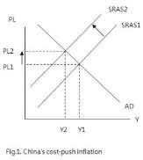
Price level

Real GDP

- Describe the shift in the aggregate supply curve.

- Explain why the depreciation of a nation’s currency can lead to cost-push inflation. (Illustrate this on the diagram below)

Dollars to the Euro

Quantity of Euros traded

Demand-Pull inflation

- Demand-pull inflation usually occurs when the economy is operating near to or at its full employment level of output

- At which stage of the business cycle are we most likely to witness demand-pull inflation and why?

This type of inflation essentially occurs when demand for goods and services
outstrips/exceeds supply.

- Complete the diagram below illustrating how demand-pull inflation occurs

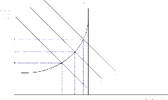
Price level

Real GDP

- Explain and Illustrate on the diagram on the next page why demand-pull inflation would not occur if there were spare capacity in the economy.

Price
Level

Real GDP
Give a real world example of demand-pull inflation.
Monetarist inflation (inflation due to excessive monetary growth

‘Too much money chasing too few goods’

- What is a ‘Monetarist’?

- What is the money supply?

- From the list below choose the items that are included within the money supply of a nation.
Notes and Coins
Shares
Current Accounts
Credit Cards
Treasury Bills
Deposit Accounts

- Illustrate the concept of Monetarist inflation on the diagram below.

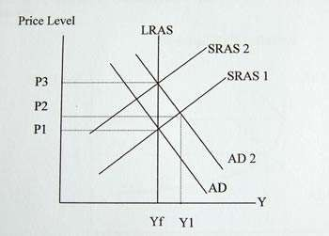
Price
Level

Real GDP

“Inflation is always and everywhere a monetary phenomenon”

The theory can be explained using the Fischer equation

MV = PQ

M = V = P = Q =

- Using the above equation summarise the monetarist argument on inflation.

This means that if banks lend more money then there will be more
and there will be an increase in the
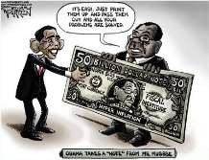
of the economy.

- Give a real world example of Monetarist inflation?

Measures to combat inflation

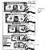
The solution to rising inflation largely depends upon the type of inflation that an economy is experiencing. Hence the first challenge is to identify what factors in the economy are responsible for price rises.
Solutions to cost-push inflation

Solution | Explanation | Drawback
Subsidies to firms
Fixed/managed exchange rate
Incomes policies
Restricting trade union power
Cutting indirect tax

Solutions to demand-pull inflation

- Contractionary fiscal policy

- Contractionary monetary policy

- Supply-side policies

- Illustrate how these policies would reduce the rate of inflation using a diagram.

Price
Price

Real GDP Real GDP

- Why might the implementation of a contractionary fiscal policy to combat rising demand-pull inflation prove problematic?

Public opinion

Time lag

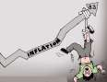
- Why do most industrialised countries tend to use monetary policy to control the rate of inflation?

- What are the drawbacks of the contractionary monetary policy measures?

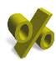
Notes and Coins

8. Reduction of the money supply
Solutions to monetarist inflation

Credit Controls

Money Supply

Interest rates

The Phillips Curve
In today’s lesson we will be covering the Phillips curve and looking at :

- The original Phillips curve.
- How to derive a Phillips curve.
- Arguments related to the Phillips curve.

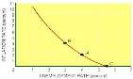
1. The original Phillips curve was based on data relating to the rate of change of money wages and the rate of unemployment.

What relationship do you imagine there would be between the rate of change of money wages and the rate of unemployment?

On the graph below plot the Phillips curve.

Rate of change of money wages

Unemployment rate %

- Other economists thought that this research gave a good insight into the relationship between inflation and unemployment.

How are changes in wages and changes in prices linked?

- Using the inflation and unemployment data below can you plot the relationship between the two variables?

Year | Unemployment (% of workforce) | Inflation (% change)
1974 | 2.0 | 17.0
1975 | 3.2 | 23.5
1976 | 4.8 | 15.7
1977 | 5.1 | 14.7
1978 | 5.0 | 9.5
1979 | 4.6 | 13.7
1980 | 5.6 | 16.3
1981 | 8.9 | 11.2
1982 | 10.3 | 8.7
1983 | 11.1 | 4.8
1984 | 11.1 | 5.0
1985 | 11.5 | 5.3
1986 | 11.5 | 4.0
1987 | 10.6 | 4.3
1988 | 8.7 | 5.0
1989 | 7.3 | 5.9
1990 | 7.0 | 5.5
1991 | 8.8 | 7.4
1992 | 10.1 | 4.7
1993 | 10.4 | 3.5
1994 | 9.6 | 2.5
1995 | 8.8 | 2.6
1996 | 8.4 | 2.7
1997 | 5.8 | 3.4

Inflation
%

Unemployment %

- Show the basic shape of the Phillips curve on the diagram below.

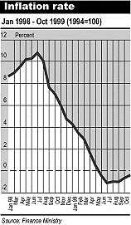
Inflation
%

Unemployment %

- If the government decides to increase government spending ( policy) in order to boost the economy what will happen in the economy? (Illustrate on the diagram above)

- The rate of inflation will now be at 4%. In the short-term workers suffer from a « Money Illusion ». They don`t realise that in real terms their wages have actually :-

- When they do realise their wages have fallen in real terms? What action might they take ?

- How big an increase in wages will the workers demand?

- What impact will this have on the rate of inflation?

- Illustrate this on the diagram on the next page.

Inflation
%

Unemployment %

- If the government tries to increase government spending one more time once the economy is at point C what will happen?

- To what rate of unemployment will the economy tend?

- What do we call this rate of unemployment?

- On the diagram below illustrate the Classical Phillips Curve.

Inflation
%

Unemployment %

- How would Classical economists advocate reducing the rate of unemployment?

- Illustrate this on the diagram below.

Inflatio n
%

Unemployment %

Stagflation

  - What do you understand by the term Stagflation?

  - Draw a diagram to show that one would normally associate rising prices with lower levels of unemployment.

Price Level

Real G.D.P.

  - What is an external supply-side shock and what shock occurred in the 1970s?

  - Draw a diagram to show what happened to the U.K./U.S. economy when there was a supply-side shock.

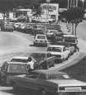
Price Level

Real G.D.P.

  - Why was there an increase in aggregate demand at the end of the 1970’s?

  - Would the economy remain at point C?

Classical economists

Price Level

Real G.D.P.
Keynesian Economists

Price Level

Real G.D.P.

  - On the Phillips Curve below illustrate the concept of ‘stagflation’.

Inflation
%

Unemployment %

