Inflation

In this chapter we will be covering the following

- Definition of the terms: inflation, deflation and disinflation
- The measurement of inflation
- Costs of inflation & deflation
- Causes of inflation
- Solutions to inflation
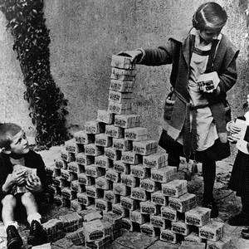
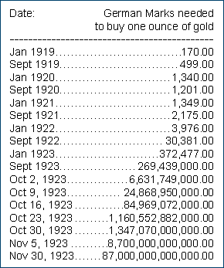
- Use the graph below to identify the following terms and write definitions in the table
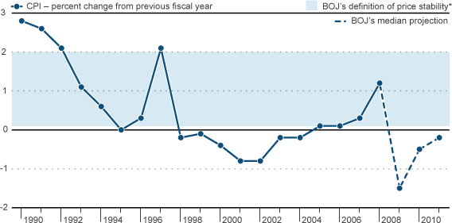

Inflation
Deflation
Disinflation

- Governments measure the rate of inflation using the ‘Consumer Price Index’. In some countries they use the ‘Retail Price Index’.

- The prices of goods and services have to be measured in an economy from one year to the next in order to calculate the rate of inflation.

Why is it necessary for the government to compile a ‘representative basket of consumer goods and services?

- The 650 items contained within the basket of goods and services are grouped into different categories.

- The prices of the items are measured to calculate the average price change of the goods and services in the basket.

- The average change in the price of goods and services is reflected by a change in the

.

- Consumers spend a larger proportion of their income on some items than others. Therefore some categories are given a than others.

Larger weight every month consumer price index

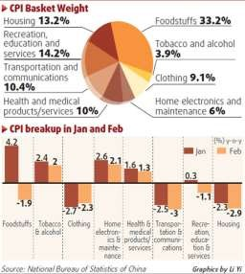
- In the table below, please complete the following:-

  - – Arrange the different categories into descending order by importance/weighting.
  - – Identify the weighting of each category.
  - - Give examples of the different goods and/or services that would be found in each category.

The figures in the table are for the UK (2011)

Category Order Weight Example 1 Example 2 Example 3
Alcohol and Tobacco
Clothing and footwear
Food and non-alcoholic beverages
Transport
Housing and household goods
Recreation and culture
Furniture and household goods
Communication
Restaurants and hotels
Health
Miscellaneous
Education

- How are the weights that make up the Consumer Price Index determined?

- What will happen to the composition of the basket of goods and the weightings over time?

- In the table below identify three items that have been added to the UK’s CPI basket of goods in 2019 and three items that have been removed.

Items adde Ite

Costs of Inflation

Lesson Objectives
To look at the different costs of inflation for different groups in society. To look at how inflation may effect the macro economy.

The following are all costs of inflation:-

- Shoe-leather costs
- Menu Costs
- Psychological and political costs
- Redistribution costs
- Unemployment and Growth

Cost | Explanation
1. Shoe-leather costs
2. Menu Costs

3. Psychological costs
4. Redistributional costs

5. Unemployment

- Using your own knowledge say how inflation would have a negative/positive effect upon the following groups of people answers should be in sentence format and not one word answers.

Politicians in power

A pensioner on a fixed income

A Restaurant owner

A saver who receives a rate of interest of 4% on her savings when inflation is running at 6%.

A borrower who borrowed money at 5% when inflation is 6%. (income rises in line with inflation)

A worker whose tax allowance did not rise in 1999 when the rate of inflation was 6%.(income rises in line with inflation)

A factory owner who manufactures rubber ducks for export. (U.K. inflation 6%; E.U. average 4%)

A saver who receives a rate of interest on her savings of 4% when inflation is at 3%.

A worker whose personal income tax allowance is £4000 in 1997, inflation is running at 2% and his allowance increases to £4500 the next year. (income rises in line with inflation)

A Marketing Director whose salary increases by 10% in response to an increase in the rate of inflation of 3%

- Give three/four reasons why inflation might have a negative impact upon the whole economy. Use the notes you have been given to help you.

Unemployment
Lower rate of economic growth Less money from exports

Complete the flow chart below.

There is a sustained rise in the price level of an economy

Do people become more confident or less confident about the future?

If people are less confident,
what happens to the amount of money they spend?

What impact will this
have on businesses and how will they react?

What happens to the rate of unemployment?

- If less people are working and less people are spending money then what will be the impact upon the level of Real G.D.P. (National Income) in the economy?

Look at the diagram below and imagine that there are just two nations in the world and that they trade with each other.
Country A Average Price of Exports: $10
Country B Average Price of Exports: $10
Now imagine that country A experiences inflation at a rate of 5% and country B experiences inflation at a rate of 8%.

Calculate the new average price of exports for country A and the new average price of exports for country B. Mark this on the diagram below.
Country A Average Price of Exports:
Country B Average Price of Exports

What will happen to the level of exports in both nations and how can this be linked to the rate of inflation?

Deflation – Causes and Costs

  - Generally speaking, deflation can occur due to one of two reasons.

Price Level

Real G.D.P.

- However, ‘good deflation’ can also occur due to improvements in the supply-side of the economy. Illustrate this below and give some examples of the type of policies that may lead to a fall in the average price level.

Price Level

Real G.D.P.

Using the table below, explain the costs of deflation in more detail.

Factor | Explanation
Unemployment
Investment

Debtors (think consumers and firms)

Causes of Inflation
Cost-push inflation Demand-pull inflation
The Monetarist explanation

Cost-push inflation occurs due to an increase in the costs of production of firms.

- How might a firm respond to an increase in its costs so that it maintains its profit margins?

- In the table below identify why a firm might experience an increase in its costs of production.

Increase in cost | Reason
Petrol/oil
Imported raw materials
Tax payments
Wages

Cost-push inflation sometimes occurs due to supply-side shocks. A supply-side shock is an exogenous increase in costs.

- Explain why the depreciation of a nation’s currency can lead to cost-push inflation. (Illustrate this on the diagram below)

Demand-Pull inflation

- Demand-pull inflation usually occurs when the economy is operating near to or at its full employment level of output

- At which stage of the business cycle are we most likely to witness demand-pull inflation and why?

This type of inflation essentially occurs when demand for goods and services
outstrips/exceeds supply.

- Explain and Illustrate on the diagram on the next page why demand-pull inflation would not occur if there were spare capacity in the economy.

Price
Level

Real GDP
Give a real world example of demand-pull inflation.

