Industrial location notes

There are many different types of industry. We can classify industry into three main categories:
- Primary – these industries extract raw materials directly from the earth to the sea. (LICS)
- Farmers
- Coal-miners
- Fishing
- Secondary – these industries process and manufacture products from raw materials. (MICs)
- Car manufacturing
- Iron and steel industry
- Tertiary - these industries provide a service. (HICs)
- Doctor
- Lawyer
- Cleaner
- Banker
- Waiter
- Retailing
- Teaching
- Dentistry

- Quaternary – these industries incorporate a high degree of research and technology in their processes and employ highly qualified people.
- Biotechnology
- Computer programing

Cotton in the fashion Industry
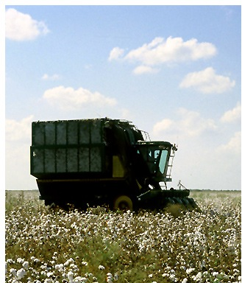
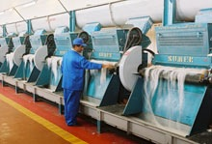
Primary
Cotton is grown and picked on a cotton farm
Tertiary
Cotton clothes (eg jeans and shirts) are sold in high street shops.
Secondary
Cotton is processed to a cloth, which is, in turn, sewn in to clothing

Industry as a system
Industries are a system of inputs, processes, outputs and feedback.

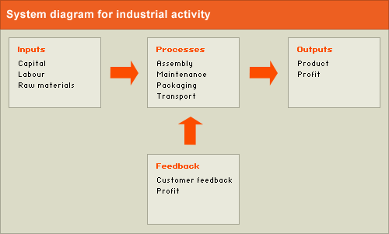

1. Inputs are everything that goes into the system. The main three inputs are:
- Physical inputs. These include raw materials such as cotton, metal or oil in secondary industries
- Labour – People who work in a factory, either skilled or unskilled,
- Capital. The money invested in the business to pay for raw materials, staff, machinery and the buildings used for production and storage.
2. Processes are all the things that happen to those inputs, to help turn them into outputs. These include:
- Production - for example the manufacturing of cars, or the sewing of textiles
- Factory maintenance, - ensures machines are kept in working order.
- Packaging - protects products, when transported, and also presents them in a way that makes customers want to buy them.
- Transport, - is needed to move products from the factory to the warehouse and then to the shops.
3. Outputs. The finished products include:
- profits
- wages.
4. Feedback includes anything that improves the system, such as:
- Customer feedback. Companies find out what consumers think of their products through market research. They may use this to improve their product to sell more and increase their profits.
- Profits - the money left after inputs (staff wages, raw materials, machinery and buildings etc) have been paid for. Profits need to be high enough to make it worthwhile for the company to continue investing in making the product. If profits fall too low, the company will change the inputs, process or outputs to improve profit, diversify into other products (start to make different types of products) - or go bust!

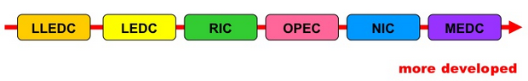
Development – the process of change whereby countries became better organised and better off. The basic fuel of development is economic growth.
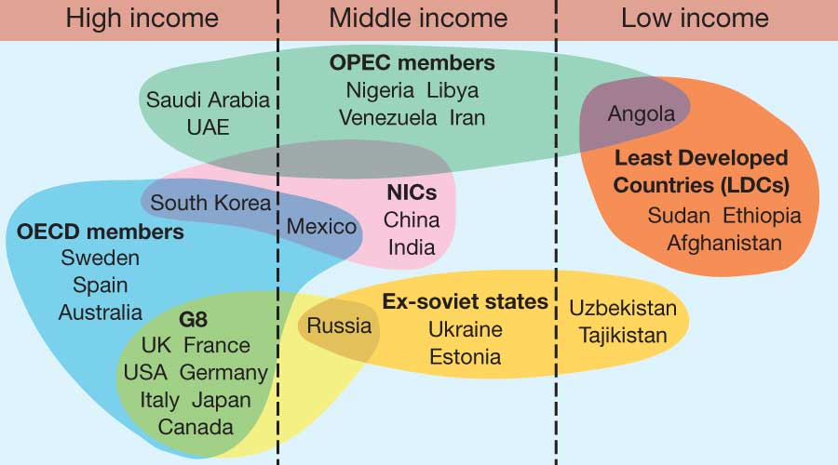
Just to live by
Subsistence farming – when you farm just to support your family
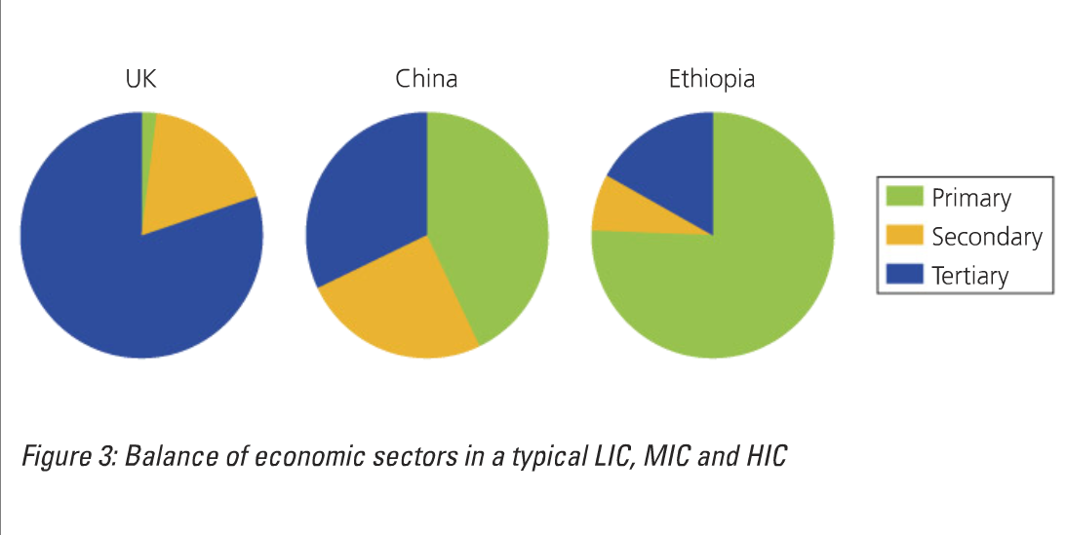

Explain how and why the types of industries found in HIC may be different to those in a LIC (4)

A HIC like the UK has only 2% of the population working within the primary industry, whereas a LIC like Ethiopia has 75% of people in this industry. This is because primary jobs pay less so not many people in the UK are willing to do them. In addition many industries such as farming have be mechanised, therefore machines do jobs that people would have done. In LICs many more people farm for a living to provide food for their families or don’t have a high enough level of education to have a job in the tertiary sector.
In HICs there are more tertiary jobs such as a surgeon, as the population has a far better education.

Changes in Employment structures over time
Sector Shifts – Changes in the relative importance of economic sectors (primary, secondary, tertiary and quaternary) over time.
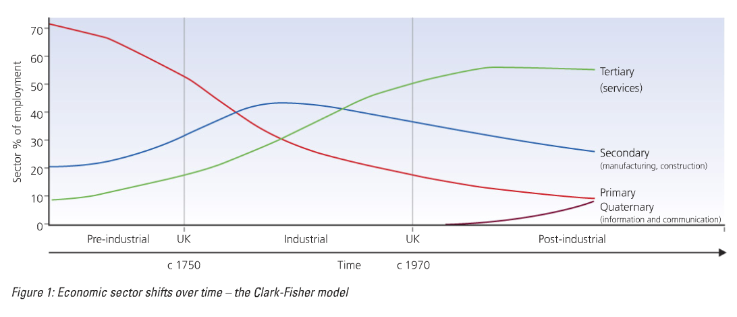
The Clark Fisher Model
Three phases
- The pre-industrial phase – the primary sector leads the economy and may employ more than 2/3 of the working population. Agriculture is the most important
- The industrial phase – the secondary and tertiary sectors increase in importance. The primary sector declines
- The post-industrial phase- as the tertiary sector becomes the most important sector, the secondary sector declines and the primary sector employs a small percentage of the active population.
LICs
HICs
MICs
Reasons for the decline in primary industries in the Uk

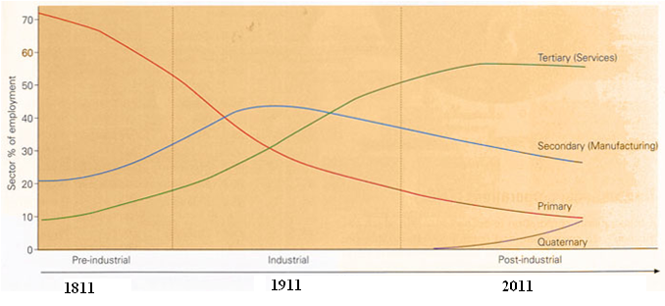

Describe the changes in employment shown in figure 1. (3)
Use data in your answer

Employment in the primary industry started to decline in 1811 falling to its lowest level of 9% in 2011. This meant it has declined by 62% in the three centuries.
On the other hand, employment in the secondary industry increased by 25%. However in 1911 it begins to decline. In the time till 2011 it gradually decreased by 15%.

Why was there a decline in the primary sector in the Uk?
- Industrial revolution – 1760
- In 1760 60% workers were in the primary industry

Mechanisation – the replacement of human (or animal) labour with machines

 | Key Words | Explain the reasons for the decline
Agriculture | - Importation  - Mechanisation  - Agribusiness | - The Uk used to provide nearly all its food, although limitations mean some have to be imported.  - Today the uk produces less than 40% of its food – as it is much cheaper to import some of it.  - Agriculture has become highly mechanised  - Livestock are reared by factory like methods.  - Farming has been taken over by agribusiness. Everything has been scaled up; family farms have joined together to make commercial farms. Hedgerows removed to allow for bigger fields. A lot of money has been invested into new technology. Many crops are genetic modification.
Fishing | - Overfishing  - Mechanisation  - International control | - Many small towns fishing used to be there main industry. However now there are three Scottish ports that catch most of the uks fish; Peterhead, Lochinver and Fraserburgh.  - Over-fishing, caused mostly by mechanisation  - Tight international controls on the amount of fish that can be caught daily.
Mining | - Importation  - Industries collapse  - Other sources of energy  - Environmental concerns | - Resource depletion – because most accessible and profitable coal deposits have been worked out.  - It is now cheaper to import coal from other countries, particularly Russia.  - The collapse of large-scale traditional industries has cut the demand for steel.  - Modern electricity generating stations are powered by natural gas rather than coal.  - Coal is not good for air quality and contributes to global warming, therefore people don’t want to use it.
Forestry |  | - There has been little decline.

Suggest reasons for the decline in the primary sector in the UK (4)

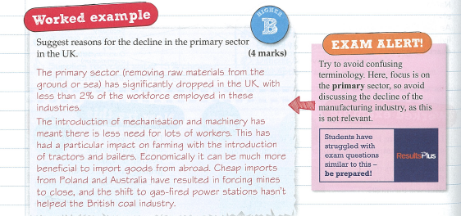

Miners strike

- Cheaper coal from abroad
- Huge protests in 1984/85
- Number of coal mines in the UK fell from 170 to only 12
- Thousands of people lost there jobs, particularly in the North of England

The Collapse of Secondary Industry

The decline of the secondary sector in the UK
- 50 years ago manufacturing produced 40% of the UK’s economic wealth, and 1/3 of the work force
- today it only produces 11% of the wealth and employs less than 10%
the things being manufactured in the UK ere being made cheaper elsewhere.
Why?
- Cheaper land and labour in poorer parts of the world
- Fast and cheap transport to move goods from country to country
- Modern communication networks

Automation
The use of machinery in manufacturing of data and processing

Explain what is mean by the ‘global shift in manufacturing’

There has been a shift from the more developed countries to the less developed countries
(talk about decline in the UK then talk about China)

Global (information) superhighway
The internet/worldwide web/cyberspace, allowing the fast transfer of information to virtually anywhere on Earth.

Communication networks
The passing of information and idea through the media (radio, TV, phone and internet)

TNCs – transnational corporation
MNC – multi- national cooperation – companies that operate in more than one country.

Globalisation
The process, led by transnational companies, whereby the world’s countries are all becoming part of one vast global economy.

Reasons for globalisation
- Firms can keep in contact with producers easily and quickly using the internet
- Developments in transport technology: goods can be moved around the world quickly and easily
- Development of aircraft and containers, efficient motorway networks which cross Europe.

Location Factors

Explain the factors that may influence the location of manufacturing industry (5):

Theme:  List 4 Factors for the location of industry | Explanation: what does this mean? | Example: describe one example where this is available.

TNCs – these companies are locating in the cheapest and therefore most profitable locations
Transport – now much faster and cheaper, therefore is no longer as significant as it used to be.
Communication - because of speed and efficiency of modern communications, a manufacturing company can keep in immediate touch with factories scattered in different countries.
Governments - Incentives to set up factories within their borders such as tax exemption.
Energy - Due to the National Grid system, electricity can be made available almost anywhere.
Footloose industries - Their location is no longer tied down to nearness of raw materials and market.
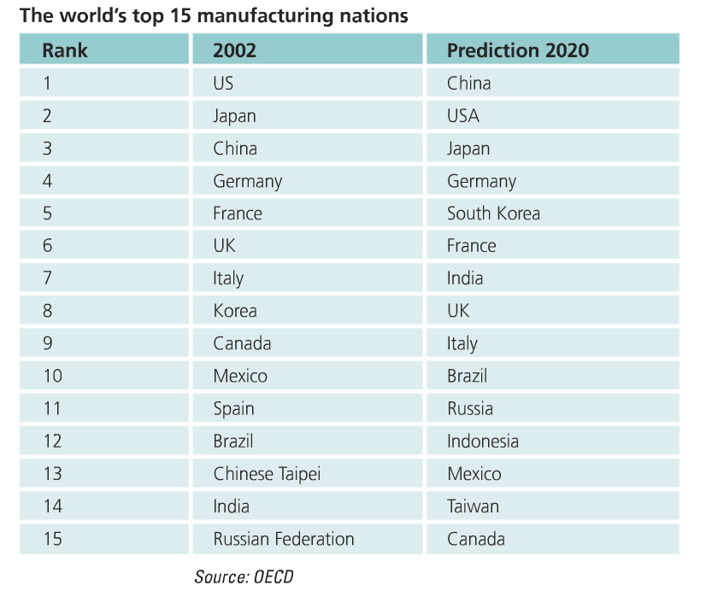

Why the decline?
- Cheaper to make products abroad – labour and land are cheaper, regulations are not as demanding.
- De-industrialisation – loss of traditional industries due to modern production and automation.
- Transport enables goods to be moved more quickly and efficiently
- Modern communication networks – easier to keep in touch.
- Growth in transnational corporations (TNCs)
- Globalisation has meant that companies have moved their manufacturing to cheaper locations (often in MICs or LICs) This has been helped by increasing technological advances and major improvements in transport.
Suggest reasons for the decline of secondary industry in the UK (4)
The introduction of mechanisation and machinery has meant there is less need for workers. Products are often produced more cheaply abroad and imported to the UK. A social factor is the perceived idea that a factory is menial. There is a big demand for workers in the tertiary (service) sector so lots of people are moving to these kinds of jobs.

Globalisation has caused a decline in the secondary industry in the UK. Suggest reasons why? (4)
- Companies are moving there manufacturing to cheaper locations often MICs and LICs as labour costs are cheaper and there are less law enforcements. Therefore these places are more profitable. Advancements in technology like the internet have made it easier for goods to be produced internationally. In addition improvements in transport have meant that goods can be transports far more easily.

Economic Locations

Location Factors:
- Labour supply – the number of people who live in an area. The industry may have specific industry skills. (Like California)
- Accessibility – how easily can the site be reached by rail and road links
- Raw materials – does the site have the necessary materials to make a product
- Distance to market – is it close by or does it have good transport links
- Government incentives – are there any grants or other incentives available from the government or local council to persuade a company to move to an area.
- Power supply – is there an adequate supply of energy to produce goods.

Primary Industry: Factors

- Relief – flat land for easy crop cultivation
- Government – grants and subsides to help industry
- Markets – somewhere to sell produce
- Soil – nutrient-rich aerated soil for crops to grow
- Climate – adequate sunshine and rainfall
- Technology – ease of introducing new machines and farming practices
- Labour and capital – local workforce available and money for investment.

Location of Primary Industry – Rice Farming in Bangladesh

Case study - the Lower Ganges Valley, India
Introduction

Rice farmer in Bangladesh
The warm, wet climate (monsoon rainfall) in India is perfect for subsistence rice farming. The land is flat and the constant flooding from the Ganges provides fertile soils.
Subsistence farming means that food is grown only to feed the family, with no surplus remaining to sell for a profit. Field sizes are small, usually 1 hectare - the size of a football pitch - and sub-divided into about 15 plots.
There is a low level of mechanisation as farmers cannot afford high-tech equipment, so they use water buffalo to plough the fields and manual labour to harvest the crop. As rice requires a constant supply of water, fields are often constructed beside water, eg the River Ganges.
Agricultural developments have greatly improved farming in developing countries like India. We will look at each of the modern developments and discuss the impact they have had on the rural landscape.

Impact of new technology
Changes in farming policy have led to a large increase in food production in India because India has a rapidly growing population to feed. The Green Revolution involved the introduction of tractors, irrigation channels and chemical fertilisers and pesticides. The use of modern farming technology has had both a positive and negative impact on rural areas

Secondary Industry

Goya factory in Katy, Texas- Hispanic bean company

- 100 hectares of flat land available, so factory can expand. Built on a greenfield site.
- there is high local employment (with relevant skills)
- Located on a greenfield site 8km for Katy, 40KM from Houston
- Located on the i10 one of the biggest freeways in the USA
- Underground aquifer which provides water for production process
- There is electricity from local power stations.
- Near attractive towns such as Katy and Fulshear- both have the development of new housing and good school Districts.

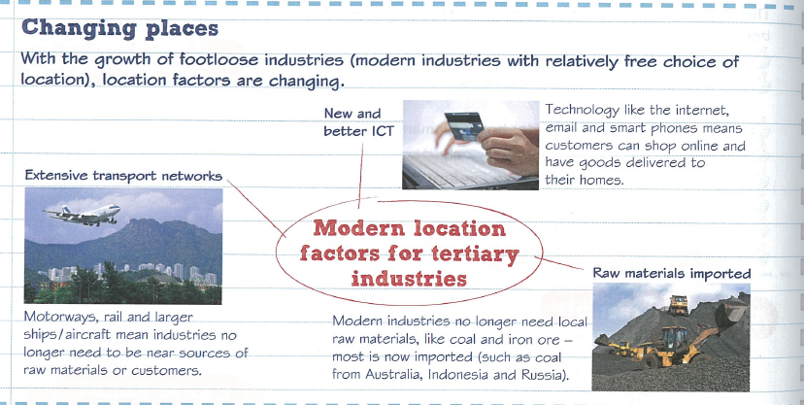
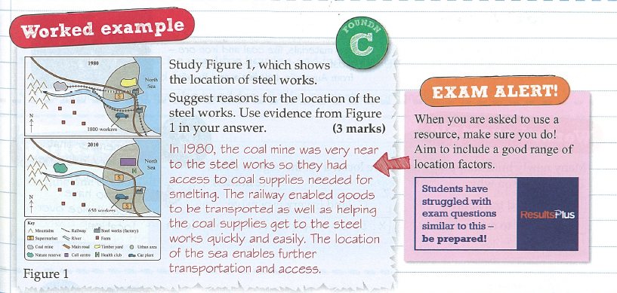
Factors effecting high tech industry
- Labour – supply of high qualified and adaptable labour
- Environment – attractive location in which to live and work
- Research and development – near to and links with top class univercity
- Access – availability of good transport, raw materials, services and markets
- Reputation – place of high-tech excellance
- Government polices - national and local governments encourage investment and enterprise

Why have high tech industries located in the Silicon Valley?

•High-technology industry uses the most advanced technology to make products (computerised systems etc)
•They involve a highly-skilled workforce and its products require a high proportion of research and development.
•High-technology industry is relatively footloose since access to raw materials is not very important. The ‘raw materials’ that are required are usually lightweight electronic components.

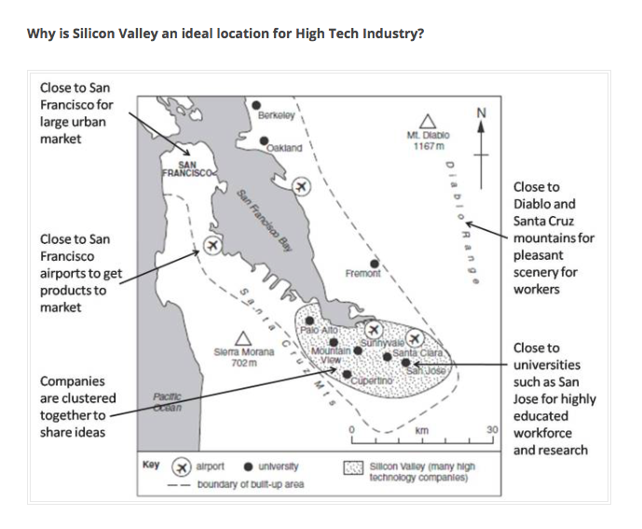

For each type of industry (primary, manufacturing and high-tech) outline the which of the factors below have influenced the location and why

Factor affecting location: | Further explanation:
Site

Climate

Capital

Raw materials

Energy

Labour

Markets

Transport

Explain how the factors affecting the location of industry can change over time (3)

4. Globalisation

People often say that the world is getting smaller, and that we live in a global village. This means that we now communicate, travel, and share each others' cultures on a world scale.
We also trade more than before, transporting products around the world in hours or days. The biggest companies are no longer national firms but have subsidiaries in many countries - becoming Transnational Corporations (TNCs).
What causes globalisation?
It is the result of -
- Technological changes that enable people, goods, money and above all information and ideas to travel the world much faster than ever before.
- Better Communications: e.g. TV, telephones and the internet make it easier to trade.
- Transport has become cheap and quick. People from other countries can travel to e.g. the UK to get better-paid jobs. Businesses can quickly transport products and raw materials all over the world. This makes products and services from all over the world available to UK customers e.g. flowers and fruits from Kenya are sold by Sainsbury.
- Trade liberalisation: governments around the world have relaxed laws restricting trade and foreign investment. Some governments offer grants and tax incentives to persuade foreign companies to invest in their country.

What is the effect of globalisation?

Globalisation has resulted in many businesses setting up or buying operations in other countries. When a foreign company invests in a country, perhaps by building a factory or a shop, this is called inward investment.

Companies that operate in several countries are called multinational corporations (MNCs) or transnational corporations (TNCs). McDonald's, the US fast food chain is a large TNC. It has nearly 30,000 restaurants in 119 countries.

The logos of the most successful TNCs are instantly recognised worldwide

The majority of TNCs come from more economically developed countries such as the USA and UK. TNCs invest in other MEDCs - the US car company Ford, for example, makes large numbers of cars in the UK. But TNCs also invest in less economically developed countries - for example the British DIY store B&Q now has stores in China.

Factors attracting TNCs to a country may include:
- cheap raw materials
- cheap labour supply
- good transport
- access to market, where the goods are sold
- friendly government policies

What are the advantages of globalisation?
- Inward investment by TNCs helps countries by providing new jobs and skills for local people.
- TNCs bring wealth / foreign currency to local economies when they buy local resources, products and services. This goes towards paying for education, health and infrastructure (roads, water supply, electricity etc.).
- There is more mixing of people and cultures from all over the world. This means e.g. people can experience foods and other products not previously available in their countries.
- Globalisation helps make people aware of events in different parts of the world. For example, people in the UK were quickly aware of the impact of the 2004 Tsunami tidal wave on countries in SE Asia, and were therefore able to send help quickly.
- It helps people be aware of global issues such as deforestation and global warming - and to the need for sustainable development.

What are the disadvantages (Problems) of globalisation?
Some people are against globalisation for example environmentalists, anti-poverty campaigners and trade-unionists.
They say:
- Globalisation operates in the interests of the richest countries. These countries dominate world trade, at the expense of developing countries. The developing countries provide the rich countries with cheap labour and raw materials.
- Often the wealth from inward investment does not benefit the local community in the developing countries. This is because sometimes the profits are sent back to the MEDC where the TNC is based. TNCs with their massive economies of scale, may drive local companies out of business. If it becomes cheaper to operate in another country the TNC might close down the factory and make local people redundant.
- There are no strict international laws. This means that TNCs can do things, for example polluting the environment, or having poor working conditions and low wages on local workers. This would not be allowed in the TNCs.
- Globalisation is viewed by many as a threat to the traditions and languages of developing countries, for example a Hollywood film is more likely to be successful worldwide than one made in India or China, which also have thriving film industries.
- Anti-globalisation campaigners try to get people’s attention to the bad effects of globalization by demonstrating against the World Trade Organisation. This is an inter-government organisation which promotes the free-flow of trade around the world.

Advantages and disadvantages of TNCs
The statements below are muddled up. Put the correct advantages and advantages in the table below;
- They bring capital, technology, knowledge and expertise
- They construct roads which can be used free of charge
- They don’t employ the locals for the well-paid jobs
- They build industries that the governments don’t have the capital and technology
- They avoid taxes through over invoicing and under invoicing
- They increase exports because of their access to markets worldwide
- They have no regard to the safety of the locals
- Profit are taken out of the country

 | Advantages | Disadvantages
To the host country

For the TNC
For the local residents

- Look at the triangular graph showing the employment structures of three countries:
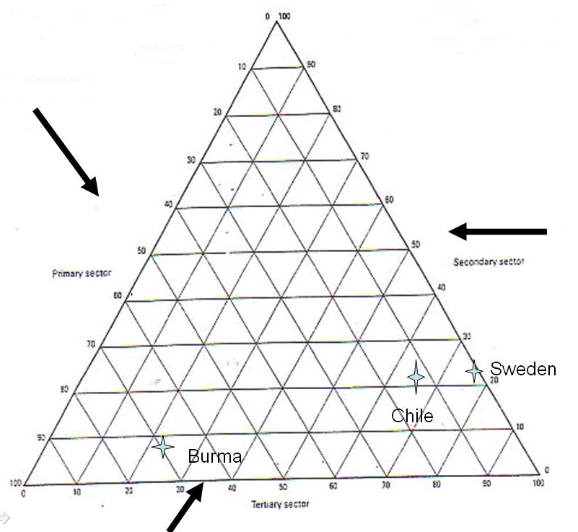
B
C
A
- Which country is the most developed? Why?

……………………………………………………………………………………………………………………………………………………………

…………………………………………………………………………………………………………………………………………………………..

- Which letter represents Chile, Burma and Sweden?

A –
B –
C –

- Why do think this?

……………………………………………………………………………………………………………………………………………………………

…………………………………………………………………………………………………………………………………………………………..

……………………………………………………………………………………………………………………………………………………………

…………………………………………………………………………………………………………………………………………………………..

The Growth of a Superpower – case study CHINA
L.O – why has the secondary sector grown and its effect

GDP – Gross Domestic Product – is the measure of an economy; the total market value of goods and services produced by workers within a country during a period of 1 year.
- Often measured per capita as this allows it to be compared the level of development

China’s growth in the secondary sector
- Majority of the population live on the east
- This is where most of the manufacturing industry is located, because of the road networks
Human Factors
Workforce | Most of the population live on the east coast, therefore industry located here.
Government | Less communist – therefore they are opening up to other companies coming in to the country
Education | Most of the best education is along the coast – in rural areas there is little education
Physical Factors
Relief | - To the north there is the Gobi desert, where you would not want to build  - The south east it is very mountainous

Effects of growth
- More jobs – benefits form income
- Better education
- Growth in GDP
- Greater pollution – water/air pollution
- Lower wages – less strict rules to protect the workers
Facts about china:
- Produces 2/3 of all shoes
- 2/3 of photocopiers
- 85% of all Christmas trees
- ½ of all clothes
Consumer industries: These making finished products, such as clothing and electrical goods

Why has there been a growth in manufacturing in China?
Physical
- Natural resources – particularly energy (coal, gas, oil)
- Close to other developing countries so good trade routes
Human
- Increased globalisation enables rich counties to manufacture there
- Increase in literacy rate – 96% in 2011
- Increase in privately owned companies - from 100 in 1979 to 280,000 in 1998.
- Political move from communism (where they control economy, media, police and ownership) towards capitalism (individuals own business and property to drive the economy).
- It allowed TNCs to invest in the country – attractive to the companies because of the good level of education (skilled workers) allowing they to build there design in China for a far lower cost
- The world has a growing demand for cheap manufactured goods
- Few regulations to hinder industrial growth
- Large labour force – cheap and fairly skilled (40p an hour) growth as TNCs are attracted to the country.
- Move away from communism has allow entrepreneurs to start up their own business – leading to it being the world largest textile manufacture
Explain the reasons for the growth in the secondary sector (6)

Over the past 10 years Chinas GNP per capita has grown from $620 to $1,700. This is due to various human and physical factors. Such as location, workforce and education.
China’s geographical position in the world benefits its development as it is near other developing markets such as South Korea, Taiwan and India. It is also on major trade routes.
A human factor that helped growth was the workforce. China has a plentiful supply of workers with a steady stream of people moving in from rural areas. In addition the workers are fairly well educated. Therefore TNCs are attracted to the country as they can get skilled workers and pay them low wages, as low as 40p.
(finish – mention political )

Impacts of the growth in the manufacturing industry

Negative
- 700 million are low wage workers
- Poor rural migrants have work in terrible conditions There is no social security in China and migrants from outside their province are under the Hoiku system which means they don’t get any education or healthcare (i.e. education/health care)
- Workers work in hard long conditions (15 hours a day, one day off a month)
- Parents only get to see their children one or two days a year as they left in their province to get an education and workers get so few days off.
- Damage to the environment
- Having to find new sources of raw materials
- Massive rural- to-urban migration as people leave for the cities
- Widening gap between rich and poor
- Pollution caused by industrial grow, is having health impacts on the population causing hundreds of thousands to die annually
- 16/25 of the world most polluted cities are in China
- Lots of the pollutants in the water are coming from run off from the factories, meaning people have difficulty getting safe water
- Climate Change – worlds biggest emitter of CO_{2,} which means there are environmental impacts

Positive
- Better income
- Improved working conditions for some
- Healthy economy
- Better housing in urban areas
- China is becoming more politically powerful

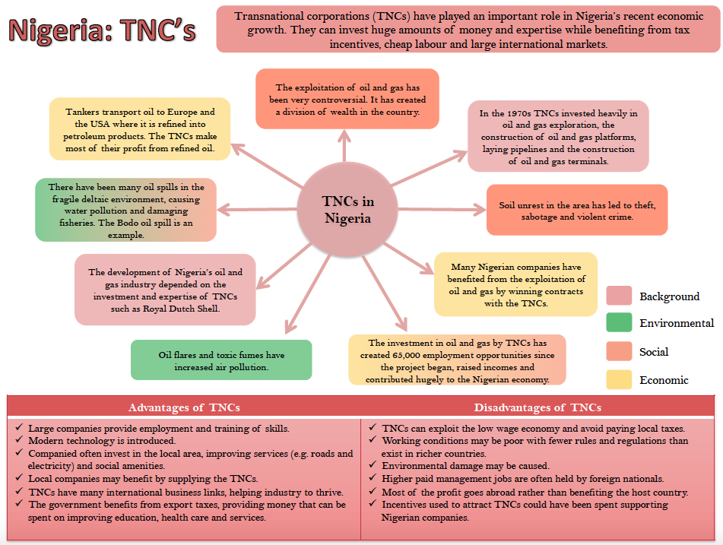

Explain 2 impacts that industrialization can have on a country (4)
The rapid Industrialisation has lead to environmental impacts. As 75% of Chinas energy is produced by coal this releases a lots of pollutants that are harming the environment. This is affecting 3 million people annually and causing 760,000 recorded deaths due to air and water pollution. China is currently the biggest emitter of CO_{2,} and it is thought that by 2025 it will also be the biggest global emitter of greenhouse gases. This is all having an impact on the environment.
In addition it is having social impacts. TNCs are coming in from aboard and seeing the opportunities of greater profits. Therefore paying workers far less, sometimes as low as 40p. In addition works work long hours and have very little holiday, therefore have very little time to see their family.

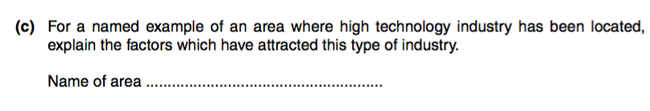

Outline how the factors affecting the location of industry can change over time (3 marks)
The iron and steel industry was once concentrated around the coalfields of the South Wales valleys due to
the need for large amounts of coal. It is now focused around the coast e.g. Port Talbot due to the fact that
many raw materials are imported. Even tertiary sector services are changing locations. Many town centres
have seen a decline as more shops are locating in out-of-town shopping centres.

What is meant by the term globalisation? (1 mark)
This refers to the idea that companies are becoming increasingly spread around the world and economies
are becoming linked e.g. as companies have a headquarters in one place and factories in other places
around the world.

Suggest reasons for the decline in the secondary sector in the UK (4 marks)
Lower wages abroad have led to increasing competition from abroad for manufacturing which has seen a
decline in the UK's secondary sector as production costs abroad are cheaper. More and more people are
also working in the tertiary sector which also helps to explain the decline in people working in the
secondary sector.

Choose a study you have made of the growth of the secondary sector in one LIC or MIC. Explain
the effects of this growth (7 marks)
China is now the world's third largest economy with its GNP tripling in just 10 years. However there have
been a number of effects of this growth. On the one hand, the Chinese economy has seen a huge growth
over the last 20 years and exports and now exceeding imports leading to a healthy economy. However
there have been a number of negative effects. Due to the high levels of industry and burning of coal to
power the industries, cities such as Linfen are now highly polluted and China is the world leader in CO2
output. 80of China's rivers are below standard for fishing due to effluent from industries and in total there
are 760,000 deaths a year recorded due to water and air pollution. The lack of laws to protect workers has
also meant there is a widening gap between rich and poor and workers work long hours for very little pay,
often in hazardous conditions.

Explain how the development of new technologies and services has led to a growth in the
tertiary sector (4)
There has been a growth in the tertiary sector as there is an increasing demand for services due to
changing trends such as an increase in online banking and an increase in online shopping. This has led to
an increase in web design for example. As demands for new technologies grow, specialist shops have
grown as well with more mobile phone shops. There has also been an increase in call centres as the
importance of customer service continues to grow. All of these have led to growth in the tertiary sector.

Choose a study of the growth of the secondary sector in one LIC or MIC. Explain the reasons for
this growth (6)
China has seen a significant increase in its secondary sector with its GNP per Capita having nearly tripled
to $1,700 by 2005 in only 10 years. It is now the world's third largest economy. There are a number of
reasons for its growth. One it its location; being close to developing markets such as Taiwan and India and
on major trading routes means there is a market for good produced in China, stimulating the secondary
industry. China also has a wealth of natural resources such as coal, oil and gas to fuel its industrial
development. The growth of the secondary sector can also be explained by a large, cheap work force with
many moving from rural to urban areas looking for work. As government policy has changed, allowing
foreign investment into China, many companies have come in to take advantage of the low labour costs.
Globalisation and the internet have also facilitated this. There has also been a growth in private enterprise
in manufacturing, with 20being privately owned whereas most used to be owned by the government.

