What was the most important invention of the Industrial Revolution?
The Industrial Revolution took place in Britain between c. 1750-1900.

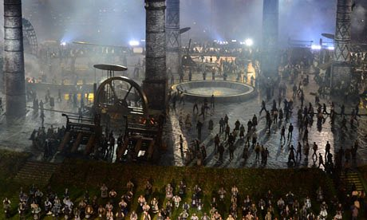
It was an incredible period in History in which work, leisure, travel, policing, medicine, agriculture, and education changed massively and much of these changes were dependent on technological shifts. You may have seen it portrayed in Danny Boyle's dramatic opening sequence of the 2012 London Olympics which told the story of a green, rural country turning into an economic powerhouse.

'Railwaymania' caught on around the country thanks to James Watts' new steam engine and George Stephenson's 0-0-2 locomotive, called Rocket. Cities such as Middlesbrough and Darlington mushroomed, seemingly overnight. The textile industry boomed thanks to inventions such as the Spinning Jenny, Flying Shuttle, and Spinning Mule. Coal mining was made easier through the invention of the Davy Lamp and production increased 20 fold. New industries and products appeared everywhere, such as bicycles with pneumatic tyres, refrigerators, cameras, phonographs, and sewing machines. Communication changed rapidly with the dawn of the telegraph and then the telephone. Bessemer's steel converter meant metal structures improved. Even the motor car was invented in this exciting period.

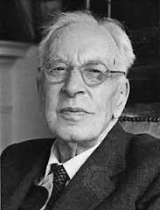
The economic developments started in Britain in places like Birmingham and Lancashire but soon impacted on the whole world. A British man called Arnold Toynbee (1852-83) wrote about how the period was created by pioneering individuals - the people who made Britain 'Great'. It is the money made from this Industrial Revolution that powered the British Empire.

Today we will be exploring the significance of a selection of inventions from this period which changed the world.

You will be working in groups to create a Dragon's Den style 'pitch' for a given product. It is important you a) describe and demonstrate your product or invention but even more important that you b) explain its significance using Geoffrey Partington's criteria:

- Importance - to the people in the past.
- Profundity - how deeply people's lives have been effected.
- Quantity - how many lives have been effected.
- Durability - for how long have people's lives been effected.
- Relevance - in terms of the increased understanding of present life.

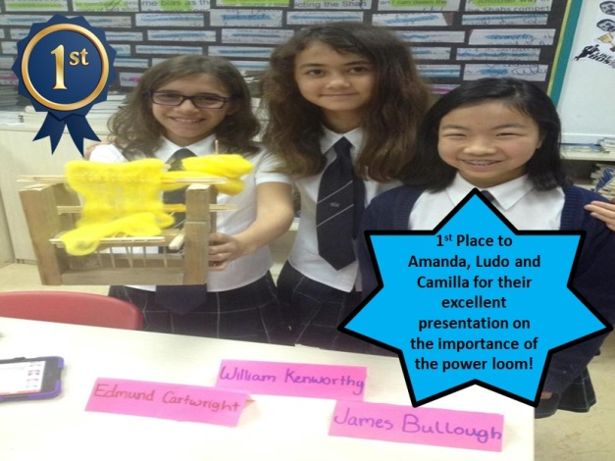
You can present your final pitch in a number of ways. These could include Power Points, videos, Prezis, models, written accounts, role plays, posters, speeches, and freeze frame activities.

There will be a prize for the best overall product pitch, which will be voted on by you. You can see a picture of last year’s winners to the left!

You should use the information sheet given to you to help you research your product.

Can you impress the Dragons? Good luck!

