Important People – The Mongol Empire

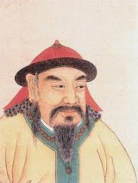  Yusugei | 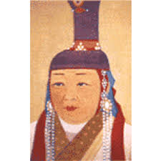  Hoelun | Chiledu | 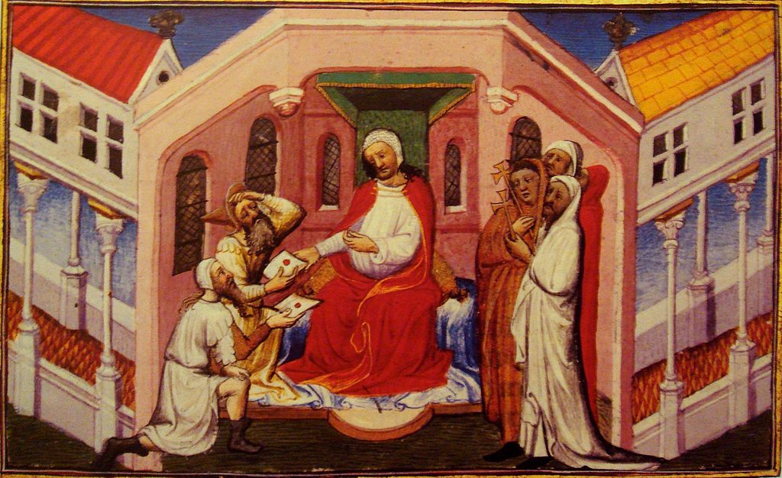  Toghril | 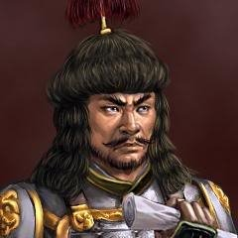  Jamukha
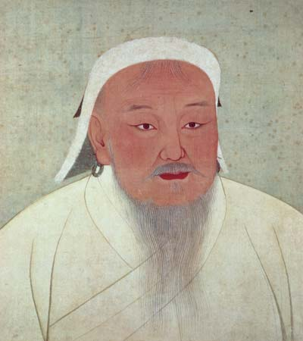  Temujin/Genghis/Chinngis Khan | 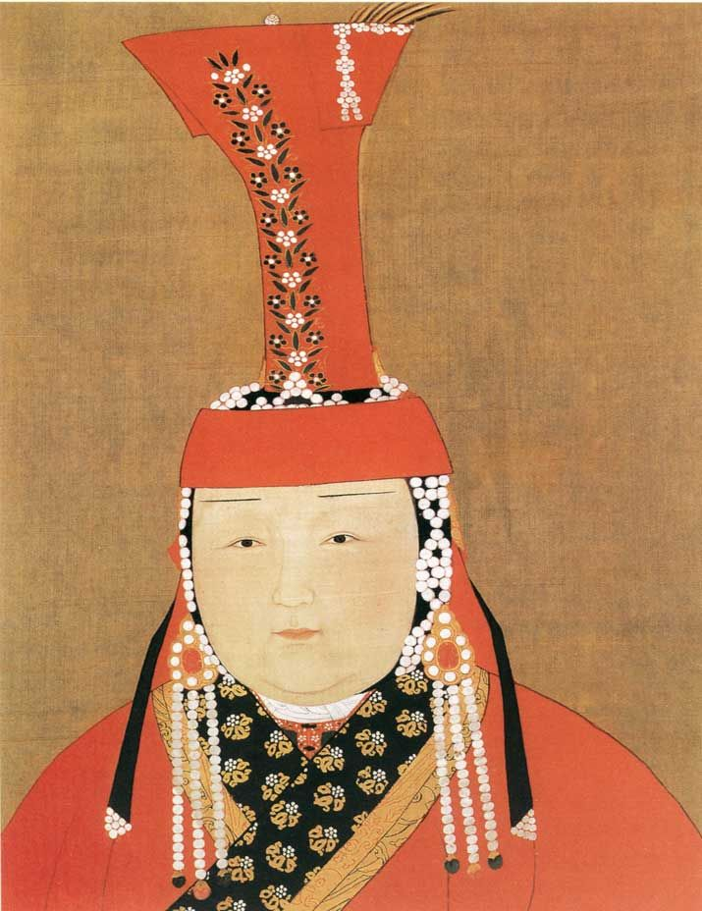  Borte | Bekter | 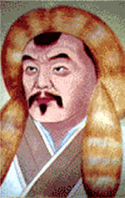  khasar | 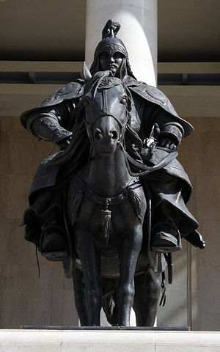  Boorchu
Jelme | Jebe

Merkit – Chiledu
Keraits – Toghril
Tartar
Mongol – Tenujin/Bekter/Khasar
Ongirad – Holeun/Borte
Taychiuts – Targutai
Naiman
Jin

