- The following diagram illustrates the demand and cost conditions of a firm.

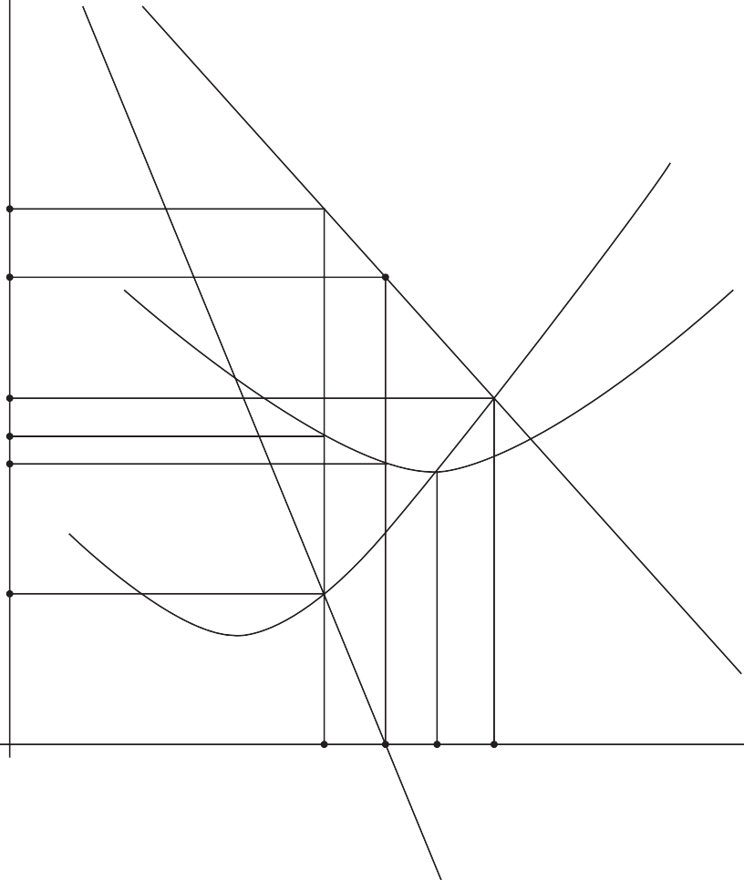
MC

20.00

18.00
Price ($ per unit)

12.00
11.00
10.20

6.00

F AC

D, AR

0 17 20 23 26

MR

Quantity per period (thousands of units)

  - Identify whether this firm is in perfect competition. You must give a reason for
your choice. [2]
. . . . . . . . . . . . . . . . . . . . . . . . . . . . . . . . . . . . . . . . . . . . . . . . . . . . . . . . . . . . . . . . . . . . .
. . . . . . . . . . . . . . . . . . . . . . . . . . . . . . . . . . . . . . . . . . . . . . . . . . . . . . . . . . . . . . . . . . . . .
. . . . . . . . . . . . . . . . . . . . . . . . . . . . . . . . . . . . . . . . . . . . . . . . . . . . . . . . . . . . . . . . . . . . .
. . . . . . . . . . . . . . . . . . . . . . . . . . . . . . . . . . . . . . . . . . . . . . . . . . . . . . . . . . . . . . . . . . . . .

(This question continues on the following page)

  - Identify the profit maximizing level of output for this firm. You must give a reason for
your choice. [2]
. . . . . . . . . . . . . . . . . . . . . . . . . . . . . . . . . . . . . . . . . . . . . . . . . . . . . . . . . . . . . . . . . . . . .
. . . . . . . . . . . . . . . . . . . . . . . . . . . . . . . . . . . . . . . . . . . . . . . . . . . . . . . . . . . . . . . . . . . . .
. . . . . . . . . . . . . . . . . . . . . . . . . . . . . . . . . . . . . . . . . . . . . . . . . . . . . . . . . . . . . . . . . . . . .
. . . . . . . . . . . . . . . . . . . . . . . . . . . . . . . . . . . . . . . . . . . . . . . . . . . . . . . . . . . . . . . . . . . . .

  - Calculate the total revenues and the total costs and the profits or losses for this firm
at the profit maximizing level of output. [3]
. . . . . . . . . . . . . . . . . . . . . . . . . . . . . . . . . . . . . . . . . . . . . . . . . . . . . . . . . . . . . . . . . . . . .
. . . . . . . . . . . . . . . . . . . . . . . . . . . . . . . . . . . . . . . . . . . . . . . . . . . . . . . . . . . . . . . . . . . . .
. . . . . . . . . . . . . . . . . . . . . . . . . . . . . . . . . . . . . . . . . . . . . . . . . . . . . . . . . . . . . . . . . . . . .
. . . . . . . . . . . . . . . . . . . . . . . . . . . . . . . . . . . . . . . . . . . . . . . . . . . . . . . . . . . . . . . . . . . . .
. . . . . . . . . . . . . . . . . . . . . . . . . . . . . . . . . . . . . . . . . . . . . . . . . . . . . . . . . . . . . . . . . . . . .
. . . . . . . . . . . . . . . . . . . . . . . . . . . . . . . . . . . . . . . . . . . . . . . . . . . . . . . . . . . . . . . . . . . . .

  - Identify the level of output this firm would choose if instead of profit it aimed at
maximizing revenues. You must give a reason for your choice. [2]
. . . . . . . . . . . . . . . . . . . . . . . . . . . . . . . . . . . . . . . . . . . . . . . . . . . . . . . . . . . . . . . . . . . . .
. . . . . . . . . . . . . . . . . . . . . . . . . . . . . . . . . . . . . . . . . . . . . . . . . . . . . . . . . . . . . . . . . . . . .
. . . . . . . . . . . . . . . . . . . . . . . . . . . . . . . . . . . . . . . . . . . . . . . . . . . . . . . . . . . . . . . . . . . . .
. . . . . . . . . . . . . . . . . . . . . . . . . . . . . . . . . . . . . . . . . . . . . . . . . . . . . . . . . . . . . . . . . . . . .

(This question continues on the following page)

Turn over

  - Explain the meaning of the term “allocative efficiency” and its implication for social
(community) surplus. [4]
. . . . . . . . . . . . . . . . . . . . . . . . . . . . . . . . . . . . . . . . . . . . . . . . . . . . . . . . . . . . . . . . . . . . .
. . . . . . . . . . . . . . . . . . . . . . . . . . . . . . . . . . . . . . . . . . . . . . . . . . . . . . . . . . . . . . . . . . . . .
. . . . . . . . . . . . . . . . . . . . . . . . . . . . . . . . . . . . . . . . . . . . . . . . . . . . . . . . . . . . . . . . . . . . .
. . . . . . . . . . . . . . . . . . . . . . . . . . . . . . . . . . . . . . . . . . . . . . . . . . . . . . . . . . . . . . . . . . . . .
. . . . . . . . . . . . . . . . . . . . . . . . . . . . . . . . . . . . . . . . . . . . . . . . . . . . . . . . . . . . . . . . . . . . .
. . . . . . . . . . . . . . . . . . . . . . . . . . . . . . . . . . . . . . . . . . . . . . . . . . . . . . . . . . . . . . . . . . . . .
. . . . . . . . . . . . . . . . . . . . . . . . . . . . . . . . . . . . . . . . . . . . . . . . . . . . . . . . . . . . . . . . . . . . .
. . . . . . . . . . . . . . . . . . . . . . . . . . . . . . . . . . . . . . . . . . . . . . . . . . . . . . . . . . . . . . . . . . . . .

  - Referring to the diagram on page 6, identify the level of output that should be produced
for allocative efficiency to be achieved. You must give a reason for your choice. [2]
. . . . . . . . . . . . . . . . . . . . . . . . . . . . . . . . . . . . . . . . . . . . . . . . . . . . . . . . . . . . . . . . . . . . .
. . . . . . . . . . . . . . . . . . . . . . . . . . . . . . . . . . . . . . . . . . . . . . . . . . . . . . . . . . . . . . . . . . . . .
. . . . . . . . . . . . . . . . . . . . . . . . . . . . . . . . . . . . . . . . . . . . . . . . . . . . . . . . . . . . . . . . . . . . .
. . . . . . . . . . . . . . . . . . . . . . . . . . . . . . . . . . . . . . . . . . . . . . . . . . . . . . . . . . . . . . . . . . . . .

  - Define the term productive efficiency. [2]
. . . . . . . . . . . . . . . . . . . . . . . . . . . . . . . . . . . . . . . . . . . . . . . . . . . . . . . . . . . . . . . . . . . . .
. . . . . . . . . . . . . . . . . . . . . . . . . . . . . . . . . . . . . . . . . . . . . . . . . . . . . . . . . . . . . . . . . . . . .
. . . . . . . . . . . . . . . . . . . . . . . . . . . . . . . . . . . . . . . . . . . . . . . . . . . . . . . . . . . . . . . . . . . . .
. . . . . . . . . . . . . . . . . . . . . . . . . . . . . . . . . . . . . . . . . . . . . . . . . . . . . . . . . . . . . . . . . . . . .

(This question continues on the following page)

  - Calculate the price elasticity of demand when the price decreases from $18.00 per unit
to $12.00 per unit. [2]
. . . . . . . . . . . . . . . . . . . . . . . . . . . . . . . . . . . . . . . . . . . . . . . . . . . . . . . . . . . . . . . . . . . . .
. . . . . . . . . . . . . . . . . . . . . . . . . . . . . . . . . . . . . . . . . . . . . . . . . . . . . . . . . . . . . . . . . . . . .
. . . . . . . . . . . . . . . . . . . . . . . . . . . . . . . . . . . . . . . . . . . . . . . . . . . . . . . . . . . . . . . . . . . . .
. . . . . . . . . . . . . . . . . . . . . . . . . . . . . . . . . . . . . . . . . . . . . . . . . . . . . . . . . . . . . . . . . . . . .

  - With reference to the firm’s revenues, comment on the price elasticity of demand at
point F of the demand curve in the diagram on page 6. [2]
. . . . . . . . . . . . . . . . . . . . . . . . . . . . . . . . . . . . . . . . . . . . . . . . . . . . . . . . . . . . . . . . . . . . .
. . . . . . . . . . . . . . . . . . . . . . . . . . . . . . . . . . . . . . . . . . . . . . . . . . . . . . . . . . . . . . . . . . . . .
. . . . . . . . . . . . . . . . . . . . . . . . . . . . . . . . . . . . . . . . . . . . . . . . . . . . . . . . . . . . . . . . . . . . .
. . . . . . . . . . . . . . . . . . . . . . . . . . . . . . . . . . . . . . . . . . . . . . . . . . . . . . . . . . . . . . . . . . . . .

  - Explain why a profit maximizing firm with monopoly power will never choose to operate
on the inelastic portion of its average revenue curve. [4]
. . . . . . . . . . . . . . . . . . . . . . . . . . . . . . . . . . . . . . . . . . . . . . . . . . . . . . . . . . . . . . . . . . . . .
. . . . . . . . . . . . . . . . . . . . . . . . . . . . . . . . . . . . . . . . . . . . . . . . . . . . . . . . . . . . . . . . . . . . .
. . . . . . . . . . . . . . . . . . . . . . . . . . . . . . . . . . . . . . . . . . . . . . . . . . . . . . . . . . . . . . . . . . . . .
. . . . . . . . . . . . . . . . . . . . . . . . . . . . . . . . . . . . . . . . . . . . . . . . . . . . . . . . . . . . . . . . . . . . .
. . . . . . . . . . . . . . . . . . . . . . . . . . . . . . . . . . . . . . . . . . . . . . . . . . . . . . . . . . . . . . . . . . . . .
. . . . . . . . . . . . . . . . . . . . . . . . . . . . . . . . . . . . . . . . . . . . . . . . . . . . . . . . . . . . . . . . . . . . .
. . . . . . . . . . . . . . . . . . . . . . . . . . . . . . . . . . . . . . . . . . . . . . . . . . . . . . . . . . . . . . . . . . . . .
. . . . . . . . . . . . . . . . . . . . . . . . . . . . . . . . . . . . . . . . . . . . . . . . . . . . . . . . . . . . . . . . . . . . .

Turn over

- In Aceland, the “typical basket of goods” purchased by the average consumer consists of 48 pizzas, 120 litres of chocolate milk and 18 jazz concerts. The following table shows the prices for these products in 2013 and 2014.

Table 1

 | Price per unit in dollars ($)
 | 2013 | 2014
Pizza | 12.50 | 12.90
Chocolate milk (litres) | 1.15 | 1.25
Jazz concert | 45.00 | 46.00
Total cost of the typical basket

  - (i) Calculate the cost of this basket in 2013 and 2014. Enter your answers in
Table 1. [2]
. . . . . . . . . . . . . . . . . . . . . . . . . . . . . . . . . . . . . . . . . . . . . . . . . . . . . . . . . . . . . . . . .
. . . . . . . . . . . . . . . . . . . . . . . . . . . . . . . . . . . . . . . . . . . . . . . . . . . . . . . . . . . . . . . . .
. . . . . . . . . . . . . . . . . . . . . . . . . . . . . . . . . . . . . . . . . . . . . . . . . . . . . . . . . . . . . . . . .
. . . . . . . . . . . . . . . . . . . . . . . . . . . . . . . . . . . . . . . . . . . . . . . . . . . . . . . . . . . . . . . . .
. . . . . . . . . . . . . . . . . . . . . . . . . . . . . . . . . . . . . . . . . . . . . . . . . . . . . . . . . . . . . . . . .
. . . . . . . . . . . . . . . . . . . . . . . . . . . . . . . . . . . . . . . . . . . . . . . . . . . . . . . . . . . . . . . . .

- Using your results from part (a)(i), calculate a consumer price index (CPI) with
2013 as the base year. [1]
. . . . . . . . . . . . . . . . . . . . . . . . . . . . . . . . . . . . . . . . . . . . . . . . . . . . . . . . . . . . . . . . .
. . . . . . . . . . . . . . . . . . . . . . . . . . . . . . . . . . . . . . . . . . . . . . . . . . . . . . . . . . . . . . . . .

(This question continues on the following page)

- Calculate the rate of inflation in Aceland in 2014. [1]
. . . . . . . . . . . . . . . . . . . . . . . . . . . . . . . . . . . . . . . . . . . . . . . . . . . . . . . . . . . . . . . . .
. . . . . . . . . . . . . . . . . . . . . . . . . . . . . . . . . . . . . . . . . . . . . . . . . . . . . . . . . . . . . . . . .

  - Outline the reason why, in addition to a consumer price index (CPI), a producer price
index may also be useful to economists. [2]
. . . . . . . . . . . . . . . . . . . . . . . . . . . . . . . . . . . . . . . . . . . . . . . . . . . . . . . . . . . . . . . . . . . . .
. . . . . . . . . . . . . . . . . . . . . . . . . . . . . . . . . . . . . . . . . . . . . . . . . . . . . . . . . . . . . . . . . . . . .
. . . . . . . . . . . . . . . . . . . . . . . . . . . . . . . . . . . . . . . . . . . . . . . . . . . . . . . . . . . . . . . . . . . . .
. . . . . . . . . . . . . . . . . . . . . . . . . . . . . . . . . . . . . . . . . . . . . . . . . . . . . . . . . . . . . . . . . . . . .

(This question continues on the following page)

Turn over

