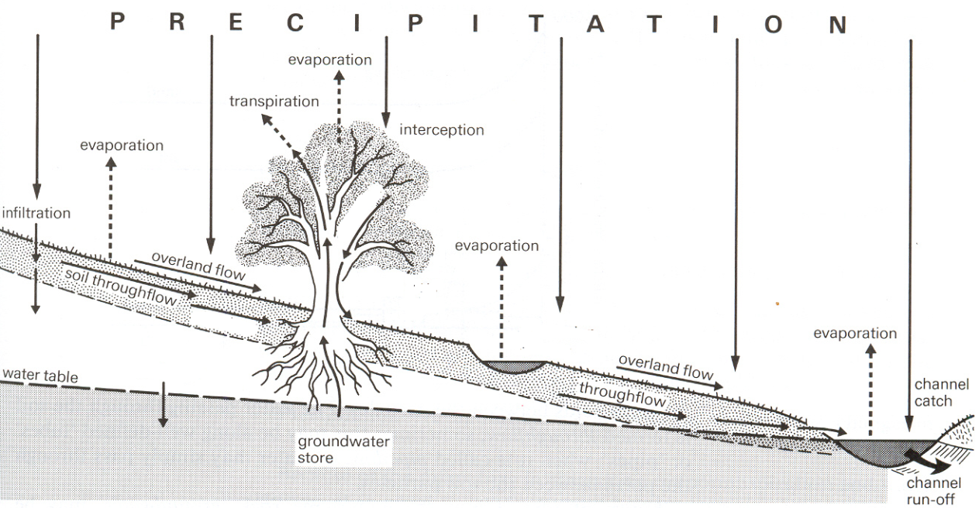
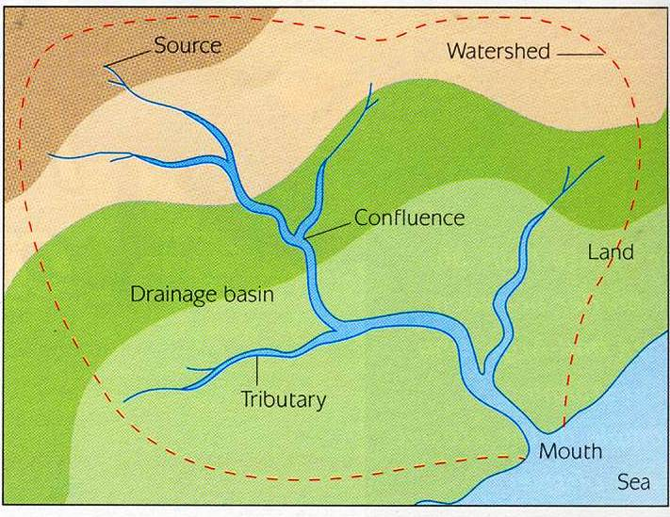
IGCSE Rivers revision book
River processes produce distinctive landforms
Basic basin hydrological cycle: Where does the water come from? Drainage basin
Key terms
Surface runoff
Groundwater flow
Percolation
- Tributaries: smaller rivers which join the main river[ increase its discharge]
- Confluence: point at which rivers meet.
- Drainage basin: land drained by a river system.
- Watershed: boundary of the drainage basin, usually made up of highland.
- Discharge: amount of water passing a specific point at a given time and is measured in cubic metres per second [cumecs]. Depends on the river’s velocity and volume.
- The volume is the amount of water in the river
- The velocity is the speed of the river.
- River channel: the area in which a river flows.
Groundwater flow
Surface runoff
Percolation
Description and explanation of the changes in the characteristics of a river valley and its channel from source to mouth.
Key terms:
The long profile of a river is a graph drawn along the course of a river from the source to the mouth.
The valley cross-profile is the view of the valley from one side to another.
The channel cross-section is a view of the river bed and banks from one side to another at any point on its course.

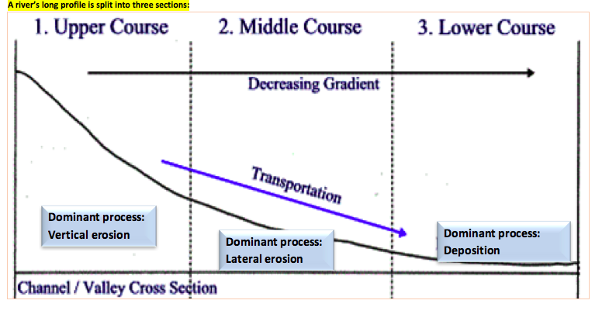
Dominant process:
Lateral erosion
Dominant process:
Deposition

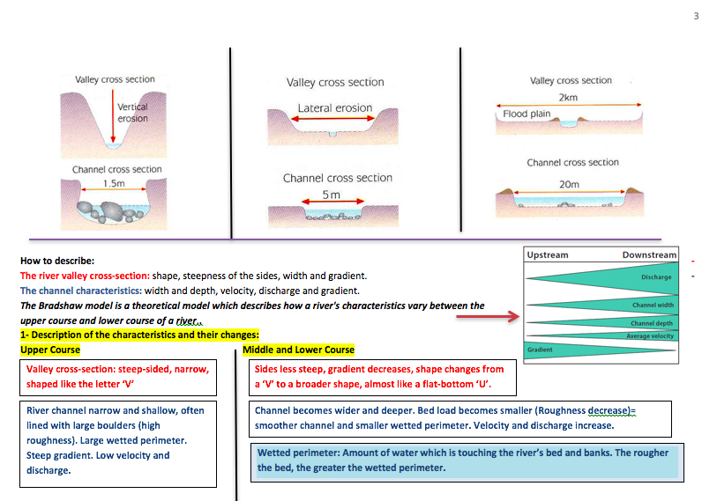
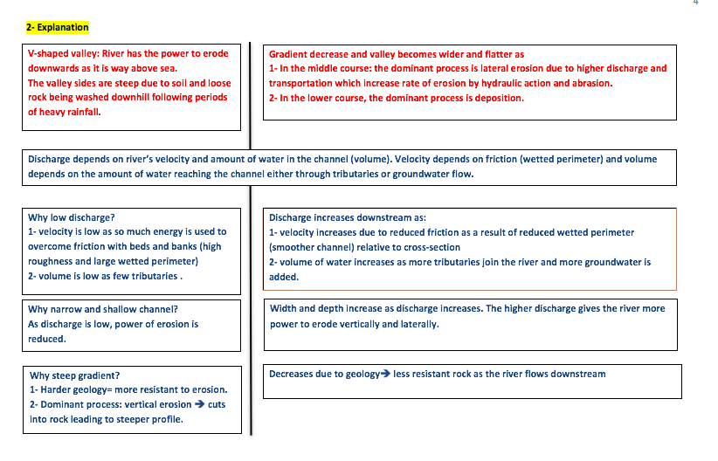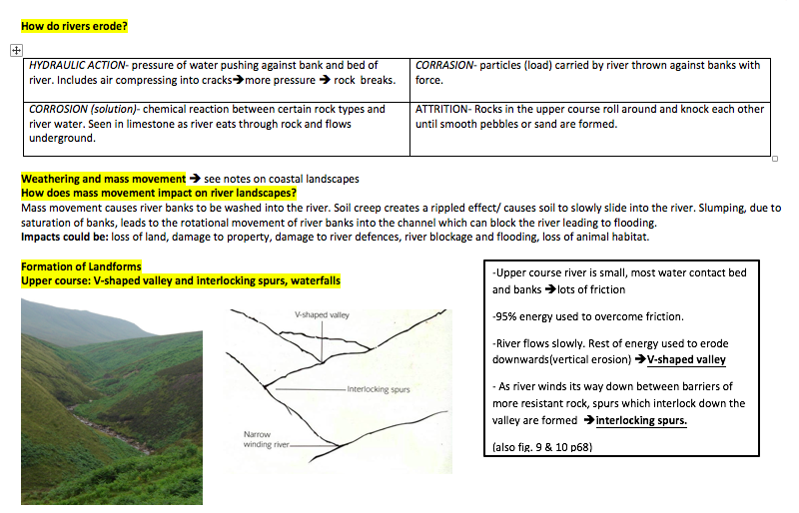

DEFINE THE FOUR TYPES OF EROSION

4 TYPES OF FLUVIAL EROSION

- DEFINE THE FOUR TYPES OF TRANSPORTATION

4 TYPES OF FLUVIAL TRANSPORTATION

4 TYPES OF FLUVIAL EROSION

TRANSPORTATION
Traction: rolling stones along the bed
Saltation: small particles bounce along bed in a leapfrog motion
Suspension: silt and clay-sized are carried within the water flow
Solution: minerals dissolve in the water
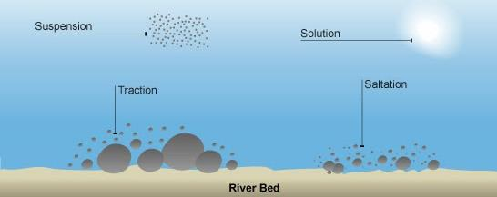

EROSION
- Attrition: large particles such as boulders collide and break into smaller pieces (occurs at higher part of river)
- Hydraulic action: the sheer force of the river dislodges particles from its banks and bed
- Abrasion: smaller particles rub against the river banks and bed like sand-paper; occurs at low part of river (smaller particles)
- Solution: acids in river dissolve rocks (occurs at any part of river)
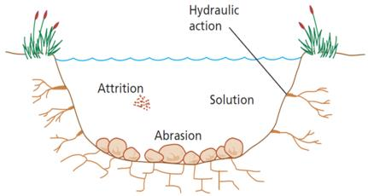
DEPOSITION
- When a river lacks the energy to carry its load; it begins with the heaviest particles; happens when there is less water or where the current slows down.
- Large boulders are deposited at the top, and very small particles are deposited at the end, resulting in sorting.

FOR EACH OF THE LANDFORMS EXPLAIN THEIR FORMATION. USE MUST USE A DIAGRAM. Remember there must be an order/sequence to the formation.
Upper: V-Shaped Valley and interlocking spurs | Upper: Waterfall
Middle/Lower: Meanders | Middle/Lower: Oxbow Lake
Lower: Flood plain | Lower: Levees

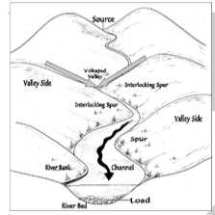
LANDFORMS
V-shaped valley:
o Valley is narrow with a narrow, shallow river channel
o Valleys have steep sides
o Channel has a steep gradient
o Water is mainly slow flowing as most of the rivers energy is used to overcome the friction of the river bed & obstructions
o Load is mainly large, angular and rough
Interlocking spurs: In the upper valley a river is in the mountains. Water takes the easiest path downhill so twists & turns around the high land (spurs) forming interlocking spurs.
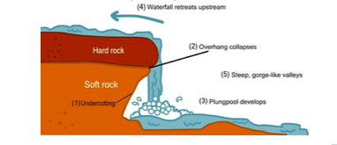
Waterfalls:
o They occur because the river flows over hard rock which erodes slowly.
o Beneath is softer rock which is eroded faster to form a “step”.
o The force of the water erodes the bottom of the waterfall to form a plunge pool.
o The hard rock gets undercut as the soft rock erodes so that it eventually collapses.

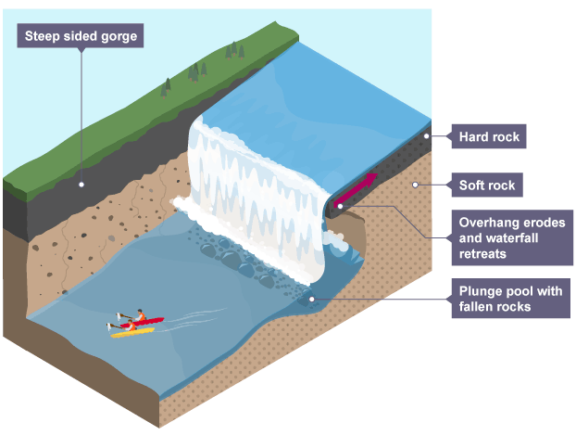

Meanders
In the middle course the river has more energy and a high volume of water. The gradient here is gentle and lateral (sideways) erosion has widened the river channel. The river channel has also deepened. A larger river channel means there is less friction, so the water flows faster:
- As the river erodes laterally, to the right side then the left side, it forms large bends, and then horseshoe-like loops called meanders.
- The formation of meanders is due to both deposition and erosion and meanders gradually migrate downstream.
- The force of the water erodes and undercuts the river bank on the outside of the bend where water flow has most energy due to decreased friction.
- On the inside of the bend, where the river flow is slower, material is deposited, as there is more friction.
- Over time the horseshoe become tighter, until the ends become very close together. As the river breaks through, eg during a flood when the river has a higher discharge and more energy, and the ends join, the loop is cut-off from the main channel. The cut-off loop is called an oxbow lake.

Oxbow lake

A meander and oxbow lake in the Amazon

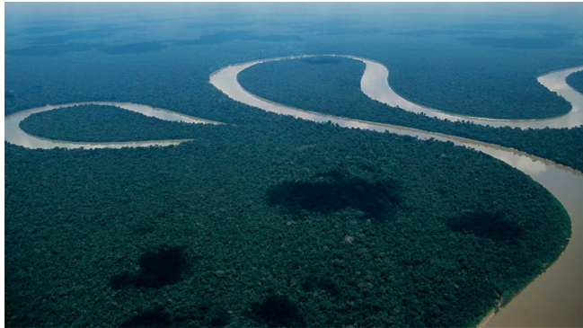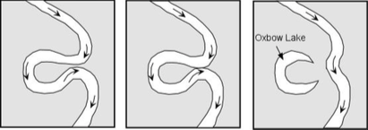
Upstream a large bend becomes a horseshoe and is eventually cut-off to become an oxbow lake. Downstream the river is eroding its outer bank and depositing on its inner bank to create a new meander.
- o Form when the neck of the meander becomes very narrow.
- o During high flow or floods the river cuts through the neck & straightens its course.
- o Deposition occurs on the bank of the river
- o The cut-off meander is an ox-bow lake.

- Deltas:
o Deltas occur where a river that carries a large amount of sediment meets a lake or the sea
o This meeting causes the river to lose energy and drop the sediment it is carrying.

o Deltas form where river mouths become choked with sediment, causing the main river channel to split into hundreds of smaller channels or distributaries.

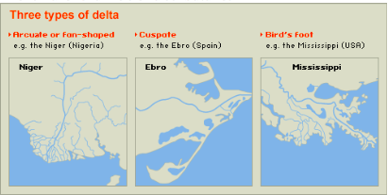

Levées: when a river floods, the coarsest material is deposited first, on the edges of the river, forming a natural embankment called a levée. Deposition happens due to increase in friction when river comes into contact with the bed meaning that energy is lost.
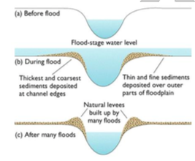
Flood plain:
o Area of alluvial deposits found beside the river in its lower course.
o As meanders move slowly down the course of the river they erode away the valley to create a wide valley floor, and they deposit layers of alluvial material on the slip off slopes building up into a large flood plain

Flooding and flood prevention
Flooding occurs when a river gets more water than its channel can hold.
What are the human and physical causes of river flooding?
Explain one human and one physical cause of flooding. (4) Explain how flooding can be caused by physical factors. (4)
Examples : Physical – impermeable rocks (granite) (1) encourages surface runoff (1), snow melt – during spring melt water (1) into rivers causes higher discharge therefore more potential for flooding (1) Human – deforestation (1) reduced interception and increased surface runoff encourages (1), urbanisation – increased impermeable surfaces (1) causes more water to enter drains therefore greater discharge (1).
Outline how urbanisation increases the risk of flooding. (3)
Urban areas provide an impermeable surface (1). This leads to increased surface runoff (1). This puts more water in river leading to a flood (1) Drainage systems in urban areas put water into rivers more directly/quickly (1) therefore increasing discharge (1) Reduced interception in urban areas (1) as trees will have been removed during building of urban area (1) Building on flood plains increases flooding potential (1)
Flood hydrograph

ADD THE FOLLOWING TO THE HYDROGRAPH: label both axis, rising and falling limb, base flow (and where it comes from), storm flow (and where it comes from), bank full discharge, flood, peak rainfall, lagtime
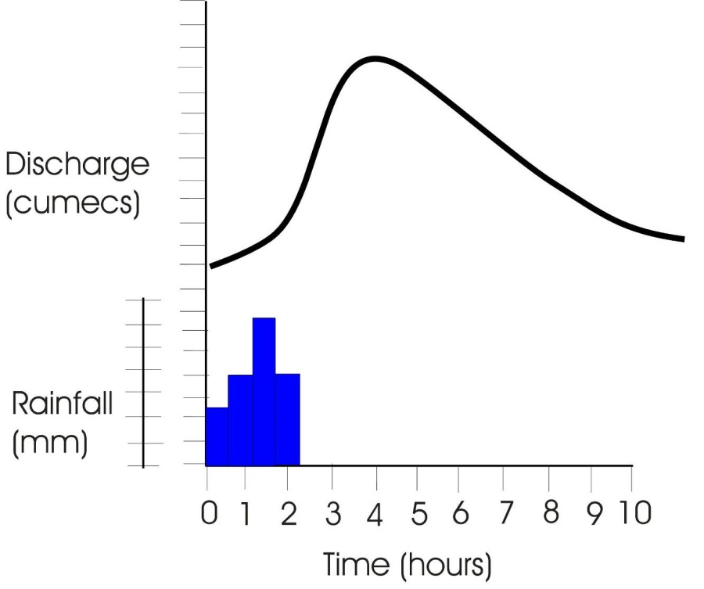

FOR EACH FACTOR STATE HOW IT WOULD EFFECT THE SHAPE OF A HYDROGRAPH/RIVER REGIME

FACTOR | HYDROGRAPH | RIVER REGIME
PRECIPITATION

TEMPERATURE

SOIL
RELIEF
ROCK TYPE
NATURAL VEGETATION
LAND USE
USE OF RIVER E.G
WATER ABSTRACTION
DRAINAGE DENSITY
DAM

Case Study-The benefits and threats of living near a river - Ganges/Brahmaputra River Basin
Bangladesh is an LEDC. The land is densely populated. Most of the land forms a delta from three main rivers - Ganges, Brahmaputra and Meghna - and 25 per cent of Bangladesh is less than 1 m above sea level. Flooding is an annual event as the rivers burst their banks. This seasonal flooding is beneficial as it provides water for the rice and jute (two main crops in the area) it also helps to keep the soil fertile. Bangladesh also experiences many tropical cyclones. The low-lying land means it is easily flooded. Half the country is less than 6m above sea level. The snowmelt in the Himalayas adds water into the main rivers. There are human causes too - building on the floodplains and cutting down trees both increase the effects of flooding.
. 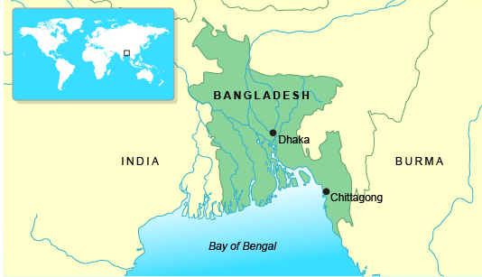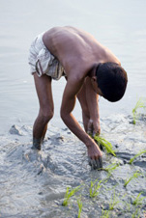
There are advantages to living here:

The flat floodplains of the delta are very fertile. Rice is grown.
The area can also be used for shrimp farming.
There are disadvantages too:
The low-lying islands are very vulnerable and flood easily. It is difficult to protect them.
There are poor communications. Many locals do not own their own telephone or television so it is difficult to give successful flood warnings.
Human Causes of the flood
Straightening of the river channel moves flooding risk downstream. Farraka Damholds water in dry season and releases it in wet season, river can't hold the water and bursts its banks and flooding the levees which has extended the flood season
Nepal has a land clearance of 1.7% a year leading to more discharge in the Ganges resulting in less infiltration causing flood risks
Land clearance in Bangladesh in 3.3% a year especially in the Meghalaya Hillswhich has increased the flood risk as there are less trees to intercept water and so more surface runoff
In 2008 Bangladesh had a popn. of 146 million people resulting in urbanisation such as in Dhaka- permeable surfaces were replaced with impermeable surfaces and so there was less drainage increasing surface runoff and so water was flowing increasing the flood risk
If global warming raises seas levels by 30-50cm Bangladesh could be at risk due to its low lying coast leaving it more vulnerable to flooding
Natural Causes of the flood
Melting Snow
Tectonic Activity - The Indian Plate is moving towards the Eurasian Plate. The land where they meet (Himalayas) is getting higher and steeper every year (fold mountains). As a result soil is becoming loose and is susceptible to erosion. This causes more soil and silt in rivers. This leads to flooding in Bangladesh.
6000m peaks of Himalaya Mountains receives snowfall as the main precipitation. In April and May higher temperatures cause the snow to melt releasing silt down the 2500km channels until it reaches Bangladesh where it provides fertile alluvial sediement for rice and wheat lands of Bengal the Golden
The monsoon season lasts from June to September is intense and prolonged with about 300-400mm of rain which increases surface runoff, with less infiltration which increases the flood risk
The Effects of the 1998 Floods
- Over 57% of the land area was flooded
- Over 1300 people were killed
- 7 million homes were destroyed
- 25 million people were made homeless
- There was a serious shortage of drinking water & dry food
- Diseases spread such as bronchitus and cholera/diarrhoea
- As the waters receded - it left fields of rotting crops, wrecked roads and bridges and destroyed villages
- 2 million tonnes of rice was destroyed
- 1/2 million cattle and poultry were lost
- Overall the floods cost the country almost $1 billion
Flood Management in Bangladesh
In 1989 the government of Bangladesh began working with a number of international agencies to produce a Flood Action Plan. This huge scheme contained 26 action points which it was hoped would provide a long term solution to the country's flooding problems.
Short Term Management  - Boats to rescue people  - Emergency supplies for food, water, tents and medicines  - Fodder for livestock  - Repair and rebuild houses, as well as services such as sewage etc  - Aid from other countries | Long Term Management  - Reduce Deforestation in Nepal & Himalayas  - Build 7 large dams in Bangladesh to store excess water $30-$40 million and 40 yrs to complete  - Build 5000 flood shelters to accommodate all the population  - Build 350km of embankment - 7 metres high at a cost of $6 billion to reduce flooding along the main river channels  - Create flood water storage areas  - Develop an effective Flood Warning Scheme
Cause of the flood:Flooding case study: Tweksbury:

Tewkesbury is vulnerable to flood events due to its geographical location with two sizeable rivers, the Severn and the Avon, meeting in the town which both overflowed their banks (Royal Geographical Society, n.d.).

The summer of 2007 in England and Wales was the wettest since records began in 1766 due to a low pressure system over the UK, with an extreme event on July 20th.

Little sunshine meant evaporation rates were low, which when combined with intense rainfall led to extreme flooding.

· The jet stream was located further south than usual since early June of 2007, with a train of waves from the North Pacific to Europe and a trough occurring near to the UK. This led to Atlantic weather systems being ‘steered towards the UK’ which were slow moving meaning prolonged rainfall events. In addition the trough near the UK caused air to move from a more southerly track than is expected, leading to air carrying more moisture due to it passing over warm seas

· The flooding of southern and central England on July 20th was a result of a low pressure system located over Calais in the morning which slowly moved Northwest bringing warm, continental air. This, when meeting the cooler air to the North, created an area of instability ideal for storm generation.
Soils were already saturated due to the heavy rainfall occurring in the months leading up to the flooding. This meant water could not infiltrate into the ground, causing overland flow and intensifying the floods.

Building on floodplains

· No flood defences in Tewkesbury (Environment Agency, 2010).

Effects of the flood: Case study Tweksbury

Social Effects
· 13 people lost their lives and hundreds had to be evacuated

· Significant damage to most properties in the area (Figure 13) with nearly 50,000 homes affected, with people losing treasured, personal belongings and made homeless- staying with friends or relatives and 850 families had to stay in caravans, some up to Christmas 2008.

· Infrastructure severely affected, with roads cut off and badly damaged.

· On 22nd May water treatment works shut down. The media reporting’s of imminent loss of supplies, meant usage doubled and led to water depletion. By 24th July, 140,000 properties in Gloucestershire had no water supply. Alternative water supplies by bottles, bowsers and tankers had to be used, see Figure 14. Water supplies were not fully restored until the 1st August (Severn Trent Water, 2007)

· 50,000 properties without power for 48 hours

Economic Impacts

· Flooding cost local councils £140 million

· Total cost to UK economy estimated to be £3.2 billion

· 9,000 businesses affected

· More than 180,000 insurance claims

Agriculture sector severely affected and where floodwater contained sewage crops had to be destroyed

Copy and complete the following table. Don’t forget to add data and explanation of the effects.
Area and river | People | Environment

How are the effects of river flooding reduced by prediction and prevention?
EDUCATION | FORECASTING
-Governments give advice to the general public via the internet. The advice includes information on how to protect your home.  -On the Environmental Agency website there is information on the likelihood of a flood. This will be identified by a system of warning codes: flood watch, flood warning, severe flood warning and all clear. These warning codes give people information on what to expect and how to react. In this way the government is helping the effects of floods by providing an effective warning system. | -The Met Office predicts (forecasts) the likelihood of a flood. The information gets to householders through weather forecasts and news broadcasts on TV and radio.  -Also on their website.  -If there is the likelihood of flooding the Met Office advises householders to be proactive and either ring a flood hotline number or go to the Environment Agency’s website to check the likelihood of a flood in their area.
BUILDING DESIGN | PLANNING
It can cost between GB£3000 and £10000 to protect a house from flooding. Some techniques are:  -Moving electricity sockets higher up the wall.  -Replacing doors with ones that are lightweight and can be moved upstairs if necessary.  -Concrete floors instead of wooden ones so they do not rot if they are wet.  -Using yacht varnish on skirting boards to protect from water.  -Waterproof MDF can be used instead of wood as a door frame.  -Building on stilts | -Before houses can be built the local authority has to give planning permission. Not granted in flood risk areas unless flood-risk assessment is carried out.  -In 2010 the law requires all new housing in flood-risk areas to be flood resistant or resilient.  - Defra (department for the Environment, Food and Rural Affairs) has the responsibility for deciding which areas are going to be defended against the risk of flooding. The Environment Agency then organises for the defences to be built and maintained. Defra provides the money for most of the work that is completed.

Hard and Soft Engineering Techniques
HARD ENGINEERING- method of river flood management which involves major construction work.
SOFT ENGINEERING – method of river flood management which works or attempts to work with natural river processes. Does not involve major construction work.

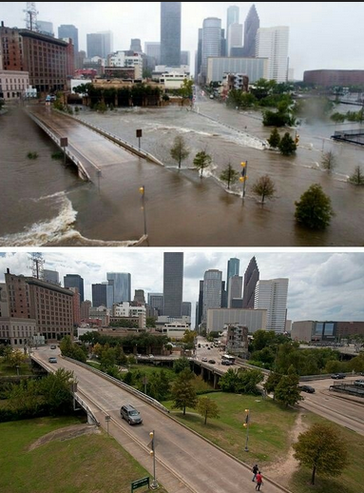
Flooding in Houston: Buffalo Bayou Tax Day floods, April 2016

Physical causes
- Extremely heavy rain: parts of the Houston area experienced 17 inches of rain in 24 hours
•Houston has a humid subtropical climate type and thunderstorm activity is common, especially during the warmer months of the year.
•13 bayous and creeks burst their banks on Monday 18th April.
•Houston is located in a low-lying Gulf coast location. The flat land means that heavy rainfall tends to sit on the land rather than run-off. This means that it can take a long time for flood waters to subside.

Human causes

Houston is one of the fastest growing cities in the United States and has experienced a population explosion since the 1950s. It lacks planning controls and has sprawled uncontrollably outwards.
•Much of the city is built on drained wetlands. Therefore the land is “meant to flood”, however, increasing urbanisation has reduced the natural capacity of the land to absorb rainwater.
•Some new housing developments in Houston include adequate space for water to run-off, but not all. This suggests that tighter building regulations are needed to help reduce the future impacts of flooding.
•Climatologists say that climate change has resulted in increased frequency of large rainfalls. The result this week was that sudden downpours overwhelmed infrastructure and in whole sections of the city.

Impacts

Travel disruptions:
On Monday 18th April Bush Intercontinental Airport was forced to cancel 800 flights and there more than 150 delays.
Roads impassable, including many sections of freeways.
•1,000 homes had already been flooded, and city and Harris county authorities responded to more than 1,500 flooding emergencies.
•Seven deaths inside submerged vehicles, including two in a car that drove around a barricade and into a flooded underpass.
In one neighborhood, Greenspoint, 1,000 people were evacuated Monday morning and transported to a mall.

Management

Hard enginnering
•The Addicks Reservoir and Addicks Dam in conjunction with the Barker Reservoir prevent downstream flooding of Buffalo Bayou in the City of Houston.

Soft enginnering

Katy Prairie
The prairie-wetlands, ranches, creeks, and other green spaces on the prairie slow water heading downstream towards Houston, providing time for floodwaters to recede. As these prairie lands shrink, so does the ability to protect downstream citizens. This is why KPC is working with others to protect these lands. In addition, we are working with others on programs that will help alleviate future downstream flooding.

Flood warning

The Harris County Flood Control District’s Flood Warning System measures rainfall amounts and monitors water levels in bayous and to inform you of dangerous weather conditions. The system relies on 133 gage stations strategically placed throughout Harris County bayous. The stations contain sensors that transmit valuable data during times of heavy rainfall and during tropical storms and hurricanes. Some gages also measure wind speed and direction, barometric pressure, air temperature, road temperature and humidity.

Use of technology to warn people….

Rivers 7 mark questions

2007: Flooding occurs on the flood plains and deltas of some rivers. For a river which you have studied, explain what has been done to reduce flooding. [7]
2008: Many people live in areas where there are natural hazards such as flooding. Name an area which you have studied and state the natural hazard faced by the people who live there. Explain why people live in the area. [7]
2010: Explain how and why a delta has formed in a named area which you have studied. You should use a labelled diagram or diagrams in your answer. [7]
2010: Describe the advantages and difficulties for people of living on a river delta. You should refer to a delta which you have studied. [7]
2011: For a named river you have studied, explain what has been done to reduce flooding. [7]
2012: Explain how an oxbow lake is formed. You should include fully labelled diagram(s). [7]
2012: For a named area which you have studied, describe the impacts of river flooding. [7]

Exam Style Questions
Explain the processes involved in the formation of waterfalls. [7 marks]

Describe the geology of where a waterfall forms
Explain how the overhang and plunge pool are then created.

Use key terms and refer to difference erosion processes.

Explain the processes involved in the formation of an ox-bow lake [7 marks]
Explain the formation of a meander
Explain the role of erosion in the formation of an ox-bow lake
Explain the role of deposition in the formation of an ox-bow lake

An example of a flood management scheme

Location: | Map
Background Information:

Threats
Management
Hard engineering |  | Soft engineering

Exam Style Questions
Explain how physical and human factors can increase the risk of river flooding (7 marks)

Identify one physical factor, explain how it increases the risk of river flooding
Identify one human factor, explain how it increases the risk of flooding.
Identify one physical or human factor, explain how it increases the risk of flooding.

State your opinion, do you agree or disagree.
Give one reasons for your opinion, explain it and support with evidence.
Give another reasons for your opinion, explain it and support with evidence.
‘The causes of river flooding are usually the result of human factors’. Do you agree with this statement? Explain you answer. [7 marks]

Exemplar answers

Explain the formation of a waterfall. You may use a labelled diagram(s) in your answer (4)

Waterfalls are 'steps' in the landscape over which water cascades and they are formed in areas where hard rock overlies softer rock (1). Soft rock is eroded as water cascades down (1) due to hydraulic action (the impact of water) (1) and abrasion (where sediments are thrown against the softer rock) (1). This leads to an over-deepening of the bedrock forming a plunge pool (1). The erosive action also cuts into the softer rock and over time an overhang of the harder 'cap' rock is created. When the overhang becomes top heavy and unstable it breaks off and collapses (1) into the plunge pool, as a consequence of gravity (1). This process repeats itself and gradually the waterfall will retreat upstream leaving a steep sided gorge (1).

Or
Waterfalls form in areas where harder rock overlies softer rock and a step is formed exposing soft rock below. As water flows over the step the soft rock is eroded by processes such as hydraulic action and abrasion (where the rivers load scrapes against the soft rock). As it falls it creates a plunge pool at the base of the waterfall. An overhang is created as the harder, cap rock above is eroded less. Eventually due to undercutting as the soft rock erodes, the overhang will collapse. The process is repeated and the waterfall retreats upstream leaving a steep sided gorge.

Learn a diagram in case you are asked to include one!

Explain the formation of a floodplain and levees. You may use a diagram(s) in your answer (4)

As a river floods material is washed over the surface directly surrounding the channel (1). As energy is lost this material is deposited with larger particles dropped first (1), due to a reduction in energy as there is an increase in frictional drag (1), leading to levee formation adjacent to channel (1). Floodplains are formed of smaller particles which require less energy to be held in the flow and travel further from the channel (1). Repeated flooding leaves layers of alluvium (silt) which builds up a floodplain (1).

(needs explanation, process and the full sequence)

Make sure you learn a diagram which you could use

Explain the formation of an ox-bow lake. You may use a diagram(s) in your answer (4)

Meanders erode on the outside of bend (1), which overtime causes an elongation of meander and narrowing of the meander neck with two outer bends eroding towards each other (1). During a large flood event the meander neck is eroded through by hydraulic action and abrasion (1). Over time material is deposited at the entrance to the meander loop cutting it off to form an ox-bow lake (1). This may eventually silt up leaving a meander scar (1)

Make sure you learn a diagram which you could use

Mass movement can occur in river valleys. Explain the process of mass movement (3)

Mass movement is the downslope movement of material due to gravity, it can include slumping and soil creep. Saturation of the ground can lubricate areas of weakness in the river bank. This can lead to material on the bank 'slumping' down, as a small landslip into the river

Compare the characteristic features of a river in its upper and lower stages (4)

In the upper course of a river there is the source of the river and the river at this stage is narrow and shallow. Whereas as it moves to its lower stages the river gets wider and deeper and flows faster and will enter the sea at its mouth.

The emphasis here is on COMPARE - so use comparative language.

Explain how discharge and gradient change with distance downstream (4)

Gradient decreases downstream as a river moves from its source in higher areas and erodes downwards towards sea level. Discharge will increase downstream as more tributaries mean water enters the channel and the channel becomes wider and deeper due to erosion and can therefore hold more.

Because you are looking at the change - you want to use words such as higher / lower / decreases / increases etc..

Explain the formation of levees (4)

Levees are raised banks which are formed when the river breaches its banks in a flood event. Water loses energy as flooding occurs and the largest material is deposited first as it requires the most energy. Finer material travels further. Overtime the material builds up to form levees.

Outline how urbanisation increases the risk of flooding (3)

Urban areas have lots of impermeable surfaces such as concrete. These result in high levels of surface run off which means that water gets to rivers quickly. Drainage systems in urban areas also take water to rivers quickly. This means discharge will increase quickly and rivers are therefore more likely to flood.

(You could also have talked about cutting trees down to build - will result in reduced interception in new urban areas).

Suggest how soft engineering methods can reduce the effects of flooding (4)

Flood warning systems can give people advance notice of poor weather (1) and people at risk could be evacuated (1)

Washlands – could be created to store flood water within the drainage basin (1), thereby lessening the impact of flooding on settled areas (1)

Floodplain zoning – positioning land use in such a way to avoid floods (1), based on prior data (flood frequency) (1). Not building on land directly adjacent to the river (1) on land which floods frequently (1) reducing the damage caused by flooding (1).

Outline the advantages and disadvantages of soft engineering techniques (4)

Soft engineering techniques, such as land-use zoning, are cheaper than hard engineering. As they don't involve altering the channel itself they are also more sustainable and less visually intrusive on the landscape. They are however overall less effective than hard engineering and don't always stop the effects. They often also require an annual maintenance cost so can be expensive in the long run.

Explain how channelisation can help to reduce erosion (2)

Channelisation leads to river bank/bed being covered in concrete (1) this reduces the ability of the river to erode (1).

Explain how the effects of river flooding can be reduced (7)

Choose a study of a river. Explain how this river is managed (7)

Describe the benefits and costs of living near a river (7)

Describe the benefits and costs of living near a river [7 marks]

Identify a benefit of living near a river.

Why is this beneficial in this area?

Include specific case study detail
________________________________________________________________________________________________________________________________________________________________________________________________________________________________________________
Identify a problem of living near a river.

Why is this a problem in this area?

Include specific case study detail
________________________________________________________________________________________________________________________________________________________________________________________________________________________________________________
Any other problems or benefits?
Conclusion

