Market Equilibrium

* Look at the equilibrium or market clearing price where demand equals supply.
* Consider how changes in demand and supply that will lead to new

equilibrium price and output being reached.

* 1. Look at the figures for demand and supply below and complete the table indicating whether there is a **shortage or a surplus**.

|  |  |  |  |
| --- | --- | --- | --- |
| **Price ( USD per Blue Ray DVD)** | **Quantity Demanded** | **Quantity Supplied** | **Shortage(-) or Surplus (+)** |
| **3** | 9 | 0 |  |
| **6** | 6 | 3 |  |
| **9** | 4 | 4 |  |
| **12** | 3 | 5 |  |
| **15** | 2 | 6 |  |

* 1. What is the **market clearing price** for DVDs?

___________________________________________________

* 1. What would be the situation if the price for DVDs was 12 USD?

___________________________________________________

* 1. What would be the situation if the price for DVDs was 6 USD?

___________________________________________________

**5)** On the diagram on the next page draw the demand and supply curves using the above figures.

### Price

**Quantity demanded/supplied**

1. Describe how the market clearing price would be restored if there was initially a **shortage** of **DVDs** in the market.



______________________________________________________________________________________________________________________________

1. Describe how the market clearing price would be restored if there was initially a **surplus** of **DVDs** in the market.

________________________________________________________________________________________________________________________________________________________

* We are now at the stage where the equilibrium price of DVDs has been established. However changes in market conditions could lead to a change in the market price.
* These changes in market conditions could lead to a shift in the demand or the supply curve.

**A Change in the conditions of demand**

* If we stay with our DVDs example for a minute. Imagine that the price of a ‘DVD Player’ falls.

1. What is the relationship between the **price** of a Blue Ray DVD Player and the **demand** for DVDs?

________________________________________________________________________________________________________________________________________________________

1. What would happen to the demand for DVDs and thus the **market price** if the price of Blue Ray DVD Player **increases**?

________________________________________________________________________________________________________________________________________________________

1. What would happen if the **price of a Blue Ray DVD Player fell**?

________________________________________________________________________________________________________________________________________________________

11. Illustrate on the demand and supply diagram below what happens to the market price of CDs in both the above examples.

###### Quantity Demanded and Supplied

### Price

**Quantity demanded/supplied**

**A Change in the conditions of supply**

1. Now let us imagine that a new machine has been developed that produces DVD’s more quickly. What impact would this have on the market for DVD’s?

________________________________________________________________________________________________________________________________________________________

###### Quantity Demanded and Supplied

### Price

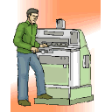

**Quantity demanded/supplied**

1. Now let us imagine that the workers go on strike because they are not happy about using some new machinery. What would be the impact on the market?

________________________________________________________________________________________________________________________________________________________

1. Illustrate the above effect on the diagram.
2. For the following four scenarios illustrate what would happen to the market price and quantity demanded/supplied after the changes in market conditions.
   * In the market for **soft drinks** there is a decrease in the price of mineral water and workers demand a pay rise.
   * In the market for **wheat,** bread is becoming more popular in China and more land is being used to cultivate biofuel.
   * In the market for **cars** there is a global increase in disposable income and the car industry acquires some new efficient machinery.
   * In the market for **hamburgers** there is a successful advertising campaign and beef falls in price.

###### Quantity Demanded and Supplied

### Price

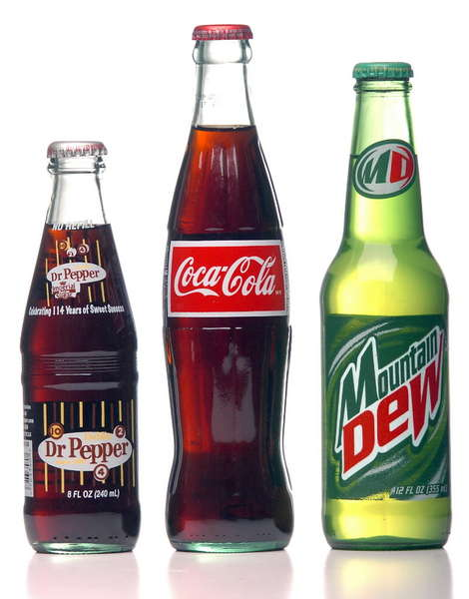

**Quantity demanded/supplied**

###### Quantity Demanded and Supplied

### Price



**Quantity demanded/supplied**

###### Quantity Demanded and Supplied

### Price

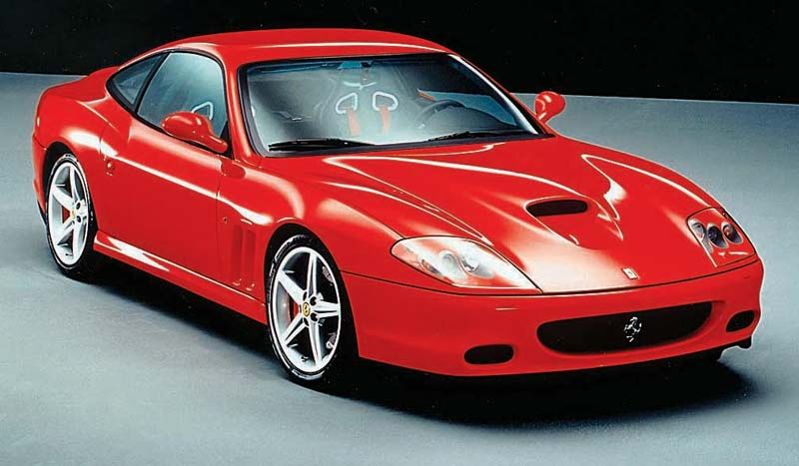

**Quantity demanded/supplied**

###### Quantity Demanded and Supplied

### Price

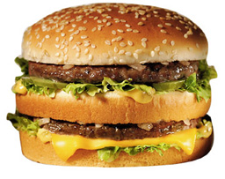

**Quantity demanded/supplied**

Market Equilibrium Lesson 2

1. **Illustrate revenue using a demand and supply diagram.**
2. **Reviewing how changes in demand and supply conditions can change the equilibrium price in the market.**
3. **Completing an applied exercise using demand and supply analysis.**
4. What is **revenue** and how is it calculated?

___________________________________________________________________________________________________________________________________________________________

1. Illustrate using the demand and supply diagram illustrate the amount of revenue received by the firm/business.

## Price

# Quantity demanded/supplied

**Quantity demanded/supplied**

1. On the diagram below show how the revenue received by producers would change if there was a **fall** in consumer income.

## Price

# Quantity demanded/supplied

**Quantity demanded/supplied**

1. Find four articles from different online newspapers that relate to changes in the price of a good or service. Use demand and supply analysis to illustrate why the price has changed.

* If you find a good article, you can use it for your first piece of coursework. The following websites are good sources of articles.



http://[www.bbc.co.uk/news](http://www.bbc.co.uk/news)

<http://www.guardian.co.uk/>

<http://www.iht.com/>

<http://www.timesonline.co.uk/tol/news/>

* **Use the graphs below to illustrate the changes in the market that are highlighted in the articles.**

**Article One**

___________________________________________________________________________________________________________________________________________________________

## Price

# Quantity demanded/supplied

**Quantity demanded/supplied**

**Article Two**

____________________________________________________________________________________________________________________________________________________________

## Price

# Quantity demanded/supplied

**Quantity demanded/supplied**

**Article Three**

___________________________________________________________________________________________________________________________________________________________

## Price

# Quantity demanded/supplied

**Quantity demanded/supplied**

**Article Four**

____________________________________________________________________________________________________________________________________________________________

## Price

# Quantity demanded/supplied

**Quantity demanded/supplied**