IGCSE Geography Patterns of Population Density

Complete the following 7 mark exam questions:
- For a named area you have studied, explain why it has a low population density (7)
- For a named area you have studied, explain why it has a high population density (7)

Success criteria
- Name the region/country and correctly locate it (likely to be a region in North America)
- Include a range of specific reasons (3-4 developed ideas)
- Think about the influence of both human and physical factors
- Use facts, figures, specific details and names of places
- Answer the questions in your Geography book (if you type your answers, please print and attach in your book)

Population Density North America
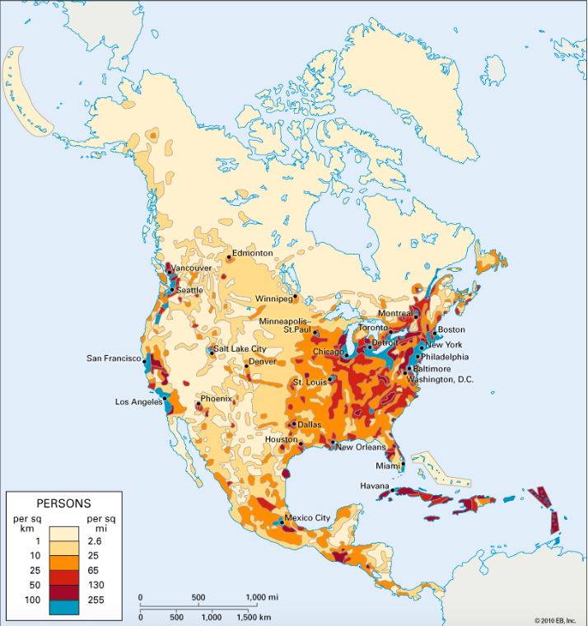

Model answers for a different example (China):

Population Density China
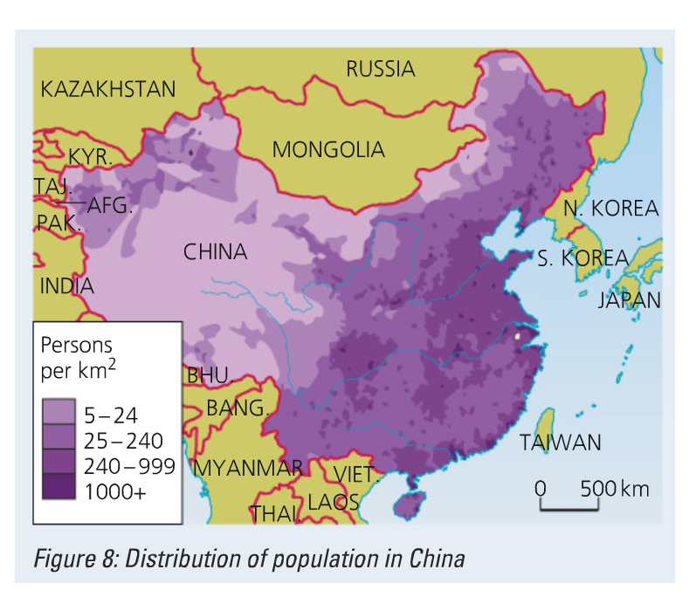
Describe the pattern of population density in one named country/region.
Named country: China
- China’s population is concentrated in the east of the country; densities everywhere in the east are greater than 25 persons per km2 and in places exceed 1000 people per km2.
- There is a very sparsely populated belt to the west of China, where densities are less than 5 people per km2.
- To the north-west there is another belt where populations densities are greater; between 25-250 people per km2.

For a named area you have studied, explain why it has a low population density (7)
Named area: Western China
Only 3% of China’s population are to be found towards the west of the country. China’s physical geography has led to a lack of development in the west. For instance, the relief of western China is very mountainous with land over 5000m (e.g. the Tibetan Plateau), this means that it is hard to access, to build on and to grow crops. The west also lacks natural resources, e.g. oil, that might have led to an increase in population for those who sought to extract them. As a result of the physical geography there is an absence of human influence in the area for example the location of business, industry and infrastructure; these have not emerged as the land is unsuitable for habitation. It would be very costly to try to settle people in the west of China as these areas are so remote and cut off that providing adequate transport and communication links and other services would be too expensive and not worthwhile.

For a named area you have studied, explain why it has a high population density (7)
Named area: Eastern China
97% of China’s population are concentrated in the east of the country. Population density is much greater in the east of China, with all areas containing more than 300 people per km2 on average.
There are many physical and human reasons why the majority of China’s population are located in the east. For example, the land is flat in the east which enables building and makes constructing communication links much easier. River valleys, with fertile floodplains, are found in the east of the country, near the major rivers e.g. the Yangtze. This attracts people as it is a good landscape for farming who can grow crops in the fertile valleys.
The country’s largest cities (e.g. Beijing and Shanghai) are found along its eastern seaboard. The coastline is a desirable location as it provides opportunities for trade. For example, Port of Shanghai is the world’s busiest port, handing more than 35 million twenty-foot shipping containers per year (TEUs). Proximity to the coastline and flat terrain also mean that the east of China has a more temperate climate than places in land. The area receives adequate rainfall, enabling farming, and temperatures are neither extremely cold nor extremely hot. The development of megacities at the coast, such as Shanghai, means there are more job opportunities in these locations. China has been under-going rapid urbanization (increase in the number of people moving into cities), therefore, the number of people living in coastal urban areas continues to rise.

