IGCSE Revision
Economic Development
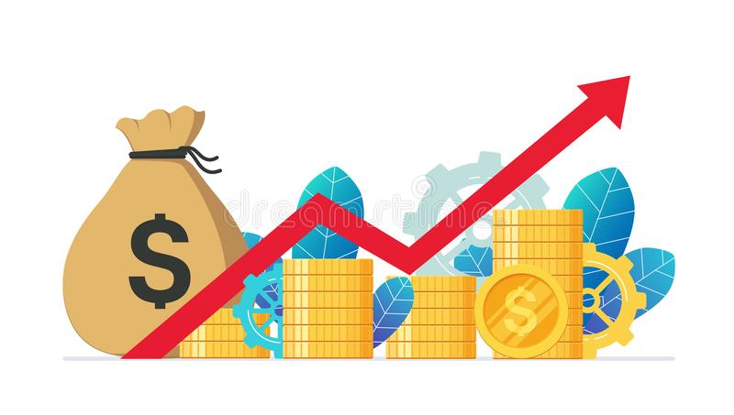

3.1 Development

Objectives:

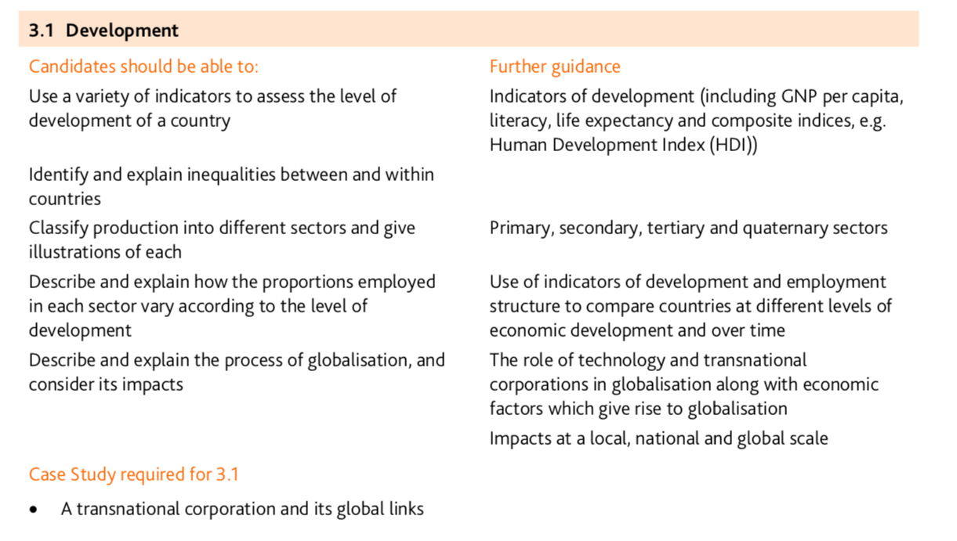

Factors influencing development

The factors influencing a country’s development are social, historical, economic and political. Understanding reasons why a country may be in poverty is a way to help with its development.

Physical factors

Climate
The Sahel region in Africa suffers from a lack of rainfall. This means that droughts are common. The result is that crops may suffer. There are certain diseases which thrive in tropical climates, such as malaria and yellow fever, because of the hot and humid conditions.

Natural hazards
Floods, droughts and tectonic activity can limit future growth and destroy buildings and agricultural areas. This also means a country may divert income to help recover from these events.

Landlocked countries
16 countries in Africa are landlocked. This means it is more difficult to trade as goods have to be driven through other countries to get to the coast for shipping. It is also more difficult for new technology to reach a landlocked country, as the fiber optic cables are laid under the ocean.

Natural resources
Natural resources such as minerals, gas and oil can help improve a country's level of development. However, this is closely tied in with the ability to exploit the resource for the benefit of the country. There are also countries, such as Japan, which are low in natural resources, but have based their development on human factors such as education and skills.

Human factors

Historical development
Colonialism hindered a developing country's level of development. A colony helped supply food and minerals to countries like Britain and France. There was investment in colonies, but this was focused on things that would help the trade between the countries.
Borders of some colonial countries were set without attention to tribal and cultural differences, causing tensions and instability.

Political factors
Poor governance does not help a country to develop. Money that could be spent on development may be used to fund military weapons or an affluent lifestyle of an elite group of people.

Economic factors
World trade is often not fair. LEDCs tend to sell primary produce. LEDCs have to compete with each other to win the trade - which lowers the prices farmers get. A poor harvest means less income. There is more money to be made in processing goods, which MEDCs tend to do.
Foreign investment can help a country to develop. Africa receives less than 5 per cent foreign direct investment. It has 15 per cent of the world's population. Europe receives 45 per cent of foreign direct investment, and only has 7 per cent of the world's population. Who controls world trade is also important, and it is developed countries that control the most trade?
Many LEDCs are in debt to MEDCs. Some of their income has to pay off these debts.

Social factors
A poorer country finds it more difficult to invest in education. The problem is made worse because many countries have a high dependency ratio. Having money to invest in a healthcare system is important for a country to develop. That is because it is difficult for sick people to work hard.
Clean water is essential for health. One in six people do not have access to safe water. If water is not safe, people may be unable to work or care for their families because of illness.

Contrasts in development
Measuring development is about comparing one country to another. We can do this by using various human and economic indicators, development indices, correlations and statistics.

Measuring development
Studying development is about measuring how developed one country is compared to other countries, or to the same country in the past. Development measures how economically, socially, culturally or technologically advanced a country is. The two most important ways of measuring development are economic development and human development.
- Economic development is a measure of a country's wealth and how it is generated (for example agriculture is considered less economically advanced then banking).
- Human development measures the access the population has to wealth, jobs, education, nutrition, health, leisure and safety - as well as political and cultural freedom. Material elements, such as wealth and nutrition, are described as the standard of living. Health and leisure are often referred to as quality of life.

Development indicators
There is no single way to calculate the level of development because of the variety of economies, cultures and peoples. Geographers use a series of development indicators to compare the development of one region against another. For example:
- Health. Do the population have access to medical care? What level of healthcare is available - basic or advanced? Is it free?
- Industry. What type of industry dominates? LEDCs focus on primary industries, such as farming, fishing and mining. MEDCs focus on secondary industries, such as manufacturing. The most advanced countries tend to focus more on tertiary or service industries, such as banking and information technology.
- Education. Do the population have access to education? Is it free? What level of education is available (i.e. primary, secondary or further/higher education)?

The North South Divide
MEDCs are countries which have a high standard of living and a large GDP. LEDCs are countries with a low standard of living and a much lower GDP.
The map shows the locations of LEDCs and MEDCs. Most of the southern hemisphere is less developed, while countries in the northern hemisphere are more developed.

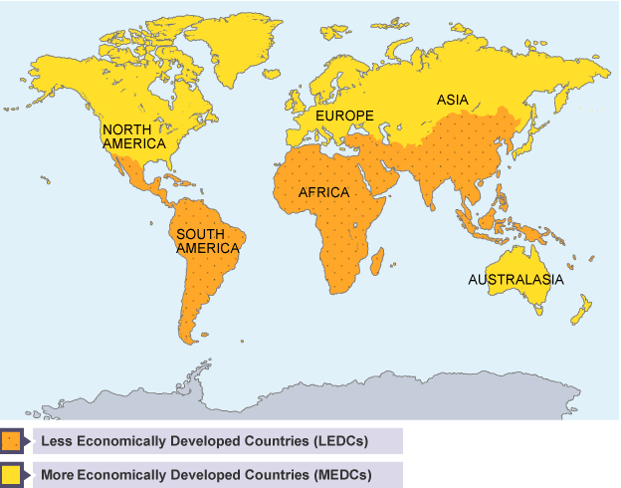

Economic development indicators
To assess the economic development of a country, geographers use economic indicators including:
- Gross Domestic Product (GDP) is the total value of goods and services produced by a country in a year.
- Gross National Product (GNP) measures the total economic output of a country, including earnings from foreign investments.
- GNP per capita is a country's GNP divided by its population. (Per capita means per person.)
- Economic growth measures the annual increase in GDP, GNP, GDP per capita, or GNP per capita.
- Inequality of wealth is the gap in income between a country's richest and poorest people. It can be measured in many ways, (eg the proportion of a country's wealth owned by the richest 10 per cent of the population, compared with the proportion owned by the remaining 90 per cent).
- Inflation measures how much the prices of goods, services and wages increase each year. High inflation (above a few percent) can be a bad thing, and suggests a government lacks control over the economy.
- Unemployment is the number of people who cannot find work.
- Economic structure shows the division of a country's economy between primary, secondary and tertiary industries.
- Demographics study population growth and structure. It compares birth rates to death rates, life expectancy and urban and rural ratios. Many LEDCs have a younger, faster-growing population than MEDCs, with more people living in the countryside than in towns. The birth rate in the UK is 11 per 1,000, whereas in Kenya it is 40.

Human development indicators
Development often takes place in an uneven way. A country may have a very high GDP - derived, for example, from the exploitation of rich oil reserves - while segments of the population live in poverty and lack access to basic education, health and decent housing.
Hence the importance of human development indicators, measuring the non-economic aspects of a country's development.
Human development indicators include:
- Life expectancy - the average age to which a person lives, e.g. this is 79 in the UK and 48 in Kenya.
- Infant mortality rate - counts the number of babies, per 1000 live births, who die under the age of one. This is 5 in the UK and 61 in Kenya.
- Poverty - indices count the percentage of people living below the poverty level, or on very small incomes (eg under £1 per day).
- Access to basic services - the availability of services necessary for a healthy life, such as % of people with access to clean water and sanitation.
- Access to healthcare - takes into account statistics such as how many doctors there are for every patient.
- Risk of disease - calculates the percentage of people with diseases such as AIDS, malaria and tuberculosis.
- Access to education - measures how many people attend primary school, secondary school and higher education.
- Literacy rate - is the percentage of adults who can read and write. This is 99 per cent in the UK, 85 per cent in Kenya and 60 per cent in India.
- Access to technology - includes statistics such as the percentage of people with access to phones, mobile phones, television and the internet.
- Male/female equality - compares statistics such as the literacy rates and employment between the sexes.
- Government spending priorities - compares health and education expenditure with military expenditure and paying off debts.
Development indices

A development index measures a country's performance according to specific development indicators. Some countries may appear to be developed according to some indices, but not according to others.

Development indicators
- Vietnam and Pakistan have a similar per capita GDP. However, life expectancy and literacy are considerably higher in Vietnam than they are in Pakistan.
- Saudi Arabia has a per capita GDP comparable to that of Croatia. However, in Saudi Arabia there is greater inequality between men and women when considering access to education and political power. So, although they are equal on an economic development index - Saudi Arabia is less developed on a human development index.

Problems with indices
Development indices can be misleading and need to be used with care. For example:
- Many indices are averages for the whole population of a country. This means that indices do not always reveal substantial inequalities between different segments of society. For example, a portion of the population of a highly developed country could be living below the poverty line.
- In some countries, the data used in indices could be out of date or hard to collect. Some countries do not wish to have certain index data collected - for example, many countries do not publish statistics about the number of immigrants and migrants.
To balance inaccuracies, indices tend to be an amalgamation of many different indicators. The United Nations Human Development Index (HDI) is a weighted mix of indices that show life expectancy, knowledge (adult literacy and education) and standard of living (GDP per capita). As Vietnam has a higher literacy rate and life expectancy than Pakistan, it has much higher HDI value even though it has a similar per capita GDP.
HDI is measured between 0 and 1. The USA has an HDI of 0.994 whereas Kenya has an HDI of 0.474.

Uneven development

Uneven development means that development takes place at different rates in different regions. There are various causes of uneven development and a number of policies to change this

Case study: Uneven Development in China

DESCRIBING THE PATTERN:
China’s Development is very uneven. GDP per capita ranges from less than $4000 in some inland areas
to $40,000+ in the eastern coastal regions.
CHINA’S PHYSICAL GEOGRAPHY:
China’s physical Geography has resulted in uneven development.
90% of China’s population reside in the east of China.
This is because of favorable physical geography in the east compared with western and northern China.
The east:
Has a coastline - meaning that land is flat and easy to build on and it provides opportunities for trade.
Receives sufficient rainfall to allow crop growth.
The west:
Is sparsely populated due to high relief - the west contains mountain ranges such as the Himalayas
and Tibetan Plateau. These areas are inhabitable due to harsh weather conditions and steep land meaning it is difficult to build.
The north:
A large desert stretches from Mongolia into northern China. The Gobi Desert is a cold desert - the climate is
harsh and it is very dry meaning it is difficult to grow crops.

CHINA’S HUMAN GEOGRAPHY:
Job opportunities:
Coastal cities e.g. Shanghai, Hong Kong and Beijing have the greatest range of job opportunities, including an increasing array of higher paid jobs in the tertiary sector.
Land values in the coastal regions have risen so much that manufacturing production has started to move further inland - this is leading to the production of secondary sector employment in and from the coast.
There remain few job opportunities in the more isolated areas of western China, beyond some jobs in resource extraction. (primary sector).

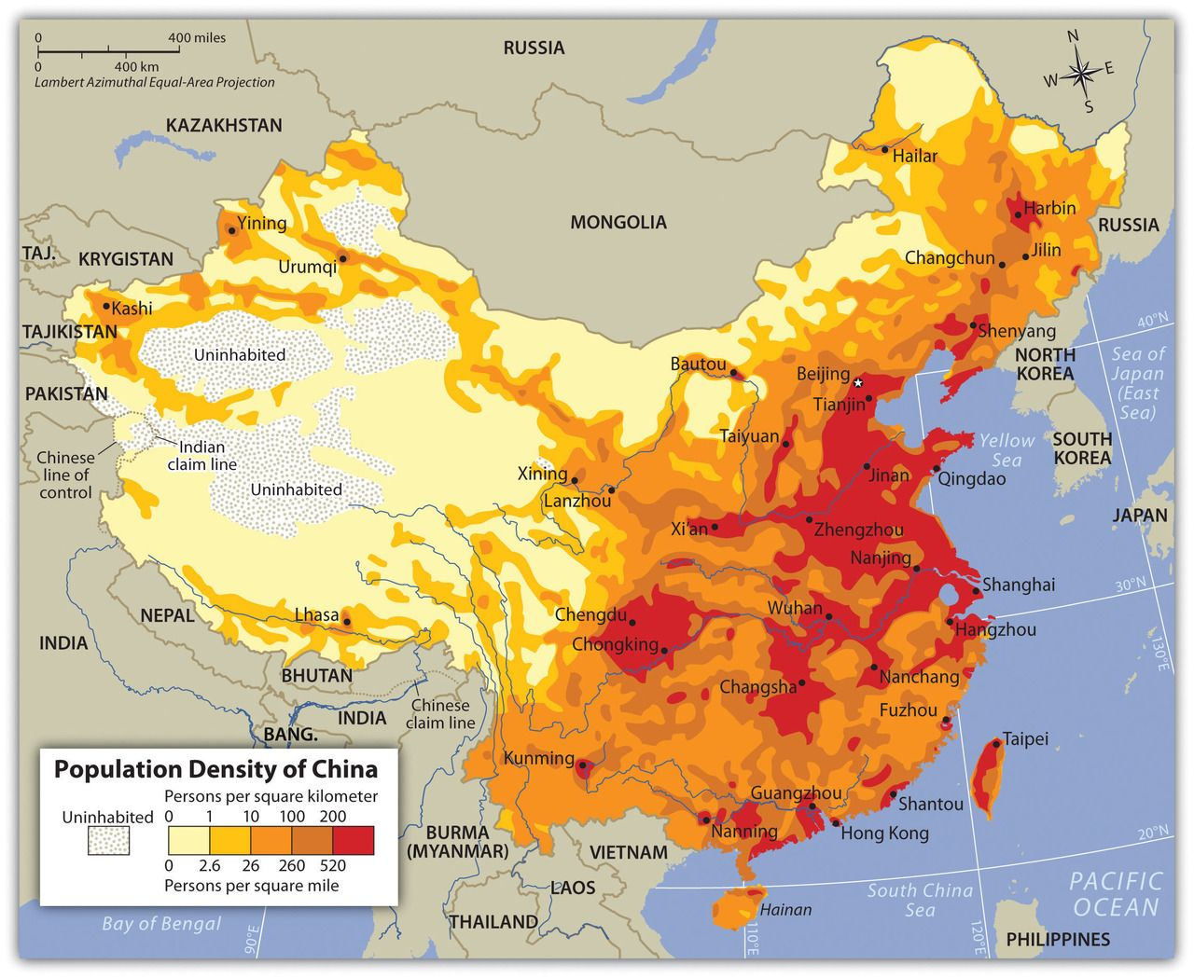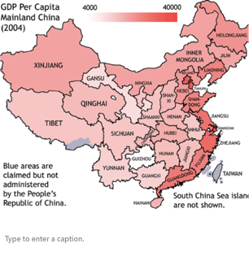

3.2 Food production

Objectives:
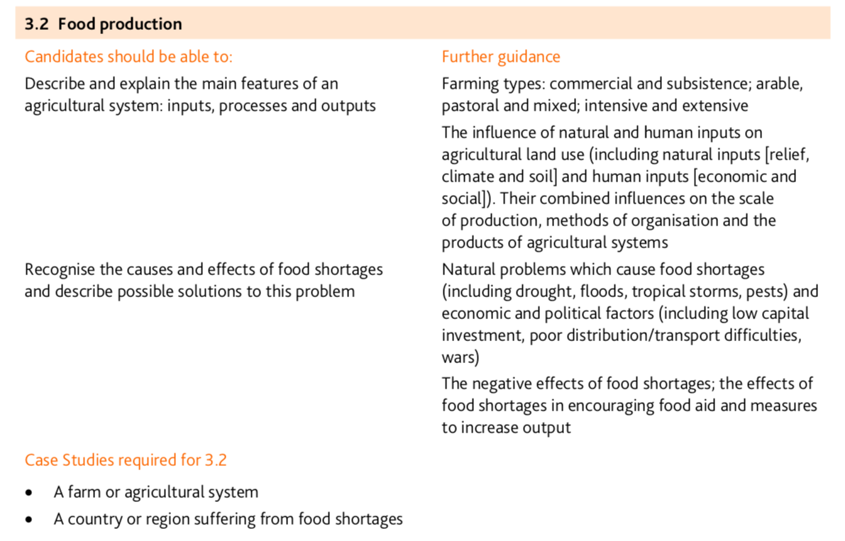

Types of farming:

Farms can be categorised according to what is being grown or reared, the size of the operation and the agricultural techniques being used.
Farming can be:
- sedentary or nomadic
- subsistence or commercial
- arable, pastoral or mixed
- extensive or intensive

Sedentary or nomadic?
- Sedentary farming is when a farm is based in the same locationall the time.
- Nomadic farming is when a farmer moves from one place to another. This is common in some LEDCs.

Subsistence or commercial?
- Subsistence farming is when crops and animals are produced by a farmer to feed their family, rather than to take to market.
- Commercial farming is when crops and animals are produced to sell at market for a profit.

Arable, pastoral or mixed?
- Arable farms grow crops. Crops are plants that are harvested from the ground to be eaten or sold.
- Pastoral farms rear animals - either for animal by-products such as milk, eggs or wool, or for meat.
- Mixed farms grow crops and rear animals.

Extensive or intensive?
- Extensive farming is where a relatively small amount of produce is generated from a large area of farmland.
- Intensive farming is where a large amount of produce is generated from a relatively small area of land. Inputs will be high to achieve a high yield per hectare. Inputs could be either fertilisers, machines or labour.

Farming as a system:
Any farm can be viewed as a system, with inputs, throughputs (or processes), outputs and feedback. The diagram shows how these link together:
Inputs can be divided into two groups.
Physical inputs are naturally occurring things such as water, raw materials and the land.
Human or Cultural Inputs are things like money, labour, and skills.
Processes or Throughputs are the actions within the farm that allow the inputs to turn into outputs. Processes could include things such as milking, harvesting and shearing.
Outputs can be negative or positive, although they are usually the latter. Negative outputs include waste products and soil erosion. The positive outputs are the finished products, such as meat, milk and eggs, and the money gained from the sale of those products.
Feedback is what is put back into the system. The main two examples of this are money, from the sale of the outputs, and knowledge, gained from the whole manufacturing process. This knowledge could then be used to make the product better or improve the efficiency of the processes.
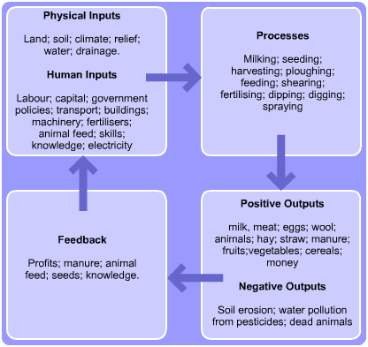
Case study of a farming system

Example 1: Subsistence Farming in the Ganges Delta (India:
Introduction

The warm, wet climate in India is perfect for subsistence rice farming. Subsistence farming means that food is grown only to feed the family, with no surplus remaining to sell for a profit. Field sizes are small, usually 1 hectare - the size of a football pitch - and sub-divided into about 15 plots.
There is a low level of mechanisation as farmers cannot afford high-tech equipment, so they use water buffalo to plough the fields and manual labour to harvest the crop. As rice requires a constant supply of water, fields are often constructed beside water, e.g. the River Ganges.
Agricultural developments have greatly improved farming in developing countries like India. We will look at each of the modern developments and discuss the impact they have had on the rural landscape.

Impact of new technology
Changes in farming policy have led to a large increase in food production in India because India has a rapidly growing population to feed. The Green Revolution involved the introduction of tractors, irrigation channels and chemical fertilisers and pesticides. The use of modern farming technology has had both a positive and negative impact on rural areas:

Positive and negative impact of new technology:
Positive | Negative
Irrigation channels allow two to three harvests a year instead of one, because of a constant water supply | Land is constantly in use so soil quality becomes poorer over time
Crop yields increase which leads to higher profits for some farmers | Poorer farmers cannot compete as they can't grow as many crops without irrigation
Some farmers can grow a variety of cash crops to further increase profit | The poorest farmers are unable to buy chemicals or machines so new technology is of no benefit to them
There is less physical work for people because of increased mechanisation | Fewer jobs are available because of mechanisation, leading to increased unemployment
The need for machinery and chemicals has created new industries and jobs, eg mechanics to fix tractors | Machines are expensive to buy and repair but this can be overcome through co-operatives where machines are shared among farmers
Living standards have increased as some farmers have money to buy goods | Many poorer families still live in extreme poverty as they cannot afford new technology

Case study of a farming system

Example 2: Large Scale Commercial Farming in Indiana, USA e.g. Fair Oaks Farm

Fair Oaks Farm Introduction
- Fair Oaks Farm is a large commercial farm occupying 30 square miles in NW Indiana, in the Mid-West region of the USA.
- Fair Oaks Farm lies within the Corn Belt, this is a region in which corn (maize) and soybeans are the dominant crops.
- This region is good for the farming of these crops because soils are deep, fertile, and rich in organic material and nitrogen, and the land is relatively level.
- The warm nights, hot days, and well-distributed rainfall of the region during the growing season are ideal conditions for raising corn.
- On average, the frost-free growing season in northern Indiana starts Apr 27 and ends Oct 7, totaling 163 days.
- The Corn Belt area is, however, considerably diversified agriculturally, and an alternative name—the feed-grains and livestock region—describes it more accurately.
- Indeed, Fair Oaks Farm is a farm that is considerably diversified. It produces feed grains and raises livestock for the purpose of dairy farming and it also offers agritourism experiences.
- An example of an agritourism experience is the the Dairy Adventure Center where visitors can watch cheese and ice cream being made from an observation deck, take in a 4-D film or try to prep a fiberglass cow for milking in 19 seconds -- the time allotted to Fair Oaks technicians.
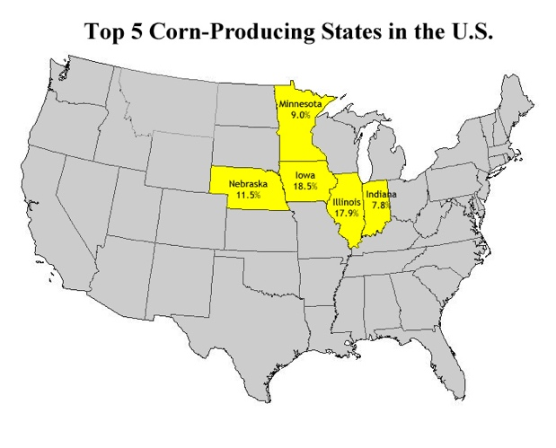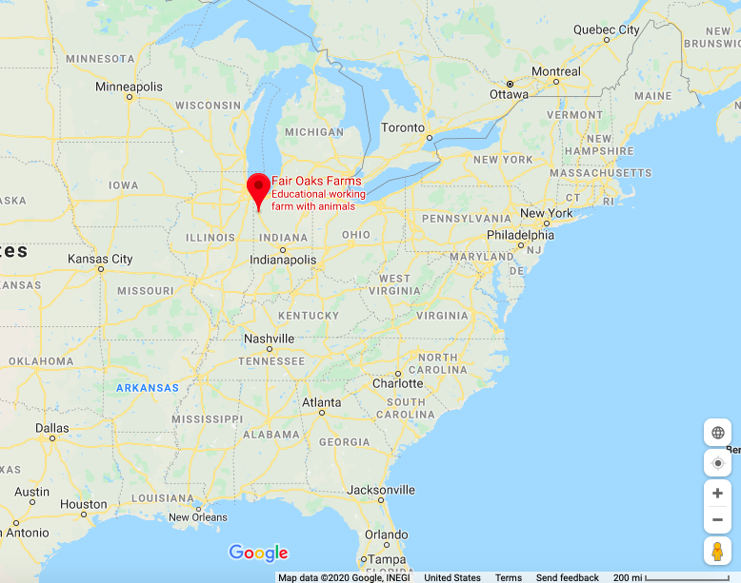
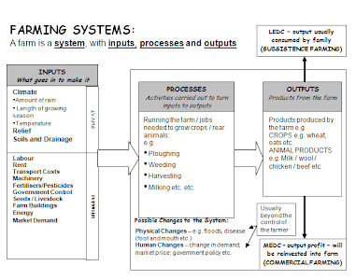
Fair Oaks Farm Systems Diagram:

Inputs | Processes | Outputs
Natural Inputs:  - Relief: flat, level land (Great Plains Region)  - Climate: The warm nights, hot days, and well-distributed rainfall of the region during the growing season are ideal conditions for raising corn. On average, the frost-free growing season for corn in northern Indiana starts Apr 27 and ends Oct 7, totalling 163 days. The Dairy Farm is operational year-round as the cows can survive the colder winter temperatures seen in northern Indiana.  - Soils are deep, fertile, and rich in organic material and nitrogen.  Human inputs:  - Buildings and machinery e.g. the milking parlour- a huge building with a rotating turntable with 72 cows on it.  - Labour from the local rural communities in northern Indiana  - Seeds and livestock i.e. grain seeds and cattle  - Fertilizers and pesticides to help crops grow/prevent pests from damaging the crops | - Ploughing, weeding and harvesting grains to be used as animal feed for cattle.  - Milking the cows in the milking parlour – 72 at a time. Each cow is milked 3x per day.  - Ice cream and cheese production.  - Manure is turned into biofuel and is used to power the farm’s milk trucks | - 280,000 gallons of milk per day.  - Other dairy products e.g. cheese and ice cream  - Manure from the cows  - Biofuel from manure

For a named farm or agricultural area you have studied, describe the farming system (7)
For a named farm or agricultural area you have studied, explain how the natural environment (climate, relief and soil) has influenced how the land is used (7)
For a farm or agricultural system in a named area you have studied, explain how the land use is influenced by natural factors (7)

Food shortages:

Definition: Food shortage occurs when food supplies within a region do not provide the energy and nutrients needed by that region's population. Food shortage is typically the result of a production problem, but constraints on importation as well as storage can also cause or contribute to food shortage. (Source: UN University website)

Causes of food shortages:
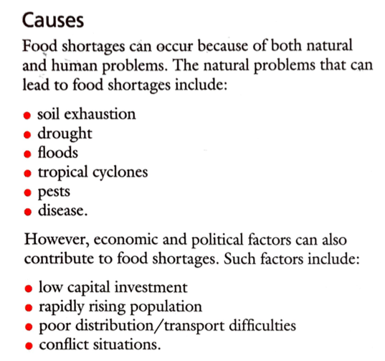
Case Study: Food Shortages in the Sahel, Africa
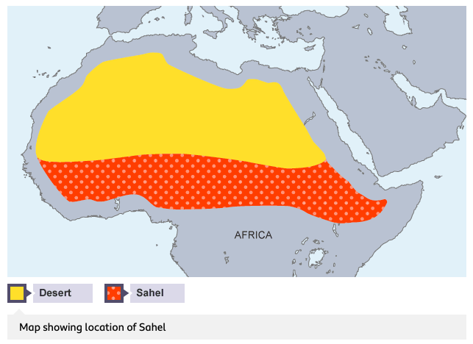
Introduction:
- The Sahel is an area of ecosystem transition between desert and savannah.
- It is 1000 km wide and stretches across Africa from the Atlantic Ocean in the west to the Red Sea in the East.
- The Sahel is found in Senegal, Mauritania, Mali, Burkina Faso, Algeria, Niger, Nigeria, Chad, North Sudan, Eritrea, Cameroon, Central African Republic and the extreme north of Ethiopia.
- Rainfall totals 100 mm/year, is highly variable and concentrated in a single season of 2 weeks to a few months.
- Rainfall is highly variable and drought has been a common feature of the area for around 5000 years. Though below average years have been more common since the mid 1970's.

Causes of food shortages:
- The Sahel region of Africa has been suffering from drought on a regular basis since the early 1980s. The area naturally experiences alternating wet and dry seasons. If the rains fail it can cause drought.
- In addition to natural factors, the land is marginal. Human activities such as overgrazing, overcultivation and the collection of firewood can lead to desertification, particularly when combined with drought conditions.
Effects:
- The result is crop failure, soil erosion, famine and hunger: people are then less able to work when their need is greatest. It becomes a vicious circle and can result in many deaths, especially among infants and the elderly.
- According to the United Nations Food and Agriculture Organization, 18.7 million people in the Sahel region faced an extreme food crisis in 2012.
- Many families were left with nothing to eat and found their only sustenance in soups made from wild plants so bitter that animals often neglected to eat them. “To make them edible, peasants boil the plants repeatedly so as to get rid of the bitter taste,” Some households in the Sahel had been without food reserves for seven months.
- Today, 20 million people in the region are at risk of food insecurity and 2.5 million of them need immediate lifesaving food assistance. An estimated 5 million children younger than 5 suffered from malnutrition.
- Migration – people within the Sahel move from drought-affected areas to marginal areas that are put under more strain than they can handle. These new areas then become degraded and unable to support the increasing population.
Solutions:
Solution 1: Food Aid:
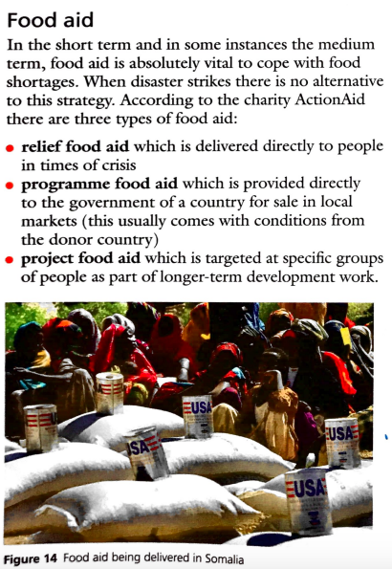
Solution 2: The Great Green Wall
- The Great Green Wall is a Green Wall of trees 10 miles wide and 4,350 miles long that are being planted across the width of Africa through its Sahel region. It was launched in 2007 by the African Union, and it aims to restore Africa’s degraded landscapes and transform millions of lives in one of the world’s poorest region. Once complete, the Wall will be the largest living structure on the planet.
- The Great Green Wall is now being implemented in more than 20 countries across Africa and more than eight billion dollars have been mobilized and pledged for its support.

Objectives
By 2030, the ambition of the initiative is to restore 100 million hectares of currently degraded land; sequester 250 million tons of carbon and create 10 million green jobs. This will support communities living along the Wall to:
- Grow fertile land, one of humanity’s most precious natural assets
- Grow economic opportunities for the world’s youngest population
- Grow food security for the millions that go hungry every day
- Grow climate resilience in a region where temperatures are rising faster than anywhere else on Earth
- Grow a wonder of the world spanning 8000 km across Africa
More detail on the causes of drought/food shortages in the Sahel:
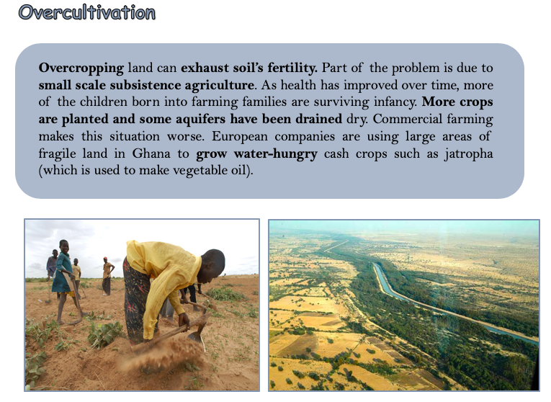
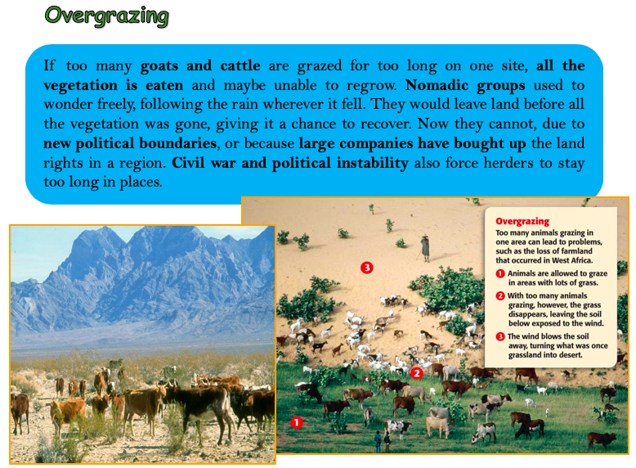

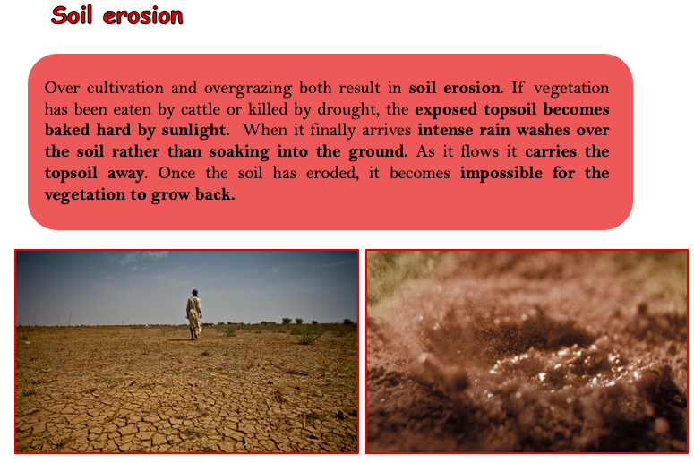
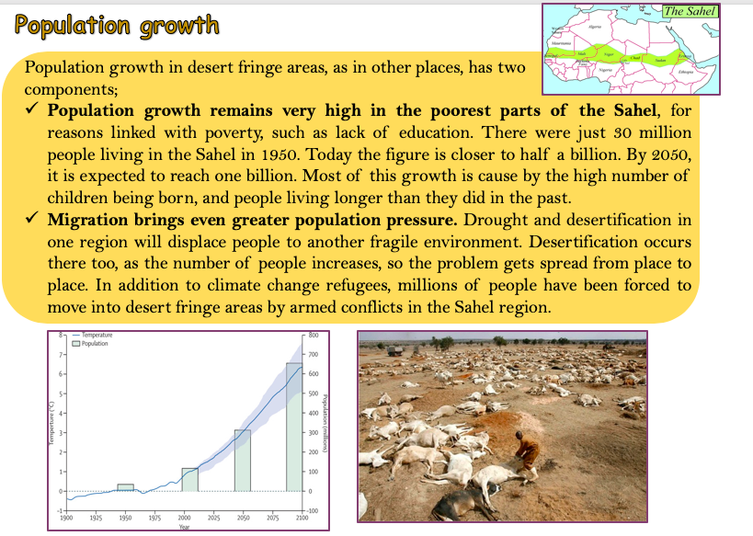
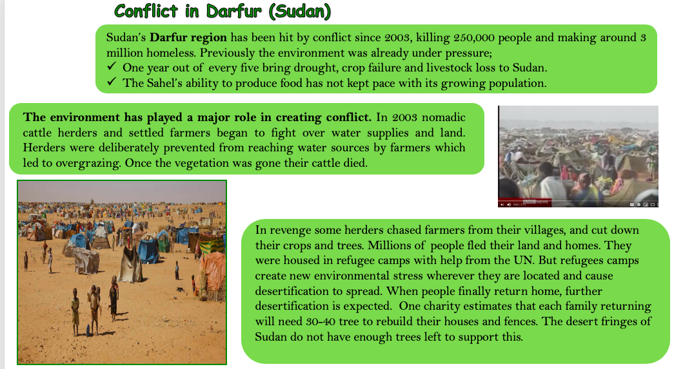
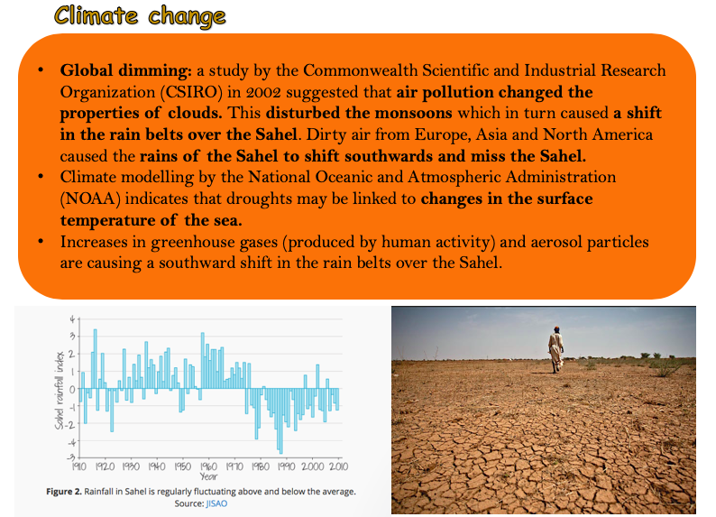
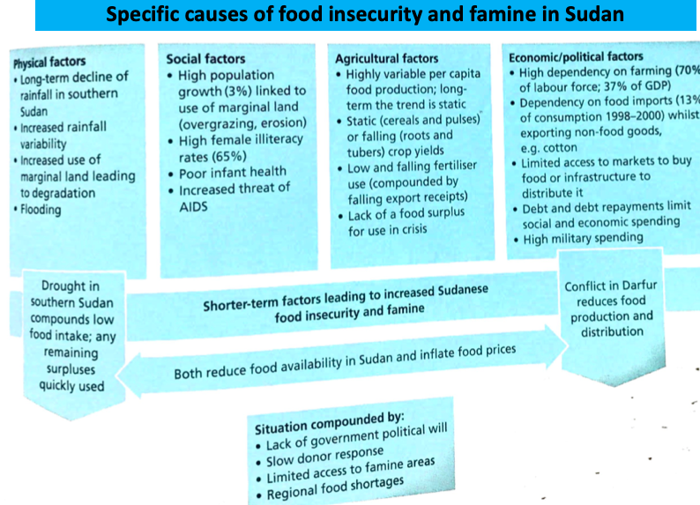
For a named area or country you have studied which suffers from food shortage, explain why there is a shortage of food. [7]
For a named country or region you have studied, describe the effects of food shortages on the people who live there. [7]

3.3 Industry

Objectives:
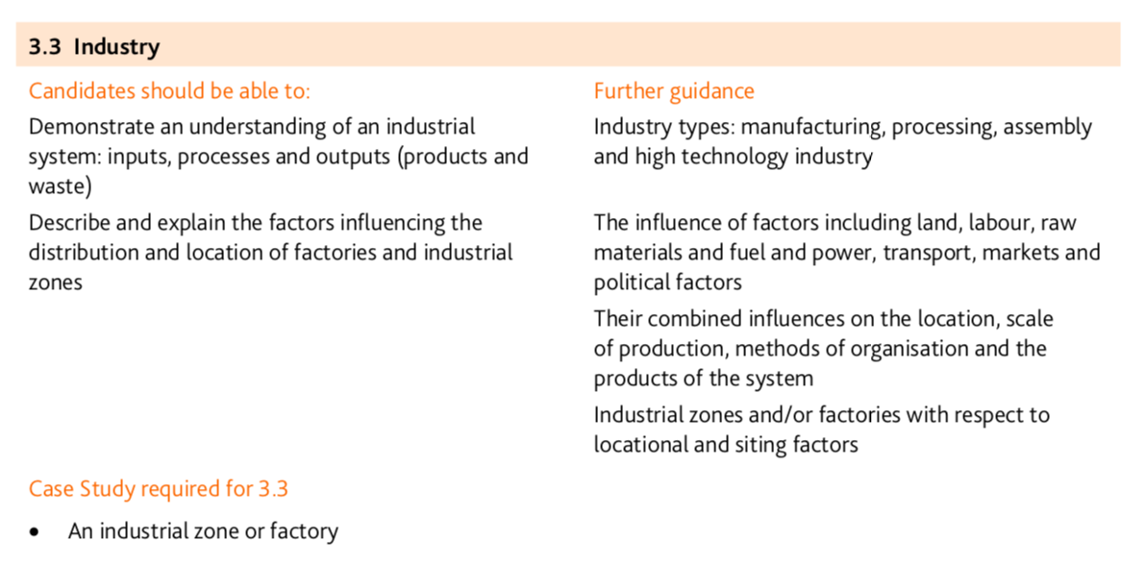

There are many different types of industry. We can classify industry into three main categories:
- Primary – these industries extract raw materials directly from the earth to the sea. (LICS)
- Farmers
- Coal-miners
- Fishing
- Secondary – these industries process and manufacture products from raw materials. (MICs)
- Car manufacturing
- Iron and steel industry
- Tertiary - these industries provide a service. (HICs)
- Doctor
- Lawyer
- Cleaner
- Banker
- Waiter
- Retailing
- Teaching
- Dentistry

- Quaternary – these industries incorporate a high degree of research and technology in their processes and employ highly qualified people.
- Biotechnology
- Computer programing

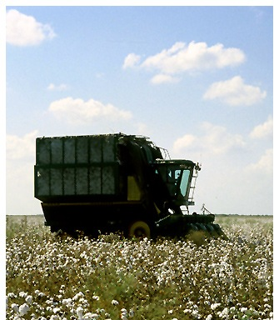

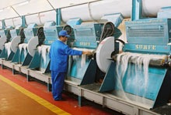
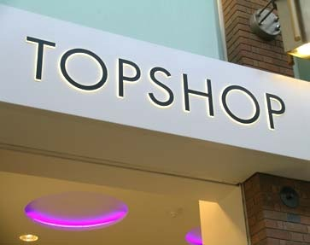

Primary
Cotton is grown and picked on a cotton farm
Secondary
Cotton is processed to a cloth, which is, in turn, sewn in to clothing
Tertiary
Cotton clothes (eg jeans and shirts) are sold in high street shops.

Industry as a system
Industries are a system of inputs, processes, outputs and feedback.

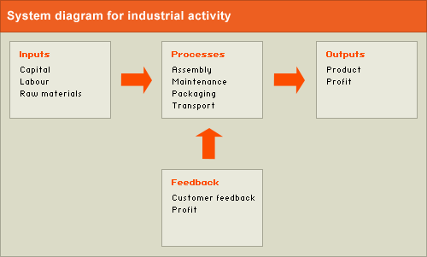

1. Inputs are everything that goes into the system. The main three inputs are:
- Physical inputs. These include raw materials such as cotton, metal or oil in secondary industries
- Labour – People who work in a factory, either skilled or unskilled,
- Capital. The money invested in the business to pay for raw materials, staff, machinery and the buildings used for production and storage.
2. Processes are all the things that happen to those inputs, to help turn them into outputs. These include:
- Production - for example the manufacturing of cars, or the sewing of textiles
- Factory maintenance, - ensures machines are kept in working order.
- Packaging - protects products, when transported, and also presents them in a way that makes customers want to buy them.
- Transport, - is needed to move products from the factory to the warehouse and then to the shops.
3. Outputs. The finished products include:
- profits
- wages.
4. Feedback includes anything that improves the system, such as:
- Customer feedback. Companies find out what consumers think of their products through market research. They may use this to improve their product to sell more and increase their profits.
- Profits - the money left after inputs (staff wages, raw materials, machinery and buildings etc) have been paid for. Profits need to be high enough to make it worthwhile for the company to continue investing in making the product. If profits fall too low, the company will change the inputs, process or outputs to improve profit, diversify into other products (start to make different types of products) - or go bust!

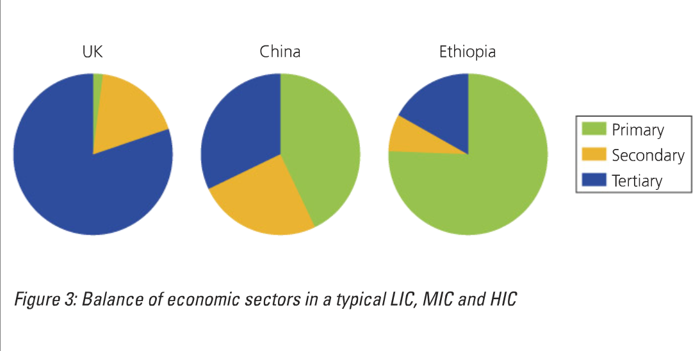

Explain how and why the types of industries found in HIC may be different to those in a LIC (4)

A HIC like the UK has only 2% of the population working within the primary industry, whereas a LIC like Ethiopia has 75% of people in this industry. This is because primary jobs pay less so not many people in the UK are willing to do them. In addition, many industries, such as farming, have been mechanized and therefore machines do jobs that people would have done. In LICs many more people farm for a living to provide food for their families or don’t have a high enough level of education to have a job in the tertiary sector.
In HICs there are more tertiary jobs such as a surgeon, as the population has a far better education.

Changes in Employment structures over time
Sector Shifts – Changes in the relative importance of economic sectors (primary, secondary, tertiary and quaternary) over time.
The Clark Fisher Model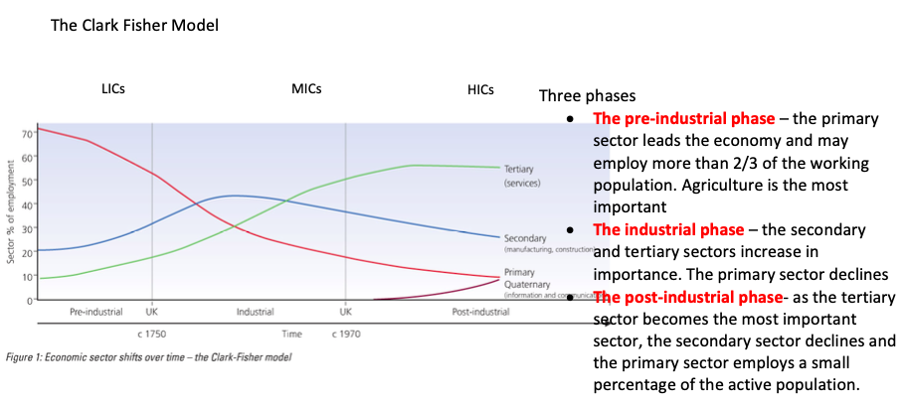
Reasons for the decline in primary industries in the UK

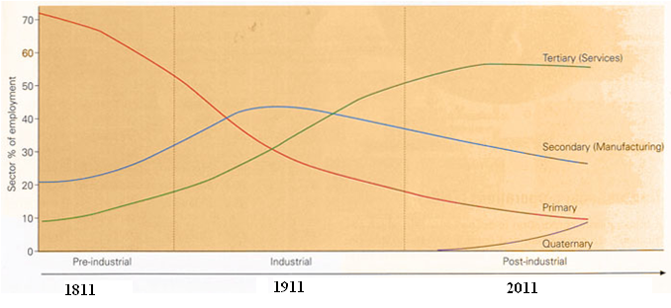

Describe the changes in employment shown in figure 1. (3)
Use data in your answer

Employment in the primary industry started to decline in 1811 falling to its lowest level of 9% in 2011.
This meant it has declined by 62% in the three centuries.
On the other hand, employment in the secondary industry increased by 25%. However, in 1911 it begins to decline. In the time till 2011 it gradually decreased by 15%.

Why was there a decline in the primary sector in the UK?
Mechanisation – the replacement of human (or animal) labour with machines

See further ideas about the decline of particular primary sector industries in the table below:

 | Key Words | Explain the reasons for the decline
Agriculture | - Importation  - Mechanisation  - Agribusiness | - The UK used to provide nearly all its food, although limitations mean some have to be imported.  - Today the UK produces less than 40% of its food – as it is much cheaper to import some of it.  - Agriculture has become highly mechanised  - Livestock are reared by factory like methods.  - Farming has been taken over by agribusiness. Everything has been scaled up; family farms have joined together to make commercial farms. Hedgerows removed to allow for bigger fields. A lot of money has been invested into new technology. Many crops are genetic modification.
Fishing | - Overfishing  - Mechanisation  - International control | - Many small towns fishing used to be there main industry. However now there are three Scottish ports that catch most of the UK’s fish; Peterhead, Lochinver and Fraserburgh.  - Over-fishing, caused mostly by mechanisation  - Tight international controls on the amount of fish that can be caught daily.
Mining | - Importation  - Industries collapse  - Other sources of energy  - Environmental concerns | - Resource depletion – because most accessible and profitable coal deposits have been worked out.  - It is now cheaper to import coal from other countries, particularly Russia.  - The collapse of large-scale traditional industries has cut the demand for steel.  - Modern electricity generating stations are powered by natural gas rather than coal.  - Coal is not good for air quality and contributes to global warming, therefore people don’t want to use it.

Suggest reasons for the decline in the primary sector in the UK (4)

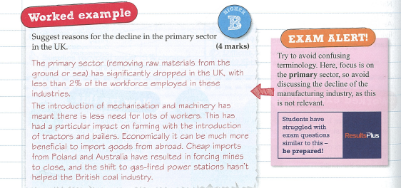

The Collapse of Secondary Industry

The decline of the secondary sector in the UK
- 50 years ago manufacturing produced 40% of the UK’s economic wealth, and 1/3 of the work force
- today it only produces 11% of the wealth and employs less than 10%
the things being manufactured in the UK were being made cheaper elsewhere.
Why?
- Cheaper land and labour in poorer parts of the world
- Fast and cheap transport to move goods from country to country
- Modern communication networks

Automation
The use of machinery in manufacturing of data and processing

Explain what is mean by the ‘global shift in manufacturing’

There has been a shift from the more developed countries to the less developed countries
(talk about decline in the UK then talk about China)

Global (information) superhighway
The internet/worldwide web/cyberspace, allowing the fast transfer of information to virtually anywhere on Earth.

Communication networks
The passing of information and idea through the media (radio, TV, phone and internet)

TNCs – transnational corporation
MNC – multi- national cooperation – companies that operate in more than one country.

Globalisation
The process, led by transnational companies, whereby the world’s countries are all becoming part of one vast global economy.

Reasons for globalisation
- Firms can keep in contact with producers easily and quickly using the internet
- Developments in transport technology: goods can be moved around the world quickly and easily
- Development of aircraft and containers, efficient motorway networks which cross Europe.

Location Factors

Explain the factors that may influence the location of manufacturing industry (5):

Theme:  List 4 factors for the location of industry | Explanation: what does this mean? | Example: describe one example where this is available.

Key ideas:

TNCs – these companies are locating in the cheapest and therefore most profitable locations
Transport – now much faster and cheaper, therefore is no longer as significant as it used to be.
Communication - because of speed and efficiency of modern communications, a manufacturing company can keep in immediate touch with factories scattered in different countries.
Governments - Incentives to set up factories within their borders such as tax exemption.
Energy - Due to the National Grid system, electricity can be made available almost anywhere.

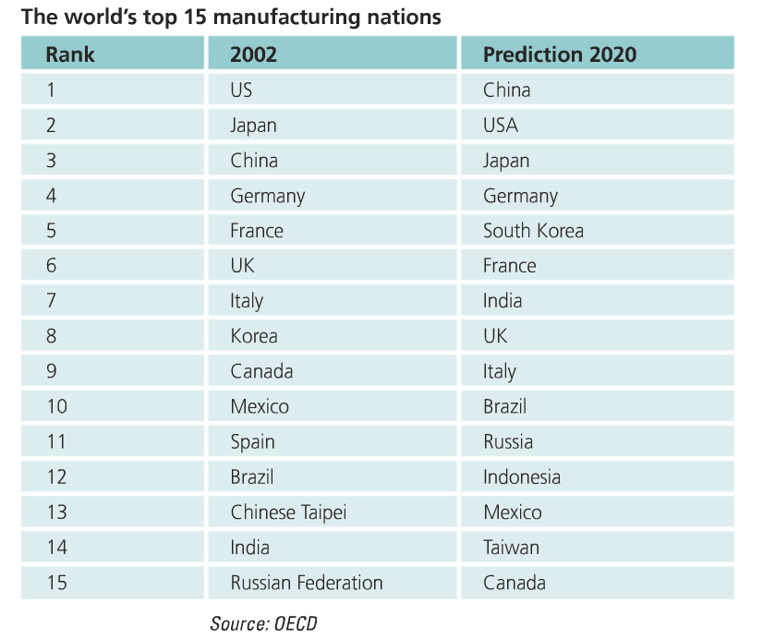

Why has employment in manufacturing industries declined in wealthy countries e.g. the UK ?
- Cheaper to make products abroad – labour and land are cheaper, regulations are not as demanding.
- De-industrialisation – loss of traditional industries due to modern production and automation.
- Transport enables goods to be moved more quickly and efficiently
- Modern communication networks – easier to keep in touch.
- Growth in transnational corporations (TNCs)
- Globalisation has meant that companies have moved their manufacturing to cheaper locations (often in MICs or LICs) This has been helped by increasing technological advances and major improvements in transport.
Suggest reasons for the decline of secondary industry in the UK (4)
The introduction of mechanisation and machinery has meant there is less need for workers. Products are often produced more cheaply abroad and imported to the UK. A social factor is the perceived idea that a factory is menial. There is a big demand for workers in the tertiary (service) sector so lots of people are moving to these kinds of jobs.

Globalisation has caused a decline in the secondary industry in the UK. Suggest reasons why? (4)
- Companies are moving there manufacturing to cheaper locations often MICs and LICs as labour costs are cheaper and there are less law enforcements. Therefore, these places are more profitable. Advancements in technology like the internet have made it easier for goods to be produced internationally. In addition, improvements in transport have meant that goods can be transports far more easily.

Economic Locations

Location Factors:
- Labour supply – the number of people who live in an area. The industry may have specific industry skills. (Like California)
- Accessibility – how easily can the site be reached by rail and road links
- Raw materials – does the site have the necessary materials to make a product
- Distance to market – is it close by or does it have good transport links
- Government incentives – are there any grants or other incentives available from the government or local council to persuade a company to move to an area.
- Power supply – is there an adequate supply of energy to produce goods.

Primary Industry: Factors

- Relief – flat land for easy crop cultivation
- Government – grants and subsides to help industry
- Markets – somewhere to sell produce
- Soil – nutrient-rich aerated soil for crops to grow
- Climate – adequate sunshine and rainfall
- Technology – ease of introducing new machines and farming practices
- Labour and capital – local workforce available and money for investment.

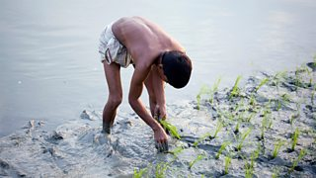
Location of Primary Industry – Rice Farming in Bangladesh (to be covered in food topic)

Case study - the Lower Ganges Valley, India
Introduction

Rice farmer in Bangladesh
The warm, wet climate (monsoon rainfall) in India is perfect for subsistence rice farming. The land is flat and the constant flooding from the Ganges provides fertile soils.
Subsistence farming means that food is grown only to feed the family, with no surplus remaining to sell for a profit. Field sizes are small, usually 1 hectare - the size of a football pitch - and sub-divided into about 15 plots.
There is a low level of mechanisation as farmers cannot afford high-tech equipment, so they use water buffalo to plough the fields and manual labour to harvest the crop. As rice requires a constant supply of water, fields are often constructed beside water, eg the River Ganges.
Agricultural developments have greatly improved farming in developing countries like India. We will look at each of the modern developments and discuss the impact they have had on the rural landscape.

Impact of new technology
Changes in farming policy have led to a large increase in food production in India because India has a rapidly growing population to feed. The Green Revolution involved the introduction of tractors, irrigation channels and chemical fertilisers and pesticides. The use of modern farming technology has had both a positive and negative impact on rural areas

Secondary Industry

Goya factory in Katy, Texas- Goya beans

- 100 hectares of flat land available, so factory can expand. Built on a greenfield site.
- there is high local employment (with relevant skills)
- Located on a greenfield site 8km for Katy, 40KM from Houston
- Located on the i10 one of the biggest freeways in the USA
- Underground aquifer which provides water for production process
- There is electricity from local power stations.
- Near attractive towns such as Katy and Fulshear- both have the development of new housing and good school Districts.

The location of secondary industry: Bangladesh (textiles)

The garment industry in Bangladesh exports 1.2 billion pieces of clothes a year to the west. . TNC clothing manufactures like H and M and Zara are attracted to complete their production in Bangladesh because of the cheaper cost of production and abundance of workers. The workers can work long hours (about 13 hours a day) and earn low wages (about $4 a day). Prices are also kept low by factories ignoring safety and environmental control laws. Despite this many have migrated to Dhaka from rural parts of Bangladesh to work in the textiles industry. There are 4 million textile workers in Bangladesh
There are environmental consequences of the textiles industry in Bangladesh. The factories use a lot of energy; much of this from coal fired power stations so contributing to emitting greenhouse gases. The factories also use a lot of water in the production which takes it away from the locals. 56 million tonnes of contaminated water are produced by the textiles industry each year- this untreated water is dumped into Dhaka’s rivers. This impacts the local ecosystems causing the rivers to be biologically dead and also impacts the local people as they are forced to consume unsafe water causing disease.
Poor safety standards in the factories can lead to gas leaks and in the Rana Plaza incident a factory collapsed killing 1100 people as basic building standards had not been upheld,

Explain the location of a factory or industrial zone in a named area you have studied.
Describe the impacts of a named transnational corporation (TNC) on a country where its goods are produced or services provided.

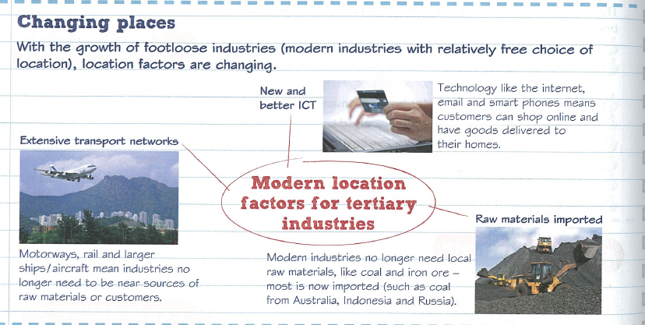

Factors effecting high tech industry
- Labour – supply of high qualified and adaptable labour
- Environment – attractive location in which to live and work
- Research and development – near to and links with top class univercity
- Access – availability of good transport, raw materials, services and markets
- Reputation – place of high-tech excellance
- Government polices - national and local governments encourage investment and enterprise

Why have high tech industries located in the Silicon Valley?

•High-technology industry uses the most advanced technology to make products (computerized systems etc)
•They involve a highly-skilled workforce and its products require a high proportion of research and development.
•High-technology industry is relatively footloose since access to raw materials is not very important. The ‘raw materials’ that are required are usually lightweight electronic components.

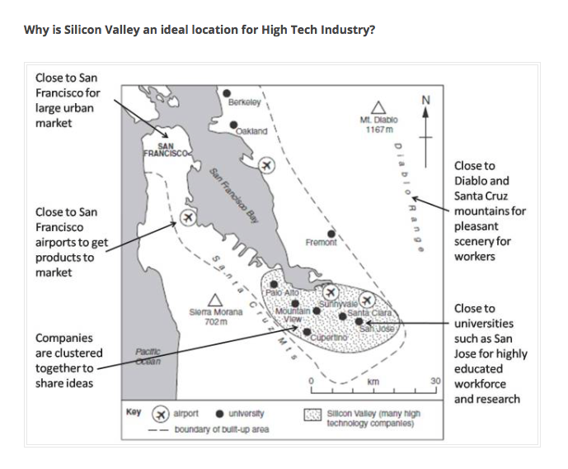

For each type of industry (primary, manufacturing and high-tech) outline the which of the factors below have influenced the location and why

Factor affecting location: | Further explanation:
Site

Climate

Capital

Raw materials

Energy

Labour

Markets

Transport

Explain how the factors affecting the location of industry can change over time (3)

4. Globalisation

People often say that the world is getting smaller, and that we live in a global village. This means that we now communicate, travel, and share each others' cultures on a world scale.
We also trade more than before, transporting products around the world in hours or days. The biggest companies are no longer national firms but have subsidiaries in many countries - becoming Transnational Corporations (TNCs).
What causes globalisation?
It is the result of -
- Technological changes that enable people, goods, money and above all information and ideas to travel the world much faster than ever before.
- Better Communications: e.g. TV, telephones and the internet make it easier to trade.
- Transport has become cheap and quick. People from other countries can travel to e.g. the UK to get better-paid jobs. Businesses can quickly transport products and raw materials all over the world. This makes products and services from all over the world available to UK customers e.g. flowers and fruits from Kenya are sold by Sainsbury.
- Trade liberalisation: governments around the world have relaxed laws restricting trade and foreign investment. Some governments offer grants and tax incentives to persuade foreign companies to invest in their country.

What is the effect of globalisation?

Globalisation has resulted in many businesses setting up or buying operations in other countries. When a foreign company invests in a country, perhaps by building a factory or a shop, this is called inward investment.

Companies that operate in several countries are called multinational corporations (MNCs) or transnational corporations (TNCs). McDonald's, the US fast food chain is a large TNC. It has nearly 30,000 restaurants in 119 countries.

The logos of the most successful TNCs are instantly recognised worldwide

The majority of TNCs come from more economically developed countries such as the USA and UK. TNCs invest in other MEDCs - the US car company Ford, for example, makes large numbers of cars in the UK. But TNCs also invest in less economically developed countries - for example the British DIY store B&Q now has stores in China.

Factors attracting TNCs to a country may include:
- cheap raw materials
- cheap labour supply
- good transport
- access to market, where the goods are sold
- friendly government policies

What are the advantages of globalisation?
- Inward investment by TNCs helps countries by providing new jobs and skills for local people.
- TNCs bring wealth / foreign currency to local economies when they buy local resources, products and services. This goes towards paying for education, health and infrastructure (roads, water supply, electricity etc.).
- There is more mixing of people and cultures from all over the world. This means e.g. people can experience foods and other products not previously available in their countries.
- Globalisation helps make people aware of events in different parts of the world. For example, people in the UK were quickly aware of the impact of the 2004 Tsunami tidal wave on countries in SE Asia, and were therefore able to send help quickly.
- It helps people be aware of global issues such as deforestation and global warming - and to the need for sustainable development.

What are the disadvantages (Problems) of globalisation?
Some people are against globalisation for example environmentalists, anti-poverty campaigners and trade-unionists.
They say:
- Globalisation operates in the interests of the richest countries. These countries dominate world trade, at the expense of developing countries. The developing countries provide the rich countries with cheap labour and raw materials.
- Often the wealth from inward investment does not benefit the local community in the developing countries. This is because sometimes the profits are sent back to the MEDC where the TNC is based. TNCs with their massive economies of scale, may drive local companies out of business. If it becomes cheaper to operate in another country the TNC might close down the factory and make local people redundant.
- There are no strict international laws. This means that TNCs can do things, for example polluting the environment, or having poor working conditions and low wages on local workers. This would not be allowed in the TNCs.
- Globalisation is viewed by many as a threat to the traditions and languages of developing countries, for example a Hollywood film is more likely to be successful worldwide than one made in India or China, which also have thriving film industries.
- Anti-globalisation campaigners try to get people’s attention to the bad effects of globalization by demonstrating against the World Trade Organisation. This is an inter-government organisation which promotes the free-flow of trade around the world.

Advantages and disadvantages of TNCs
The statements below are muddled up. Put the correct advantages and advantages in the table below;
- They bring capital, technology, knowledge and expertise
- They construct roads which can be used free of charge
- They don’t employ the locals for the well-paid jobs
- They build industries that the governments don’t have the capital and technology
- They avoid taxes through over invoicing and under invoicing
- They increase exports because of their access to markets worldwide
- They have no regard to the safety of the locals
- Profit are taken out of the country

 | Advantages | Disadvantages
To the host country

For the TNC
For the local residents

TNC Case Study Apple:

Apple: Introduction

A US based TNC and one of the world’s largest manufacturers of phones.

Brief History and major product release dates

Started by Steve Jobs and Steve Wozniak in 1976 to develop and sell the personal computers they developed in Steve Jobs parents’ garage.

The first iPhone was released in 2007. This was the first smartphone. By early 2017 there were more than 2 million apps available for downloading and use on iphones.

Apple update their main product (the iphone) each year.

Supply chain
Design phase takes place in the Silicon Valley, California.

Raw materials are obtained from small scale, labour intensive mines in Rwanda and the Democratic Republic of the Congo. One of the materials in coltan, a highly conductive metallic ore. Because the mining is largely unregulated, environmentalists are critical of the mining on local ecological systems, as land eroded by mining pollutes the lakes and rivers of the are. The mines are also close to the homes of mountain gorillas. Many of the mines are owned by rebel groups who use profits to purchase weapons. Because of some of these issues Apple has fine-tuned some of its sourcing relationships and now only uses ‘conflict- free tantalum’.

Work is outsourced to whichever supplier can deliver the highest quality goods at the lowest price within the timeframe demanded. One of Apple’s largest component suppliers is Samsung (one of its largest competitors) who supply silicon chips. Other suppliers include Sony (cameras) and Sharp and LG (touchscreen displays). Apple has around 200 vendor suppliers around the world.

The manufactured components are sent to China for their final assembly. Apple does not manufacture its own mobile phones, but outsources the assembly of parts to other companies in various parts of China where skilled workers can be employed for wages that are relatively cheap by world standards.

All early models of the iPhone were assembled in Foxconn, a Taiwanese TNC electronics company. As well as factories in Taiwan, Foxconn also has 12 factories in mainland China, as well as factories in Brazil, Hungary, India, Japan, Malaysia, Mexico, South Korea, USA and several other countries. It is estimated that about 40% of all electronic products are assembled in Foxconn Factories.

Foxconn have been accused of exposing their workers to harsh working conditions and mistreatment – including employment of young teenage workers, cramped dormitory accommodation for workers, long hours with no time off and forced over-time. To balance these concerns, however, Foxconn and Pegatron have no shortage of applicants for jobs in their factories; with wages being higher than most other Chinese factory jobs.
When phones have been assembled and packaged they are air-freighted to distribution centers in several parts of the world, including Australia, China, Singapore, The UK and the USA. Apple operates a “just in time” distributing system, using constantly updated information on purchases. Apple aim to keep as little stock as possible in its warehouses.

The small size and weight of iPhones makes air freight feasible and it gives Apple an advantage over their competitors who transport by ship because it is cheaper.

Although Apple does not manufacture its iPhones, it does retain control of sales and marketing. Apple phones are sold in four main ways:
- Online from their own website
- Retail through its own stores
- Contracts with mobile phone network providers e.g. AT&T/T-Mobile
- Unauthorised sales – selling phones that have been smuggled out of assembly plants by employees (obviously Apple aims to eliminate this retail channel).

A final stage of the supply chain is the production of outputs from the system. In the case of Apple’s supply chain, the profits flow to Apple’s shareholders – all of Apple’s large shareholders are based in the United States.

The disposal of used iPhones is the last stage of the supply chain. Mobile phones are designed to have a life of just a few years. They contain a number of hazardous metals e.g. lead, mercury and cadmium, which males environmentally responsible disposal difficult. Apple encourages consumers who have finished with their iPhones to return them to Apple for recycling.
Early mobile phones were designed to be disassembled; however, newer phones are made by gluing components together, which means they must be shredded if they are to be recycled – this is an energy consuming process.
Most mobile phones do not go through the official recycling program and are either re-sold for second-hand use or are sent to e-waste sites in China, Pakistan or Ghana where recycling is done by hand in a labour intensive manner.

Exam question and model answer:
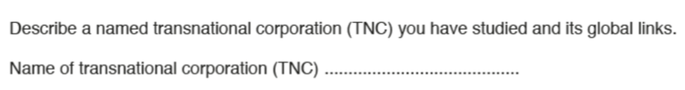
Apple is a USA owned TNC that produces many well-known and popular electronic products, including the Apple iPhone. Apple’s global links relate the different elements of Apple’s supply chain.
The research and development for the iPhone is done at Apple’s Headquarters in Silicon Valley, California. However, to produce their products Apple utilizes materials, skills and expertise from many countries throughout the globe. They also market and sell their products in many countries.
One country that Apple is linked to is the Democratic Republic of Congo where raw materials are obtained from small scale, labour intensive mines. One of the materials is coltan, a highly conductive metallic ore.
Apple also source many of the component parts for the iPhone from other countries. For example, Samsung is a South Korean Company who supply silicon chips. Other suppliers include Sony (Japan) who provide the cameras and LG (South Korea) who provide the touchscreen displays. In total, Apple has around 200 vendor suppliers around the world.
Raw materials and components from many parts of the world are shipped to China where the iPhone are manufactured and assembled. Apple does not manufacture its own mobile phones, but outsources the assembly to other companies. One such company is Foxconn, a Taiwanese TNC electronics company. It is estimated that about 40% of all electronic products are assembled in Foxconn Factories. When phones have been assembled and packaged, they are air-freighted to distribution centers in several parts of the world, including Australia, China, Singapore, The UK and the USA.

Look at the triangular graph showing the employment structures of three countries:
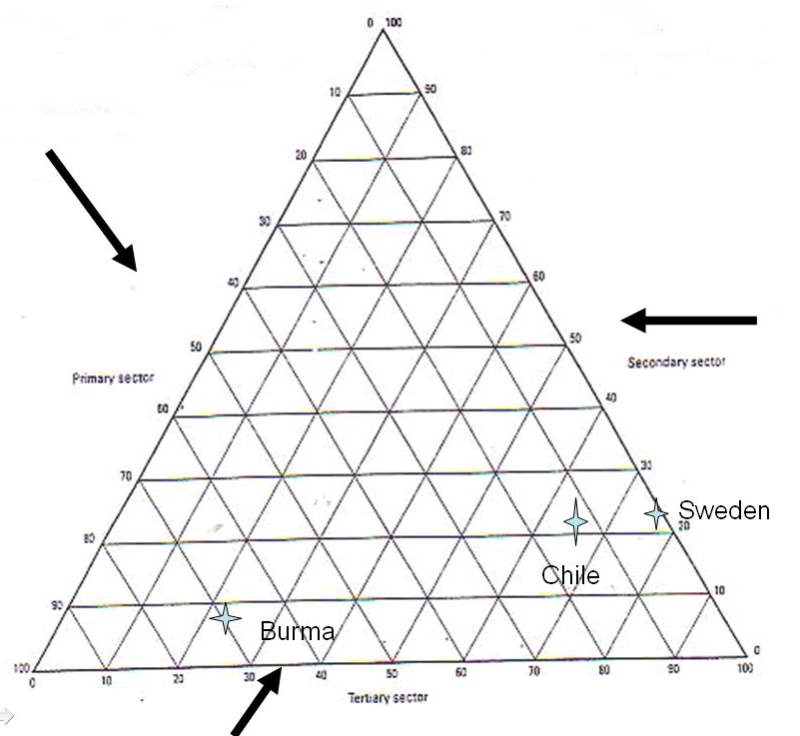
B
C
A
- Which country is the most developed? Why?

……………………………………………………………………………………………………………………………………………………………

…………………………………………………………………………………………………………………………………………………………..

- Which letter represents Chile, Burma and Sweden?

A –
B –
C –

- Why do think this?

……………………………………………………………………………………………………………………………………………………………

…………………………………………………………………………………………………………………………………………………………..

……………………………………………………………………………………………………………………………………………………………

…………………………………………………………………………………………………………………………………………………………..

The Growth of a Superpower – Case Study CHINA
L.O – why has the secondary sector grown and its effect

GDP – Gross Domestic Product – is the measure of an economy; the total market value of goods and services produced by workers within a country during a period of 1 year.
- Often measured per capita as this allows it to be compared the level of development

China’s growth in the secondary sector
- Majority of the population live on the east
- This is where most of the manufacturing industry is located, because of the road networks
Human Factors
Workforce | Most of the population live on the east coast, therefore industry located here.
Government | Less communist – therefore they are opening up to other companies coming in to the country
Education | Most of the best education is along the coast – in rural areas there is little education
Physical Factors
Relief | - To the north there is the Gobi desert, where you would not want to build  - The south east it is very mountainous

Effects of growth
- More jobs – benefits form income
- Better education
- Growth in GDP
- Greater pollution – water/air pollution
- Lower wages – less strict rules to protect the workers
Facts about china:
- Produces 2/3 of all shoes
- 2/3 of photocopiers
- 85% of all Christmas trees
- ½ of all clothes
Consumer industries: These making finished products, such as clothing and electrical goods

Why has there been a growth in manufacturing in China?
Physical
- Natural resources – particularly energy (coal, gas, oil)
- Close to other developing countries so good trade routes
Human
- Increased globalisation enables rich counties to manufacture there
- Increase in literacy rate – 96% in 2011
- Increase in privately owned companies - from 100 in 1979 to 280,000 in 1998.
- Political move from communism (where they control economy, media, police and ownership) towards capitalism (individuals own business and property to drive the economy).
- It allowed TNCs to invest in the country – attractive to the companies because of the good level of education (skilled workers) allowing they to build there design in China for a far lower cost
- The world has a growing demand for cheap manufactured goods
- Few regulations to hinder industrial growth
- Large labour force – cheap and fairly skilled (40p an hour) growth as TNCs are attracted to the country.
- Move away from communism has allow entrepreneurs to start up their own business – leading to it being the world largest textile manufacture

Exam questions/model answers

Explain the reasons for the growth in the secondary sector (6)

Over the past 10 years Chinas GNP per capita has grown from $620 to $1,700. This is due to various human and physical factors. Such as location, workforce and education.
China’s geographical position in the world benefits its development as it is near other developing markets such as South Korea, Taiwan and India. It is also on major trade routes.
A human factor that helped growth was the workforce. China has a plentiful supply of workers with a steady stream of people moving in from rural areas. In addition, the workers are fairly well educated. Therefore, TNCs are attracted to the country as they can get skilled workers and pay them low wages, as low as 40p.
(finish – mention political)

Impacts of the growth in the manufacturing industry

Negative
- 700 million are low wage workers
- Poor rural migrants have work in terrible conditions There is no social security in China and migrants from outside their province are under the Hokou system which means they don’t get any education or healthcare (i.e. education/health care)
- Workers work in hard long conditions (15 hours a day, one day off a month)
- Parents only get to see their children one or two days a year as they left in their province to get an education and workers get so few days off.
- Damage to the environment
- Having to find new sources of raw materials
- Massive rural- to-urban migration as people leave for the cities
- Widening gap between rich and poor
- Pollution caused by industrial grow, is having health impacts on the population causing hundreds of thousands to die annually
- 16/25 of the world most polluted cities are in China
- Lots of the pollutants in the water are coming from run off from the factories, meaning people have difficulty getting safe water
- Climate Change – world’s biggest emitter of CO_{2,} which means there are environmental impacts

Positive
- Better income
- Improved working conditions for some
- Healthy economy
- Better housing in urban areas
- China is becoming more politically powerful

Explain 2 impacts that industrialization can have on a country (4)
The rapid Industrialisation has led to environmental impacts. As 75% of Chinas energy is produced by coal this releases a lot of pollutants that are harming the environment. This is affecting 3 million people annually and causing 760,000 recorded deaths due to air and water pollution. China is currently the biggest emitter of CO_{2,} and it is thought that by 2025 it will also be the biggest global emitter of greenhouse gases. This is all having an impact on the environment.
In addition, it is having social impacts. TNCs are coming in from aboard and seeing the opportunities of greater profits. Therefore, paying workers far less, sometimes as low as 40p. In addition works work long hours and have very little holiday, therefore have very little time to see their family.

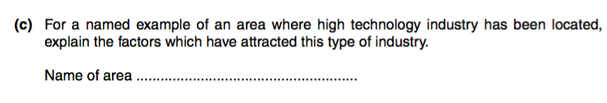

Outline how the factors affecting the location of industry can change over time (3 marks)
The iron and steel industry was once concentrated around the coalfields of the South Wales valleys due to
the need for large amounts of coal. It is now focused around the coast e.g. Port Talbot due to the fact that
many raw materials are imported. Even tertiary sector services are changing locations. Many town centres
have seen a decline as more shops are locating in out-of-town shopping centres.

What is meant by the term globalisation? (1 mark)
This refers to the idea that companies are becoming increasingly spread around the world and economies
are becoming linked e.g. as companies have a headquarters in one place and factories in other places
around the world.

Suggest reasons for the decline in the secondary sector in the UK (4 marks)
Lower wages abroad have led to increasing competition from abroad for manufacturing which has seen a
decline in the UK's secondary sector as production costs abroad are cheaper. More and more people are
also working in the tertiary sector which also helps to explain the decline in people working in the
secondary sector.

Choose a study you have made of the growth of the secondary sector in one LIC or MIC. Explain
the effects of this growth (7 marks)
China is now the world's third largest economy with its GNP tripling in just 10 years. However, there have
been a number of effects of this growth. On the one hand, the Chinese economy has seen a huge growth
over the last 20 years and exports and now exceeding imports leading to a healthy economy. However
there have been a number of negative effects. Due to the high levels of industry and burning of coal to
power the industries, cities such as Linfen are now highly polluted and China is the world leader in CO2
output. 80of China's rivers are below standard for fishing due to effluent from industries and in total there
are 760,000 deaths a year recorded due to water and air pollution. The lack of laws to protect workers has
also meant there is a widening gap between rich and poor and workers work long hours for very little pay,
often in hazardous conditions.

Explain how the development of new technologies and services has led to a growth in the
tertiary sector (4)
There has been a growth in the tertiary sector as there is an increasing demand for services due to
changing trends such as an increase in online banking and an increase in online shopping. This has led to
an increase in web design for example. As demands for new technologies grow, specialist shops have
grown as well with more mobile phone shops. There has also been an increase in call centres as the
importance of customer service continues to grow. All of these have led to growth in the tertiary sector.

Choose a study of the growth of the secondary sector in one LIC or MIC. Explain the reasons for
this growth (7)
China has seen a significant increase in its secondary sector with its GNP per Capita having nearly tripled
to $1,700 by 2005 in only 10 years. It is now the world's third largest economy. There are a number of
reasons for its growth. One it its location; being close to developing markets such as Taiwan and India and
on major trading routes means there is a market for good produced in China, stimulating the secondary
industry. China also has a wealth of natural resources such as coal, oil and gas to fuel its industrial
development. The growth of the secondary sector can also be explained by a large, cheap work force with
many moving from rural to urban areas looking for work. As government policy has changed, allowing
foreign investment into China, many companies have come in to take advantage of the low labour costs.
Globalisation and the internet have also facilitated this. There has also been a growth in private enterprise
in manufacturing, with 20 being privately owned whereas most used to be owned by the government.

3.4 Tourism

Objectives:
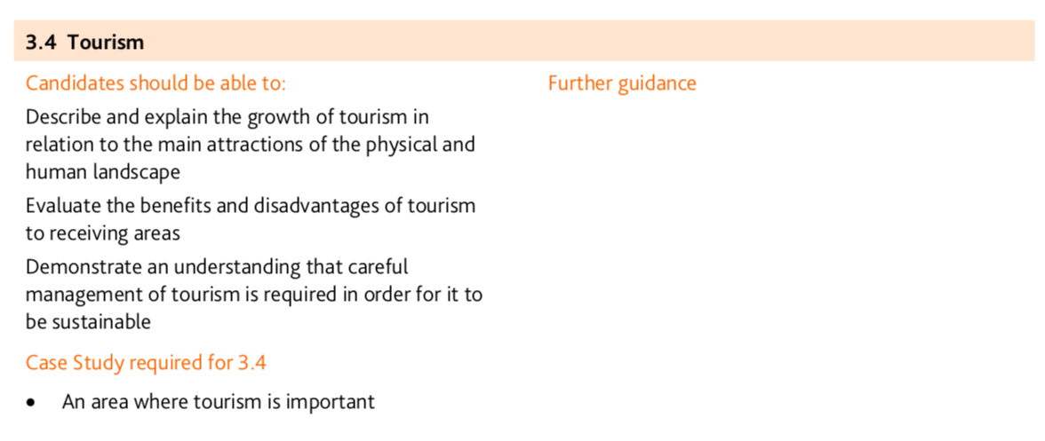
The growth of tourism

Tourism trends
Tourism is one of the world's fastest growing industries with the Middle East and Asia experiencing the biggest growth. Find out about the reasons behind these trends.

The growth of tourism
In 2010, 940 million people were recorded as arriving in a country from abroad because of tourism. This is worth $919 billion dollars, making tourism one of the world's largest industries.
Tourism is also one of the world's fastest-growing industries. In 2010, the Middle East and Asia had the greatest growth of tourists. Europe still has the greatest number of tourists - nearly 500 million in 2010.

The tourism industry therefore is very important to economic growth as well as the environment.
Tourism can help a country's economy and infrastructure. For example, it provides jobs. Some countries such as the Caribbean have tourism as their main source of income.

Reasons behind the trends in tourism
There are many factors that help explain the growth in tourism:
- More affluence - since 1950 people have become wealthier. There is more disposable income. People also now have paid time off work for holidays.
- Greater awareness - through advertising or television programmes people are more aware of how and where they can spend their free time.
- More car ownership - more families own a car. This gives greater freedom to choose when and where to spend time.
- Improvements in technology - travelling today is much quicker. Motorways and aircraft have helped reduce the time it takes to get to different countries. Travelling by air has become more accessible as you can book on line and choose more budget options.
- More leisure time - people have paid holidays from work (on average three weeks per year are paid). Also people who are retired remain active for longer. There is also a trend to take more than one holiday in a year.
- More choice - in the past seaside holidays and package holidays were the most popular. The industry is seeing more people look at ecotourism and more unusual holiday destinations.

Types of tourism
Tourists can be divided into different categories. This can be on the basis of which types of places they like to visit or the type of activities they like to be involved in.
- Beach holidays, e.g. in Spain and the Maldives. People can relax on the beach or take part in water sports.
- Outdoor adventure, e.g. skiing and walking in the European Alps or the Rocky Mountains of North America.
- Cultural/historic, e.g. people like to visit historic sites, art galleries and museums in cities such as Rome and Paris. In cities like New York and London they can go shopping or see shows.
- Ecotourism, e.g. small numbers of people go trekking in the Amazon rainforest or on whale and dolphin conservation holidays in Scotland. This type of tourism is designed to be sustainable tourism provides tourism opportunities for visitors and jobs for locals while protecting the environment and culture from damaging change. This means that in the future, people will continue to enjoy and benefit from them. A common slogan is "Take only photographs, leave only footprints".
Tourism attractions
Tourism contributes to a country’s economy but can have a negative impact if not properly managed. LEDCs can become especially dependent on tourism, which is risky if tourists suddenly stop coming.

The human and physical resources found in a particular place often influence tourism to a particular destination. Human resources are tourist attractions that have been made by people, such as the Eiffel Tower in France. Physical resources are the attractions that have been made by nature such as beaches or lakes.

Popular tourist activities
- According to a recent survey of British people travelling within the UK, the activity that people like to do the most while on holiday is walking. Walking allows people to enjoy the physical resources of the countryside such as hills, rivers and lakes.
- The second most popular activity was visiting heritage sites. This includes historical buildings and sites of historic significance. These are human resources.
- The third most popular activity was swimming. People like to swim at the beach or in lakes (physical resources) or swimming pools (human resources).
- Other popular activities were visiting art exhibitions, watching performing arts and visiting theme parks (all human resources).

Attractions in different countries
Types of man-made tourist attractions in the UK include:
- art galleries
- architecture
- cultural monuments
- museums
- local traditions
- food and drink
- music and drama
- important historical or political sites
The table below shows that tourists in the UK are attracted to many different types of man-made tourist attractions.

Examples of tourist attractions abroad
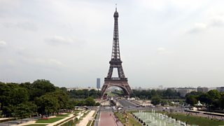
The Eiffel Tower, Paris
The Eiffel Tower in Paris is an example of a cultural monument and a place of architectural interest. As well as admiring it from ground level, tourists can go to the top and see a great view of Paris, including the River Seine (physical resource) and many beautiful buildings (human resources).
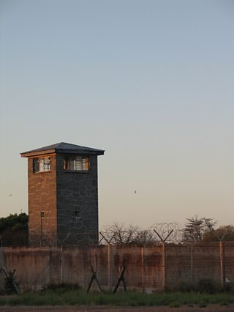
Guard Tower at Robben Island
Robben Island in South Africa is an example of a historical or political site. Many people who visit South Africa go to Robben Island to see where Nelson Mandela spent most of his 27 years in prison. People are interested because Nelson Mandela's struggle and sacrifice helped end Apartheid in South Africa.
Physical tourism attractions
Physical resources are the natural features of an area which might attract tourists, such as:
- the physical landscape - such as beaches, mountains, rivers, lakes and glaciers
- ecosystems - such as rainforest or tropical grasslands
- weather and climate - most tourists seem to like it warm and dry
Impacts of tourism

Advantages of tourism
- Tourism brings much needed investment into an area. If it is an LEDC, the foreign currency is very important to the local people.
- Tourism provides employment for many local people, ranging from working in the hotels to selling trinkets on the beach. Without the tourist industry some less developed countries would have a much greater unemployment problem.
- The money that tourism brings in can be used to improve the infrastructure of the area. New roads, airports and facilities can be built, which cater for the increasing number of tourists, but also benefit the local residents.
- Income from tourism may be used to help conserve the natural environment that is the reason why visitors come in the first place.
- The country can benefit from overseas investment, primarily in the tourist industry, but also in other related industries.
- Tourism may help to preserve local cultures and communities, as they become a tourist attraction. This is certainly the case with some Masai tribes in Kenya and Maori's in New Zealand. Both use the visitor's interest and curiosity in their culture to become a tourist attraction.

Disadvantages of tourism
- In many resorts in LEDC's very little of the money paid for the holiday actually reaches the country. The holiday company, travel agents, airlines and hotel companies swallow most of it.
- The jobs for the locals are often badly paid, with very poor working conditions.
- The huge number of tourists coming to see it could easily damage the environment. It is very easy for a country to see the short-term economic gains of mass tourism without really taking heed of the long-term environmental damage going on.
- Increasing numbers of tourists brings problems such as littering, pollution and footpath erosion. All of these take time and money to clear up.
- Overseas investment, in things like luxury hotels, can mean that the money goes back to the country of origin. These hotels may also take trade away from local guesthouses and hotels.
- Local cultures could be devalued by tourism. They may almost become a freak show, where the visitors begin to look down on the locals as different.

The benefits and disadvantages of tourism for receiving areas

Tourism in an LEDC: advantages and disadvantages
Countries rich in physical resources - such as warm climates, beautiful beaches, rare ecosystems, and abundant plant and animal life - are often sought-after holiday destinations by people from MEDCs. Tour operators and developers invest in these locations in the hope that they will become as popular as European resorts.
Places such as Kenya in East Africa, where tourists go on safari, or Bali in Indonesia, visited for its beautiful beaches, all benefit financially from tourism. However, tourism in LEDCs needs to be carefully managed to prevent harm to the environment and disruption to local communities.
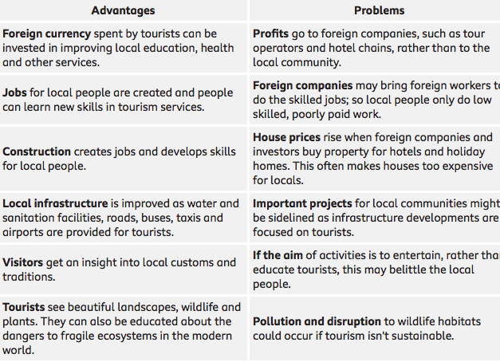

Tourism – case study Kenya

Tourism in LEDCs needs to be managed in order to prevent problems for the environment and communities of the host countries. Discover how conservation is managed in the Serengeti.

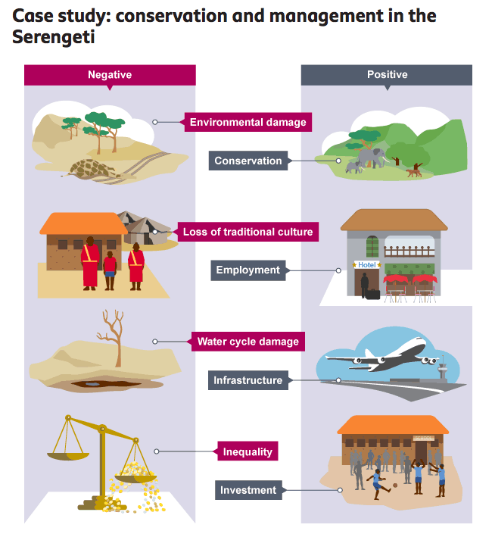

Tourism brings income to Kenya and gives tourists a greater understanding of the area's animals and plants. The Serengeti is especially popular for safari holidays, which give tourists a chance to observe the annual migration of the wildebeest and zebra.
Tourism can also have negative impacts on the area. These need to be managed carefully to ensure that the natural environment isn't damaged for future generations.

Positive impacts of tourism
- Conservation - tourism has supplied the economic incentive to set up national parks and conservation areas which protect wildlife.
- Employment - tourism has generated jobs, improving the living standards for local communities.
- Infrastructure - roads, airports and other facilities have been built.
- Investment profits from tourism have been invested in education and other programmes for local communities.

Negative impacts of tourism
- Environmental damage - roads and tracks for safari jeeps can erode grass cover, damaging plants and animals and disturbing local habitats. The removal of trees and other vegetation for the construction of roads can lead to soil erosion.
- Inequality - often the profits of tourism are reaped by wealthy landowners or the hotel and travel companies in MEDCs.
- Loss of traditional cultures - the Masai's way of life and traditional farming methods have been disrupted by the setting up of the Serengeti National Park.
- Water cycle damage - diverting water for tourists can exploit local water reserves, leaving local people, plants and animals short of water. Tourist hotels sometimes dump waste into rivers.

More Kenya notes from DVD:

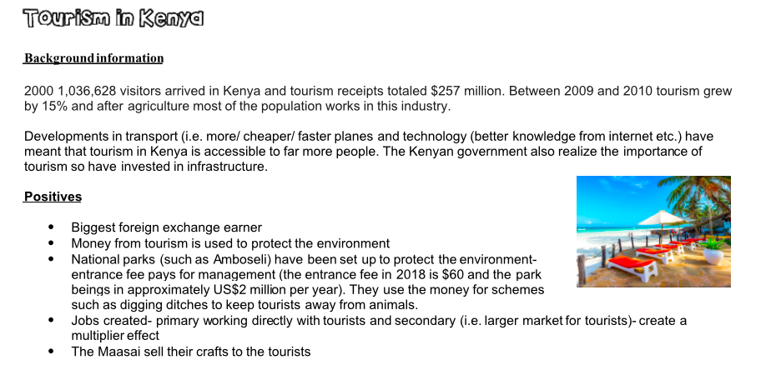

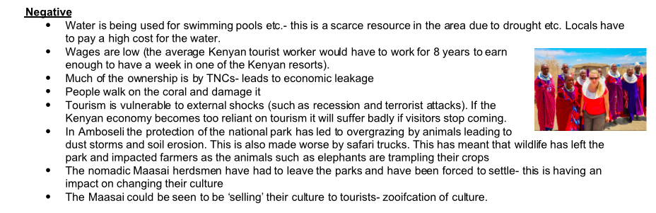

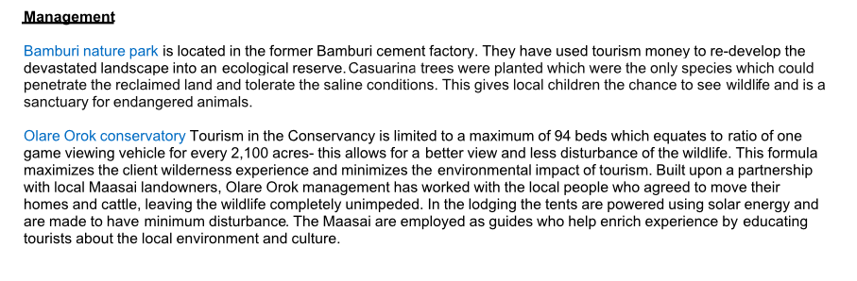
Sustainable management of tourism – eco-tourism

Ecotourism encourages visitors to a country to leave a small carbon footprint, to the benefit of local communities and environments. It has become an increasingly popular option for many people.

Ecotourism is a type of sustainable development. The aim of ecotourism is to reduce the impact that tourism has on naturally beautiful environments.
Any tourist destination can be harmed by increased levels of tourism. If areas are damaged or destroyed, they might not be available to future generations.

The ecotourism approach
- Ensuring that tourism does not exploit the natural environment or local communities.
- Consultation with local communities on planned developments.
- Making sure that infrastructure improvements benefit local people and not just tourists.
Ecotourism now has the backing of the United Nations, which made 2002 the International Year of Ecotourism.
Ecotourism encourages visitors to a country to leave a small carbon footprint, to the benefit of local communities and environments. It has become an increasingly popular option for many people.

Guidelines for ecotourists
Ecotourism sets out guidelines for how tourists should behave when visiting fragile environments:
- Protect the environment - keep to footpaths, don't leave litter or start fires.
- Don't interfere with wildlife - don't scare or feed the animals.
- Protect resources - don't take too many showers or use air conditioning.
- Support local communities - stay in locally owned accommodation and buy produce from local people.
- Eat local food and drink - avoid products that have been imported from MEDCs.
- Respect local customs and traditions - some communities are offended when tourists wear inappropriate clothes in religious places, strip off on the beach or behave in a rowdy manner. Locals appreciate tourists who try to learn the language and show an interest in their culture.
Ecotourism is increasingly popular and many people appreciate remote locations, small numbers of tourists and less sophisticated facilities. If a resort becomes overdeveloped then they will choose alternative destinations.
For a named area you have studied, describe the problems caused by tourism for local people and the local natural environment (7)
For a named area you have studied where tourism is important, explain how it is being managed in order for it to be sustainable. (7)
For a named example of an area you have studied, explain why the physical and human landscapes attract tourists. (7)
Explain how tourism can be managed so that the natural environment is not destroyed (7)
For a named area you have studied where tourism is important, explain how it has both positive and negative impacts on local people (7)

Explain why the growth of tourism in an area leads to the development of its infrastructure. (5)
Explain how the human landscape can attract tourists to an area. (5)
Explain how the tourist industry might cause problems for the local natural environment. (5)

3.5 Energy

Objectives:
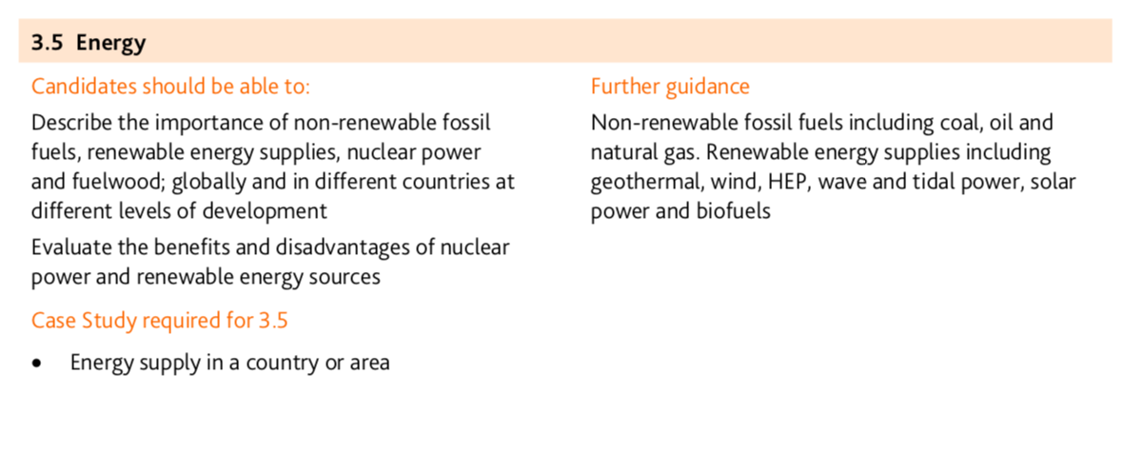
Energy

Fossil fuels are non-renewable and will one day run out, so scientists are exploring the potential of renewable sources of energy. Find out about changing energy use and alternative energy sources.

Renewable and non-renewable energy resources
All life on earth is sustained by energy from the sun. Plants and animals can store energy and some of this energy remains with them when they die. It is the remains of these ancient animals and plants that make up fossil fuels.
Fossil fuels are non-renewable because they will run out one day. Burning fossil fuels generates greenhouse gases and relying on them for energy generation is unsustainable. Hence the need to find more renewable, sustainable ways of generating energy. Renewable or infinite energy resources are sources of power that quickly replenish themselves and can be used again and again.
Some resources can be thought of as both renewable and non-renewable.
- Wood can be used for fuel and is renewable if trees are replanted.
- Biomass, which is material from living things, can be renewable if plants are replanted.

Type of fuel | Where it is from | Advantages | Disadvantages
Coal (fossil fuel) | Formed from fossilized plants and consists of carbon with organic and inorganic compounds. It is mined from seams of coal found between layers of rock in the earth. | Coal is a ready-made fuel which is cheap to mine and convert to electricity – it lasts longer than oil or gas. | When burned, coal gives off atmospheric pollutants, including greenhouse gases.
Oil (fossil fuel) | Carbon-based liquid formed from fossilized animals. Lakes of oil are found between seams of rock in the earth. | Oil is a ready-made fuel which is cheap to extract and convert into energy. It is used in industry and transport. | When burned, oil gives off atmospheric pollutants, including greenhouse gases. There is a limited supply of oil.
Natural gas (fossil fuel) | Methane and other gases trapped between seams of rock under the earth are released through pipes sunk into the ground. | Gas is a ready-made fuel and relatively cheap. It is used in houses for heating and cooking and is a slightly cleaner fuel than coal and oil. | When burned, it gives off atmospheric pollutants, including greenhouse gases. There is a limited supply of gas.
Nuclear | Radioactive minerals such as uranium are mined. Electricity is generated from the energy that is released when atoms from these minerals split. | A small amount of radioactive material produces a lot of energy, it’s relatively cheap and can last a long time. It doesn’t give off pollutants. | Nuclear reactors are expensive to run and nuclear waste is highly toxic. Leakage of nuclear materials can have a devastating impact on people and the environment.
Biomass | It is generated from decaying plant or animal waste, or organic material and can be burned to provide energy. | It is a cheap and readily available source of energy. If crops are replaced, it can be a long-term, sustainable energy source. | When burned, it gives off atmospheric pollutants, including greenhouse gases.
Wood | Obtained from felling trees, burned to generate heat and light. | A cheap and readily available source of energy. If trees are replaced, wood burning can be a long-term sustainable energy source. | When burned, it gives off atmospheric pollutants, including greenhouse gases.

How long will fossil fuels last?
Estimates from international organisations suggest that if the world's demand for energy from fossil fuels continues at the present rate that oil and gas reserves may run out within some of our lifetimes. Coal is expected to last longer.
Fossil fuel | Time left
Oil | 50 years
Natural gas | 70 years
Coal | 250 years

Fuel wood in LICs
Fuelwood is the most common source of energy for people living in LEDCs - it is estimated that about 40% of the world's population rely on fuelwood.
Fuelwood is often the main source of energy because countries either can't afford to buy raw materials to produce energy, don't have the technology or money to build and operate powers stations and certainly don't have a national grid to distribute energy.
​Fuelwood has multiple functions, it can be used for cooking, heating and scaring away wild animals.
​Although using fuelwood is essential for many people it can cause environmental and social problems such as eye disease and respiration problems. Environmental issues include depletion of trees which leads to soil erosion and desertification.

Case study Fuel wood : Mali, Africa, Sub-Saharan Africa (Sahel region)
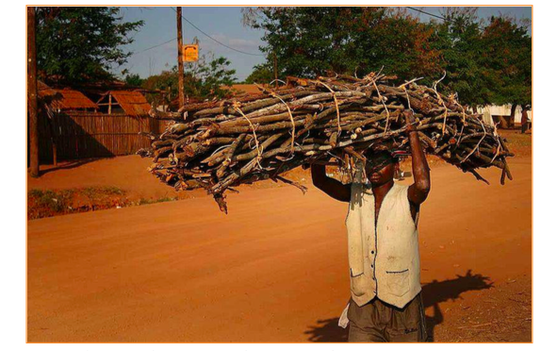
Facts:
- About 80% of the families in Mali use fuel wood and charcoal.
- 13 million of hectares were lost by 2005 but the country is losing around 100,000 hectares of forest a year for fuelwood, making it easier to wind and water to carry out soil erosion which would eventually make the area into a desert.
- Cheaper than other sources of energy cost $7 a bag of fuel wood for a whole month.
- No fossil fuels in the country.
- To deal with the problem, the government in 2011 launched a five-year programme to reduce dependence on fuel wood, in an attempt to protect the country against ongoing climate change and get rid of the air pollution generated by the smoke of the burning woods, with the help of other countries.

How it affects peoples lives
people in Mali are being affected by fuel wood in positive and negative ways:
Positive: People wouldn't be able to have any kind of energy as they don't have the money to pay the electricity builds, so they need a cheap kind of energy that also easy to acquire. people can use this kind of fuel to provide heat in cold nights and a fire to cook their food or any other basic need for living.
Negative: The negative aspects of this source of energy is that it causes lots of indoor pollution (air pollution inside houses), generating lots of lung problems to kids or even adults. people have to waste time going to cut down the trees from the forest and bringing them to their home, this affects their personal life as they have less time to do their homework, jobs, etc. also this kind of energy is a non-renewable energy meaning it can only be used once, so people will always have to cut down trees to get this kind of energy.

Energy supply in Iceland

66% from geothermal (Underground reservoirs of steam and hot water can be tapped to generate electricity or to heat and cool buildings directly) and 15% from HEP- the rest comes from fossil fuels but these need to be used for cars etc

Reykjavik, the capital of Iceland, has the largest district heating system across the globe, and 90 percent of all households in Iceland are connected to a district heating system. District heating is pipes under Reykjavik to heat homes, water and melt snow.

Advantages

Clean/ non polluting
Once set up- It’s also relatively inexpensive; savings from direct use can be as much as 80 percent over fossil fuels.
Creates an energy surplus- e is a proposal to construct a 600-mile power line between Iceland and the United Kingdom to export Iceland's abundant geothermal power. If countries like Iceland are able to successful export their supply of renewable energy to other regions throughout the world, then geothermal energy might prove to be a giant step toward mitigating global climate change.
geothermal energy can be generated consistently throughout the 24-hour day

Disadvantages

Expensive to set up power stations- Require high investments in machinery. Hellisheidi Power Station decided last October that a number of turbines will be added, along with 90MW – these amounts to $197 million. Construction of a plant & well drilling costs ~ €2-5 million per generated MW of electricity.
Power stations ugly
Confined to certain geographical locations
release of hydrogen sulfide, a gas that smells like rotten egg at low concentrations. Another concern is the disposal of some geothermal fluids, which may contain low levels of toxic materials.
If not done with adequate care enhanced geothermal systems can trigger earthquakes, thus severely affecting land stability & putting nearby areas at risk – potential threat to settlements.

Case study of changing energy use: The UK (notes from BBC Bitesize)
The UK government wants to reduce its carbon dioxide emissions. It also wants to increase the amount of energy which comes from renewable sources.
By 2020 European Union targets state that 20% of energy must come from renewable sources. Each member state of the EU may have a different target, as 20% is an average figure for the EU.
The UK has a target of 15% of its energy consumption being sourced from renewable energy. (In 2009 only 3% of energy came from renewable sources in the UK). Sweden has a target of nearly 50% whereas Malta has a target of 10%.
The EU also aims to reduce greenhouse gas emissions by 80-95% below 1990 levels by 2050.
There are two ways the energy use can change in the UK:
- Reducing the demand for energy
- Increasing the supply of renewable energy

Reducing energy demand
The demand for energy in the UK varies. This is because of:
- Economic factors: For example during the recession energy demand did not increase as predicted
- Seasonal factors: For example the demand for domestic energy over winter is greater than over the summer.
- Temporal factors: For example at night there is surplus energy on the national grid because demand is lower
Regulations have forced vehicles to become more energy-efficient and give off less atmospheric pollution. The government has also continued to increase fuel and road taxes. Even so, the use of transport is rising so fast that the amount of CO₂ given off by transport vehicles continues to rise.
There are also incentives to save energy – for example grants are available to help make a home more energy efficient. Find out more about energy efficient homes in the waste and pollution revision bite.

Renewable power

Wind
UK power companies are now investing hundreds of millions of pounds in renewable power. The greatest amount of renewable energy in the UK comes from wind generation. In 2010 the world’s largest offshore wind farm was opened in Thanet, on the Thames estuary.
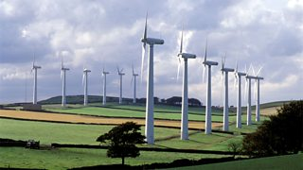
Wind Turbines on Ovenden Moor, West Yorkshire
Many wind farms have been set up, particularly in Scotland and Wales. However some plans for large wind farms have been blocked by planners.

Biomass
Production of energy from biomass is expanding. In 2011 a new biomass energy centre was opened in Chilton, Durham. The supply of energy for biomass is more predictable than other forms of renewable energy. However people are concerned about how sustainable the sourcing of biomass is.

Wave and tidal
Energy from wave and tidal power could be developed more.

Case study of energy in a country – The UK

The UK’s energy mix

Historically the UK used coal as this resource was in plentiful supply. Areas such as South Wales had large deposits and so coal powered power stations developed in this area (i.e. Aberthaw power station, Barry, South Wales). Coal went into decline as the resource became used up and there was an increasing awareness of the environmental damage it caused. The usage of coal has reduced from 80% 50 years ago to 38% today.
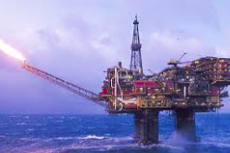
Today the energy mix in the UK is 28% natural gas, 38% coal, 21% nuclear, 11 % renewable and 2% other sources. Using a range of energy like this ensures the country is energy secure.

When gas was found in the North Sea this became a more popular source of energy in the UK. Now much of the resource has been used up so the UK mainly relies on imports.

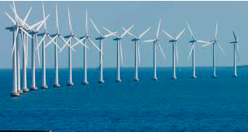
The UK has very good potential for wind power- it has an average wind speed of 9.7 mph. It also has a high population density so wind farms can be located near to demand. Scout Moore is the biggest onshore terminal on the Pennines. However, some days no wind is produced, therefore, a good energy mix is needed as backup. On a windy day, 20% of the energy in the UK can be produced by wind and this percentage is increasing. There have been demonstrations against wind farms being created as people are worried about the aesthetics and noise from them so more farms are being created offshore to reduce rejection. Groups of people who do not want developments built close to where they live are called NIMBYs (not in my back yard). Offshore plants are more efficient, but cost 2 times more to build.
The main benefits of wind turbines are that they reduce carbon emissions. Once the expensive cost of building them is recuperated they produce cheap energy.

Sleaford in the East of England is one of the 4 straw biomass power stations in the UK. This station uses straw, but wood or plant matter can be used to produce electricity. The station produces enough power to generate heat and electricity for 66,000 homes. At the Sleaford power plant, 240 lorries of straw are delivered each week as an input for the biomass energy. The power station processes are automated- head from the boiler produces steam which runs the turbine.
The benefit of biomass as a source of energy is that crop growth creates a carbon sink. The issue is that straw needs to be available locally as straw is a bulky input. The 4 straw-based power plants in the UK are based in the East of the country. They only produce 1/15 of the energy of a gas fired power station.

Government incentives to use solar power have meant that many solar panels have been put onto private roofs i.e. homes. The UK has good solar potential- 1500kw per square meter per year. The panels need to be south facing and are better in the south of the country, e.g. Dorset, where there is a higher sun intensity. There are fields covered in solar panels, but farming can be done around the panels. They need to be located in an area that is accessible for machinery and has connections to the grid. Like wind power, many people are against solar panels as they feel they are a visual eyesore (NIMBY). Another issue is that they can only be used on sunny days and not through the night.
Solar power makes up less than 1% of the global energy mix, but its use is increasing as it is cheap and easy to harness. Technology is improving for it to be utilized in less developed locations as an appropriate technology.

For a named country you have studied, describe the importance of different types of energy (7)
For a named country you have studied, explain how its energy is supplied (7)

3.6 Water
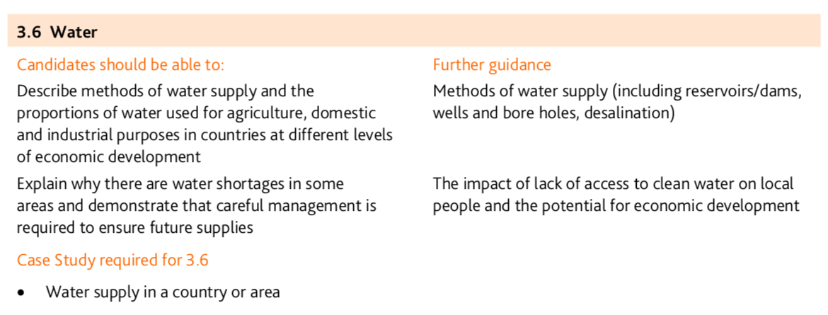
Methods of water supply:

Reservoirs/dams:Rivers transport water to the sea. Dams block rivers so that reservoirs of water build up behind, rather than drain away. This provides large supplies of drinking water all year round and reduces water insecurity, especially where precipitation may be seasonal. Dams and reservoirs can also prevent flooding, as the flow of the river is controlled, and they can generate electricity through hydroelectric power (HEP). There over 600 dams in Africa. The Akosombo dam in Ghana and the Aswan dam in Egypt are two of the largest.

Aquifers/boreholes: These are naturally occurring stores of water found under the ground. Water soaks down through soils and rocks via the pores spaces in them to collect under ground. People then extract the water by drilling boreholes or wells through the rock and brought up using buckets, pumps or pressure. This source of water is also known as ground water.

Desalination: It is not possible to drink seawater as it contains salt. Desalination plants remove the salt from seawater to make it safe to drink. Desalination plants could solve many of the world’s water insecurity issues, but the process is expensive and therefore not viable in some developing countries.

There are problems in supplying water in LEDCs. These are:
- lack of availability of clean water due to underdevelopment climate change causing drought and population increase
- diseases spread via the water supply
- Many children can’t go to school as they have to spend time collecting water
- water pollution

Case study of water supply in a country or area:
1. Appropriate technology in Mali- play pumps

As the merry-go-round spins, it pumps clean water up from deep underground and stores it in a huge tank. . It acts a pump taking water from the aquifer and pumping it to the surface.People are welcome to come and help themselves to the water.
In rural Africa, clean water is a luxury. Most people don’t have plumbing in their homes. Instead, they often must walk long distances to wells and haul heavy containers of water back. So far, more than 800 PlayPumps are operating in schools and communities in four African countries, providing water for almost two million people
The PlayPump can pump up to 370 gallons (1,400 liters) of clean water an hour It is appropriate technology as it is using local resources and can easily be installed and maintained.

2. Providing water in the Western USA- The Colorado River and Desalinization
The Colorado river is the only river in the Desert area of the Western USA, and 5 major cities (Las Vegas, Los Angeles, San Diego, Tucson and Phoenix), and 25 million people rely on the water from the river. A series of hard engineering- dams- have been used to manage the river. There are 20 dams that have been constructed along the Colorado river such as the Hoover Dam. Dams can also be used for energy to support growing cities like Las Vegas. Glen Canyon was flooded to create a new Dam and reservoir, Lake Powell. This caused the loss of a canyon and sacred native American sites. 720 million tonnes of water are lost per year from the Lake Powell by seeping into the rocks.
Growth in cities in Arizona meant that they wanted more water. The ‘All American Canal’ an irrigation canal transports 550km water from the Colorado river. Previously, the city of Phoenix had extracted water from an aquifer but climate change had meant the aquifer was no longer being recharged due to lack of rain the water table from the aquifer had dropped by 3m per year.
In California, which has suffered from drought due to climate change, the Carlsbad desalinization plant near San Diego produces 54 million gallons of water per day. It is produced through reverse osmosis where the output is 50% freshwater and 50% saltwater. The desalinization plant is the biggest user of energy in San Diego.

Describe how people can be provided with a reliable supply of safe drinking water. You should refer to an area or country which you have studied. [7]
Many areas have a shortage of water supplies. Describe the likely impacts of a water shortage on the people and development of a named area which you have studied. [7]

3.7 Environmental Risks of Economic Development

Objectives:
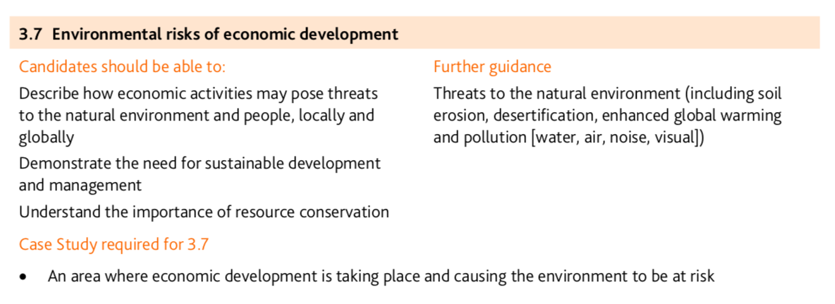

Threats to the natural environment:

1. Desertification/soil erosion
Desertification is the process by which productive land becomes dry and useless.

Causes of desertification:
- Desertification is triggered mainly by the overuse of land and unsustainable agricultural practices (over-cropping, overgrazing, poor irrigation and deforestation) which lead to a loss of natural vegetation and healthy soil.
- An expanding human population and urban living area as well as the low level of priority placed on environmental protection efforts also contributes.
- For more detail on the causes and impacts of desertification and soil erosion see Sahel case study in the Food Production topic

Solutions to desertification
- Great Green wall- Sahel. A line of Acacia trees have been grown along the whole length of the Sahel in Africa. These trees bind the soil, add nutrients to the soil and the trees act as cover from wind erosion etc. This has helped with food production in the area
- Educating farmers on sustainable farming practices to manage the soil and not over use it
- Conservation of water i.e., in California. Having restrictions on water use i.e., limit filling pools and using plants that are suited to the environment that limit water use (xeriscaping)

Suggest ways in which both economic activities and natural processes may have caused soil erosion (5)

2. Global Warming:

The enhanced greenhouse effect

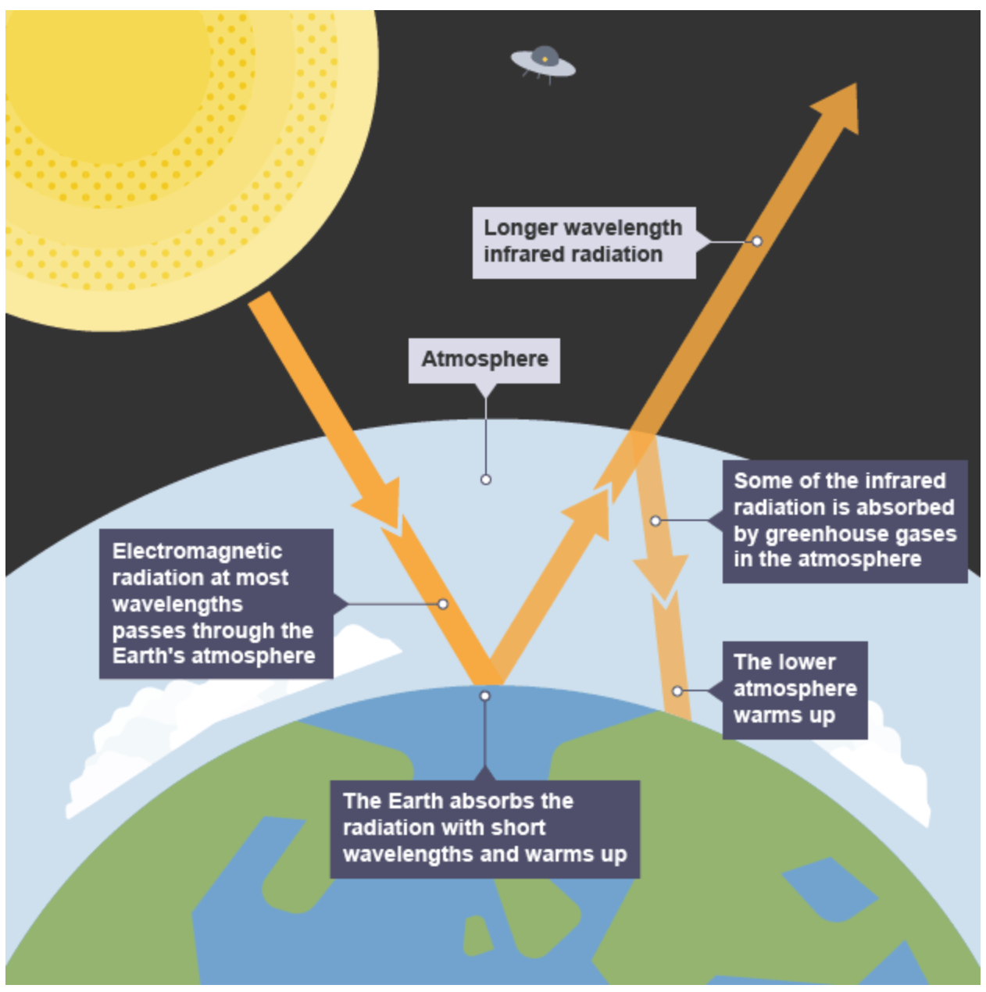
The greenhouse effect is the name given to the natural process that causes the Earth to be warmer than it would be in the absence of an atmosphere. Greenhouse gases are produced naturally and trap heat in the Earth’s atmosphere, like a blanket. Global warming is attributed to the enhanced greenhouse effect. This is caused by the increased concentration and effect of greenhouse gases, such as carbon dioxide, methane and fluorocarbons. When fossil fuels are burned in power stations, vehicles, industry or homes, greenhouse gases enter the atmosphere. Although these gases have always been present in the world's atmosphere their concentration is increasing as more and more fossil fuels are burned. Increasing greenhouse gases absorb more of solar radiation that is reflected back from the Earth's surface, trapping heat and keeping it in the atmosphere.
Causes:

Physical causes
- Variations in solar energy - sunspot activity raises global temperature.
- Volcanic eruptions - large quantities of volcanic dust in the atmosphere shield the Earth from incoming insolation, lowering global temperature. For example, the eruption of Mount Pinatubo in 1991 caused a dip in global temperatures.
- Alternatively, some scientists would argue that large eruptions could exacerbate the green house effect and lead to global warming.
- Milankovitch cycles or variations in the tilt and/or orbit of the Earth around the Sun (Wobble, roll and stretch theory).
- Changing oceanic circulation such as the periodic warming (El Nino) and cooling (La Nina) of areas of the tropical Pacific Ocean.
- Melting permafrost releasing large quantities of methane gas.
Human causes
The human causes of global warming have been in the news a lot in recent years and continued to cause much controversy. Developed countries currently use more energy, burn more fossil fuels and give off more greenhouse gases than developing countries.
Developing countries want to catch up with developed countries and this normally means using more energy and burning more fuel. Many of the human factors below are the result of growing population and economic development.
- The burning of fossil fuels for transport, industry and power, producing carbon dioxide.
- Worldwide deforestation, sometimes involving rainforest burning, which also produces carbon dioxide.
- Car exhausts and nitrogen fertilisers, producing nitrous oxide.
- CFCs found in fridges, air conditioning and aerosols and as a bi-product of the production of polystyrene packaging, like pizza and burger boxes.
- Methane, produced from rice fields, landfill sites and from both ends of cattle.
- Increasing industrialisation leading to air pollution.
- Traffic pollution.
- Rubbish dumps.

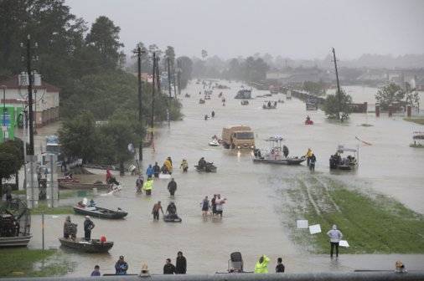
The threats/ impacts of global warming
Hurricane Harvey, Houston
Human‐induced climate change continues to warm the oceans. The resulting environment, including higher ocean heat content and sea surface temperatures, invigorates tropical cyclones to make them more intense, bigger, and longer lasting and greatly increases their flooding rains. In 2017 there were 17 named storms and 10 hurricanes, 6 of which were categorized as “major.”
The effects of Hurricane Harvey:
- The most expensive in U.S. history at over $190 billion, surpassing Hurricane Katrina.
- Harvey has also swamped one-third of oil refining capacity of the US. It could be weeks before refineries return to full operation. This has caused huge concerns about fuel supplies. Prices for refined products like gasoline have jumped.
- Death toll more than 60
- 1 million cars lost
- 50,000 homes destroyed
- 150,000 homes damaged

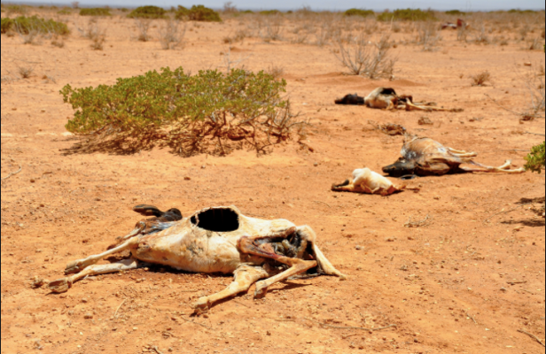
Drought in the Sahel
In the Sahel, droughts are becoming more and more intense. Temperatures are rising 1.5 times faster than in the rest of the world. In the Sahel more than elsewhere, these natural disasters are degrading the natural resources that are essential to the agropastoral livelihoods that underpin the economy in much of the area. Two out of three people in the Sahel countries live from agriculture and livestock. Under the combined effect of drought and floods, land is deteriorating and losing its fertility. Insufficient rain-fed irrigation means that crops fail or are destroyed, while livestock struggle to find water for drinking and sufficient pasture. Agricultural yields will fall by 20% per decade by the end of the 21st century in some areas of the Sahel.

Flooding in Bangladesh
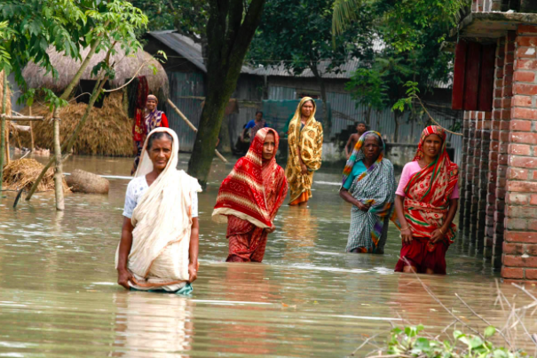
Bangladesh is an LEDC. It is one of the most densely populated countries in the world. Most of the land forms a delta from three main rivers - Ganges, Brahmaputra and Meghna. Twenty-five per cent of Bangladesh is less than 1 metre above sea level. Flooding is an annual event as the rivers burst their banks. Bangladesh also experiences many tropical cyclones, such as tropical Alia in 2009. The tropical storms are getting worse due to climate change and travelling further inland causing more damage. The low-lying land means it is easily flooded from the coastal waters. Glacial flooding in the Himalayas is increasing to the flooding risk in Bangladesh.
The flooding reduces the productive agricultural land and force more of the rural population to move to Dhaka increasing overpopulation issues in the city.

Sea level rise in the Sundarbans, Bangladesh
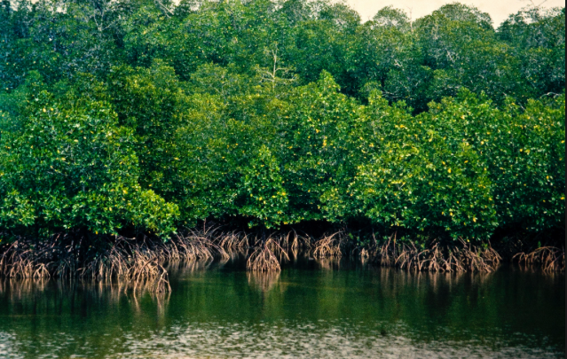
Sundarbans is the world’s largest contiguous mangrove forest and is a designated world heritage site. Shared by India and Bangladesh, it is home to several species including tigers. The habitat supports approximately 4.37 million people. As per the research conducted it is believed that the Sundarbans have soaked in 4.15 crore tonnes of carbon dioxide.

Due to climate change the Sundarbans faces several challenges. With rising sea levels, islands are disappearing and the increasing salinity in the water and soil has severely threatened the health of mangrove forests and the quality of soil and crops. Additionally, there have been serious disturbances to hydrological parameters and change in fishing patterns, resulting in disastrous consequences for fishermen. Frequent cyclones and erratic monsoon raining pattern are damaging ecology and humanity.

Coral reef bleaching
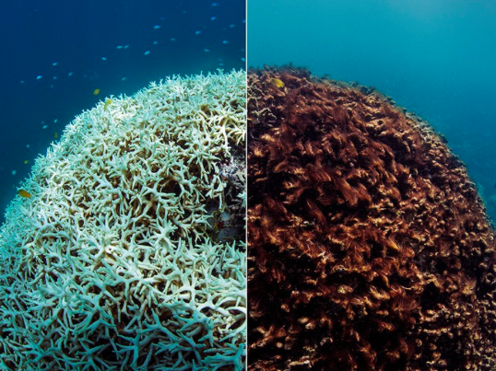
One of the most vulnerable ecosystems in Australia is the Great Barrier Reef. This tropical reef ecosystem is located in the north-east of Australia, and it is now affected by a disease known as coral bleaching. This condition occurs when the temperature of the seawater rises by over one degree more than average. As a result, the coral turns white, photosynthesis ceases and the coral often dies due to disease.

Explain why global warming is a threat to the natural environment (7)

3. Pollution (air, water and noise):

Sources of pollution
The increasing human population has led to an increase in pollution. Some of this is due to:
- more fossil fuels being burnt for heat and power
- more food being grown
- land taken over for industry and housing

Industrial pollution
Any large-scale economic activity may have a negative impact on the natural environment. Manufacturing industries in particular can cause air, water and noise pollution. Industrial pollution can affect the environment in a number of ways:
- It may damage the wellbeing of humans and other species. For example, industrial waste can pollute drinking-water supplies or poison plants and animals.
- It may interfere with natural processes. For example, industrial waste could change local climatic conditions or destroy wildlife habitats.
- It may impact on people's livelihoods. For example, pollution of the sea will affect people who are involved in the fishing and tourism industries.
Some governments have introduced legislation to try to cut down on avoidable pollution and to encourage industries that are more sustainable.

Case Study – An area where economic development is taking place and causing the environment to be at risk)

Risks- use either Bangladesh and textile Manufacturing case study, Development in the Borneo rainforest, or Tourism in Kenya

Management- Tourism in Kenya/ Management in the Borneo rainforest

- Name an area which you have studied and state an economic activity which is causing the environment to be at risk and explain the risks it is causing (7)

- For an example of an economic activity in a named area you have studied, describe how the threats to the natural environment are being managed (7)

