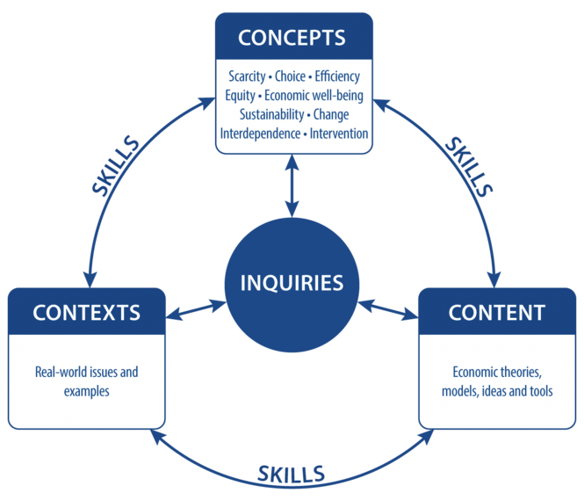

IB Inquiry Title: WHY DO ELASTICITIES MATTER?

IB Concepts:

Scarcity-Choice-Efficiency-equity-Economic well-being

Sustainability - Change-Interdependence-Intervention

IB Content:

Economic theories, models, ideas and tools

Contexts:

Real world issues and examples

Outcome:

Design an infographic to illustrate

different applications of elasticity

Concepts

Change – economic well-being - equity

Context

Firms production decisions, Government taxation efficiency, challenges of primary commodity markets

Inquiry

Content

PED, PES, YED

Determinants, calculations