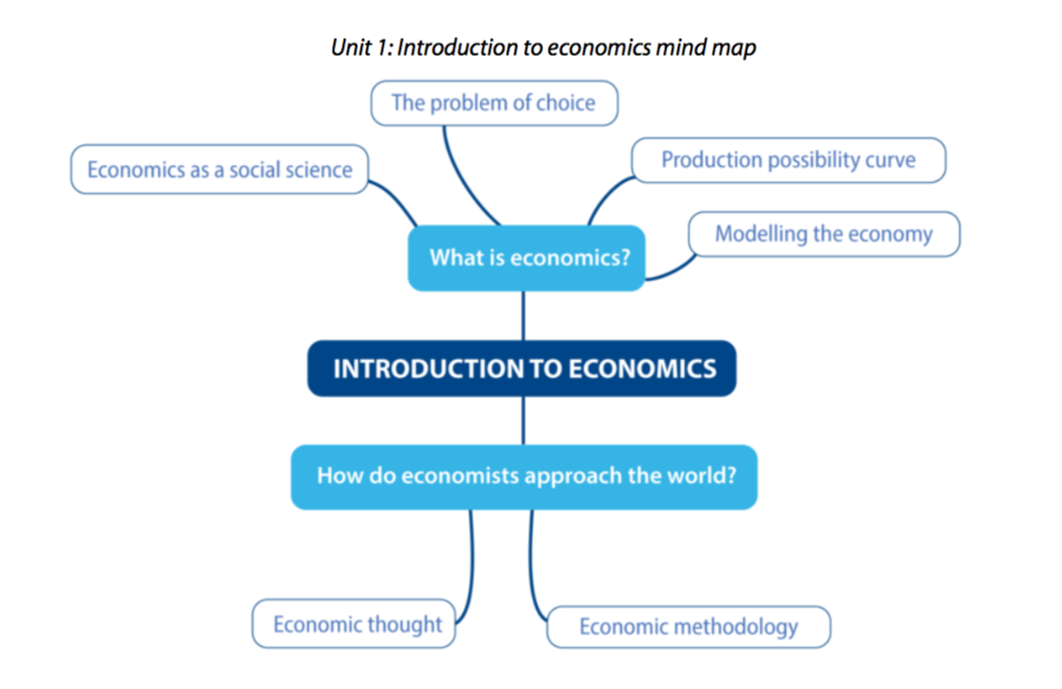
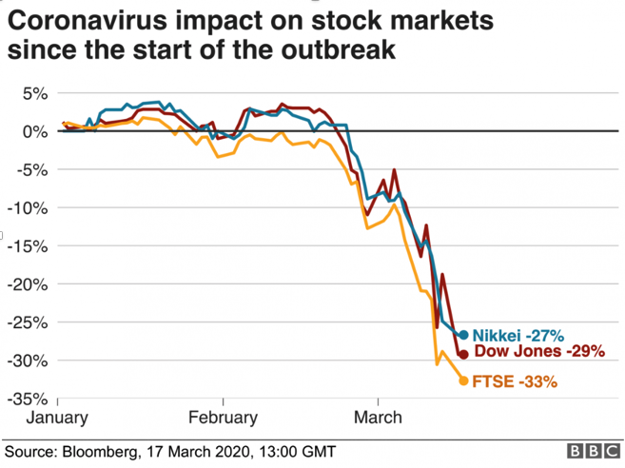
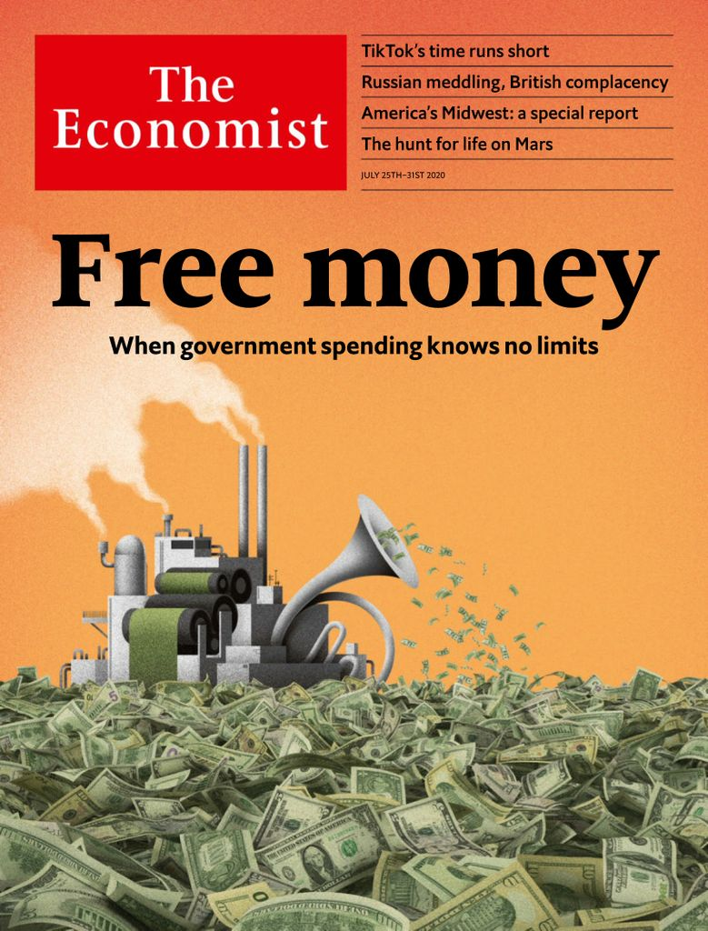
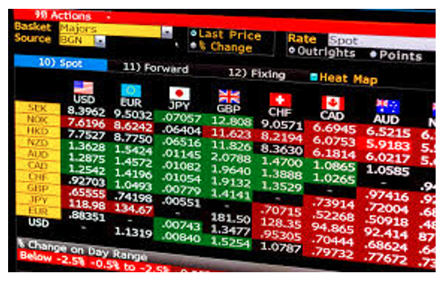
IB Economics at BIS Houston

IB Economics

- Economics is a particularly rigorous and respected post-16 choice
- It is looked upon very favorably for the academic challenge it provides
- It utilizes social and economic theories to understand individuals and societies
- The course is divided into 4 units and these follow on from those that are studied at iGCSE. However, many of our students have not studied Economics prior to IB
- There are a total of 41 students studying Economics at IB level

UNIT 1:

Introduction

to Economics
4 of our 5 Oxford Students and Oxford Alumni studied IB Economics at BISH.
Students aspiring to go into careers in business, finance, banking, accountancy and law will find that IB Economics will set them in the right direction
Students wishing to study Economics at university will find it gives them a competitive
In the past 3 Years, 20 students have gone on to study Economics at university; including the Universities of Oxford, UCLA Berkeley, Toronto, Houston and NYU

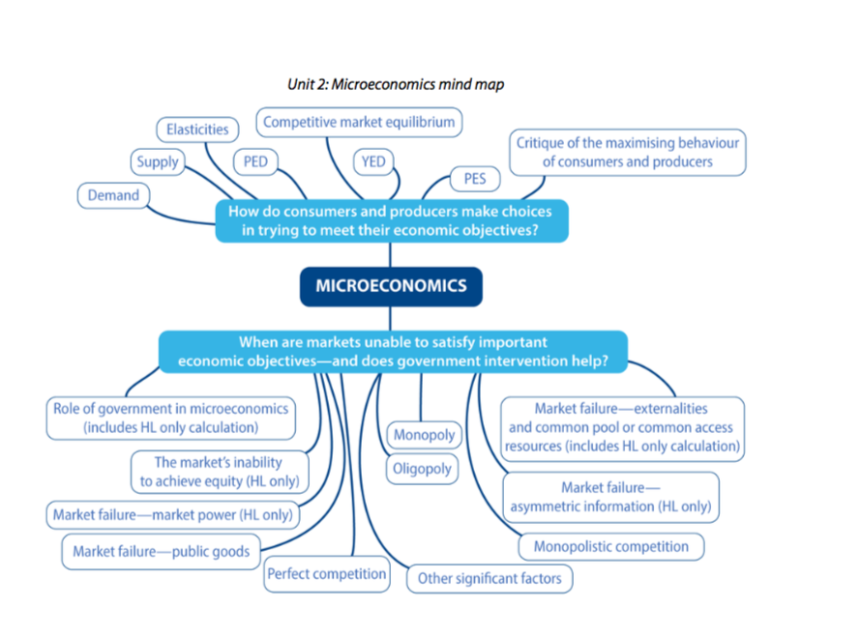  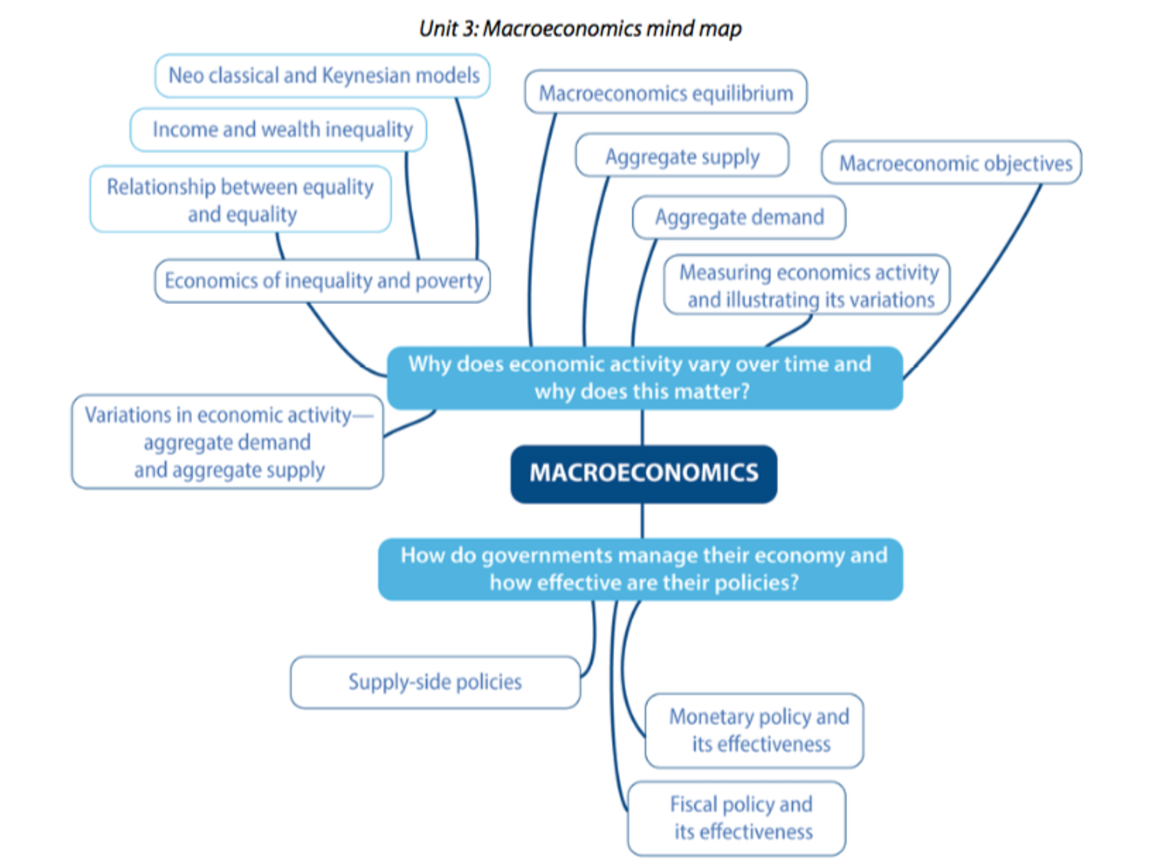  2019 Student outcomes:  100% of students achieved grades 4-7  31% Students Grade 7  - 7 students (31% students) achieved grade 7 in Economics  - World Average 12%  - BISH Ave 5.6 |  | UNIT 2:  Microeconomics  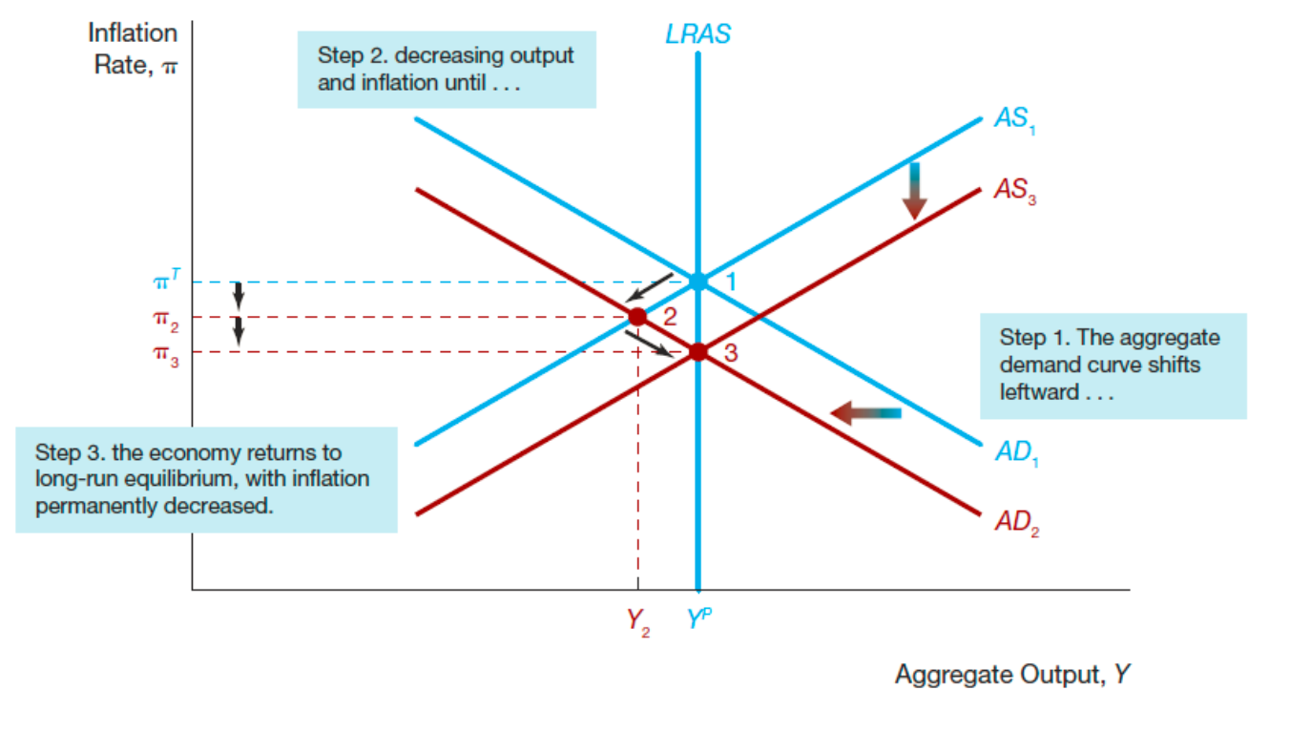  UNIT 3: Macroeconomics
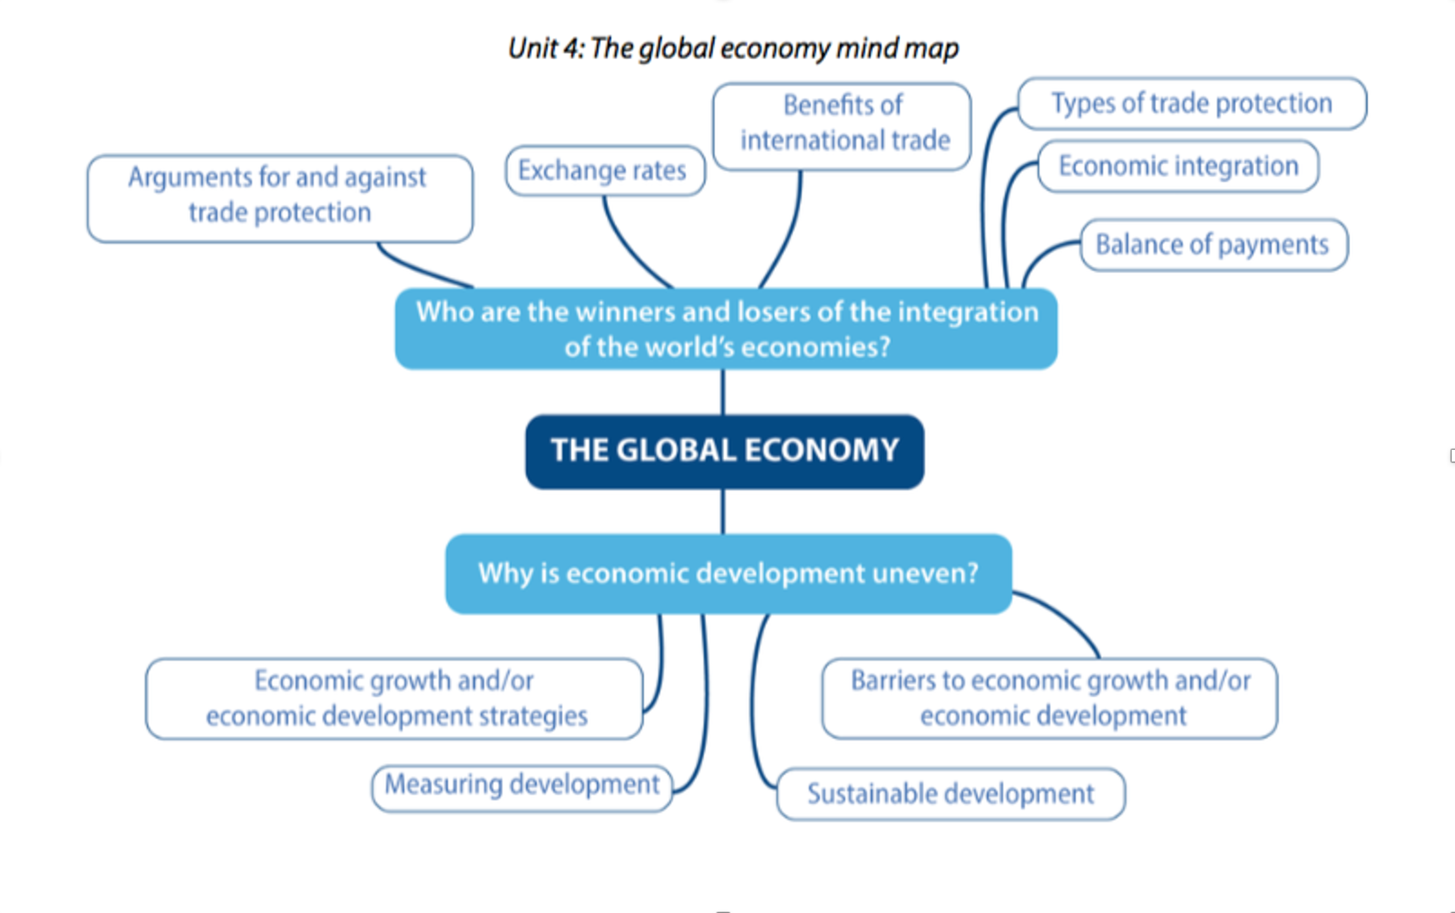 |  | UNIT 4: The Global Economy  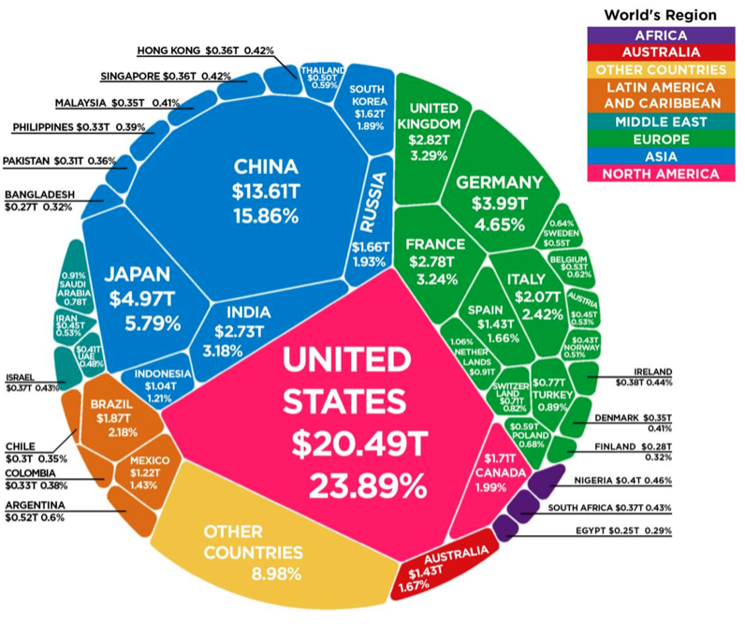
 |  | Reasons to study Economics

