IB Economics ‘Give Me 5’™
Revision
Booklet

IB Economics ‘Give Me Five’ – Microeconomics SL

Non-Price Determinants of Demand
- Price of the good or service
- Advertising and marketing
- The quantity of disposable income
- Tastes and preferences
- Price of substitutes and/or compliments

Non-Price Determinants of Supply
- Changes in the costs of production
- Changes of the number of firms in the market
- Changes in indirect texts
- Technological changes
- Changes in subsidy levels given to firms

Price Mechanism
- When the increase in supply occurs a marginal decrease in demand will occur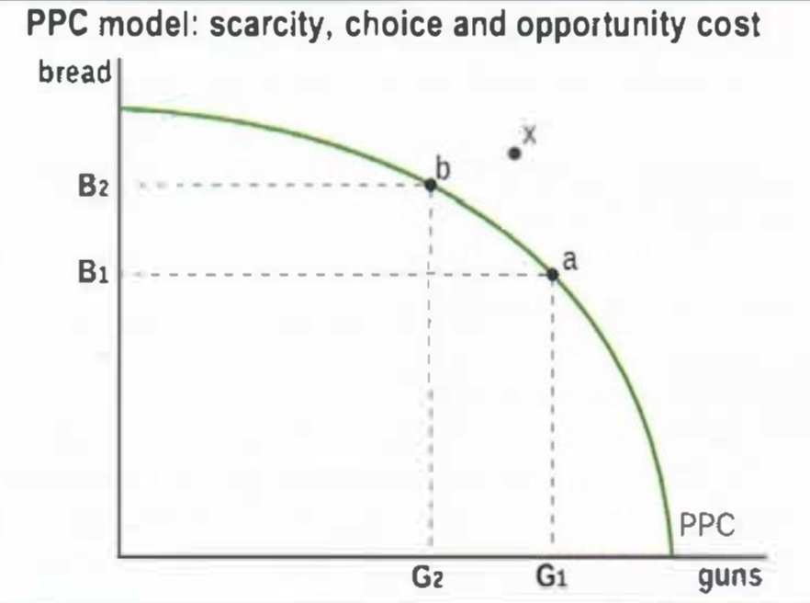
- Resource allocation allows for the assigning of specific resources for the production of a specific good or service
- Scarcity means production cannot occur outside the PPC
- Opportunity cost is the cost of producing one good over another good within a market

Market Efficiency
- Consumer surplus is the benefits received by consumers when they purchase a good at a lower price than they were willing to pay 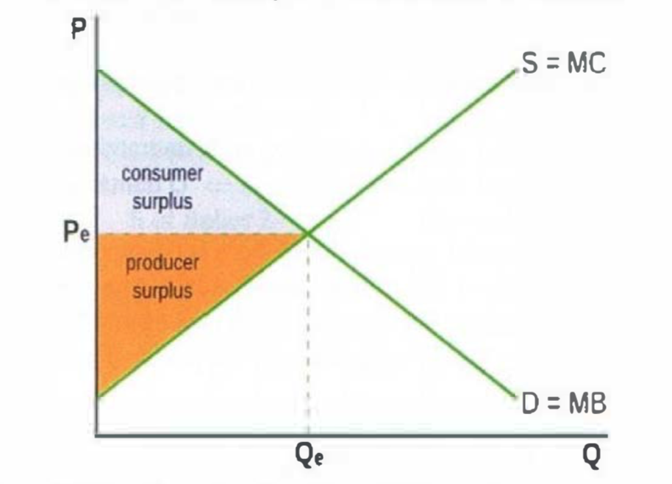
- Producer surplus is the benefits received by producers when they sell a good at a higher price than they were willing and able
- In a free competitive market, both consumer and producer surplus are maximized
- Social surplus is the product of consumer and producer surplus
- Allocative efficiency is reached when MB = MC, at the market equilibrium

Price Elasticity of Demand
1. Formula: %quantity demanded%price
2. A measure of the responsiveness of the quantity of a good demanded to changes in its price.
3. The value is treated as positive even though irl its negative (smh)
4. Percentages are used for two reasons:
- A measure of responsiveness should be independent of the quantity
- It is meaningless to think of changes in price or quantity (e.g. $15) because it tells us nothing about the relative size of the change.
Value of PED | Classification | Interpretation
0<PED<1 | Inelastic Demand | Quantity demanded is relatively unresponsive to price
1<PED<∞ | Elastic Demand | Quantity demanded is relatively responsive to price
PED=1 | Unitary elastic demand | Percentage change in quantity demanded equals percentage change in price
PED=0 | Perfectly inelastic demand | Quantity demanded is completely unresponsive to price
PED=∞ | Perfectly elastic demand | Quantity demanded is infinitely responsive to price

Determinants of PED
- Number of close substitutes to the good or service
- Degree of necessity of the good or service
- Proportion of income spent on the good or service
- Time the good is available for

Applications of PED
- PED and total revenue
- Production of commodities by the FOP land
- Indirect taxes

Cross-Price Elasticity of Demand
1. Measure of the responsiveness of demand for one good to a change in the price of another good.
2. Formula: % quantity demanded of Good X% in price of Good Y
3. Positive when price of good Y increases and quantity demanded of good X increases (ie. they are positively proportional) - this means they are substitutes
4. Negative when price of good Y increases and quantity demanded of good X decreases (ie. they are negatively proportional) - this means they are complements
5. Zero XED - unrelated goods

Income Elasticity of Demand
1. $\frac{\%∆QD}{\%∆Y}$
2. Measures the responsiveness of the quantity demanded of a good, to a change in income of consumers
3.
Value of PES | Classification | Interpretation
YED<0 | Inferior Good | Quantity demanded decreases as income increases
0<YED<1 | Necessity | Quantity demanded increases slightly with increased income
YED>1 | Luxury Good | Quantity demanded increases greatly with increased income
4. Impact on producers: as wages grow, demand increases more for luxury goods than for necessities.
5. Impact on the economy: Agricultural sectors are necessities (0<YED<1), so it develops slower than the economy, so the economy shifts more towards the manufacturing sector

Price Elasticity of Supply
- Formula: $\frac{\%∆QS}{\%∆P}$
- Measures the responsiveness of the quantity supplied by a company when a change in price occurs
Value of PES | Classification | Interpretation
0<PES<1 | Inelastic Supply | Quantity supply is relatively unresponsive to price
1<PES<∞ | Elastic Supply | Quantity supply is relatively responsive to price
PES=1 | Unitary elastic supply | Percentage change in quantity supply equals percentage change in price
PES=0 | Perfectly inelastic supply | Quantity supply is completely unresponsive to price
PES=∞ | Perfectly elastic supply | Quantity supply is infinitely responsive to price

4. Measure of responsiveness should be independent of quantity supplied

Why governments impose Indirect Taxes (taxes on spending to buy particular goods and services, paid indirectly to the government by the seller)
- Gain revenue for gov. expenditure
- Improve allocation of resources during negative externalities
- Decrease consumption of socially harmful demerit goods
- Reduce quantity of imports into a country
- Can redistribute income

Impacts of indirect taxes on stakeholders and market outcomes
- Equilibrium quantity falls
- Prices for consumers increase (consumers lose, higher price and lower quantity)
- New price received by producer is lower (producers lose, lower price and lower quantity)
- Workers lose as less is produced and some could lose jobs
- Governments gain tax revenue
- Society loses as resource misallocation occurs

Why governments impose subsidies (payment by the government to firms in order to lower costs and price, and increase supply)
- Help increase revenues and thereby incomes of struggling industries
- Make goods affordable to low-income consumers
- Encourage production and consumption of socially desirable goods
- Support growth of specific industries
- Encourage exports of a specific good
- Improve resource allocation of positive externalities

Impacts of subsidies on stakeholders and market outcomes
- New equilibrium quantity is higher
- Prices paid by consumers are lower
- Prices received by producer is higher
- Consumers and producers gain
- Workers gain as production increases and jobs form
- Government loses as they spend government revenue
- Society loses due to:
  - Resource misallocation
  - Opportunity costs from gov. expenditure
  - high-cost/inefficient producers in the industry are protected

Price controls (government intervention in the market involving the setting of price ceilings (maximum prices) or price floors (minimum prices),thus preventing the market from reaching a market-clearing equilibrium price.)

Price floor (a minimum price on a good set by the government that is above the equilibrium rice of the market, resulting in a surplus)
- Supports producers incomes
- Support wages of low-skilled workers
- Creates surpluses in the market
- Allows inefficient firms to survive and not try to cut costs
- Governments have to buy the excess supply, which creates opportunity costs

Price floors consequences on stakeholders
- Consumers lose as they are paying a higher price for a lower quantity
- Producers gain as they receive a higher price for a larger quantity
- Workers gain because more output is produced and therefore there are more jobs
- The government loses as they have to pay to purchase the excess supply and thus create opportunity costs
- Other countries lose if the good is exported as it contributes to lowering global prices and increasing global supply, thus harming foreign producers (especially in the case of agricultural price floors)

Price ceiling (a maximum Price on a good set by the government that is below the equilibrium price of the market, resulting in a shortage)
- Makes necessities more affordable to low-income consumers
- Shortages as equilibrium remains the same but the price falls, thus producers supply less and consumers demand more
- Non-price rationing mechanisms - Since price no longer fulfills its signaling and incentive functions, methods other than price are needed to ration (= distribute) the good to buyers, such as waiting lines, first-come first-served, favoritism (ex selling the good to friends)
- underground/parallel markets emerge as people are dissatisfied at the new price
- Welfare loss due to resource under allocation

Price ceiling consequences on stakeholders
- Consumers who are able to by the good at the lower price gain
- Other consumers lose as they cannot consume the quantity of the good demanded
- Some workers lose jobs due to lower production quantities
- Producers lose as they sell lower quantities at a lower price
- Government won't gain or lose economically but may gain political popularity

Minimum wages (a minimum price of labor usually set by the government to protect low-skilled workers and ensure they can achieve a minimum standard of consumption; it is an application of a minimum price in the labor market)
- Some workers may accept to work illegally for wages below the legal minimum
- The minimum wage prevents efficient allocation of labor resources as it disrupts the signalling and incentive functions of the labor price
- Misallocation of resources in product markets as firms who employ low-skilled workers receive higher costs of production
- Workers who receive the minimum wage benefit, but many lose as there are less jobs (due to firms being willing to employ less at the higher price)
- Firms who hire low-skilled workers lose as they have to pay more
- Higher costs of production for specific firms creates a leftward shift in the supply curve of their product, leading to higher prices and lower quantity for consumers

Allocative inefficiency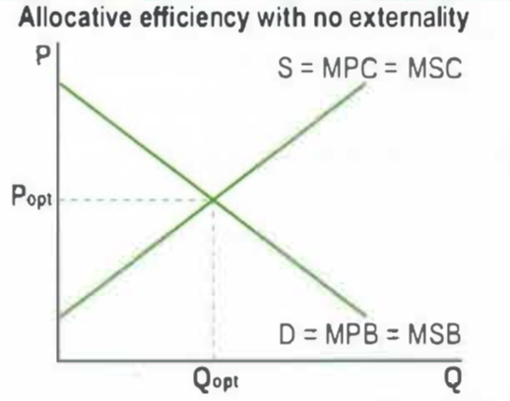
- Market failure which is the failure of the market to allocate goods. This results in over or under allocation of resources
- Marginal Private Benefits is the additional benefits for consumers arising from an additional unit of a good
- Marginal Social Benefits are additional benefits to society from the consumption of an additional good
- Marginal Private Costs are additional costs to producers from the production of an additional good
- Marginal Social Costs are additional costs to society from the additional production of a good

Positive Externalities of production
- Marginal Social Costs < Marginal Private Costs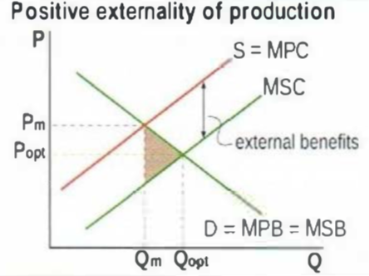
- Marginal Private Benefits = Marginal Social Benefits
- Welfare loss is created in the brown triangle
- Underallocation of resources, therefore: Qm = Qopt
- Research by private firms leads to development of new technologies
- benefit the whole of society
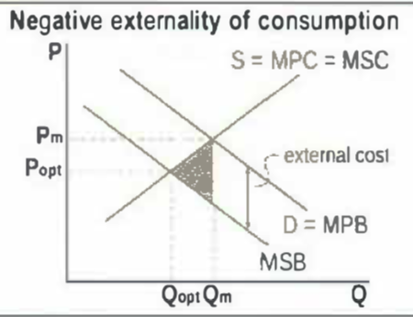
Negative Externalities of consumption
- Marginal Social Benefits < Marginal Private Benefits
- Marginal Private Costs = Marginal Social Costs
- Overallocation of resources, therefore: Qm > Qopt
- Welfare loss created in the brown triangle
- Production of goods by use of fossil fuels leading to carbon emissions, hence there are external costs including pollution of clean air
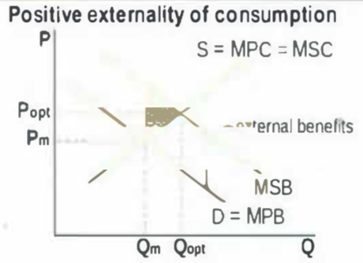
Positive Externalities consumption
- Marginal Social Benefit > Marginal Private Benefits
- Marginal Private Costs = Marginal Social Costs
- Underallocation of resources, therefore:Qm < Qopt
- Deadweight loss created in the brown triangle
- Consumption of education leads to benefits for society including lower unemployment

Negative Externalities production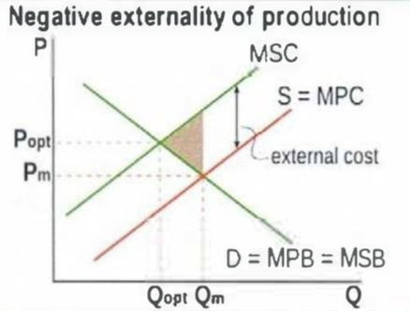
- Marginal Social Costs > Marginal Private Costs
- Marginal Private Benefits = Marginal Social Benefits
- Underallocation of resources, therefore: Qm = Qopt
- Deadweight loss
- Fossil fuels leading to carbon emissions
- Indirect taxation

Lack of public goods
- Private good: Rivalrous (use of it makes it less available for use by others) and excludable (people can be prevented by charging a price for it).
- Public good: Non rivalrous (the use of it does not make it less available for others) and non excludable (not possible to charge a price)
- Free rider problem occurs when people use a good without paying for it
- Public goods are a type of failure due to the fact that the market fails to provide them
- Public goods are provided by the government through tax revenue

Common access resources
- They are non excludable
- They are normally natural resources that aren't owned by anyone
- They are rivalrous
- They do not have have a price
- They are subject to overuse and therefore extreme depletion of the resource

IB Economics ‘Give Me Five’ – Microeconomics HL

Definitions and key terms in bold

Micro
Elasticity
- Tax incidence (tax burden) changes with elasticity
- If PES < PED, incidence is greater on producers
- If PES > PED incidence of tax is greater on consumers

Government Intervention
- Welfare loss (deadweight loss) is the benefits lost by society because of resource misallocation
- Tax incidence is the particular group bearing the burden of a tax (group paying all or a portion of a tax)

Market Failure
- Asymmetric information is a type of market failure occurring when one party to a transaction has more information than the other party, leading to allocative inefficiency
- Abuse of monopoly power
- Monopoly power is the ability of a firm to influence the price of the good that it produces and sells; it is a type of market failure because it results in an under allocation of resources to the production of the good in question, and hence in allocative inefficiency and welfare loss
- Monopoly power is associated with all market structures excluding perfect competition (mainly monopoly and oligopoly)
- Monopoly power leads to:
  - Allocative inefficiency (P > MC)
  - Higher prices and lower quantities than in a competitive market
  - Productive inefficiency (production at higher than minimum AC)
  - Welfare loss

Government responses to monopoly power
- Legislation
  - Anti-monopoly laws intended to prevent the formation of monopolies or to break up monopolies
- Gov’t regulation
- Nationalization (the transfer of ownership form the private to the public sector, as an alternative to regulation to natural monopolies)
- Trade liberalization (removal of barriers to trade, resulting in larger quantities of imports entering a country, which creates competition for existing firms that must compete with products from abroad)

Theory of the Firm (HL)
Production and Costs
Definitions in Productions and Costs
- Short run is the period of time when at least one factor of production (FOP) is fixed and all other factors are variable
- Long run is the period of time when all FOPs are variable; no fixed factors
- Variability in the FOP is the ability to change in quantity over short periods of time
- Law of diminishing returns states that as more units of variable input (e.g. labor) are added to a fixed input (e.g. capital), the marginal product (MP) of the variable input at first increases, reaches a maximum, and then begins to fall; occurs in the short run when at least one input is fixed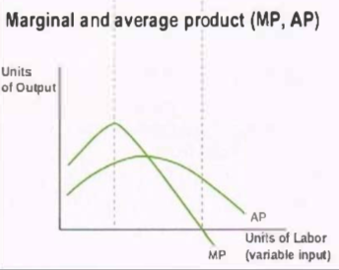
- Total product (TP) is the total quantity of output produced
- Average product (AP) is the total quantity of output produced on average by each unit of variable input
- Marginal Product (MP) is the additional output produced by one additional unit of variable input
- Constant returns to scale describe how as inputs increase, output increases in the same proportion
- Increasing returns to scale describes how as inputs increase, output increases more than in proportion
- Decreasing returns to scale describes how as inputs increase, output increases less than in proportion

Costs of Production
- Explicit cost is a cost involving payment of money made by a firm to obtain a FOP for use in production (e.g. wages paid to workers)
- Implicit cost is a cost involving sacrificed income for the use of a FOP that is owned by the firm of use in production (e.g. the income sacrificed for work put into one’s own business)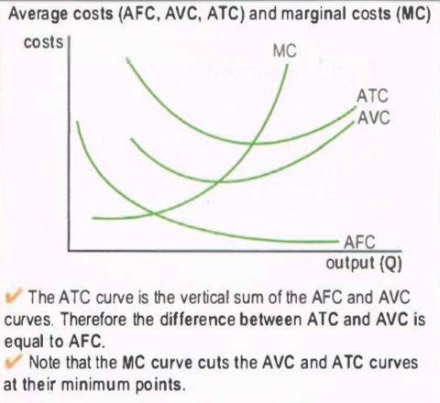
- Economics cost is the sum of explicit and implicit costs
- Fixed costs are the costs that do not vary with output (must be paid even when output is zero; TFC = total fixed costs)
- Variable costs are the costs that vary with output (TVC = total variable cost)
- Total costs (TC) is the sum of fixed and variable costs
- Average costs is the costs per unit of output
- Average fixed costs (AFC) is the total fixed costs per unit of output
- Average variable costs (AVC) is the total variable cost per unit of output
- Average total costs (ATC) is the total costs per unit of output
- Marginal costs (MC) the extra cost of producing an additional unit of output

Economies of Scale
- Economies of scale describes how increases in the size of a firm (in the long run) leads to falling costs per unit of output (falling average costs)
- Diseconomies of scale describes how increases in the size of the firm (in the long run) leads to rising costs per unit of output (rising average costs)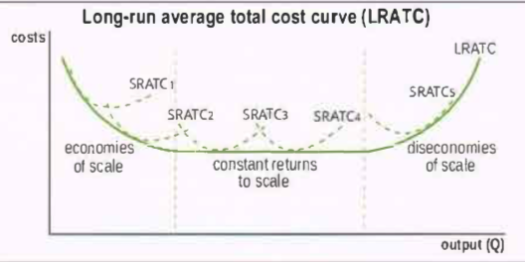

What Arises from Economies of Scale for Larger firms:
- Specialization of labour or management, leading to greater efficiency
- The efficiency of larger machines that can be afforded by larger firms
- Spreading of marketing, advertising, Research and Development cost over larger quantities of output.
- Bulk buying of inputs, or buying large quantities of inputs by larger firms that need large supplies, offered at lower prices per unit.
- Lower cost financing or borrowing at lower interest rates and better terms, often available for larger firms.

What Arises from Diseconomies of Scale for Larger firms:
- Management problems due to poor coordination and monitoring of firm activities
- Bureaucracy
- Communication difficulties
- Low worker morale and motivation if they are an unimportant part of a very large firm

Goals of firms
- Growth maximisation- economies of scale, lower AC, diversification, greater market power and lower takeover risk
- Managerial utility maximisation- large firms run by managers will do things to benefit themselves e.g higher their own salaries which reduce profits
- Satisficing- some companies may not be focused on maximising profits, may be focused on achieving a satisfactory outcome
- Revenue maximisation- focus on maximising revenue rather than profits
- Corporate social responsibility- avoidance of activities that may lead to production externalities; this encourages consumers to buy from them
Relationship between product curves and cost curves in the short run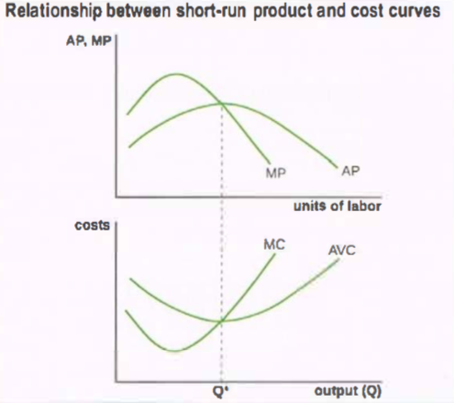
- The shape of the SR cost curve is due to the law of diminishing returns; therefore, product and cost curves are mirrors of each other
- The marginal product of labour increases, therefore, the extra output produced per unit of labour increases
- The extra cost of producing each extra unit of output decreases
- Diminishing returns set in and the marginal product of labour begins to fall
- Extra output per unit of labour decreases and cost per production of extra unit increases

Definitions in Profits, Revenues, and goals of firms
- Economic profit is the total revenue (TR) minus economic costs (explicit and implicit costs)
- Abnormal profit = positive economic profit (TR> economic costs)
- Normal profit = zero economic profit (TR = economic costs)
- Loss = negative economic profit (TR < economic costs)
- Average revenue (AR) = revenue per unit of output
- Total revenue (TR) = price * quantity
- Marginal revenue (MR) = extra revenue arising from the sale of one more unit of output

Understanding why MR=MC gives rise to maximum profit
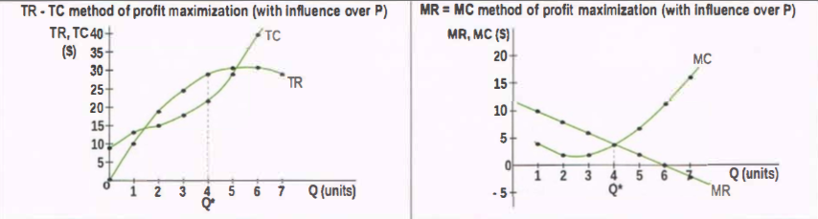
(USE ABOVE DIAGRAMS TO UNDERSTAND POINTS)
- Q<Q*, MR>MC aka extra rev. Of producing 1 more unit of output > cost of producing the same unit, therefore firms produce more
- Q> Q*, MC> MR extra cost of producing 1 more unit of output > revenue obtained from the same unit, therefore the firms should produce less.

The relationship between production and costs in the long run
- Falling ATC due to economies of scale correspond to increasing returns to scale in production
- As inputs double, output more than doubles
- Cost per unit of ATC must be falling
- Increasing ATC due to diseconomies of scale correspond to decreasing returns to scale in production
- Cost per unit of ATC must be rising

TOPIC: MARKET STRUCTURES
Characteristics of a monopoly
- One large firm operates in the market
- There are no close substitutes
- Strong barriers to entry and exit

Summary of monopoly
- Price- high
- Choice- no choice
- Output- less output than allocative efficiency
- Allocative efficiency- never
- Productive efficiency- never

Characteristics of a perfectly competitive market
- Many small firms
- Perfect mobility of resources
- Perfect information
- Goods are identical or homogenous
- Free entry and exit
- Achieves allocative efficiency (P = MC)
- Achieves productive efficiency (minimum ATC)
- Break-even price is the price at which the firm makes normal profit (P = minimum ATC)
- Shut-down price is the price at which firm will shut down; in the short run it is where P = minimum AVC
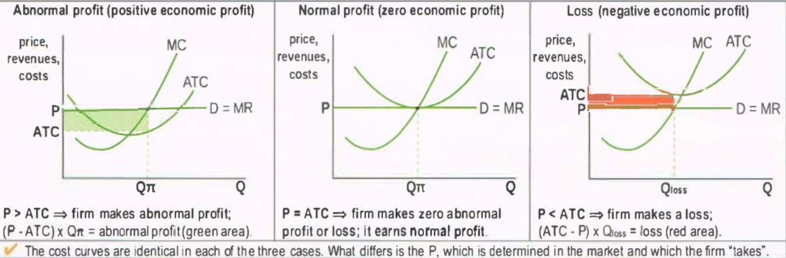
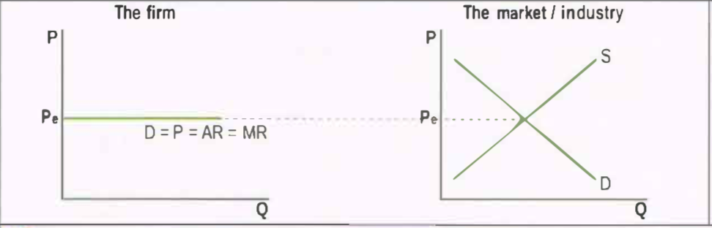

Summary of a perfectly competitive market
- Price- lower at ATC
- Choice- large choice
- Output- smaller output per firm
- Allocative efficiency- yes
- Productive efficiency- no in short run and yes in the long run
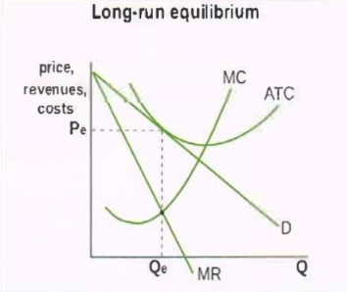
Characteristics of monopolistic competition
- There are many small firms
- Goods are similar and slightly differentiated
- Each firm has some ability to set the price
- There are low barriers to entry
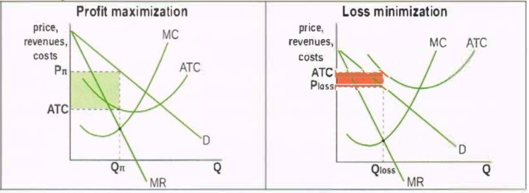

Summary of monopolistic competition
- Price- high in the short run and low in the long run
- Choice- large choice
- Output- less output than allocative efficiency
- Allocative efficiency- never
- Productive efficiency- never

Oligopoly assumptions
- A small number of large firms
- High barriers to entry
- Interdependence among firms
- Homogeneous or differentiated products
- 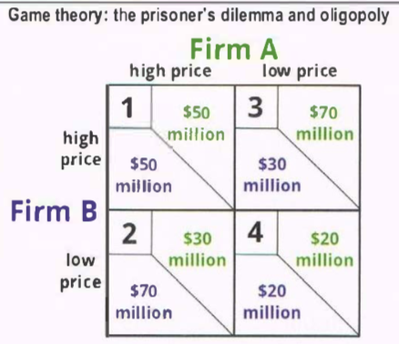
- Strategic interdependence
- 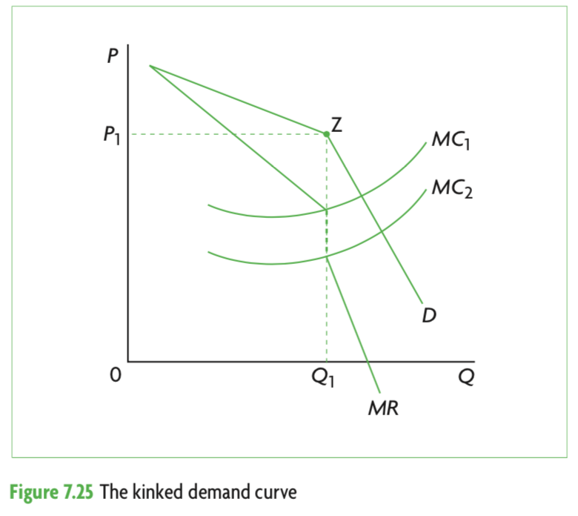
- 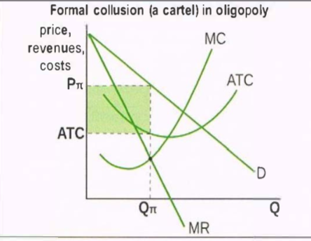

Price Discrimination
- Price discrimination is selling a product at different prices to different consumer groups, where the price differences are not due to the difference in costs of production
- The firm must have monopoly power
- Different consumer groups must have different elasticities of demand for the product
- Must be able to separate consumers

Relevant diagrams: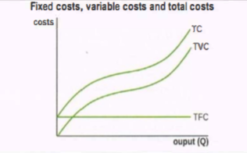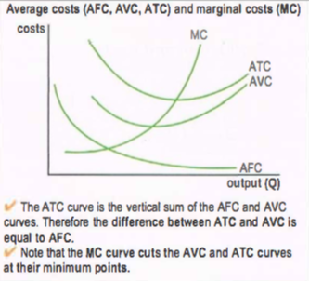
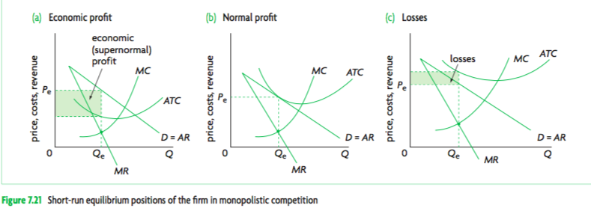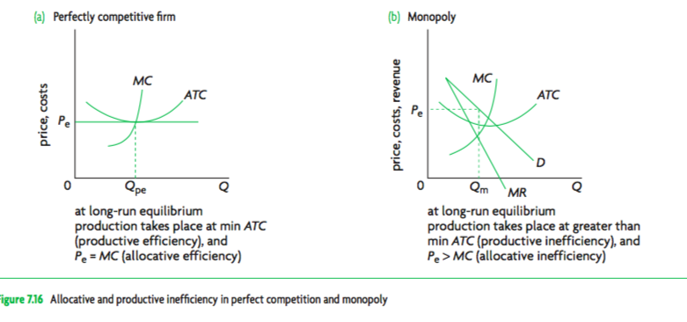

IB Economics ‘Give Me Five’ Macroeconomics SL

8.1 CIRCULAR INCOME FLOW

Leakages in a circular income flow
- Saving
- Taxes
- Imports

Injections in a circular income flow
- Investment
- Government spending
- Exports

Factor incomes
- Wages
- Rent
- Interest
- profit

8.2 MEASURES OF ECONOMIC ACTIVITY

Total spending in the expenditure approach
- Consumption
- Investment
- Government Spending
- Net exports

Approaches to measuring aggregate output
- Expenditure approach
- Income approach
- Output approach

Why national income statistics do no accurately measure the ‘true’ value of output
- GDP and GNI do not include non-marketed output
- GDP and GNI do not include output sold in underground (parallel) markets
- GDP and GNI do not take into account quality improvements in goods and services
- GDP and GNI do not account for the value of negative externalities (pollution,toxic wastes, etc..)
- GDP and GNI do not take into account the depletion of natural resources
- GDP and GNI and differing domestic price levels

Government spending ( Public investment)
- Airports
- Roads
- Public transport
- Schools
- Hospitals

8.4 THE BUSINESS CYCLE

Phases of the business cycle
- Expansion
- Peak
- Contraction
- Trough

9.1 AGGREGATE DEMAND AND THE AGGREGATE DEMAND CURVE

Components of aggregate demand
- Demand of consumers
- Demand of businesses
- Demand of the government
- Demand for foreign exports minus demand for imports

Reasons for downward sloping aggregate demand curve
- Wealth effect
- Interest rate effect
- International trade effect

Causes of changes in consumption spending
- Changes in consumer confidence
- Changes in interest rates
- Changes in wealth
- Changes in personal income taxes
- Changes in the level of household indebtedness

Causes of changes in investment spending
- Changes in business confidence
- Changes in interest rates
- Changes in technology
- Level of corporate indebtedness
- Changes in business taxes (fiscal policy)
- Legal/institutional changes

Causes of changes in government spending
- Changes in political priorities
- Changes in economic priorities: deliberate efforts to increase aggregate demand

Causes of changes in export spending minus import spending
- Changes in national income abroad
- Changes in exchange rates
- Changes in the level of trade protection

Determinants of aggregate demand
- Interest rates
- Federal Deficit
- Money supply
- Consumer confidence

9.2 SHORT-RUN AGGREGATE SUPPLY AND SHORT-RUN EQUILIBRIUM IN THE AD-AS MODEL

Reasons for sticky labour prices
- Labour contracts fix wages
- Minimum wage legislation
- Labour unions resisting wage cuts
- Wage cuts having a negative effect on worker morale

Changes in Short-Run Aggregate Supply
- Changes in wages
- Changes in non-labour resource prices
- Changes in business taxes
- Changes in subsidies offered to businesses
- Supply shocks

Short run equilibrium states of the economy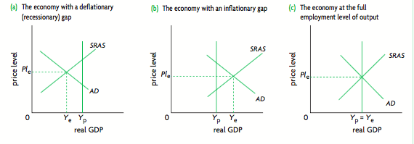

9.4 AGGREGATE SUPPLY AND EQUILIBRIUM IN THE KEYNESIAN MODEL

Reasons for getting stuck in the short-run
- Wage and price downward inflexibility.
- The inability of the economy to move into the long run.

Equilibrium states of the economy in the Keynesian model
- Recessionary gap
- Inflationary gap
- Full employment equilibrium
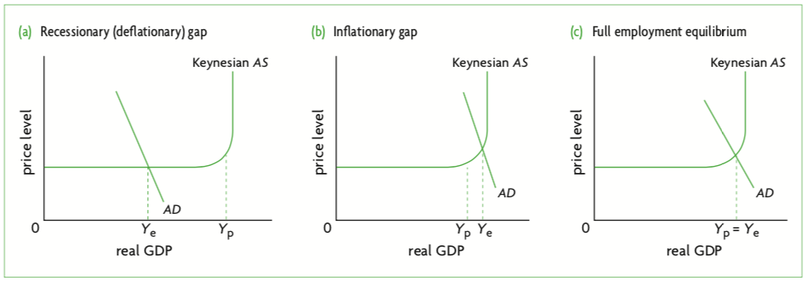

9.5 SHIFTING AGGREGATE SUPPLY CURVES OVER THE LONG TERM

Factors affecting long-run aggregate supply
- Increases in quantities of the factors of production
- Improvements in the quality of factors of production
- Improvements in technology
- Increases in efficiency
- Institutional changes
- Reductions in the natural rate of unemployment

Long-term economic growth: achieving potential (full employment) output in a growing economy
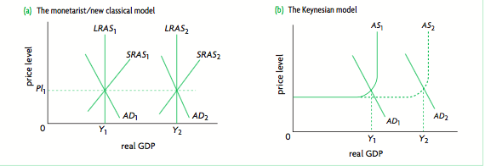
10.1 LOW UNEMPLOYMENT

Types of unemployment
- Structural
- Cyclical
- Frictional
- Natural

Reasons for hidden unemployment
- Unemployment figures include unemployment workers not actively seeking work
- No distinction between full-time and part-time employment
- No distinction on the type of work done
- Do not include ‘underground’ employment

Economic consequences of unemployment
- Loss of real output ( Real GDP)
- Loss of income for unemployed workers
- Loss of tax revenue for government
- Cost to the government for unemployment benefits
- higher income inequality

Causes of structural unemployment
- Changes in demand for particular labour skills
- Changes in the geographical location of jobs

Labour market rigidities
- Minimum wage legislation
- Labour union activities and wage bargaining with employers
- Employment protection laws
- Generous unemployment benefits

10.2 LOW AND STABLE RATE OF INFLATION

Problems with the consumer price index (CPI)
- Different rates of inflation for income earners
- Different rates of inflation depending on regional or cultural factors
- Changes in consumption patterns due to consumer substitutions when relative price changes
- Changes in consumption patterns due to increasing use of discount stores and sales
- Changes in consumption patterns due to introduction of new patterns
- Changes in product quality
- International comparisons
- Comparability over time

Redistribution effects
- People who receive fixed incomes or wages.
- People who receive incomes or wages that increased less rapidly than the rate of inflation.
- Holders of cash
- Lenders
- Savors

Why deflation rarely occurs in the real world
- Wages of workers do not ordinarily fall
- Large oligopolistic firms may fear price wars
- Firms want to avoid incurring menu costs resulting from price changes

11.1 ECONOMIC GROWTH

Explaining economic growth
- Increases in actual output
- Increases in production possibilities

11.2 EQUITY IN DISTRIBUTION OF INCOME

Types of poverty
- Relative
- Absolute
Causes of poverty
- Low incomes
- Unemployment
- Low levels of human capital
- Low levels of capital or land ownership
- Discrimination
- Geography
- Age
- Limited social services
- Poverty itself may further develop poverty

Consequences
- Low living standards
- Lack of access to health care and education
- Higher infant, child and maternal mortality
- Higher levels of preventable diseases
- Social problems
- Inability to realise one’s full potential (me)

Methods to promote income equity
- Transfer payments
- Subsidized provision or direct provision of merit goods
- Government intervention in markets
- Taxation

Types of direct taxes
- Personal income tax
- Corporate income tax
- Wealth tax
- Payroll taxes

Types of indirect taxes
- General expenditure taxes (sales tax)
- Excise taxes
- Custom duties (tariffs)

12.2 FISCAL POLICY

Fiscal policy
- Taxation
- Sales of goods and services (public sector)
- Sales of government owned firms
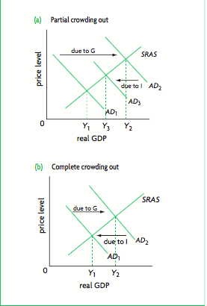
Types of contractionary fiscal policy
- Decreasing government expenditure
- Increasing personal income taxes
- Increasing business taxes
- Combination of decreasing spending and increasing taxes

Types of government expenditure
- Current expenditures
- Capital expenditures
- Transfer payments

Effects of fiscal policy
- Change in level of governments spending
- Level of consumption spending
- Level of investment spending

Strengths of fiscal policy
- Pulling an economy out of a deep recession
- Dealing with rapid and escalating recession
- Ability to target sectors of an economy
- Direct impact of government spending on aggregate demand
- Ability to affect potential output

Weaknesses of a fiscal policy
- Problems with time lags
- Political constraints
- Inability to deal with supply-side causes of instability
- In a recession, tax cuts may not be very effective in increasing aggregate demand.
- Inability to ‘fine tune’ an economy
- Crowding out (Government deficit)

12.3 MONETARY POLICY

Responsibilities of central banks
- Banker to the government
- Banker to commercial banks
- Regulator of commercial banks
- Conduct monetary policy

Role of monetary policy
- Changes in interest rate and aggregate demand
- Expansionary monetary policy
- Contractionary monetary policy
- Monetary policy and inflation targeting

Advantages of inflation targeting
- A lower rate of inflation
- A more stable rate of inflation
- Improved ability to anticipate the future rate of inflation
- Greater coordination between monetary and fiscal policy
- Greater central bank transparency and accountability

Disadvantages of inflation targeting
- Reduced ability of the central bank to respond to supply-side shocks
- Reduced ability of the central bank to pursue other macroeconomics objectives
- Reduced ability of the central bank to deal with unexpected events
- Finding an appropriate inflation target
- Difficulties of implementation

Strengths of monetary policy
- Relatively quick implementation
- Central bank independence
- No political constraints
- No crowding out
- Ability to adjust interest rate incrementally

Weaknesses of monetary policy
- Time lags
- Possible ineffectiveness in recession
- Conflict between government objectives
- Inability to deal with stagflation

12.4 SUPPLY-SIDE POLICIES

Forms of investment in human capital
- Training and education
- Improved healthcare services and access to these

Forms of industrial policies
- Support for small and medium sized enterprises
- Support for ‘infant industries’

Ways of encouraging competition
- Privatisation
- Deregulation
- Private financing of public sector projects
- Contracting out the private sector
- Restricting monopoly power
- Trade liberalisation

Labour market reforms
- Abolishing minimum wage legislation
- Weakening the power of labour unions
- Reducing unemployment benefits
- Reducing job security

Incentive related policies
- Lowering personal income taxes
- Lowering taxes on capital gains and interest income
- Lowering businesses taxes

IB Economics ‘Give Me Five’ – Macroeconomics HL
TOPIC

Calculating GDP
- Expenditure approach: GDP = C + I + G + (X-M)
- GNI = GDP + Net income from abroad
- Real GDP =nominal GDPprice deflator X 100
- Output approach: Value of each good and service produced in the economy and then sums them up to obtain the total value of output.
- Income approach: income earned by factors of production within a country over a period of time (rent [land], wages [labour], investment [capital], profit [enterprise]).

Phillips Curve
- Suggests that if there is a constant negative relationship between the two variables, then every economy faces a trade-off between inflation and unemployment.
- According to the Short-Run Phillips Curve, there is a negative relationship between the rate of inflation and the unemployment rate (forms a trade off)
- Long-Run Phillips Curve is vertical at the natural rate, indicating that unemployment is independent of inflation.

The Keynesian Multiplier
- Multiplier = Change In Real GDPInitial Change In Expenditure
- Multiplier = 11 - MPC
- Multiplier = 1MPS + MPT + MPM
- Marginal Propensities: Marginal propensity to consume (MPC), marginal propensity to save (MPS), marginal propensity to tax (MPT) and marginal propensity to import (MPI)
- The full effect can only be experienced when prices are constant, and if prices increase, then the multiplier effect is smaller

Marginal Propensities

- Marginal propensity to consume: Additional income spent on goods and services
- Marginal propensity to save: Fraction of additional income saved
- Marginal propensity to tax: Fraction of additional income taxed
- Marginal propensity to import: Fraction of additional income spent on imports

Title: topics on inflation
- Price index for a specific yearvalue of a basket in a specific yearvalue of the same basket in the base yearx100
- Calculating inflation from weighted price index % change in A=final value of A-intial value of Ainitial value of Ax100
- Calculating real income real income =normal incomeCPIx100

IB Economics ‘Give Me Five’ – International Economics SL

Benefits of trade
- Increases in domestic production and consumption as a result of specialization
- Economies of scale in production
- Greater choice for consumers
- Increased competition and greater efficiency in production
- Lower prices for consumers
- Acquiring needed resources
- Free trade and a more efficient allocation of resources
- Sources of foreign exchange
- Trade makes possible the flow of new ideas and technology
- Trade makes countries interdependent, reducing the possibility of hostilities and violence
- Trade as an ‘engine for growth’

World Trade Organisation (WTO)
- Historical context
  - Great depression(economic decline)=trade protection ↑ = ‘tariff wars’ = reducing international trade. Formation of GATT to ↓ tariff wars.

- Important
  - Liberalised trade and prevent further tariff war= increasing international trade.

- The Principles of the WTO/GATT:
  - Non-Discrimination
  - Gradual elimination of non-tariff trade barriers (exceptions:agricultural products and countries with BOD difficulties)
  - consultation to resolve the trade disputes.

- Functions of the WTO
  - Administrer WTO trade agreements
  - Provide a forum for trade negotiation
  - Handles trade disputes
  - Monitor national trade policy
  - Provide technical assistance and training for developing countries
  - Provision of aid

- Current principles of the WTO
  - Non-Discrimination
  - Free trade
  - Predictability
  - Promotion of fair trade and competition
  - Development economic reform should be encouraged

Restrictions on free trade (trade protection)
- 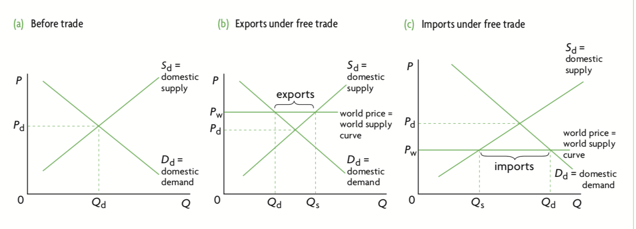
- Tariffs (custom duties):taxes on imported goods, most common form of trade restriction

- Effect of tariff on stakeholders:
- Domestic producers:
- Consumers: worse off
- Domestic Producers: better off
- Foreign producers: worse off
- Domestic employment increases
- Government gains tariff revenue

- Quotas: limit on the volume of goods and services allowed to enter a country
- Effect of quota on stakeholders:
- Domestic consumers: worse off
- Domestic producers: better off
- Employment increases
- Government neither gains nor loses

- Subsidies: reduce quantity of imports
- 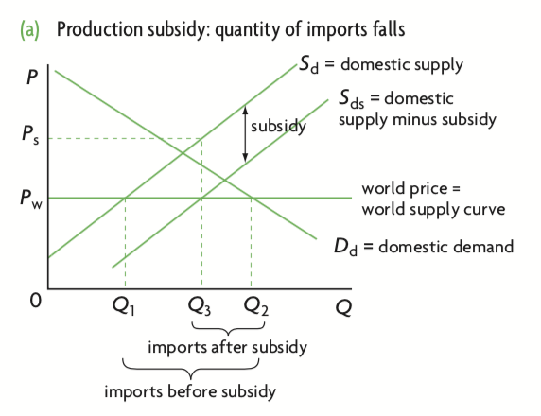
- Administrative barriers: administrative procedures that countries may use to prevent the free flow of imports into a country ex: controls of packaging, safety regulations

Exchange rates
- What is the role of the foreign exchange market, and what is foreign exchange:
  - Where one currency is exchange for another currency, and any individual and organisations that engages in the foreign exchange rate system.
    - Demand increase for domestic currency: increased foreign currency
    - Demand increase for foreign: Increased domestic currency
  - Exchange rate: The value of a good in the price of another.

- Determination and change of the exchange rates and the evaluation of the effects of change on the exchange rates
  - Determinant:
    - Foreign demand in domestic country exports
      - Increase: Currency value ↑
      - Decrease: Currency value

    - Domestic demand for imports
      - Increase: Currency value ↓
      - Decrease: Currency value ↑

    - Relative interest rate changes
      - A country’s interest rates and the value of the currency change in the same direction, ceteris paribus.

    - Relative rates of inflation
      - ↑ inflation, in relation to another country, currency

    - Investment from abroad
      - Increase: Currency value ↑
      - Decrease: Currency value

    - Change in income
      - A country’s level of income relative to another countries and the value of currency change in the opposite direction

    - Speculations
      - Speculation of currency depreciation: Currency value
      - Speculation of currency appreciation: Currency value ↑

  - Effects:
    - Cost-Push Inflation
      - Depreciation: Imports
      - Appreciation: Exports .
    - Demand-Pull inflation
      - Depreciation: Export cheaper, imports expensive, ↑ employment, → AD curve.
      - Appreciation: Imports cheaper, export expensive, ↓ employment, ← AD curve.

    - Effect on unemployment
      - Currency depreciation: ↑unemployment
      - Currency appreciation: ↓ unemployment.

    - Effect on economic growth
      - Currency depreciation: ↑real GDP
      - Currency appreciation: ↓ in real GDP

    - Effect on the current account balance
      - Currency depreciation: Import , export ↑
      - Currency appreciation: Export , Import ↑

    - Effect on foreign debt
      - Depreciation: Foreign debt ↑
      - Appreciation: Foreign debt

- What are the exchange rate systems:

  - Floating: based on the market forces
    - (+)
      - Protection against external shock
      - Lack of political restraints
      - Correction of the balance of payments
    - (-)
      - Speculation can cause instability
      - uncertainty to firms and consumers

  - Pegged: Pegged against another currency
    - (+)
      - Lower production cost
      - higher output, protection against volatile prices.
    - (-)
      - Change in the price if pegged nation value depreciates

  - Managed: Government intervention is involved
    - (+)
      - Certainty
      - Easy adjustment
    - (-) difficulty to respond to supply shocks.

- Government intervention in the exchange rate:, and evaluation on the effect of the intervention

  - Devaluation: Government ↓ fixed rate

  - Revaluation: Government ↑ fixed rates

  - Interventions:
    - Using official reserves to maintain exchange rate
    - Change the interest rates
    - Borrowing from abroad
    - Efforts to limit imports
    - Imposing exchange controls.

- Overvalued and undervalued currencies

  - Overvalued:
    - (+)
      - Imports cheaper
      - Developing countries may want a cheaper import = speed up industrialisation.
    - (-)
      - Exports become expensive
      - Payment difficulty
      - Domestic unemployment decrease.
    - Correction: Devalue or depreciate currencies

  - Undervalued:
    - (+)
      - Exports cheaper
      - Payment easier
      - Domestic unemployment ↓
      - Expand economy.
    - (-)
      - Creation of unfair competition
      - foreign countries: reduced level of exports, and increase imports

Arguments for trade protection
- Infant industry argument
- Strategic trade policy
- National security
- Health, safety and environmental standards
- Efforts of a developing country to diversify
- Questionable arguments: Tariffs as a source of government revenue, means to overcome BOP deficit, anti-dumping, protection of domestic jobs

Balance of payments
- Current Account
  - Balance of trade in goods
  - Balance of trade in services
  - Income
  - Current transfers

- Capital account
  - Capital transfers
  - Non-produced, non-financial assets

- Financial account
  - Direct investment
  - Portfolio investment
  - Reserve assets

- Errors and omissions: refers to an item that is included to account for possible omissions and errors in items that have been included or excluded, in order to ensure that the BOP (sum of credits and debits) is equal to zero
- Relationship between the accounts
  - Current account + capital account + financial account + errors and omissions = 0
  - Current account = - (capital account + financial account + errors and omissions)
- Balancing deficits with surplus through government interventions
  - Managed exchange rate: Combination of central bank buying and selling currencies, and market forces
  - Fixed exchange rates: Balance of payment is made to balance policies that keep their currencies fixed.

Fiscal and monetary objectives in an open Economy
- Fiscal policy: What is it, evaluate (advantage and disadvantage)
- Monetary policy: What is it, and evaluate it (advantage and disadvantage)
- Relationship between the Fiscal and Monetary policy and trade (applicable policies to improve trade deficit, surplus etc.)
- Preventing currency speculation and recession
- Cost-push inflation (from higher import) and recessions, and the suitable policies.

Economic integration
- Preferential trade agreement: an agreement between two or more countries to lower trade barriers between each other on particular products.
- Bilateral trade agreement: agreement between two countries
- Multilateral trade agreement: agreement between many countries
- Regional trade agreement: agreements between a group of countries that are within a geographical region

- Trading bloc: group of countries that have agreed to reduce tariff and other barriers to trade for the purpose of encouraging free or freer trade and cooperation between them
- Free trade area: consists of a group of countries that agree to gradually eliminate trade barriers between themselves
- Customs union: consists of a group of countries that fulfils the requirements of a free trade area (elimination of trade barriers between members) and in addition adopts a common policy towards all non-member countries
- Common market: countries eliminate any remaining barriers to trade between them. They continue to have a common external policy (as in a customs union), and in addition, they agree to eliminate all restrictions on movements of any factors of production within the common market

- Advantages of trading blocs
- Increased competition
- Expansion into larger markets
- Economies of scale
- Lower prices for consumers and greater consumer choice
- Increased investment
- Better use of factors of production: improved resource allocation
- Improved efficiency in production and greater economic growth
- Political advantages

- Possible disadvantages of trading blocs
- Trading blocs may not be the best way to achieve trade liberalization
- Trading blocs may create obstacles to the achievement of free trade on a global scale
- Unequal distribution of gains and possible losses

Advantages of the monetary union
- Single currency eliminates exchange rate risk and uncertainty
- Single currency eliminate transaction costs
- Encourages price transparency
- Promotes higher level of inward investment
- Low rates of inflation give rise to low interest rates, therefore more investment and increased output

Disadvantages of the monetary union
- Single currency involves loss of exchange rates as a mechanism for adjustment
- Single currency involves loss of monetary policy as an instrument of economic policy
- Fiscal policy is constrained by the convergence requirements
- Monetary policy pursued by the single central bank impacts differently on each member country, depending on its own particular circumstances

IB Economics ‘Give Me Five’ – International Economics HL

Absolute and comparative
Absolute advantage info
- Absolute Advantage Definition: Is when one country can produce more goods or services than another allocating equal or less resources to production
- Theory of Absolute Advantage: If countries specialize in and export the good in which they have an absolute advantage the result is increased production and consumption in each country
- 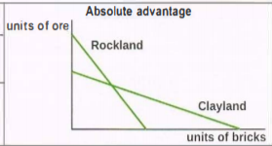
In this diagram Rockland can produce more units of ore than Clayland when producing 0 units of brick. On the other hand Clayland can produce more bricks than Rockland when producing 0 units of ore
- When producing the equilibrium amount of bricks and ore, the amount of total goods produced by each country will be less than if each country only produced the good they specialize in.

Comparative Advantage
- Comparative Advantage Definition: Is when one country has a lower opportunity cost in the production of a good than another country
- Theory of Comparative Advantage: As long as two or more countries have different opportunity costs, it is possible for all countries to gain from specialization and trade according to their comparative advantage.
- Countries can gain from specialization even if one country has absolute advantage in both goods because the production of one good is relatively cheaper in one country than in another, even if it is not absolutely cheaper.
- 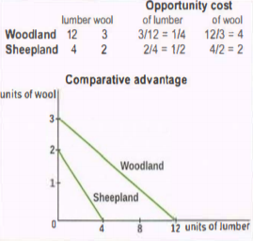

Limitations of theory of comparative advantage

- Unrealistic assumptions (free trade, fixed factors of productions, perfect competition, no transportation costs)
- Risk of excessive specialization
- developing countries to diversify into manufacturing or services
- Arguments in favor of trade protection (SL)
- Higher domestic prices due to lack of efficiency compared to its competition

Diagram calculations

Calculating effects of tariffs
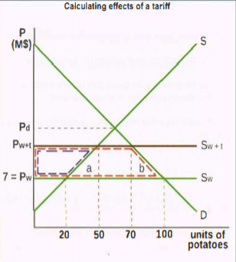
- Size of tariff: Difference between Pw+t and Pw
- Change in consumption: 100 - 70
3.Change in imports (100-20) to (70-50)
4.Producer revenue (7*20) to (11*50)
5. Change in consumer CS falls by the amount of the dotted red shape since P paid by consumers rises from Pw to Pw+t. Loss of CS = l(Pw+t - Pw) x 70] + area of triangle b = [(11 - 7) x70 + 60 = 280 + 60 = M$340

Quota
- 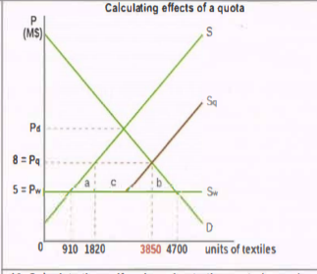
Size of quota: Difference between Sq and S
- Difference in imports after quota: (4700-910)-(3850-1820)
- Quota revenue: C
- Welfare loss: a + b + c

Subsidies
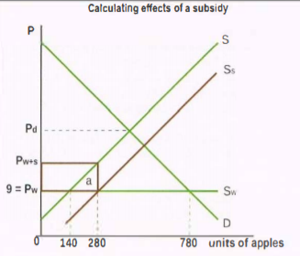
1. P received by producers is Pw +subsidy/unit= Pw+s = 9 + 5 = M$14
2. Imports change-Before: 780-140 = 640 units; after: 780- 280 = 500 units
3. No change in consumer expenditure
4. Government spending on subsidy = subsidy/unit x Q produced = 5 x 280 =
MS1400 = the area of the rectangle outlined in bold brown
5. Welfare loss [subsidy/unit x (280 -140)] / 2 = (5 x140) / 2 = M$350

Exchange rate calculations
- Currency 1 valueCurrency 2 value
Balance of payments
- Balance of trades in goods = exports - imports
- Balance of trade in goods and services = exports of goods + imports of goods + exports of services + imports of services
- Current account = balance of trade in goods + balance of trade in services + income inflows - outflows + current transfer inflows - outflows
- Capital transfers = inflows - outflows
5.
Implications of consistent current account deficits
- Higher interest rates,
- Contractionary fiscal policies
- Depreciation of the currency
- Lower economic growth in the future
- Increased sale of domestic assets
Methods to reduce current account deficits and evaluation
- Expenditure switching policies: switches consumption from imports to exports (protectionist policies [may cause retaliation], depreciation [impacts inflation])
- Expenditure reducing policies reducing aggregate demand through fiscal and monetary policies.
- Supply side policies, lowers inflation, domestic firms more competitive

Implications of consistent current account surplus
- High rates of economic growth
- Appreciation of the currency
- Lower consumption
- Lower standards of living
- Lower domestic investment
Marshall Lerner condition
- Depreciation of currency- trade deficit occurs only after a time delay. The reason lies in the price elasticity of demand (PED) for imports and exports, which is often quite low over short periods of time (price inelastic demand)
- If PEDexports + PED1mports > 1, depreciation smaller trade deficit. But if PED,exports + PED import, < 1, depreciation larger trade deficit.
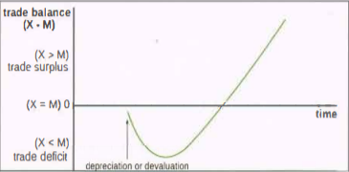

Terms of trade
- Terms of trade: a concept that relates the prices that a country receives for its exports to the prices it pays for its imports
- index of average export pricesindex of average import prices 100
- Deterioration in terms of trade involve a decrease in the value of the ratio of average export prices to average import prices. It involves an increase in opportunity cost of imports
- Increase in export prices or decrease in import prices can lead to an improvement in terms of trade

Short term causes of terms of trade
- Changes in demand condition
- Changes in supply conditions
- Changes in relative inflation rates
- Changes in exchange rates

Long term causes of terms of trade

- Changes in productivity
- Technological improvements
- Changes in income levels

Consequences of fluctuations in terms of trade
- Fluctuating revenues leads to uncertainties for firms and the government Makes long term planning, Prevents efforts of diversification
- Deteriorating terms of trade results in poverty
- Growing gap of income inequalities around the world

IB Economics ‘Give Me Five’ – Development economics SL
Understanding development
Economic growth versus economic development
- Economic growth refers to increase in output over time
- Economic development refers to processes that lead to improved standards of living
- Increasing output levels and income from economic growth means societies are better at satisfying the needs of its populace.
- Even if countries can achieve significant economic growth, this does not mean they guarantee improved standards of living
- Poverty and failure to develop economically will mean standard of living will not increase.

The multidimensional nature of economic development
- It was believed that economic growth over long periods of time would automatically provide economic and social benefits for the whole population.
- Large quantities of goods and services (e.g: more health care and education, economic opportunities, and social change) would be spread out to most people in the economy (‘Trickle-down theory’)
- There are three main core values of human development: Life sustenance, Self-esteem, Freedom
  - Life sustenance: Access to basic services such as food, water shelter, etc.
  - Self-esteem: The feeling of self-respect, development is desirable since it provides individuals with a feeling of dignity, honour, and independence.
  - Freedom: Freedom to make choices that are not available to people who are subjected to the conditions of poverty.
- Distinction between income poverty and human poverty, income poverty occurs when income falls below a nationally or internationally determined poverty line. Human poverty occurs when there is deprivation and the lack of opportunities that allows individuals to enjoy a decent standard of living with freedom, self respect, dignity, and so on.
- Economists began to realize that since economic growth did not necessarily eliminate widespread poverty and improve standards of living, there would have to be a different approach in order to directly deal with the problems of developing countries.

Sources of economic growth in economically less developed countries
- Physical capital is an important source of economic growth as it increases labor productivity. This is significant as labor productivity is lower than in more developed countries due to lower physical capital.
- Human capital is also important as it increases labor productivity. In LEDCs, there is lower educational and health standards meaning there is lower productivity.
- The use of new technologies is important to growth. Though technology contributes to the quality of physical capital, it is not always appropriate as infrastructure and education levels of LEDCs is different to that of the country where tech is developed.
- Institutional changes play a significant role as they offer stable legal, economic, and social basis’ to build economic growth by creating fair systems of taxation, enforcement of laws, and baking systems.
- The role of resources in economic growth is questionable as many resource rich nations are often experience low or even negative rates of growth as they become dependant on this production, experiencing low terms of trade, volatile export revenues, and balance of payment issues due to increasingly large debts.

Relating economic growth to economic development
- Economic growth does not lead to economic development.
- In fact, economic development can occur without economic growth.
- This is through the creation of basic social services to its people
- By repurposing resources from the production of industrial goods to merit goods, health, education, and sanitation will be available to the poor.
- A production possibility curve depicting this change:
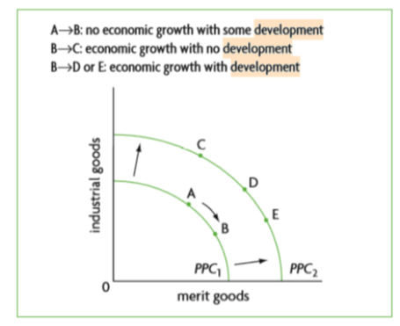

Distinguishing between economically more developed and less developed countries
Common characteristics of developing countries
- Low economic development. LEDC experience low levels of GDP or GNI per capita and have very high levels of poverty (where citizens are making less than $2.00 a day)
- Large agricultural and informal urban sectors. The informal sector is very large in LEDCs where workers are unregistered and often have no worker protection, access to basic services, or a stable source of income.
- Population growth is an issue due extremely high birth rates. This creates a high dependency ratio (adult to child) meaning income is spread across several family members. Dependant ratios in sub-Saharan Africa are 85% dependant.
- Low productivity is rampant in LEDCs. This is because of low human and physical capital levels, creating low levels of labor productivity.
- Dual economies form due to several factors through levels of wealth, development, productivity, and commercial sectors.
The poverty cycle (trap)
- When conditions of poverty feeds on itself, it creates more poverty. This causes the poverty cycle to be created.
- The poverty cycle arises when low income results in low or zero savings, there low or zero investments in physical, human, and natural capital, therefore low productivity of labour and land, thus giving rise to low or no growth in income.
- Poverty can be transmitted across generations in the following ways: People who earn very low income usually have very low productivity, they are not able to send their children to school, they cannot afford the necessary medical care for themselves or their children, and they often have larger families where they see additional children as an additional source of income.
- Government intervention is required in order to remove people from the poverty cycle such as investments in human capital, physical capital in the form of infrastructure, and natural capital.
- For a country, an escape from the poverty cycle is only possible through public investments.
Diversity among economically less developed countries 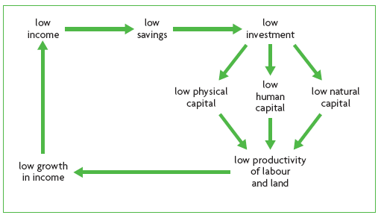
- Resources, geography, and physical and human capital vary in LEDCs, affecting their ability to trade and labor productivity.
- Climate determines many different economic activities. Agricultural production is affected while tropical climates change labor productivity due to health and infrastructure. Most developed countries are in temperate climates.
- History affects many nations as they were former colonies. They were set up to extract resources, not develop economically and this has hindered them.
- Political system is important as different political structures will have different views on the effect of people and their development/wellbeing.
- Political stability is important as it affects the government’s ability to act and creates uncertainty on economic policy and property rights.
International development goals
- Millenium development goals are targets to be achieved within a period of 15 years and also specifies indicators to be used to monitor countries’ progress.
- There are several indicators that have been specified to monitor and measure the progress made in each country with respect to each target.
- There are one or more targets corresponding to each goal with several indicators used for each goal.
- The millenium development goals are very important tools used by international organisations and national governments in their fight against poverty and effort to achieve economic development.
- They are used systematically to monitor and measure progress or setbacks that are achieved in each country according to each goal.
Measuring Economic Development
Complexities of measuring economic development
- Economic development is measured through indicators
- Indicators are based on statistical information
- No single indicator can define economic development
- This is because economic development is multidimensional and complex
- Many of them are combined to form a composite indicator to assess development.
Single indicators
- There are hundreds of indicators used as measures or different characteristics of an economy and of dimensions of development.
- GDP is an indicator of the value of output produced within a country, GNI is an indicator of the income (or a value of output) received by the residents of a country.
- GDP per capita measures the amount of output produced in a year per person in the population.
- GNI per capita measures the amount of income received by residents in a year.
- Other indicators include health indicators, education indicators, and so on.

Composite indicators
- Composite indicators are used to assess development more holistically
- The Human Development Index is an example of this (HDI). It measures life expectancy, expected years of schooling, and GNI per capita.
- Inequality-adjusted Human Development Index (IHDI) is the measure of loss of development due to inequality.
- Gender Inequality Index (GII) measures reproductive health, empowerment, and the labor market to measure the loss of development due to gender inequality.
- Multidimensional Poverty Index (MPI) measures the deprivations in health, education, and standard of living.
The Role of Domestic factors
Education and Health: the development of human capital
- Positive externalities of education and health services includes
- External benefits of education in OLDC’s include economic growth, reduced unemployment, and so on.
- External benefits of health include economic growth, lower risk of spreading diseases, improved school attendance, and so on.
- Government policies may include provision of schools that are free to attend, laws that make education compulsory, and so on.
- In countries that have grown and developed rapidly over the last several decades, the main factor behind their successes have been major investments in education.

The Role of Appropriate Technology
- Appropriate technology must be useful for the country it is applied in.
- Use of labour intensive technologies results in increased employment, increased use of local skills, and so on.
- Use of capital intensive technologies results in greater unemployment, reduced incomes and greater poverty, and so on.
- Import substitution policies in the 1950s and 1960s was the use of imported capital- intensive technologies which contributed to a rise in unemployment.
- Use of inappropriate technologies is one of the major drawbacks of foreign direct investment.

Credit and Micro-Credit
- Banking and credit are important because they provide an incentive to save, provide funds for investors, offer a way out of poverty, etc.
- However, poor people are excluded because credit system is not well developed, lack geographical access to branches, dominated by foreign banks, etc.
- As a result: poor people are resort to illegal money-lender (offer high interest rate) and exploitative pawnbroker, and lack sufficient and low-cost sources.
- Microcredits offer small money for a short duration of time to people who have low access to credit.
- Use of microcredit is useful by the poor to be self-employed, women norrower have high repayment rate (provide good income for family), and reduce poverty.
- However, there is the lack of microcredit schemes to cover billions of poor, risk of scheme to government poverty reduction policies, excessive borrowing, etc.

Empowerment of Women
- Serious gender inequalities in many countries causes many women to be deprived of economic opportunities.
- Empowerment of women involves eliminating the discrimination faced by girls and women with respect to access to education and health care, in the labour market, and so on.

Income Distribution

Infrastructure
- Reliable transportation systems make it possible to transport goods and services to markets, allow for lower transportation costs, improve international competitiveness through lower costs, and allow easier access to schools and health care services.
- Clean water supplies and sewerage systems improve the health of the population, reducing preventable illnesses, and contribute to improved standards of living.
- Energy systems increase the range of production methods that can be powered by electricity or gas, resulting in greater worker productivity; they lead to reduced indoor pollution arising from the burning of polluting fuels; they improve gender equality by freeing womens’ and girls’ time otherwise spent collecting firewood and carrying water.
- Telecommunications permit…...

Additional Domestic Factors

IB Economics ‘Give Me Five’ – Quantitative Techniques HL

Microeconomics

TOPIC: Demand functions

Basics of linear demand functions
- Qd= a - bP
- Qd is the quantity demanded
- a= the quantity that would be demanded if the price was zero. A change in ‘a’ will shift the demand curve. ( The x-intercept : where demand curve meets the x-axis)
- b= a change in ‘b’ will affect the slope of the demand curve. ( a divided by b gives the y-axis)
- P is the price of the good

Steps to plot/draw demand curve from demand function
- Find quantity demanded when price is zero. This will be the ‘a’ value and gives point on the demand curve known as the x-intercept.
- Find the price where demand is zero. Make Qd=0. Gives a second point at the other end of the demand curve, known as the y intercept.
- Now have two points on the demand curve.
- Draw axes for the market and insert values for price and quantity.
- Insert two points that you have calculates.

Changes in a and b
- If ‘a’ value changes the demand curve shifts to left or right (will be parallel to the original curve)
- Shift right means change in non-price determinant of demand to make product more attractive.
- Shift to the left means change in non-price determinant to make product less attractive to consumers.
- If value ‘b’ changes the slope of the demand curve will change.
- If b gets smaller will get steeper and if b gets bigger it will become flatter.

TOPIC: Supply functions

Basics of linear supply functions
- Qs= c + dP
- Qs= the quantity that is supplied
- c= the quantity that would be supplied if the price was zero. A change in ‘c’ will shift the supply curve.
- d= a change in ‘d’ will affect the slope of the supply curve
- P= price of the good

Steps to plot/draw supply curve from a supply function
- Find the quantity supplied when the price is zero.
- Choose a price above zero. Put it into the equation, in order to get a quantity supplied at that prie
- Draw your axes or the market ona piece of graph paper and insert values for price and quantity.
- Now extend line upwards.
- Label the axes and the supply curve.

TOPIC: Market equilibrium

Market Equilibrium: Find P and Q
- Put the Demand (Qd) and Supply (Qs) functions equal to each other
- Solve for P
- Substitute P into the demand or supply function- to find Q
- Apply the demand/ supply function to the graph using the value P and Q calculated
- Remember to label the axis with the correct units

Calculating Excess Demand
- Excess demand arises when P< P_{e} , where Q_{d}>Qs
- For any value where P <P_{e}, substitute this value into the demand and supply function
- Subtract the new quantities to find Excess Demand→ Q_{d}-Qs

Excess Supply
- Excess supply arises when P >P_{e}
- Where Q_{d}<Qs
- Substitute any value of P where P >P_{e} , into the demand and supply functions.
- Subtract the new quantities to find excess supply → Q_{s}-Q_{s}

TOPIC: Elasticities

Price elasticity of demand (PED)
- PED= percentage change in quantity demanded/ percentage change in price
- % change in price= (new price - old price/ old price) x 100
- % change in quantity demanded = (new quantity - old quantity/ old quantity) x 100
- Then divide the two values achieved.
- Calculating PED between two points n demand curve is the same as above.

Cross elasticity of demand (XED)
- XED= percentage change in quantity demand of good x/ percentage change of good y
- Calculate the percentage changes in price of one good and the quantity demanded of the other good.
- % change in price good Y = (new price - old price / old price) x 100
- % change in Quantity demanded of good X = (new quantity - old quantity/ old quantity) x 100
- Divide the percentage change in quantity demanded of second good by the change in price of the first good. Positive value means substitutes. If negative value goods are complements.
Income elasticity of demand (YED)
- YED= percentage change in quantity demanded/ percentage change in income
- Calculate the percentage changes in income and quantity demanded
- % change in income= (new income - old income/ old income) x 100
- % change in quantity demanded =( new quantity sold quantity/ old quantity) x 100
- Divide the percentage change in Qd by the percentage change in income. Positive value means that the good is normal. If has negative value means product is inferior good.

Price Elasticity of Supply (PES)
- PES= %ΔQ/ %ΔP = ((ΔQ/Q) x100)/ ((ΔP/P)x100))
- ΔQ= Q_{final} -Q_{initial}
- Q= initial Q value
- ΔP= P_{final} -P_{initial}
- Q= initial P value

TOPIC: Specific taxes

Specific (Indirect) Taxes
- Use linear functions to draw the relevant demand and supply curves and identity the equilibrium price and quantity before the tax.
- Find after equilibrium Q,P paid by consumers (Pc) and P received by producers.
- Plot new S curve by shifting S upward by tax per unit. Then find the new point of intersection.
- Using the rule: after tax Qs= c + d ( P-t) where t is tax per unit.
- Using the D equation and new S equation make equal to find P and Q.

Effect of tax on stakeholders
- Consumer expenditure: equilibrium quantity after tax x equilibrium price after tax
- Producer revenue: equilibrium quantity after tax x equilibrium price after tax
- Government tax revenue: tax per unit x number of units sold
- Then calculate the new consumer surplus (shown below how to)
- Then find the welfare loss which is calculated by (( Pc- Pp) x (Q1 - Q2)) / 2

Producer and consumer surplus how to calculate
- Consumer surplus: area under D curve above P padi by consumers (find before and after tax to see how it changes)
- Producer Surplus: area above S curve under P received by producers (find before and after tax to see how it changes)

Tax incidence
- Particular group bearing the burden of a tax ( group paying all or a portion of a tax.)
- Usually shared between consumers and producers. However the share paid by each group is determined by the relative size of PED and PES.
- PED = PES tax incidence is the same on consumers and producers
- PED>PES tax incidence is greater on producers
- PED<PES, tax incidence is greater on consumers
􏲤􏰆􏰾􏴣􏰂􏰾􏷂􏰈􏷙􏰆􏱡􏲐
TOPIC: Subsidies

Calculating the effects of a subsidy using Linear demand and supply functions: Market Outcomes
- Find Q and P BEFORE the subsidy: Plot Qd function and Qs function
- Intersection of lines shows P and Q
- OR Put Qs= Qd to find P and Q
- Find Q and P AFTER the subsidy: Plot the new S curve by shifting the curve by the value of the subsidy.
- OR use the supply function Qs= c+d (P + s); where s= subsidy per unit
- Use the Qd function and new Qs function to find the new P and Q
- Price paid to consumers= P_{c}; whilst P_{p} = (P_{c} + S)

Effect of Subsidies of Stakeholders
- Consumer expenditure (Before Subsidy)= Price (Before Sub) x Quantity (before sub)
- Consumer Expenditure (After Subsidy)= Price (After Sub) x Quantity (After sub)
- Producer Revenue (Before Subsidy)= Price (before sub) x Quantity (Before sub)
- Producer Revenue (After Subsidy)= Producer Price(P_{p}) X Quantity (New S curve)
- Government spending= subsidy per unit x number of units sold (new S curve)
- Consumer Surplus before= (∆Consumer expenditure- P) x Q /2)
- Consumer Surplus After= (∆Consumer expenditure- P_{c}) xQ_{sub} /2)
- Producer surplus= ( Area above S curve under P received by producers)
- Before subsidy=(∆Consumer expenditure- P)x Q/ 2)
- After subsidy=(P_{p}-P_{c})x Q_{sub})/2
- Welfare Loss= ((P_{p} -P_{c}))x ((Q₂- Q₁))/2

TOPIC: Price ceilings and price floors

Price Ceilings
- To find the shortage, substitute the ceiling price in the demand and supply equations
- To calculate the change in consumer expenditure and firm revenue, find equilibrium P and Q before the price ceiling:
- Consumer expenditure before the price ceiling = P paid x Q purchased
- Consumer expenditure after price ceiling = P paid x Q purchased

Price Floors
- To find the surplus, substitute the floor price in the demand and supply equations
- To calculate the change in consumer expenditure, find equilibrium P and Q before the price floor is imposed
- To calculate the change in firm revenue, compare firm revenue before and after the price floor. Revenue before the price floor is found using the equilibrium P and Q you found above (it is the same as consumer expenditure)
- Government expenditure to purchase the surplus = price floor x amount of the surplus
- Consumer expenditure before the price floor= price paid x quantity purchased
- Consumer expenditure after the price floor= price paid x quantity purchased

TOPIC: Product, Cost, Revenue & Profit

Product Terms
- Total product = total quantity of output produced by a firm
- Average product = total product per unit of labor input = TP / units of labor
- Marginal product = extra product produced by an additional unit of labor

Cost Terms
- Economic Costs = Explicit + Implicit Costs
- Total Costs = Total Fixed Costs + Total Variable Costs
- Average Fixed Costs = Fixed Costs per unit of output = TFC / Q
- Average Variable Costs = Variable Costs per unit of output = TVC / Q
- Average Total Costs = Total costs per unit of output = AFC + AVC = TC / Q
- Marginal costs = extra cost of producing one more unit of output = TC / Q

Revenue Terms
- Total revenue = price x quantity (= P x Q)
- Average Revenue = Total Revenue per unit of output = TR / Q (= P)
- Marginal Revenue = Extra Revenue from the sale of an extra unit of output = Change in TR / Change in Q

Profit Terms
- Economic Profit = total revenue minus economic costs = TR - TC
- Abnormal Profit = positive economic profit = TR - TC when TR > TC
- Normal Profit = zero economic profit = TR - TC when TR = TC
- Loss = negative economic profit = TR - TC when TR < TC

TOPIC: Profit Maximising equilibrium

- Find Q, where MR= MC
- Draw an upward line to P (=D) or to ATC *Whatever line is highest*
- Compare P and ATC; P>ATC→ Abnormal profit; P=TC→ normal profit; P<ATC → Loss
- Multiply vertical distance (*2) x Q_{Produced} = Abnormal profit or total loss

Macroeconomics

TOPIC: National Income

Calculating GNI
- The total income received by the residents of a country in a year, regardless where the factors of productions owned by the residents are located.
- GNI= GDP + factor income received from abroad - factor income sent abroad
- Per capita GNI= total GNI/ population
- Per capita GNI provides an indication of how much income is received by each person in
the population on average and is therefore a better indicator of standards of living.

TOPIC: Measuring GDP

Measuring GDP using expenditure approach (nominal GDP)
1.Adds up total spending to buy all final goods and services within a year.
2..C + I + G +X-M = GDP
3.C = consumer spending
4.I = Investment spending
5.G = government spending
6. X-M= exports - imports
Measuring GDP using expenditure approach
1.Adds up all income earned by the four factors of production in the course of producing total output within a year.
2.Rent + wages + interest + profit = national income
Measuring Green GDP
1.Green GDP is a measure of GDp that takes into account environmental destruction, arising from production and consumption activities. Since GDP does not consider environmental destruction, green GDP < GDP.
2. Green GDp = GDP value of environmental destruction
Calculating real GDP using a price deflator
1.Real GDP = nominal GDP/ price index for the year x 100

TOPIC: THE KEYNESIAN MULTIPLIER
- Multiplier = change in real GDP / initial change in spending
- Change in real GDP = multiplier x initial change in spending
- Marginal Propensity to Consume (MPC) = ΔC/ΔY
- Marginal Propensity to Save (MPS) = ΔS/ΔY
- Marginal Propensity to Tax (MPT) = ΔT/ΔY
- Marginal Propensity to Import (MPM) = ΔM/ΔY
- MPC + MPS + MPT + MPM = 1
- Multiplier = 1 / 1 - MPC = 1 / MPS + MPT + MPM

TOPIC: UNEMPLOYMENT & INFLATION
Calculating the unemployment rate
- Find the number of people in the labour force
- Calculate the unemployment rate = number of unemployed people/labor force x 100
Constructing a consumer price index
- PI for year X = (value of basket in year X / value of basket in base year) x 100
Calculating the inflation rate
- Inflation rate in Year X = %ΔP = (Px - P(x-1)/P(x-1) x 100)
TOPIC: Economic Growth
Calculating economic growth
1. Growth rate = Real GDP in year 2 - Real GDP in year / Real GDP in year 1 x 100
TOPIC: Tax rates
1. Growth rate = Real GDP in year 2 - Real GDP in year / Real GDP in year 1 x 100
2. Average tax rate = total tax paid/ income x 100
3. Marginal tax rate = change in total tax paid/ change in come x 100
4. Average tax rate for Individual D = total tax paid/income x100

International Economics

TOPIC: Comparative Advantage
Calculating opportunity cost form set of data
1. In order to identify the comparative advantage that a country has over another country in producing certain goods, it is necessary to work out their opportunity costs of of producing
2.Country said to have comparative advantage in the production of a good if it can produce a good at a lower opportunity cost than another country.
3.Opportunity cost of one unit of good a= output of good b/ output of good a
4. Identify the country with the higher opportunity cost for a product and that is the one in which the country should specialise.
5. In order to illustrate comparative advantage from a set of data,just plot opportunity costs of products against each other.

TOPIC: CALCULATIONS ON THE EFFECTS OF TARIFFS
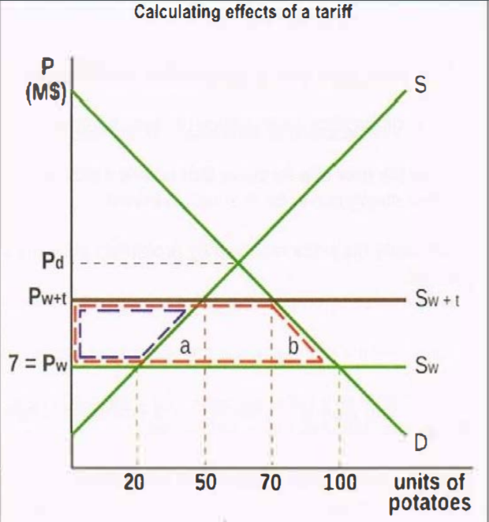
- Calculate the change in domestic production due to the tariff: Before: 20 units produced; after: 50 units produced; production increases by = 30 units
- Calculate the change in consumption due to the tariff. Before: 100 units; after: 70 units; consumption falls by 30 units (70 - 100 = - 30)
- Calculate the change in the quantity of imports (M) due to the tariff. Before:100-20 = 80 units: after: 70-50 = 20 units. Q of M falls by 60 units (20-80= -60)
- Calculate the P paid by consumers and received by producers with the tariff. Pw+t = 7 + 4 = M$11
- Calculate the change in consumer expenditure due to the tariff. Before: 7 x 100 = M$700: after: 11 x 70 = M$770. Expenditure increases to M$70 (= 770-700)
- Calculate the change in producer revenue due to the tariff. Before: 7 x 20 = M$140; after: 11 x 50 = M$550. Revenue increases by M$410 (= 550-140)
- Calculate the effects on the government budget. Tariff revenue= tariff per unit x Q of M = M$4 x 20 units = MS80
- Calculate the value of exports lost by exporters of potatoes to Merryland. Value of X before: 7 x (100 - 20) = 7 x 80 = M$560. Value of X after: 7 x (70 - 50 ) =·M$140. Value of X lost= M$420 (140 - 560 = - 420)
- Calculate the welfare loss due to the tariff. Area a= [4 x (50- 20)] / 2] = (4 x 30) / 2 = M$60; area b = [4 x (100 - 70)] / 2] = (4 x 30) / 2 = M$60. Total welfare loss= area a+ area b = 60 + 60 = M$120
- Calculate the change in consumer surplus (CS). CS falls by the amount of the dotted red shape since P paid by consumers rises from Pw to Pw+t. Loss of CS = l(Pw+t - Pw) x 70] + area of triangle b = [(11 - 7) x 70] + 60 = 280 + 60 = M$340
- Calculate the change in producer surplus (PS). PS increases by the amount of the dotted blue shape since P received by producers increases from Pw to Pw+t. Gain of PS = [(Pw+t - Pw) x 50 - area of triangle a = [(11 - 7) x 50] · 60 = 200 · 60 = M$140

TOPIC: EFFECTS OF A QUOTA
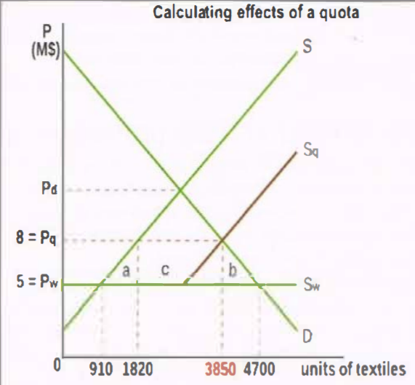
- Q consumers purchase after tax= domestic production after quota + Quota
- Q of imports before quota= Q₂- Q₁
- Change in consumer expenditure before= P_{W}xQ₂
- Change in consumer expenditure after= P_{q}x Q₄
- Change in producer revenue before= P_{W}xQ₁
- Value of textile exports before= P_{W} x (Q₂- Q₁)
- Value of textile exports after= P_{W}x (Q₄- Q₃)
- Value of exports lost= (P_{W} x (Q₂- Q₁))- (P_{W}x (Q₄- Q₃))
- Exporters gain quota revenues= (P_{q}-P_{W})x (Q₄- Q₃)
- Exporters lose exports= value of exports loss
Welfare loss of a Quota:
- Total welfare loss= a + b + c

TOPIC: EFFECTS OF A SUBSIDY
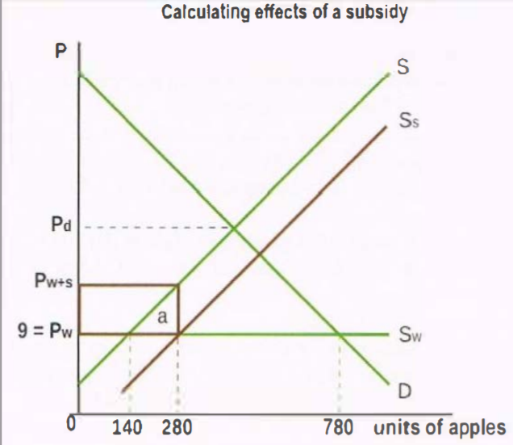
- Does Merryland have a comparative advantage or disadvantage in apples? It has a comparative disadvantage because its domestic price, Pd > Pw
- Draw the new supply curve that resulted after the subsidy. The new supply curve, Ss, is shown in brown.
- Calculate the price received by producers after the subsidy was granted. The P received by producers is Pw +subsidy/unit= Pw+s = 9 + 5 = M$14
- Calculate the change in the quantity of imports (M) due to the subsidy. Before: 780-140 = 640 units; after: 780- 280 = 500 units Q of M falls by 140 units (500 - 640 = - 140)
- What is the change in consumer expenditure due to the subsidy? There is no change, since P paid and Q bought are the same
- Calculate the change in producer revenue due to the subsidy. Before: 9 x 140 = M$1260; after: 14 x 280 = M$3920 Revenue increases by M$2660 (= 3920 - 1260)
- Calculate the effect on the government budget. Government spending on subsidy = subsidy/unit x Q produced = 5 x 280 = MS1400 = the area of the rectangle outlined in bold brown
- Calculate the value of exports (X) lost by exporters of apples to Merryland. Value of X before: 9 x (780 - 140) = 9 x 640 = M$5760 Value of X after: 9 x (780 - 280) = 9 x 500 = MS4500 Value of X lost= M$1260 (4500- 5760 = - 1260) Alternatively: value of X lost= Pw x fall in M = 9 x (280 - 140) = 9 x 140 = MS1260
- Calculate the welfare loss due to the subsidy. Welfare loss = area a = [subsidy/unit x (280 -140)] / 2 = (5 x140) / 2 = M$350

TOPIC: EXCHANGE RATES
- Given the exchange rate £ 1 = US$ 1.65, calculate the value of 1 US$ in terms of £. US$ 1 = 1/1.65 = £ 0.61
- Given the £ - US S exchange rate above, calculate the price in £ of 5 books that cost US$15 each. Total cost of books in US$= 5 x US$15 = US$75. Since US$1 = £ 0.61 => 0.61 x 75 = £45.75
- 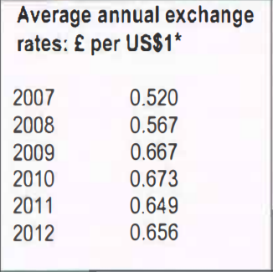
- Calculate the % change in the value of the US$ in 2007-2012. [(0.656 - 0.520)/0.520] x 100 = 26.15% appreciation of the US$
- Calculate the% change in the value of the £ in 2007-2012: Find the value of £ in terms of US$(£ price) in 2007 and 2012: 2007: £1 = 1/ 520 = 1.923 US$. 2012: £1 = 1/0.656 = 1.524 US$ : [(1.524 - 1.923)/1.923] x 100 = -20.75% depreciation for the £

TOPIC: BALANCE OF PAYMENTS
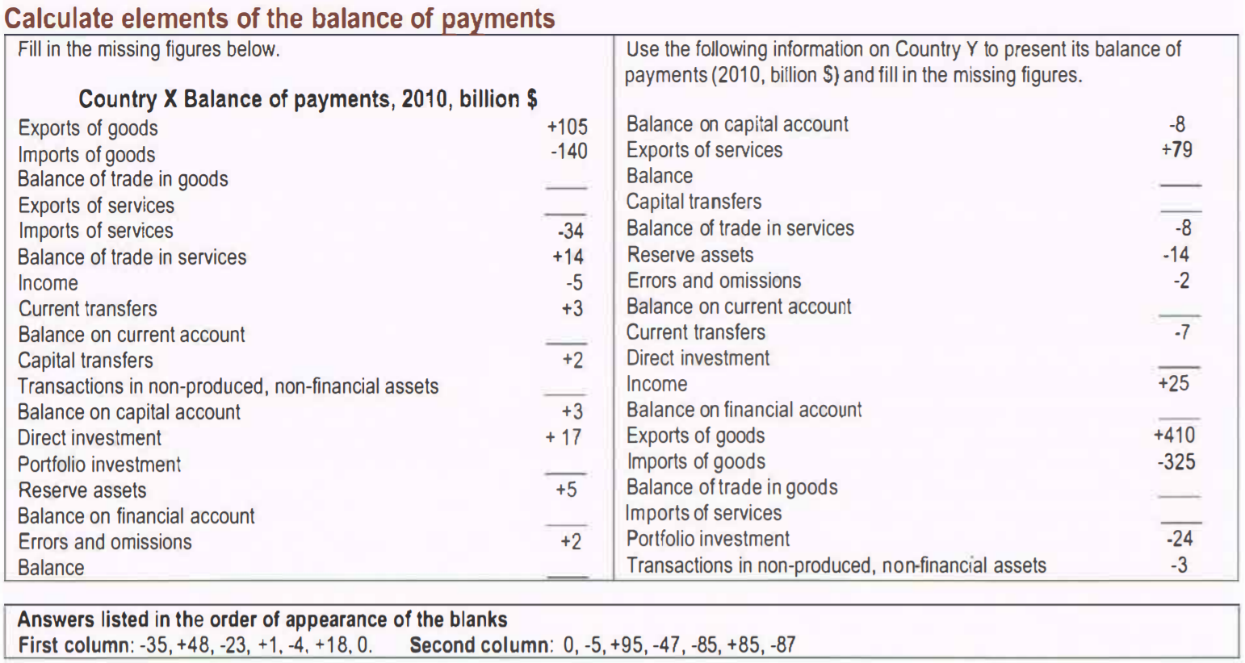

TOPIC: TERMS OF TRADE
- terms of trade = average price of exports divided by the average price of imports times 100; it is the ratio of two index numbers limes 100:
- 