How to write a quality 15-mark response on Paper 1
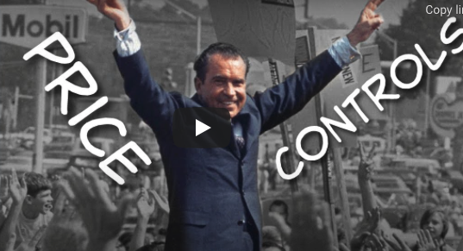
In 1973, OPEC (Organization of the Petroleum Exporting Countries) increased the price of crude oil, which is the key input in petrol (gasoline) production. This led to an increase in the price of petrol. Some countries initially responded by imposing price controls (a price ceiling) on petrol.
Examine the consequences of the policy of petrol price ceilings on the economy (including resource allocation and welfare) and stakeholders. (15 Marks)
Use the following ideas to help you plan the structure of your first 15-mark answer:
D (EFINE)
D (IAGRAM)
E (XPLAIN)
E (XAMPLES)
The evaluative tool box ‘CLASPPE’:
C (ONCLUSION)
L (ONG AND SHORT-TERM EFFECTS)
A (SSUMPTIONS)
S (TAKEHOLDERS)
P (ROS AND CONS
P (RIORITIES)
E (LASTICITIES)

Now write your answer to the question below, it will be between 1-2 pages in length without diagrams included…

