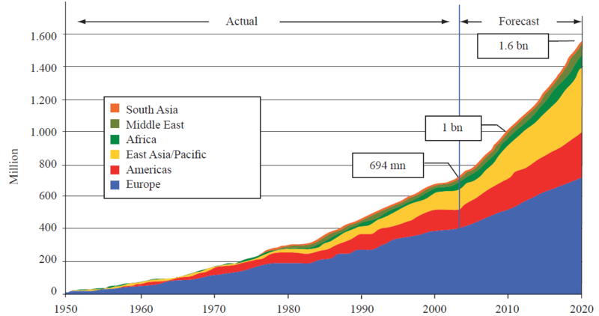

Explain two reasons for the trend shown between 1950 and 2000 (4 marks)

____________________________________________________________________________________________________________________________________________________________________________________________________________________________________________________________________________________

_______________________________________________________________________________________________________________________________________________________________________________________________________________

Describe the trend in international tourist arrivals between 1950 and 2000 (4 marks)

____________________________________________________________________________________________________________________________________________________________________________________________________________________________________________________________________________________

_______________________________________________________________________________________________________________________________________________________________________________________________________________

**How has tourism grown?**