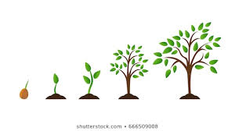

How do economies grow?

Definition: Economic growth involves increasing the total output produced by resources in the economy.

- This can be shown through a production possibilities curve. Draw a production possibilities curve below showing ‘economic growth’:

Illustrate that there are 5 ways that economies can grow over time.

- On the table below explain how an economy can achieve economic growth over time, with and without the support of government:

Explain each of the changes below: | Example 1: | Example 2: | Example 3:
The discovery of more natural resources:

Investment in new capital and infrastructure:

Technical progress:

Increasing the quantity and quality of human resources:

Reallocating resources:

