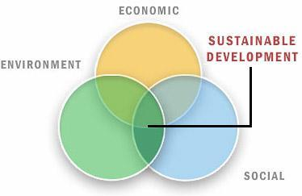
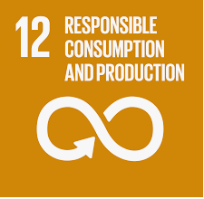
How can companies act more sustainably?
Name of company | Explanation of product | How is it socially sustainable ? | How is it economically sustainable ? | How is it environmentally sustainable ?

