Calculating The Rate of Inflation Using a Weighted Price Index

Exercise 1:

The price index figures for country x for two years are shown below:

Category | 2022 | 2023
Housing | 110 | 120
Transport | 106 | 110
Foodstuffs | 120 | 120
Entertainment | 110 | 100
Clothing | 105 | 105

Base year=2019

- Calculate the average index for each year.
- Calculate the unweighted inflation rate for 2022/23

The expenditure patterns of the population of the country are surveyed and it is discovered that the average household spends 35% of its income on housing, 25% on transport, 15% on foodstuffs, 15% on entertainment and 10% on clothing.

- Explain with the help of the figures above the relative importance of the weighting.
- Assuming that consumer expenditure patterns do not change over the period 2022/23, construct a table showing the weighted indices for 2022 and 2023. (Add columns to table above)
- Calculate the weighted inflation rate for 2022/23.
- Explain the differences between the inflation rates that you have calculated in 2 and 5.

Exercise 2:

The price index figures for country x for two years are shown below:

Category | 2022 | 2023
Housing | 110 | 120
Transport | 106 | 110
Foodstuffs | 120 | 120
Entertainment | 110 | 100
Clothing | 105 | 105
Education | 102 | 110
Healthcare | 107 | 108
Utilities | 105 | 115

The expenditure patterns of the population of the country are surveyed and it is discovered that the average household spends 25% of its income on housing, 15% on transport, 15% on foodstuffs, 10% on entertainment and 5% on clothing, 10% on education, 10% on healthcare and 10% on utilities.

- Assuming that consumer expenditure patterns do not change over the period 2022/23, construct a table showing the weighted indices for 2022 and 2023. (Add columns to table above)
- Calculate the weighted inflation rate for 2022/23.

CONSTRUCT YOUR OWN CPI INFLATION RATE

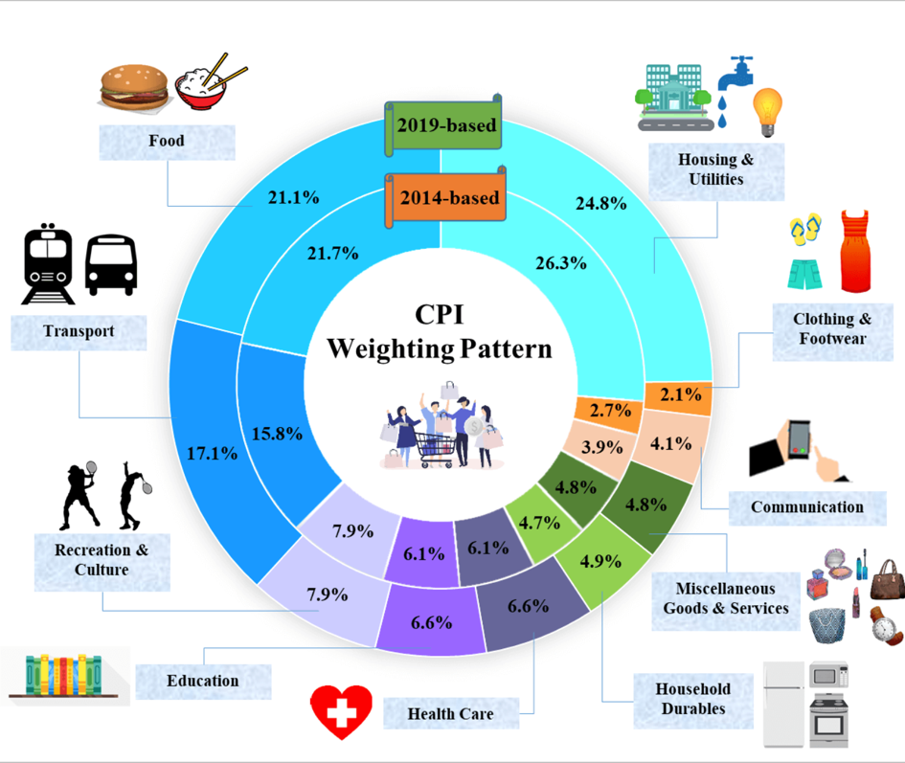

Construct your own Consumer Prices Indices (CPI)

Using the website: https://web.archive.org you are going to construct your own version of the CPI.

Method:

- First you will need to choose a representative basket of goods from the same retailer (Walmart has the most archived pages). Enter at least 10 consumer goods into the table below. I recommend you work backwards by finding the good from a year ago (April – June 2022) and then find it at today’s price. Make sure that it is the identical good; brand, size, volume etc. Enter it into the table below:

Fig 1. Constructing a consumer prices index (cpi)

Consumer Goods  Basket (List items) | April- June  2022 Price | Weighting in the Basket | Index for the year 2022 times weight | 2023 Price | Weighting in the Basket | Index for the year 2023 times weight
Totals |  | 1.0 |  |  | 1.0

- We can then work out the inflation rate by using the equation:

Index for 2021 – Index for 2020/Index for 2020 x 100 =

