HL (2020) Indirect Taxes and Subsidies Quantitative Techniques

Fig. a.) An Indirect Tax on Cigarettes ($’s and 000’s packets per week)
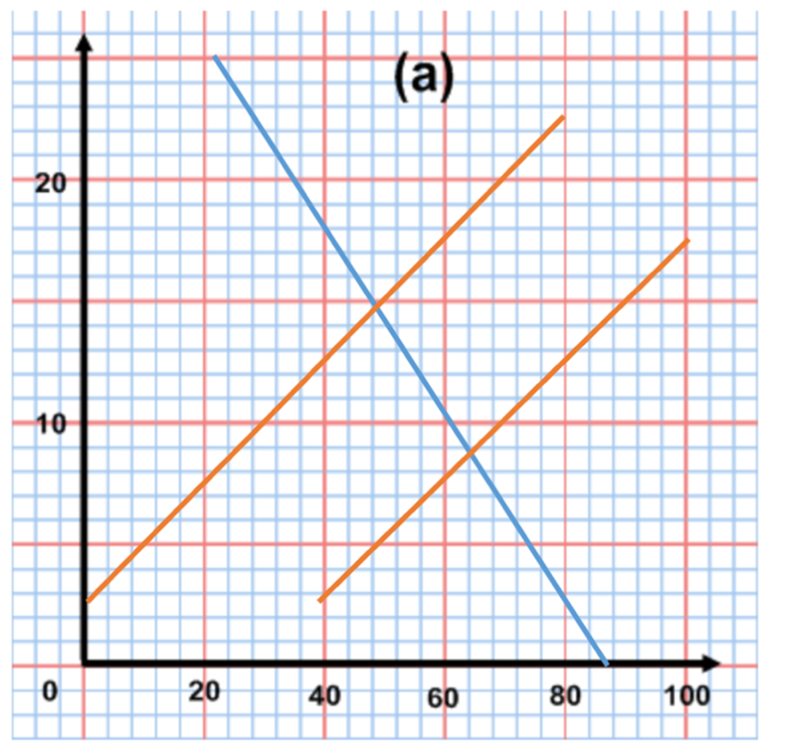

1. Label the demand and supply curves.
2. Indicate the original equilibrium price and quantity on the graph.
3. Indicate the new equilibrium price and quantity on the graph, following the imposition of the indirect tax.
4. State the amount of the indirect tax.
5. Calculate the revenue from the tax.
6. Calculate the amount of tax paid by:
a.) consumers
b.) producers
7. Calculate the change in consumer expenditure after the tax.
8. Calculate the change in producer revenue after the tax.
9. Illustrate the are showing the loss of consumer surplus.
10. Illustrate the are showing the loss of producer surplus.

Fig. b.) A subsidy granted to medium size car producers to produce electric powered cars ($ 000’s and 000’s vehicles per year

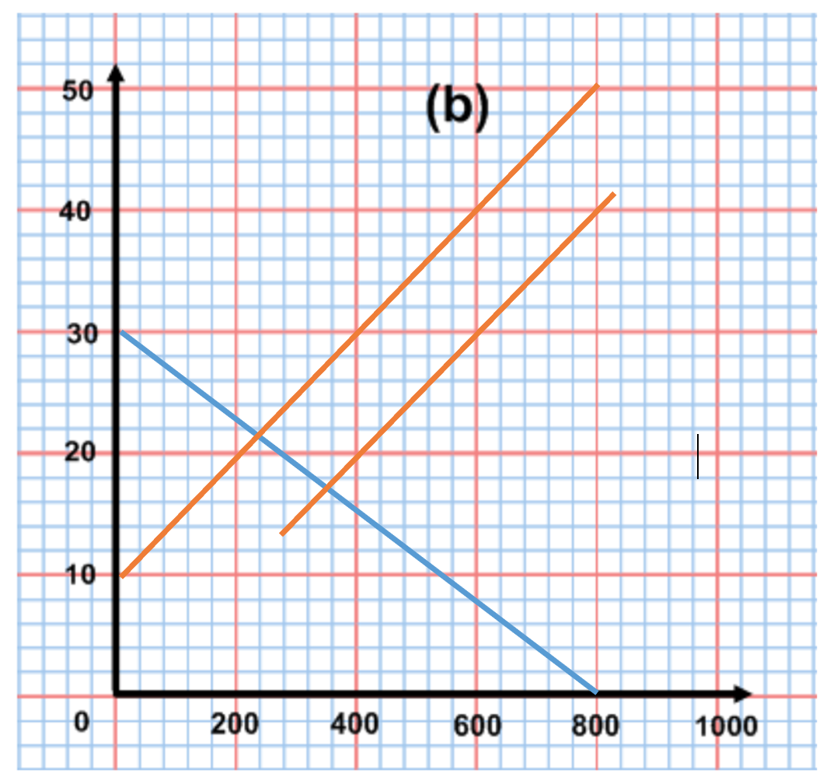

- Determine the equilibrium price and quantity in the market, before the granting of the subsidy.
- Determine the new equilibrium price and quantity in the market following the granting of the subsidy.
- Calculate the increase in the producer revenue after the subsidy is given.
- Calculate the change in consumer expenditure after the subsidy is given.
- Calculate the total expenditure of the government on the subsidy.
- Explain why both consumers and producers will benefit from the granting of the subsidy.
- Identify possible losers from the granting of the subsidy and explain why they may lose.

