Historiography of Genghis Khan

The key evidence and interpretations

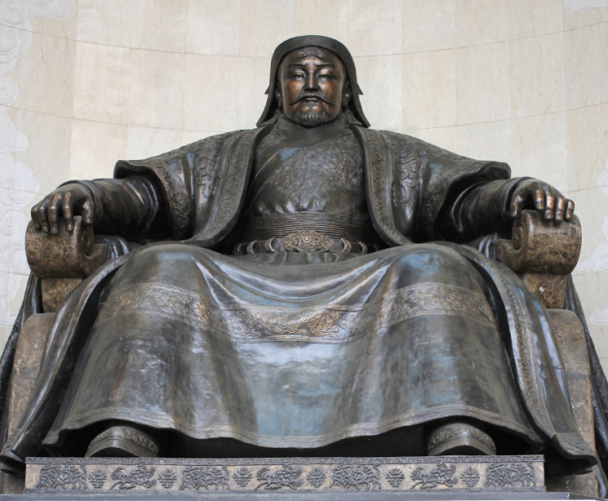

Important Historians – The Mongol Empire

Jack Weatherford
Books

Background/Methodology

Value

Limitations

Notes

Frank McLynn
Books

Background/Methodology

Value

Limitations

Notes

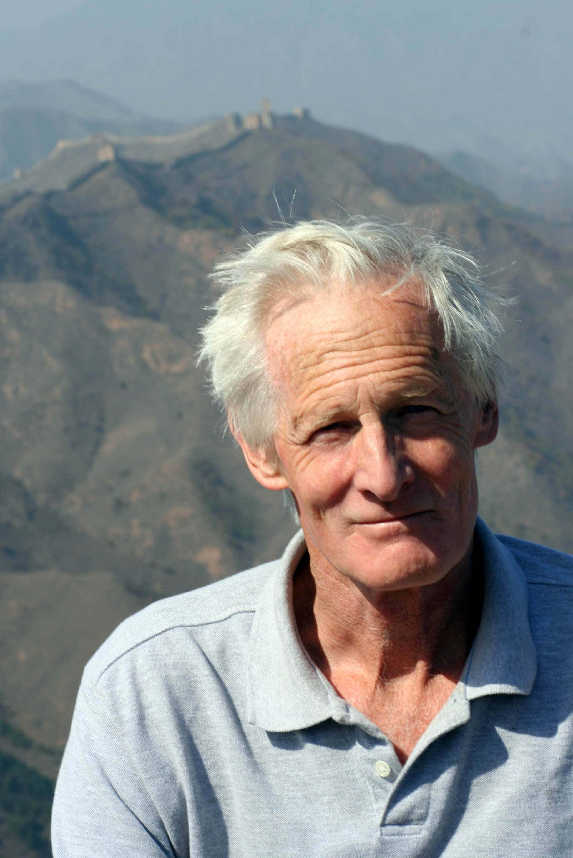
John Man
Books

Background/Methodology

Value

Limitations

Notes

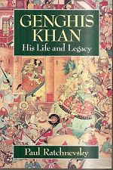
Paul Ratchnevsky

Books

Background/Methodology

Value

Limitations

Notes

Dr Morris Rossabi

Books

Background/Methodology

Value

Limitations

Notes

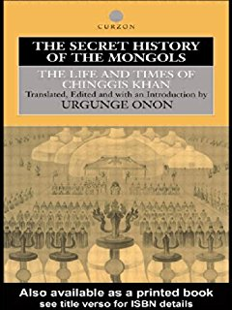
The Secret History - Unknown

Background

Value

Limitations

Notes

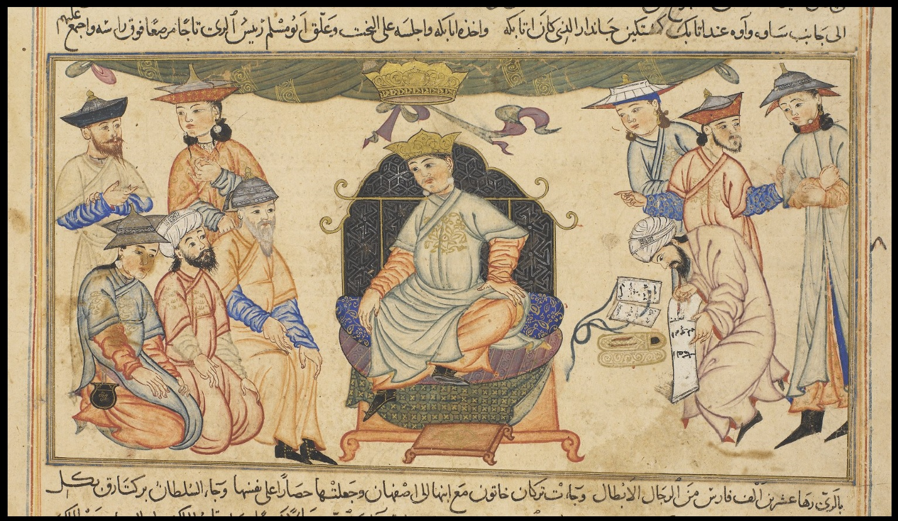
Compendium of Chronicles - Rashid al-Din

Background

Value

Limitations

Notes

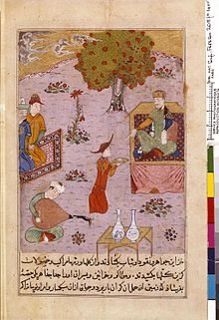
The History of the World Conqueror – Ata Malik Juvaini

Background

Value

Limitations

Notes

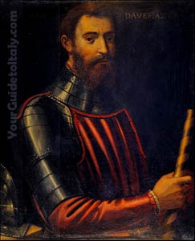
John of Plano Carpini

Background

Value

Limitations

Notes

William of Rubruck

Background

Value

Limitations

Notes

