Haiti Earthquake Case Study (LEDC):
- GDP per capita– 819.90 USD
- Life expectancy at birth – 62.70 years
- Total fertility rate – 3.21 births per woman
- Literacy rate – 61%

Causes of the earthquake:
- The earthquake occurred at a transform/conservative plate boundary between the North American and Caribbean plates).
- The North-American and Caribbean plates are sliding past each other, tension had been building up for some time.
- Friction between the plates stops them moving, however, when tension builds up they can jolt past each other, sending out shockwaves. Tension was released when the Enriquillo Plaintain Garden fault ruptured.
- The epicenter of the earthquake closest to the settlement of Leogane, which was 10 miles from the capital city Port-au-Prince.
- The earthquake measured 7.0 on the Richter scale – a moderately strong earthquake.

Background
- 12th of January 2010 (4.53pm), an earthquake measuring 7.0 on the Richter scale struck the Caribbean island of Haiti.
- Over 220,000 people lost their lives, 250,000 people injured and 1.3 million people were homeless communication, government, police and buildings were wiped out. Also one third of the buildings collapsed in Haiti’s capital Port-au-Prince
- The epicenter of the earthquake was at Leogane, 10 miles from Haiti’s capital, Port-au-Prince
Why was the earthquake so bad?
- Haiti is one of the poorest countries in the world, so it lacked the capacity to cope with the disaster.
- Haiti hadn’t had an earthquake in the past 200 years; therefore, they were not prepared.
- Haiti is a multi-hazard location - it also experiences hurricanes, flooding and landslides. These happen far more frequently than earthquakes. In 2010 Haiti was still recovering from two hurricane events that had occurred in 2008.
- Poor building quality and widespread poverty meant most people were very vulnerable to the damage of the earthquake.
- Lack of building regulations meant that the buildings were not designed to withstand earthquakes. A lot of the houses didn’t have support and were constructed on slopes.
- Half of the people were living below the poverty line; they had little or no resources to help themselves recover from the disaster.
- The government had very little money, and therefore was unable to independently cover the damage caused or provide all of the necessary supplies.
Short-term impacts and responses:
- NGO’s from around the world tried to meet needs of as many people as possible as they had been separated from families and roaming on the streets.
- Distributing food was a major challenge as the first few trucks were robbed. There were no systems for the disposal of sewage therefore with millions of people living on the streets, sanitation was poor, and diseases spread quickly .
- Oxfam delivered supplies; it was hard as most of the roads were damaged.
- Rain comes into the makeshift tents; many of the buildings were unstable and therefore could not house people anymore, as they were too dangerous.
- Made major camps at the edge of the city to house more than a million homeless people.
- Moving people to camps made it easier to provide services to people. Land ownership was hard to determine who owned lands; therefore, it was hard to find sites to set up camps, as the government doesn’t have enough resources to find this information.
- Aid agencies were reluctant to spend money to create these temporary services without getting permission from the landowners. Some of the camps were built on rubbish dumps and low-lying lands, thus susceptible to flooding. A Latin American company created a well in the caps to allow people to access fresh water as most of the people were relying on emergency handouts.
- Yele Haiti and World Vision also gave out hot meals with rice and beans to allow people to have access to nutritious food so they could survive. They also built toilets and showers, but these services were very basic. By April 2010, all the victims in the camps had access to fresh water, basic housing and sanitation.
Medium term impacts and responses:
- Social effects – sleeping on streets next to victim of earthquake, lots of children died and severe injuries occurred.
- After 3 years, people still lived in cramped conditions in the tents.
- Lots of people lost their jobs – losing their stock and most of them don’t have any money to start a new business, as they need to provide food for their family. This lead to domestic violence and theft.
- More than 300,000 are still living in the camps because they don’t have means of making an income.
- 1000’s was injured, thus reducing their ability to be employed, and became dependent on others, creating a greater social impact.
- 30,000 schools and businesses were destroyed.
- NGO’s tried to regenerate the economy using existing business to meet the needs of the people living in the camps.
- People set up 85 canteens and set up food stalls by providing people equipment to provide food to the people in the camps. Lots of the skilled workforce was employed to try and make more permanent housing but majority of the people still didn’t have jobs leading to social unrest
- Cholera appeared 9 months after the earthquake in October, due to unsanitary conditions. To combat the disease, NGO’s set up clinics for emergencies and people in rural areas who were far from clinics, were provided tablets to be dissolved and drunk with water.
- Sewage was not treated properly, which ended up getting into the water supply, contaminating water resource which was drunk by Haitians, making them sick.
- Many camps have clinics of their own and safe drinking water lead to lower death rates from cholera.
Long-term impacts and reponses:
- Prepare people for future events. Earthquake simulation exercises have then evaluated the coordination of international and national emergency services.
- Impacts of earthquake are never the same on everyone, with the greatest effects on the poor. Before the earthquake 10 50% of Haiti’s population were living below the poverty line – it was 80% after the quake.
Community, national and international responses:
International – PeePoo bags by Oxfam;
- In Haiti thousands of people were left without sanitation, often camping in tight compacted and concreted areas where no latrines could be dug.
- So, Oxfam tried various solutions - such as peepoo bags. These are bags that allow people to safely dispose of their toilet waste.
- To use a peepoo bag, a person must attach the bag to a seat on a modified commode.
- There is urea at the bottom of the bag, which helps breakdown the waste.
- The peepoo bag is then disposed of in large bins, which are continually taken away.

Short-term community responses:
- Rescue efforts began in the immediate aftermath of the earthquake, with able bodied survivors extricating the living and the dead from the rubble, of the many buildings which had collapsed. However, treatment of the injured was hampered by the lack of hospital and morgue facilities.
Long-term international responses:
- There was a peak of 22,000 US military personnel in Haiti in February 2010 ,when large numbers were dispatched to help in aid effort. The US military ended its disaster relief mission in Haiti in June 2010, nearly 6 months after the massive earthquake struck. Some 500 National Guard troops and reservists remained in Haiti to help aid workers.
- The US secretary of state co-chaired a conference of about 120 countries and international organisations at the United Nations in New York to help to co-ordinate the aid response. The conference drew $9.9bn of donations to help rebuild Haiti.

Building resilience and future capacity:
- Ensuring people have people have quake resistant housing
- Improving heath and sanitation
- People living in camps don’t have enough money to rebuilt organisations but NGO’s such as Oxfam started offering financial support for rent.
- Oxfam trained people to build structures that are more resistant to earthquakes.
- Some neighborhoods have been constructed in dangerous areas, NGO’s bought the land and rehoused people in the outskirts of Port Au Prince. The new houses have a clean water supply and 1 toilet among 5 families, but there are no jobs in the area. Therefore people need to travel long distances to find work and earn a living. These houses are also rent free, thus attracting people out of the camps and into the outskirts of the city. Transport connections are also weak so people living here are cut off from the rest of the city, thus spending a proportion of their income on transport.
- Many people have now become economically independent due to micro credit schemes from Oxfam, which have allowed people to rent spaces and stock up their businesses.
- Oxfam funded research project is started to research how to increase crop yields and reduce dependence on expensive imports. Improving food security is also about enabling that farmers get better return for their crops. Farmers have to transport their crops over large distances. Oxfam has made small processing rice mills, which allows farmers to process their rice at lower prices and a better profit in the market.

Management in Haiti:
Prediction:
- A 2006 study team presented a hazard assessment of the Enriquillo-Plantain Garden fault system to the 18th Caribbean Geologic Conference in March 2008, noting a large strain on the fault.
- The team recommended "high priority" historical geologic rupture studies, as the fault was fully locked and had recorded few earthquakes in the preceding 40 years.
- An article published in Haiti's Le Matin newspaper in September 2008 cited comments by geologist Patrick Charles to the effect that there was a high risk of major seismic activity for Port-au-Prince.
Prevention:
- There are many ideas for cheap earthquake proofing but the Haitian government has never enforced building codes.
- The devastation in Haiti wouldn’t happen in a developed country,” Yet it needn't happen anywhere. Cheap solutions exist.
- Researchers in India have successfully tested a concrete house reinforced with bamboo.
- A model house for Indonesia rests on ground-motion dampers: old tires filled with bags of sand. Such a house might be only a third as strong as one built on more sophisticated shock absorbers, but it would also cost much less—and so be more likely to get built in Indonesia.
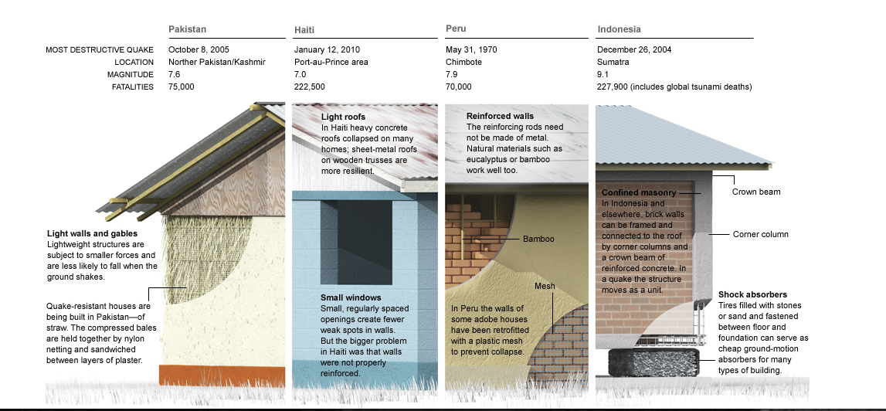
- In northern Pakistan, straw is available. Traditional houses are built of stone and mud, but straw is far more resilient.

Preparedness of the population:
- Haiti only has 2 fires stations and no army (this was demolished in 1995)- it was powerless to do anything itself
- The Health service was already bad but many hospitals were also destroyed in the quake
Aid in Haiti after the earthquake:
- The neighboring Dominican Republic was the first country to give aid to Haiti – hospitals also made available
- 7 days after the quake there was only enough food to feed 200,000 people
- Help was pledged from various countries e.g. Britain, Cuba, France, Germany
- Crews of Dominicans including engineers and telecoms technicians were the first to join the relief effort
- The world bank gave a $100 million from its emergency fund
- EU pledged $13.7 million most aid arrived too late for those trapped under the rubble or awaiting treatment
Months after the disaster: (more notes before)
- Building shelter robust enough to support heavy rains and hurricanes
- 550 000 were in makes shift camps and equal were sleeping rough.
- Many people were too scared to go back to their homes due to aftershocks
- For many proper housing is years away

