Global population growth

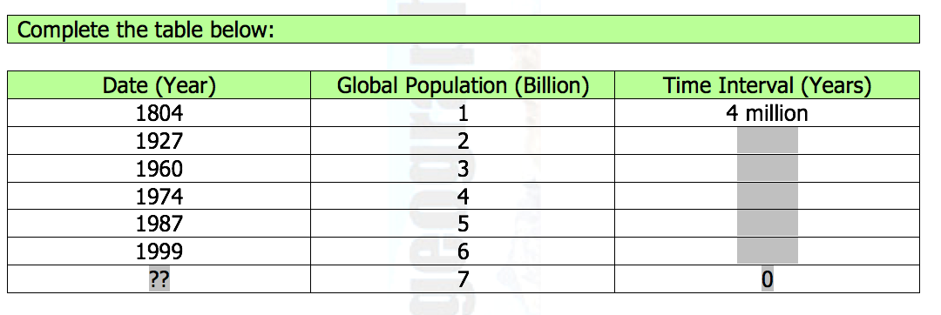
2. Plot this data onto the graph paper provided and use your graph to fill in the box with ?? in it.

3. Use the data to answer the following questions
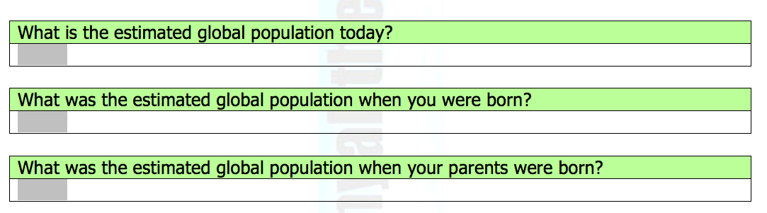

4. Using historic and future global population growth describe the overall pattern of global population growth (4).
