Geography in the News 14 (2019/20)
Wider reading in Geography
Geography in the News this week examines food insecurity in Lesotho.
Define It

To begin with, it will be very useful is know what the following terms mean. Write a definition for each:
Drought

Famine

Mitigation

Inter-governmental organisation (IGO)

International Monetary Fund

Next, read this article about the drought in the African country of Lesotho:
https://www.theguardian.com/global-development/2020/jan/30/drought-leaves-tens-of-thousands-in-lesotho-one-step-from-famine

Tiny URL: https://tinyurl.com/lesothodrought

The Facts

- Why is Tšepo Molapo concerned for his grandchildren?
- How many people in Lesotho face severe hunger?
- Why are people in Lesotho facing severe hunger?
- How many people in rural areas are one step away from famine?
- Identify the inter-governmental organisation (IGO) that launched a $34m appeal for more funding.
- Why are the government facing difficulties in receiving help from its development partners?
- How is the European Commission providing support?
- How is the World Food Programme (WFP) providing support?

The Facts

Identify the location of Lesotho on the map below. Describe the location of Lesotho.
https://www.internetgeography.net/homework/describing-location-in-geography/
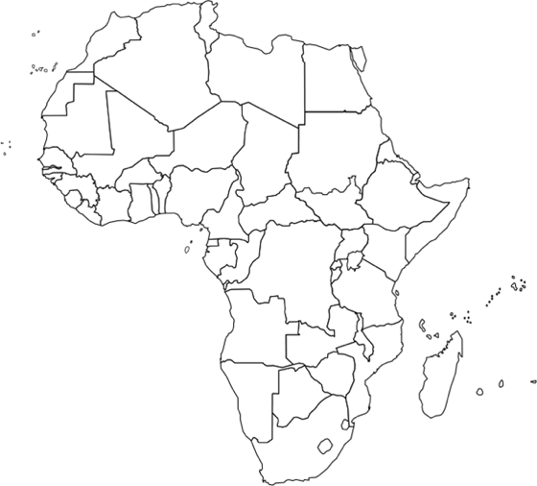
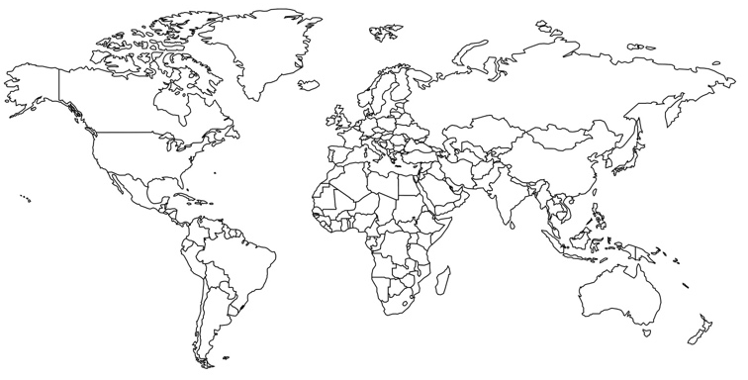

The Impacts

What are the social, economic and environmental impacts of drought?
The Links

Social Impacts | Economic Impacts | Environmental Impacts

https://www.internetgeography.net/homework/synoptic-links-in-geography/
How does this article link to what you have previously studied in geography and/or what you already know? How does this link to other aspects of geography?
The Next Level

The current response to the crisis is Lesotho focuses on the impacts of the drought. However, steps can be taken to mitigate the impact of drought. Mitigation means taking actions before, or at the beginning of, drought to help reduce the impacts (or effects) of drought. What can be done to mitigate drought?

