Geography in the News Coronavirus
Wider reading in Geography
Geography in the News this week examines the outbreak of coronavirus.

This week you are to complete independent research into the coronavirus.

Geographical Questions - To get started, create geographical questions you will research about the coronavirus. Need help? Take a look here: www.internetgeography.net/asking-geographical-questions/

What caused the outbreak?

The Facts – Research the coronavirus and answer your geographical questions.

Map It – Create a choropleth map to show the global distribution (spread) of confirmed cases of the coronavirus. Create a key and shade each country according to the number of confirmed cases. There is an example for confirmed cases in China below.
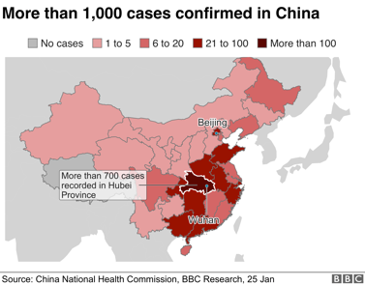
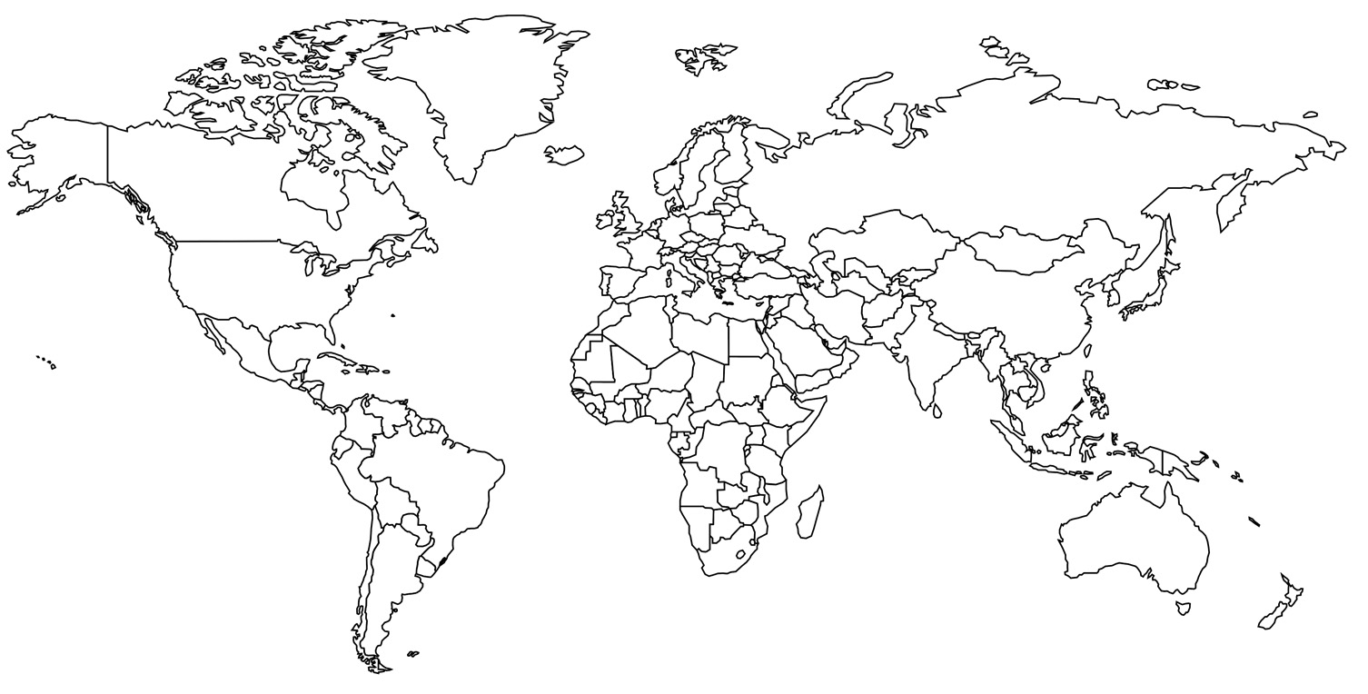

The Impacts – What are the social, economic and environmental impacts of the coronavirus?
Social Impacts | Economic Impacts | Environmental Impacts
The Links - https://www.internetgeography.net/homework/synoptic-links-in-geography/
How does this article link to what you have previously studied in geography and/or what you already know? How does this link to other aspects of geography?

The next level – Explain the importance of geographers studying major outbreaks like the coronavirus.

