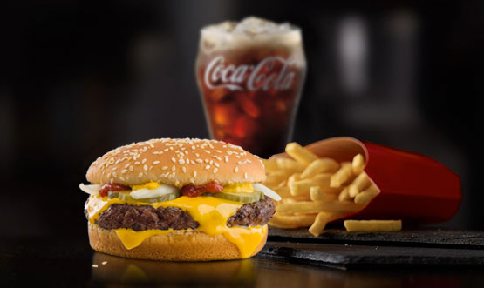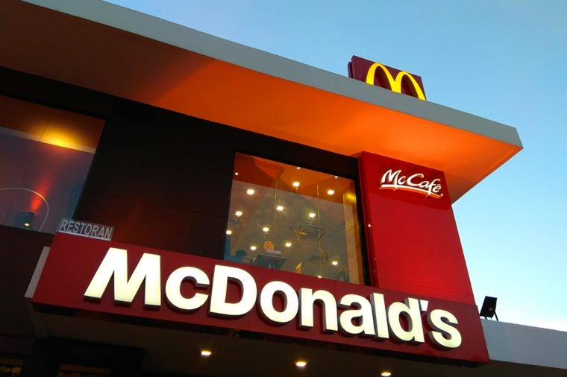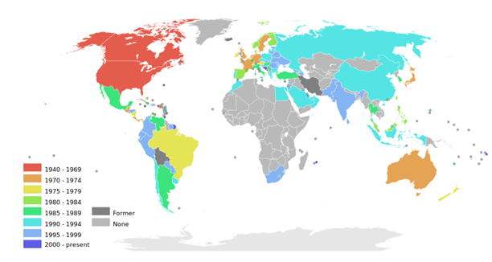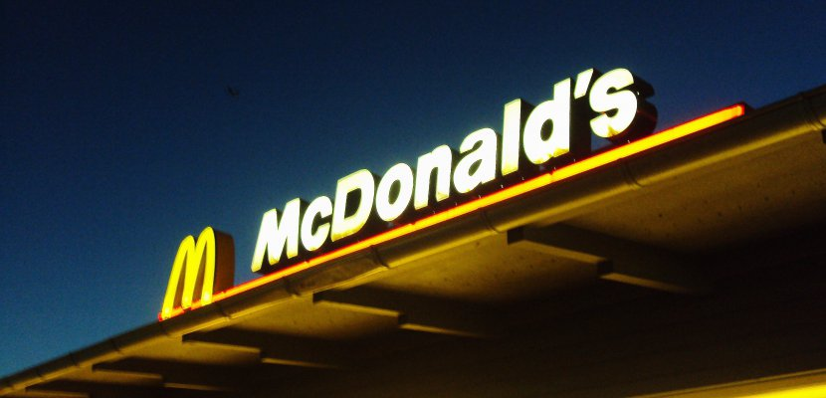

HL Paper 3 – Networks and Flows

McDonald TNC

“I’m lovin it.”

Major Product Releases

Ordered in terms of success:

1. French Fries: 1955
2. Big Mac: 1967
3. Snack Wrap: 2006
4. Happy Meal: 1979
5. Egg McMuffin: 1972
6. Baked Apple Pie: 1968
7. Chicken McNuggets: 1983
8. Double Cheeseburger: 1965

# Group Details:

# Fast-food restaurant.

# Headquarters are in Chicago, Illinois.

# The Chairman is Enrique Hernandez Jr.

# The CEO and President is Steve Easterbrook.

# Revenue: $22.820 billion in 2017.

# In 2017, they had 235,000 employees.

* In 1950, Ray Kroc visited a restaurant in San Bernardino. It was very successful and was run by Dick and Mac McDonald. He was surprised by the effectiveness of their operation.
* They had a limited menu of only three products consisting of burgers, fries and drinks, which made them very efficient.
* In 1955, he founded the McDonald’s System Incorporation through his first facility.
* First McDonald restaurant opened in 1955 in Illinois.
* Dick and Mac were the first creators of the drive-thru.
* His vision was that there would be 1000 McDonalds restaurants in the US, but they continued to grow and expanded into international markets in the beginning of 1976.
* Now the company has 36,000 in over 100 nations, the most recent opening being in Kazakhstan.

The Origins

Global products and services have to be delivered locally at each individual restaurant contrasting with other corporations like Apple. McDonalds products can’t be delivered from international locations.

* It is a global operation based in the US, with standardized products (BigMac, fries, coke) but only those independent to certain countries.
* Achieves economies of scale from international locations, with global brands and global satisfaction.
* Reasons for local strategies:

1. Local tastes and customs, beef is fundamental for recipe formula, but some countries don’t eat beef (India), where cows are seen as holy. Even in China chicken is more popular than beef. McDonalds has many local varying menus, e.g. a Chinese menu in Germany, and vegetarian dishes in India.
2. Local competition: different fast food chains have developed in different countries e.g. Nandos in South Africa but not in the US.
3. Local laws and their governments have different rules regarding what can be sold e.g. beer is sold in Spain McDonalds, but not in the US.
4. Local franchise operations: they don’t own all restaurants centrally, for many years it’s operated as a franchise system.
5. Local service quality: headquarters in the US require international standards for product range, but products are cooked locally in each restaurant with locals specifying their preferences.

Global and Local Strategies

## POWER

## It serves more than 40 million people per day.

## They have a corporate symbol and have saturated advertisement, which has driven the advertisement of their image and logo globally.

## The power rooted from McDonalds has resulted in the global phenomenon of the restaurant.

## Steve Easterbrook: CEO of McDonalds since March, 2015 and now has a salary of over $15 million a year.

4 P’s

Connecting People and Places

The greatest achievement for McDonalds was creating an image in the minds of people and introducing them to the fast-food culture that America has.

PLACES

## It drives 80% of its revenue from 8 countries, like Canada, France, Germany and the US.

## The top 3 countries with the most McDonalds:

## USA: 31.5% of the revenue comes from the US alone.

## Japan: it was the first market places for McDonalds in Asia, now with around 2,975 restaurants.

## China: 2,391 locations.

## They have attempted to move to more inaccessible places such as Bolivia, but the cuisine was not regarded as preferences differed from that of a typical American.

Processes:

* Over the past 50 years McDonalds has globalized into many different international markets.
* It was first located in the US during the 1950’s, then spread to Europe, Australia and Japan in the 1970’s.
* In the 1980’s it spread to Mexico, South America and South East Asia.
* The most recent spread occurred in China, Russia and Arabian countries throughout the 90’s.
* At the start the company had a rapid growth and between 1961 and 1999 it was 24% annually. But, because the US fast food market was already saturated, they decided to expand into different countries.
* In 1991, McDonalds had more outlets overseas than in the USA.
* 1996 was the peak year, when 200 restaurants were opened globally.

**Real Estate**

Mcdonald's makes a lot of their profits from real estate. They have licensed franchises that fall under much larger corporations. 1/3 of their $27.4 billion in revenues come from franchised restaurants.

"The only reason for which we sell 15 cent hamburgers is because they are the greatest producer of revenue, from which our tenants can pay us our rent".

**Costs**

Limited menus can cut down on overhead costs, producing higher profit margins.

Foods they offer are cheaper to make so they cash in on extras. E.g. cost of avocado is 50c while its price is $2.

Low prices --> low wages (just a little bit above of federal minimum wage).

**Marketing strategies**

Coupons and value menus lure customers into restaurant.

Marketing strategies like aesthetically appealing images of more expensive products.

Psychological tactic of asking "will you like fries with your orders", because they know it is hard for customers to say "no".

Sheer convenience --> faster option to eat and not cook

Global Strategies

POSSIBILITY

* In March 2017, they introduced a velocity growth plan. The key pillars of the growth strategy are:
  + Retain: fortifying and extending areas of strength and focusing on breakfast and family occasions.
  + Regain: regaining lost customers through improvements in taste and quality of food.
  + Convert: converting casual customers to more committed customers with coffee and snacks.
  + Digital: Re-shaping our interactions with customers.
  + Delivery: bringing McDonalds into homes, work places and dorms.
  + Due to the negative views from business analysts on the impacts of the cheap, bad quality food, they are now trying to improve the nutrition values within the food.
  + Promoting higher margin food.
  + Getting in on the fast casual dining boom (contrasting with drive-thru)
  + Improving the product range to include more healthy options.