Source Evaluation

Source | Values | Limitations
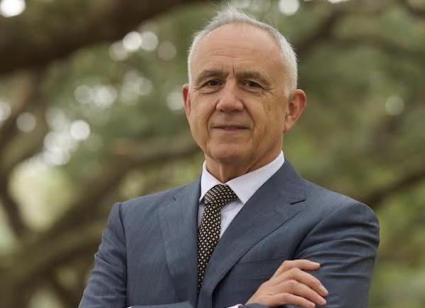  Jack Weatherford - Professor of anthropology at Macalester College in Minnesota. He is best known for his 2004 book, Genghis Khan and the Making of the Modern World. In 2006, he was awarded the Order of the Polar Star, Mongolia’s highest national honor for foreigners. | Origin:  Purpose:  Conetnt: | Origin: He is an anthropologist – his focus is on indeginous cultures and he specialises in Native American Culture. He will have an anthropologists perspective when looking at the Mogols. He will focus more on society and culture. “Weatherford provides a different slant on Genghis Khan than has been typical in most Western accounts, attributing positive cultural effects to his rule”  Purpose: Popular book made for the general public and the book charts. Won numerous awards and was best seller for two weeks in 2004. Written for popular audience it may wish to be engaging – sacraficing some aspects of accuracy.  Content: A review by Timothy May in 2005 notes that the book lacks footnotes, and notations in the back are hard to follow and lacking in many cases. In addition, he writes, "While the overall thrust of the book is on target and may promote new discourse on the influence of the Mongols in history, it is undermined by numerous mistakes." May recommended against the book's use in history classes.
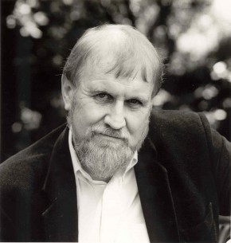  Frank McLynn  a British author, biographer, historian and journalist. He is noted for critically acclaimed biographies of Napoleon Bonaparte, Robert Louis Stevenson, Carl Jung, Richard Francis Burton and Henry Morton Stanley.  McLynn was educated at Wadham College, Oxford and the University of London.^{[2]} He was Alistair Horne Research Fellow at St Antony's College, Oxford (1987–88) and was visiting professor in the Department of Literature at the University of Strathclyde (1996–2001)^{[3]} and professorial fellow at Goldsmiths College London (2000–2002) before becoming a full-time writer. | Origin:  Purpose:  Conetnt: | Origin:  Purpose:  Conetnt:
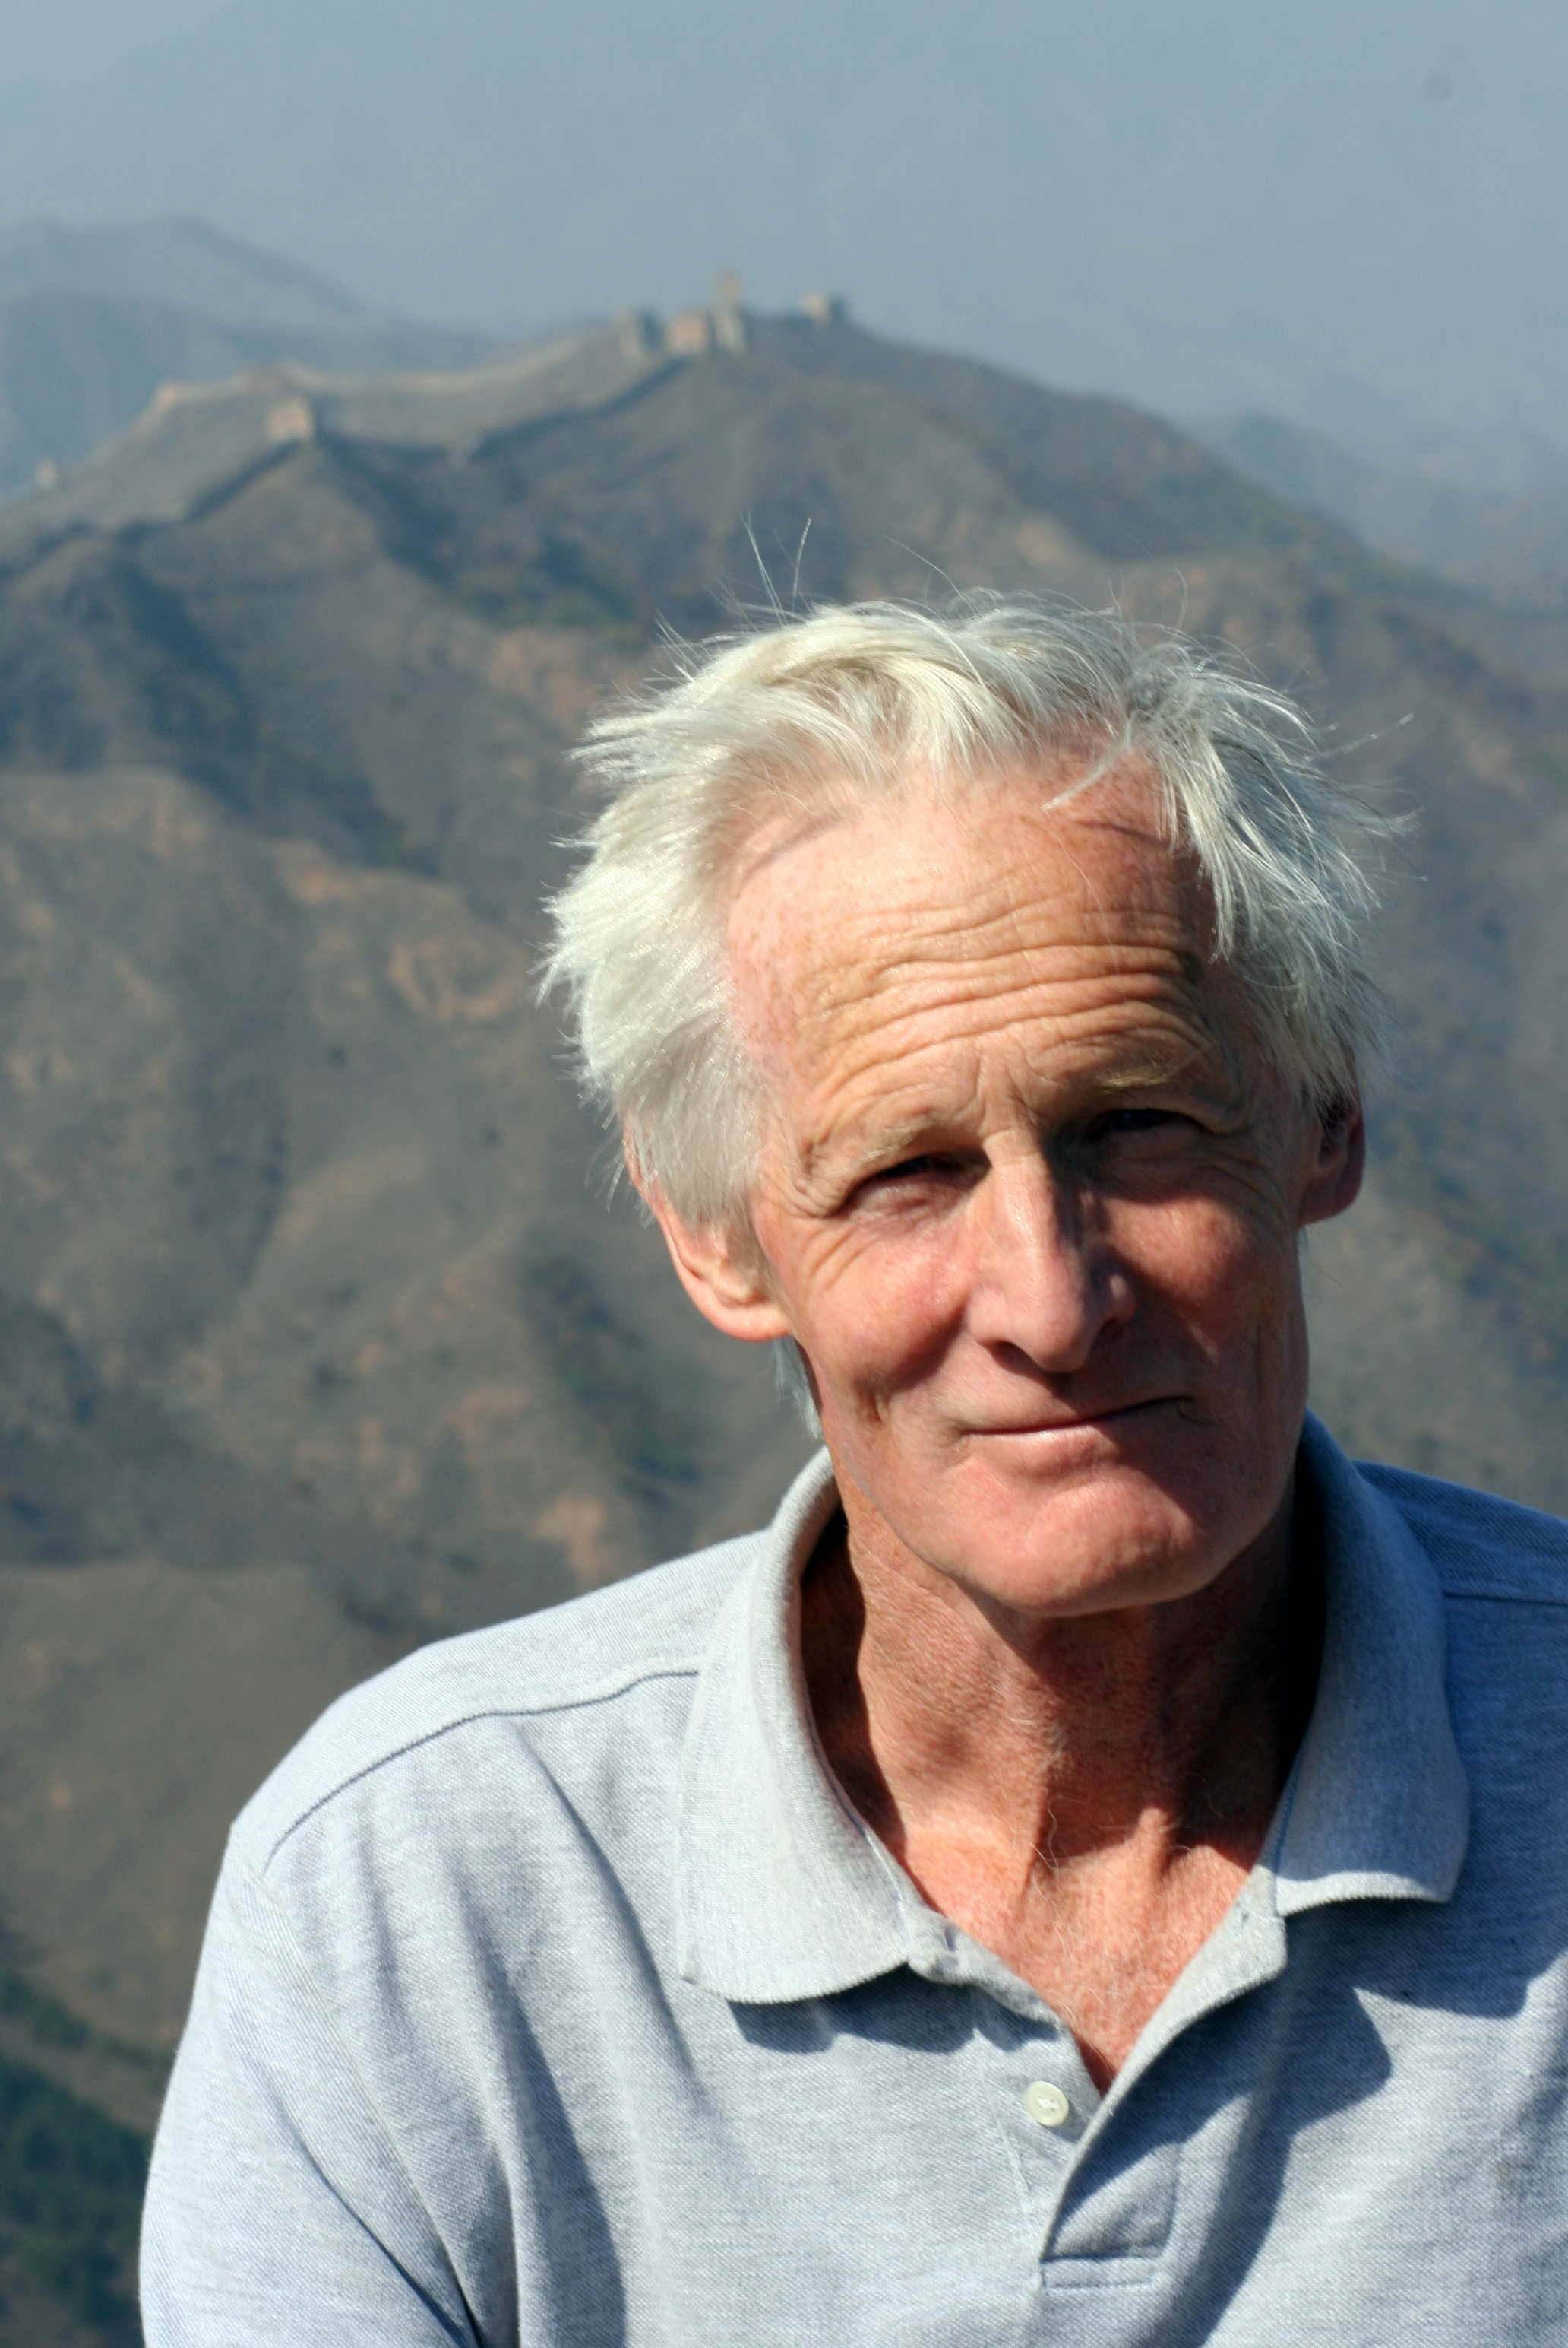  John Man | Origin:  Purpose:  Conetnt: | Origin:  Purpose:  Conetnt:
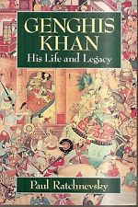  Paul Ratchnevsky | Origin:  Purpose:  Conetnt: | Origin:  Purpose:  Conetnt:
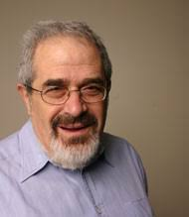  Dr Morris Rossabi | Origin:  Purpose:  Conetnt: | Origin:  Purpose:  Conetnt:
Source | Values | Limitations
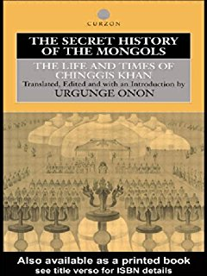
The Secret History - Unknown
Compendium of Chronicles - Rashid al-Din
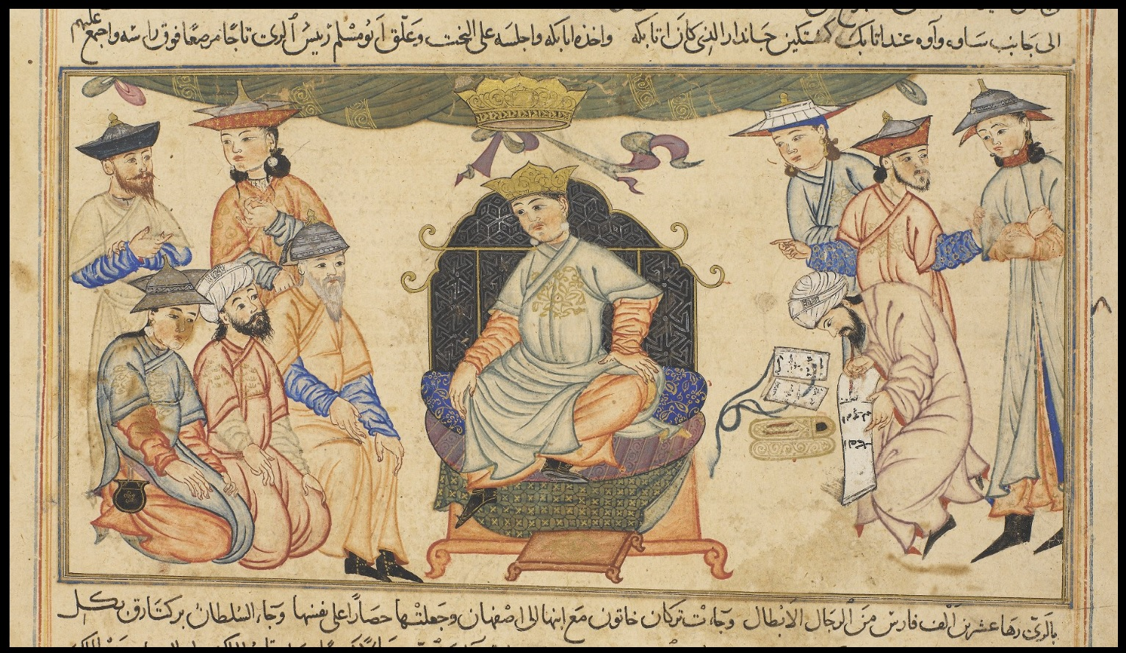
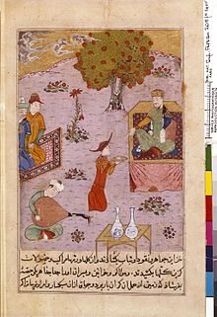
The History of the World Conqueror – Ata Malik
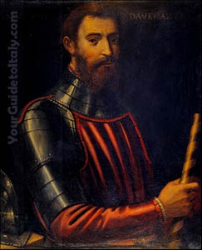
John of Plano Carpini

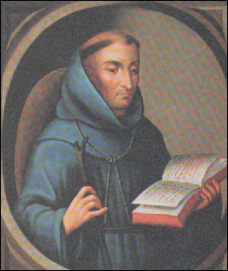
William of Rubruck

