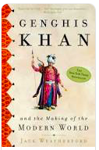
Genghis Khan – Jack Weatherford

Introduction

- What is the significance of the Spirit Banner?

- How did Genghis Khan’s Childhood shape his character?

- In what ways were the Mongol army unique? What made them successful?

- Describe Genghis Khan’s ‘New World order’.

- Explain the story of Genghis’ burial.

- Why did the Soviets restrict Genghis’ burial lands?

- Why did the Mongols only build bridges?

- How significant is the influence of the Mongols across the lands that they conquered?

- Why do the Mongols have a negative reputation throughout history?

- Why has it been difficult for Historians to find research on Genghis Khan?

- What is the ‘Secret History’?

- Describe Jack Weatherford’s methodology. How did he conduct his research?

