IGCSE Geography coursework guide

Geography Student
Coursework Guide

Important note:
Your Geography coursework is an important part of your IGCSE and contributes 27.5% towards the final grade. This booklet is designed to help you to get the best mark possible in your coursework assessment. If you read the marking criteria, follow the advice and tick every box, then your coursework should be of a high standard. It is important to bear in mind that we as your teachers mark this coursework, so any advice or suggestions we make if not considered will likely adversely affect your grade.

Why coursework?
- Critical thinking
- Creativity
- Independent learning
- Application of theory to real life

All pieces of coursework need to follow the Route to Enquiry that is outlined below.
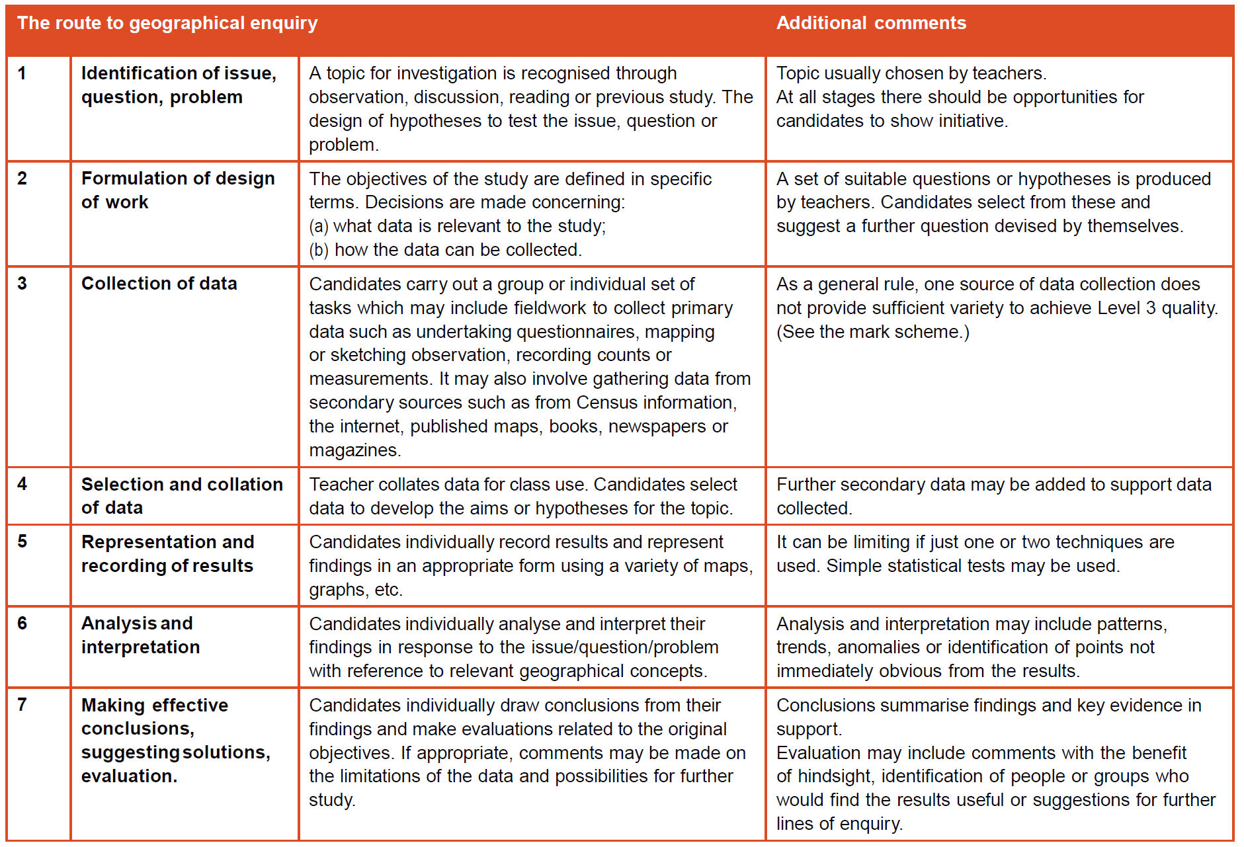

Plagiarism:

Plagiarism is the act of presenting someone else’s work or ideas as one’s own. This might happen in a number of different ways:
- failing to acknowledge quotations and concepts
- using particular graphs, phrases or sentences from another author without giving them credit via inverted commas and a footnote
- writing something that is only very slightly different by altering a few words of another author’s work (i.e. paraphrasing it)
- buying a project from an internet site and presenting it as one’s own
- downloading and pasting text or images from an internet site without acknowledgement
- getting somebody else to write all or part of one’s own work
- copying graphs or text from past or present students

Assessment of coursework:

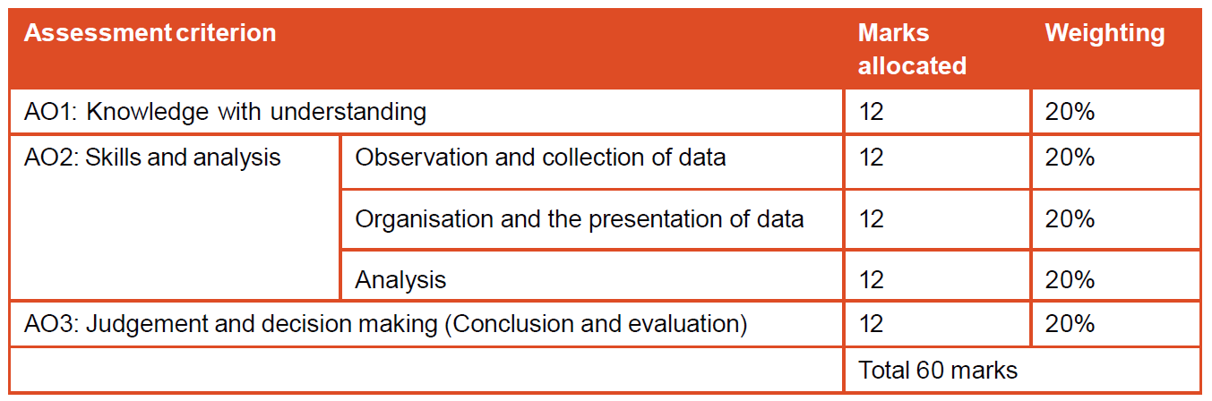

Assessment Criteria | Level 1  1–4 marks | Level 2  5–8 marks | Level 3  9–12 marks | Word count  (2000 total)
Knowledge with understanding (within the context of teaching and guidance)  (max 12) | Describes information in simple geographical terms and shows a tentative grasp of the aims. | Outlines relevant information using appropriate geographical terms and develops a clear link between the aims and geographical ideas. | Provides comprehensive information with a careful use  of appropriate geographical terms and the aims are clearly related  to relevant key geographical ideas. | Introduction 300
Skills and analysis  • Observation and collection of data (max 12) | Shows evidence of some ability to collect and record basic information from limited sources and shows evidence of simple planning. | Collects and records relevant information from valid sources with evidence of sound planning. | Collects and records detailed data from a range of valid sources within a clear planning design. | Methodology 300
• Organisation and presentation (max 12) | The presentation is loosely ordered and uses one simple presentation technique appropriately. | The presentation is logically ordered using two or more presentation techniques appropriately and effectively. | A coherent presentation using a range of appropriate techniques with accuracy and clear relevance to the aims. | Word count of graphs, calculations, annotations, labels or titles do not count as part of the 2000 word limit.
Analysis (max 12) | Makes descriptive and simple comments about the information. | Makes a number of valid statements about the data with some explanations attempted. | A thorough interpretation of the data with reasoned explanations and comments. | 1000
Conclusion and evaluation  (max 12) | States superficial conclusions showing tenuous links to the original aims. Simple evaluation showing little awareness of any shortcomings. | States tentative conclusions linked to the original aims. Some judgements linked to information collected.  Some evaluation of a limited range of weaknesses. | States clear conclusions in the light of the aims, clearly related to evidence collected. Makes a sound evaluation identifying weaknesses and suggesting improvement. | Conclusion 200  Evaluation  200

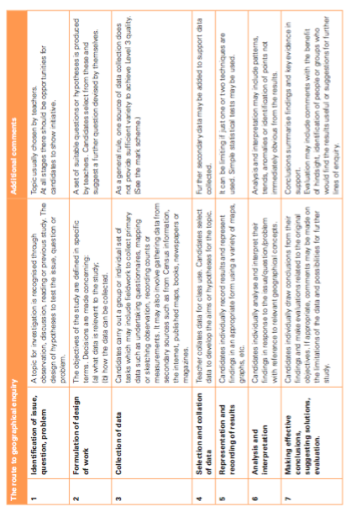
Topic for Investigation

Has tourism had both positive and negative environmental impacts on Seawall Boulevard in Galveston, TX?

Key Questions and Possible Hypotheses:
You will need to pick 3 different hypotheses to study in this piece of course work.

You can come up with your own phraseology for your hypothesis.

When you are completing your coursework it is important that for each section you are able to tick off EACH and EVERY section of the guide. If you cannot do so you will likely lose some marks.

Front Page

DETAILS (what to include) | COMPLETE
Your name
The school code
Your research question
Your word count (up to 2000)

1: Introduction
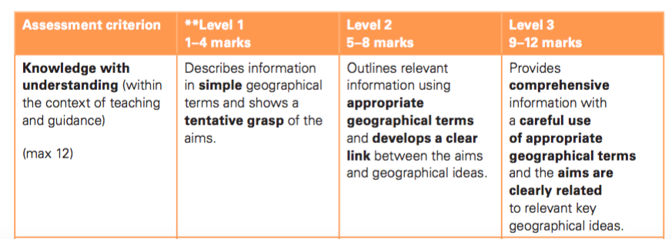

DETAILS (what to include) | COMPLETE
Your research question (this time it must be referred to in your introduction)
Link your research question to the appropriate unit
Introduction to study location. Where, size, brief history, functions.
Describe the location and include maps (these must have a title, scale and compass)- these maps must be fully annotated to explain the relavant locational context
Explain the relevant geographical theory
Introduce your three hypothesis
Expected findings. Explain why you expect your hypothesis to be true, refer to theory.

Section 1: Introduction
What are you investigating?
- State the question
- Put the question in context of your study (ideas on introduction ppoint)
- What are your aims?
Link to syllabus :
Section 3.4 “Describe and explain the growth of tourism in relation to the main attractions of the physical and human landscapes” - Introduction
“Evaluate the benefits and disadvantages of tourism to receiving areas” – Data collection focus
“Demonstrate an understanding that careful management of tourism is required in order for it to be sustainable” – Analysis and conclusion

Location of investigation
- Where is the study located?
- Provide some locational context e.g. relevant background information about Galveston and the types of tourist activities available
- Include 2 at least annotated maps in the introduction?
- Theory i.e: Research on the positive and negative environmental impacts tourism could bring to a coastal location, such as Seawall Boulevard and/ Butler/ honeypot sites
Sub-questions
- How are you investigating? What are your subsidiary questions, how do they relate to your overall coursework question?

2: Methodology
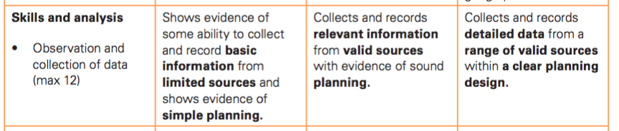

DETAILS (what to include) | COMPLETE
Locate the areas where you collected your data
List the equipment used.
What sampling method did we use to collect the data and why is this appropriate for our study?
Copies of your data collection forms should be imbedded or in your appendix
Explanation of how information is collected (methodology). You can include photos that demonstrate data gathering techniques. Explanation of why you used the particular techniques e.g. tally charts
Briefly explain why this information is important and how it will help you prove or disprove your hypothesis.

Section 2: Method
- Say what we did i.e. field visit to Galveston to collect data, date of visit, group-work.
- What sampling method was used and what was the location of the survey sites- Why did we choose the particular sampling method? (ideas on method ppoint)
- Include an annotated map of the sites
- Provide a description of methods used- what did you do?
- How, why (linked to hypotheses), where, when, what equipment, how many people etc.... JUSTIFY everything!
- You should only write about methods you are using
- Include methods of primary and secondary data – make sure you mention use of GIS

3: Organization and presentation

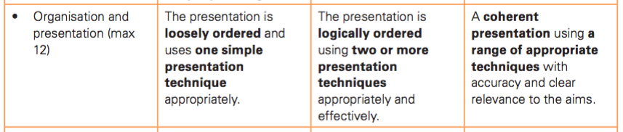

This section spans the whole coursework and must be present in all pages of your final work. However, your graphs, tables and data will influence your grade the most.

DETAILS | COMPLETE
All photos, graphs, images, tables must be labeled with a caption and must serve a purpose – you must refer to them in the main body of the coursework.
All information from the internet or books (secondary information) must be referenced correctly using the Harvard reference system.
A wide variety of different and relevant data presentation techniques used and correctly formated (graphs (line, bar, pie, scatter), tables, maps, annotated photographs, pictograms, radar graphs, etc.)
Target: try and combine data with maps to explain how results varied spatially
All data should be processed and displayed in the most appropriate form

Section 3: Data Presentation:
- Select a range of ways to present the data you are using
- Use mapping and graphing techniques (ideas on methods of presentation ppoint)
- Make sure some methods are more sophisticated (ideas on methods of presentation ppoint)
- Always give a clear title and figure number
- Make sure the methods are appropriate and clear for the data you are presenting
- Only use one method per set of data (i.e. not 3 different ways of presenting the traffic counts).

4: Analysis

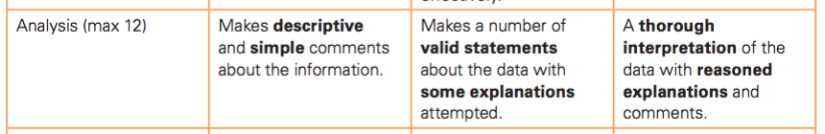

DETAILS (what to include) | COMPLETE
Divide you analysis into three sections – one for each hypothesis (create subheadings for each)
What are your expectations for the data – link this to the theory (why do you expect this)
Look and describe any trends in your data presentation (positive and negative correlations). Use figures and refer to graph/tables/maps.
Look for any anomalies in your data presentation. Use figures and refer to graph/tables/maps.
Explain any locational specific factors that may have impacted your findings
Try and explain any trends or anomalies. This is very important, what theory might help you explain trends, but how can the anomalies be explained?
Relate findings back to study question and hypotheses (ALWAYS answer your research question!). You can not do this effectively without actually reusing the words from the hypothesis and question we are investigating.

Section 4: Analysis:
- State each subsidiary question for investigation
- Describe the pattern in the graphs/photos/mapping techniques relating to that subsidiary question (show good organisation by including page numbers and figure numbers).
- Explain why you think you have that pattern
- Explain how it relates to the overall coursework question/ hypothesis

4: Conclusion

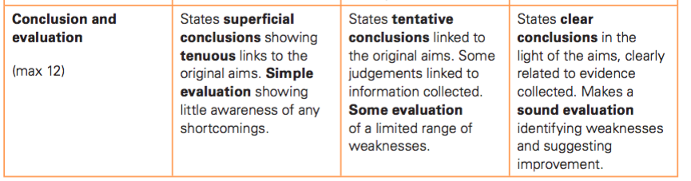

DETAILS | COMPLETE
Refer back to your research question, in one simple sentence try to provide an overview of your findings.
Refer to each of your three hypothesis, did you prove or disprove them? (briefly summarize your findings from the analysis section
Ensure that your hypothesis is consistent with what you are saying in your analysis.
Section 4 continued: Final Conclusion:
Answer the question – Has tourism had both positive and negative environmental impacts at Seawall Blvd in Galveston, Texas?
- What did you find out (summarise)? Provide an answer to each of your subsidiary questions – What did you find? Why did you find this? Was it what you expected? How does it relate to the overall coursework question?
- Overall what positive and negative environmental impacts of tourism exist at Seawall Blvd? Make sure you firmly answer this question.

5: Evaluation
DETAILS | COMPLETE
What were the strongest or most reliable sections of your investigation?
How could you develop your coursework, what extensions could you have investigated i.e. extra data, different hypotheses
Were there any problems with your techniques
Were there any limitations e.g. time, available data.

Section 5 Evaluation:
An evaluation means to provide the strengths and weaknesses of your investigation.
You should refer to the following:
- The strengths and weaknesses of your methods of data collection and how you overcame any problems to strengthen your design. How would you improve these methods if you carried out this study again?
- The strengths and weaknesses of your methods of data presentation. How would you improve these methods if you carried out this study again?
- The strengths and weaknesses of your conclusions. The reliability of your conclusions based on weaknesses outlined for your methods of data collection and presentation. What more would need to be done to improve the accuracy of your conclusions?
- How could you take the study further?

Also….

Planning and organisation
The report should:
- Be well structured and organised with page numbers, figure numbers with sections in the correct order.
- There should be a title page including candidate name and number and task title
- There should be a contents page.
- Diagrams should be integrated into the text with appropriate sub-headings.
- Grammar, punctuation and spelling errors are also assessed
- There should be clear and accurate use of geographical terminology.
- You should use a consistent referencing technique throughout

Coursework is NOT an examination, it rewards students who work hard and who are organised. If you follow this guide you WILL do well!

5

