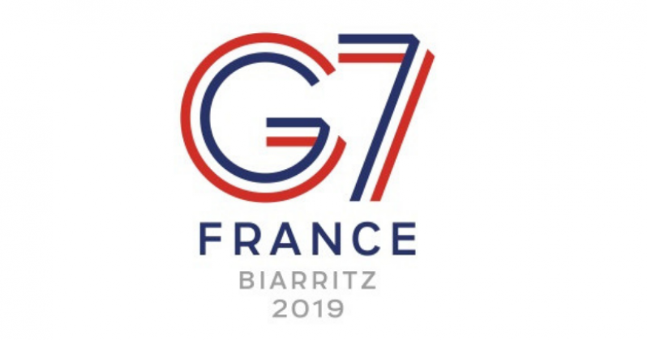
G7/G8

The Group of Seven is an international intergovernmental economic organization consisting of the seven largest IMF- advanced economies in the world: Canada, France, Germany, Italy, Japan, the United Kingdom and the United States.

Established

1975- originally called the G6

History

- Originally started with 4 nations (United States, United Kingdom, France, West Germany) called the library group in mid-1973.
- Eventually expanded 6 nations with the additions of Italy and Japan, had the first official meeting in France.
- European Union was expanded to create the G7 in 1977.
- Russian Federation was invited to the 1994 summit in Naples as an observer (G7+1), and formally joined in 1997 (G8).
- Russia was then formally ejected in 2014 following the Russian annexation of Crimea.

Recent News

- 45th G7 summit
- Held on 24-26 August 2019 in Biarritz, France.
- The meeting had the core 7 representatives alongside guest invitees from Australia, Burkina Faso, Egypt, India, Rwanda, Senegal, South Africa, Spain.

Concluding communiques

- "G7 commits to reaching an agreement in 2020 to simplify regulatory barriers and modernize international taxation within the framework of the OECD"
- G7 shares objectives on Iran "to ensure that Iran never acquires nuclear weapons and to foster peace and stability in the region."
- On Libya "We support a truce in Libya that will lead to a long-term ceasefire. We believe that only a political solution can ensure Libya’s stability. We call for a well-prepared international conference to bring together all the stakeholders and regional actors relevant to this conflict. We support in this regard the work of the United Nations and the African Union to set up an inter-Libyan conference."
- In an opaque reference to the Russian military intervention in Ukraine (2014–present), "France and Germany will organize a Normandy format summit in the coming weeks to achieve tangible results."^{[5]}
- In light of the 2019 Hong Kong anti-extradition bill protests, "The G7 reaffirms the existence and the importance of the 1984 Sino-British agreement on Hong Kong and calls for avoiding violence."

Criticisms of the G7

- https://www.theguardian.com/business/2015/jun/07/scrap-g7-summit-hopeless-divided-outdated
- It is a useless organization that fails to solve many of the worlds problems
- The G7 has for a long time lacked the unanimity and leadership to tackle its many problems, particularly cutting carbon emissions and Greece’s unpayable debts
- http://theconversation.com/g7-throws-up-plenty-of-controversy-and-debate-but-little-compromise-122042
- Throws up plenty of controversy and debate, but there is little compromise between the world leaders
- Since Donald Trump has become president, he has argued with other powers and stirred up controversy
- Trump stirred up controversy for 2020 summit by suggesting that it would be hosted at one of his hotels.

