Friedrich Hayek
00000 – 0000
Infographic: The Serious Health Risks of a Polluted Ocean Source: The Maritime Executive
Date Written: March 11 2021
Date of Article: February 8 2021
Word count: 796
Section 1: Microeconomics
Economic Concept: Sustainability

The chosen article evaluates the impact of ocean pollution on many stakeholders, any individual or group that is interested in or impacted by a situation. It also examines studies which give an idea of the extent of negative externalities generated through the consumption of plastic products. Negative externalities of consumption occur when the consumption of a good or service creates a negative impact on society. These issues link directly to the economic concept of sustainability, and present the significance of opportunity cost within a market. Seeing as the ocean is a common pool resource (resources which are rivalrous but non-excludable), plastic pollution must be controlled. This can be achieved through behavioural economics, which focuses on the decision-making leading up to an economic outcome.

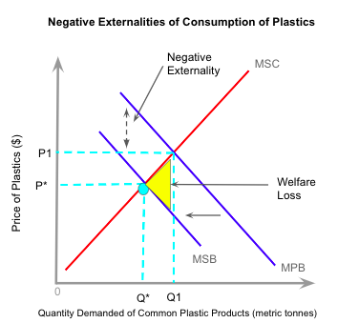
Figure 1.1 -- Negative Externalities of Consumption of Plastics

Plastic is a good that has the potential of adversely impacting society with each unit consumed. With that being said, the negative externalities of consuming plastic arise through marginal social benefits being less than marginal private benefits; the private utility received by stakeholders is lessened by negative utility.

Figure 1.1 shows that MPB>MSC by the size of the negative externality created by consumption. The socially efficient output of plastic is at Q*, so there is an over-consumption from Q1 to Q*. A welfare loss to society and a market failure occur because MSC is greater than MSB at these units. Too many resources are allocated to this market, and the goods are overproduced; an overallocation of scarce resources. In a free market, like the U.S, private benefits are maximised at MSC=MPB, so this is where consumers will consume. Even with a negative externality being produced with greater demand, it will be ignored. This means plastics will still be over-consumed at a demand of Q1 plastics with a price of P1.

The influence of the negative externality poses a threat to sustainability; greater consumption of plastics impacts marine life and humans. The harmful effects of over-consumption create an intergenerational inequity because our actions in the present will reduce the living standards of future generations. Part of the market failure occurs due to the current choice to maximise MPB in the present, so the opportunity cost to this is what MSB could be in the future.

The failure also occurs in part because consumers do not always have perfect information and more often than not, make irrational choices, this is shown through behavioural economics. When enjoying benefits in the present, consumers often badly judge the utility of a product because the consequences may not occur for quite a long time, this is a cognitive bias called Hyperbolic Discounting. Governments and third-party organisations (also known as “choice architects”) have the ability and responsibility to encourage consumers to make better choices to increase their well-being, along with the well-being of society as a whole, and that of future generations through the use of “consumer nudges” which allow consumers to alter their consumption in a voluntary manner. These nudges are essentially methods of government intervention that do not fit the traditional categories of indirect taxes, subsidies, or legislation. Governments or choice architects might use simple policies to incentivise consumers to display a desired behaviour.

As previously mentioned, consumers often have imperfect information about the negative impacts of plastic consumption. This leads to irrational decision making because there is an overconsumption of demerit goods. In order to mitigate this issue, the government could launch a public awareness campaign to create a more balanced understanding of the market failure throughout the population. Figure 1.1 displays this through the leftward shift in the demand curve due to lower consumer demand. This would bring both quantity demanded and price of plastics to their optimum levels. The public awareness campaign would achieve a decrease in welfare loss because consumers are able to act more rationally with the addition of greater knowledge and understanding of the impact of consuming demerit goods on the environment. It might take a bit of time for this tactic to have an impact on US consumers because people are so set in their ways, this links to the status quo bias which states that people would rather continue with their current lifestyle rather than change it even if they would gain greater utility. Though in the long-term, this could be a highly successful campaign. It is certain that some people would receive the new information well and would choose to change their consumption habits, this could lead others to adopt these changes too due to the natural desire to fit in with others (social conformity). Sustainability is a concept that cannot be achieved without the participation of various stakeholders such as government, consumers, and firms. The actions of these groups (to employ policy, change consumption, or change production) will have an impact on the living standards of future generations.
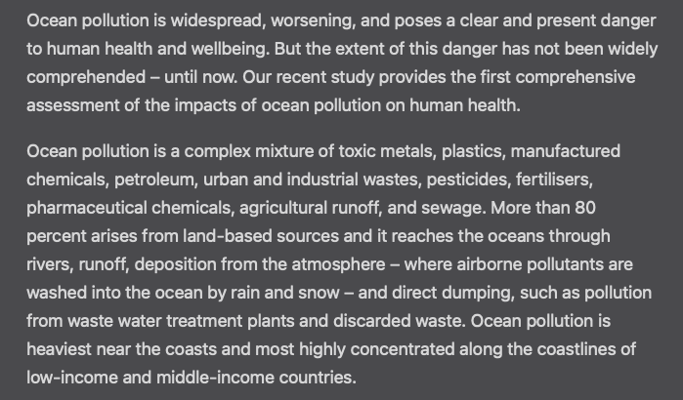
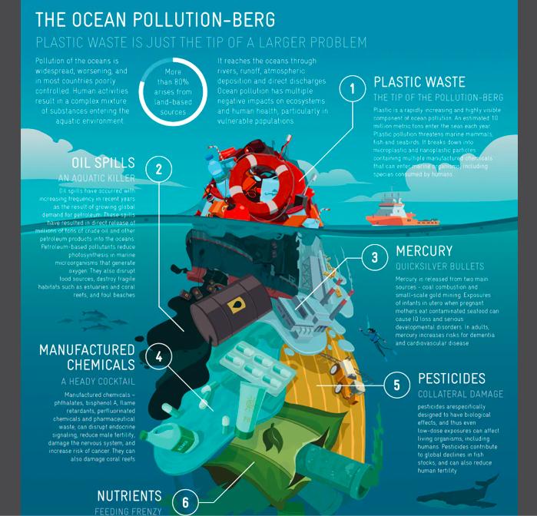
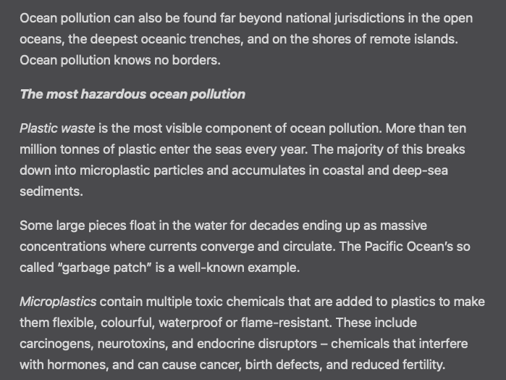
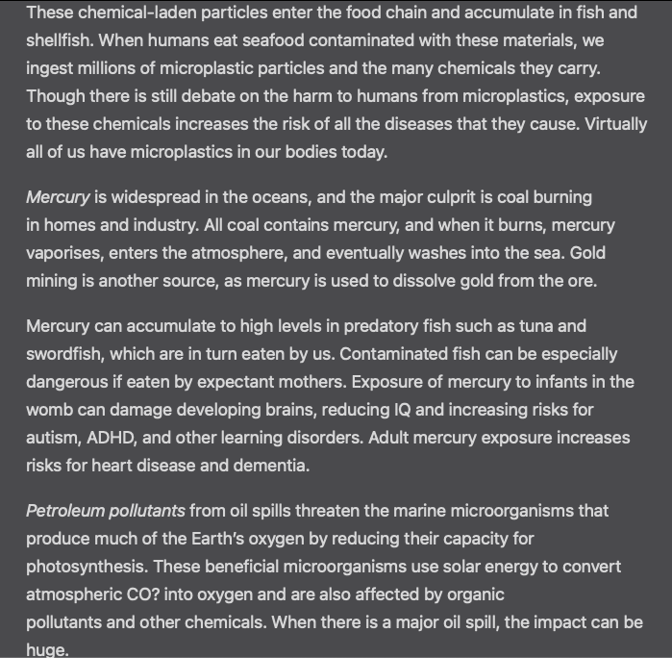
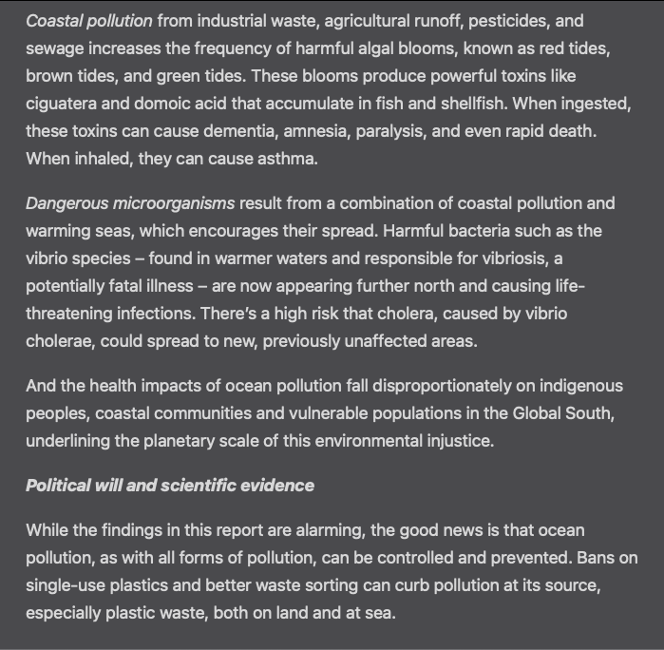
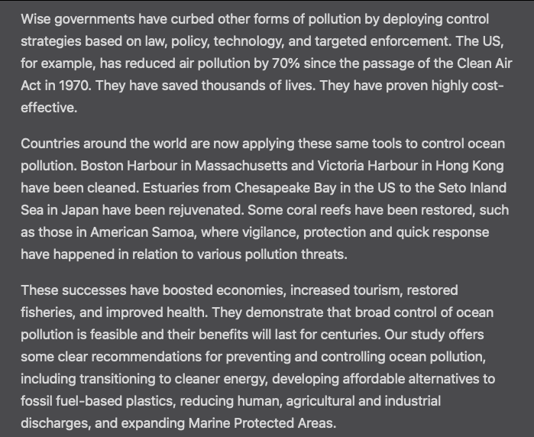

Mark Scheme

Student Name
Section |  |  |  | Date Written |  |  |  | Marks | /14
Word count |  |  |  | Article Date
 | A. Diagrams |  | B. Terminology |  | C. Application and analysis |  | D. Key concept |  | E. Evaluation
0 | The work does not reach a standard described by the descriptors below. |  | The work does not reach a standard described by the descriptors below. |  | The work does not reach a standard described by the descriptors below. |  | Either the work does not reach a standard described by the descriptors below or the key concept identified has already been used in another commentary. |  | The work does not reach a standard described by the descriptors below.
1 | Relevant diagram(s) are included but not explained, or the explanations are incorrect. |  | Economic terminology relevant to the article is included in the commentary. |  | Relevant economic theory is applied to the article with limited analysis. |  | A key concept is identified and there has been an attempt to link it to the article. |  | Judgments are made that are supported by limited reasoning.
2 | Relevant, accurate and correctly labelled diagram(s) are included, with a limited explanation. |  | Economic terminology relevant to the article is used appropriately throughout the commentary. |  | Relevant economic theory is applied to the article throughout the commentary with appropriate economic analysis. |  | A key concept is identified and the link to the article is partially explained. |  | Judgments are made that are supported by appropriate reasoning.
3 | Relevant, accurate and correctly labelled diagrams are included, with a full explanation. |  |  |  | Relevant economic theory is applied to the article throughout the commentary with effective economic analysis. |  | A key concept is identified and the link to the article is fully explained. |  | Judgments are made that are supported by effective and balanced reasoning.
4
Comments:

jyr134

00000 – 0000
U.S. workers quitting reaches record high, job openings edge down in September: Reuters
Date Written: March 11 2021
Date of Article: February 8 2021
Word count: 793
Section 2: Macroeconomics
Economic Concept: Intervention

Intervention commonly refers to the way in which governments involve themselves in the workings of markets. Although markets are largely accepted to be the most efficient mechanism to organise economic activity, it is also known that markets can fail to achieve some societal standards, and in this case there is a strong argument for the intervention of governments. The US has recently seen a vast decrease in the labour force with an all time high quits number of 4.4 million and an abundance of job positions, which may give reason for government intervention.

The chosen article focuses on the impacts of a decreasing labour force on wages and prices of consumer goods. A lack of willing and able workers has forced firms to increase wages, leading to a 4.9% wage growth increase as of October. This means that real wage growth is stagnant because nominal wages are being outpaced by inflation. Although there has been an increase in quits, this can be seen as a sign of high labour market confidence because workers feel secure in the fact that they will be able to find jobs.

This can be considered a form of natural unemployment, because there are job vacancies, but people are unwilling or unable to take these.

Figure 1.1 -- Natural Unemployment in the USA
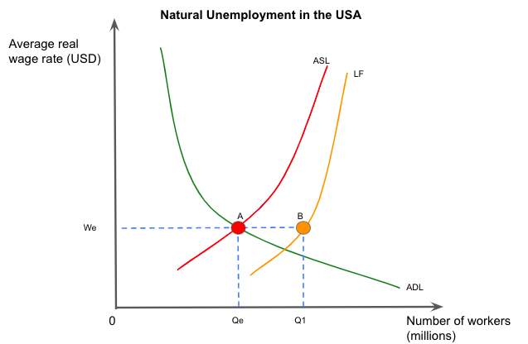

Figure 1.1 shows a labour market with little demand deficient or real-wage unemployment, but still excess unemployment. This diagram helps to explain why the number of workers in the labour force is greater than the aggregate supply of labour. We and Qe show where people are willing and able to take jobs (aggregate supply), but at points A and B there is still unemployment. There is a gap between the aggregate supply of labour curve and the labour force curve which becomes smaller at higher wages, which occurs because low wage rates garner fewer willing workers. Although with real wage rates rising, more people should be more willing to take jobs. The example of COVID creating greater job availability is actually anomalous to this idea. Many businesses are increasing wages offered (growing 4.9%), but are still not finding employees. This begins to create demand-pull inflation due to a surplus of aggregate demand for employees and aggregate supply not meeting this.

Figure 1.2 -- Long-Run Aggregate Supply of Labour
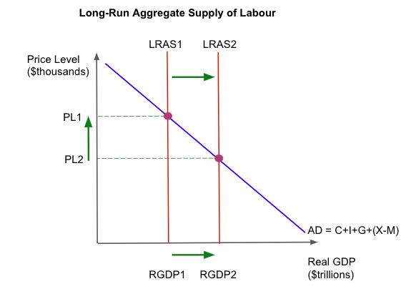

Supply-side policies are a form of government intervention aimed at stimulating supply in an economy through increasing quantity and quality of factors of production, and increasing competition. On a diagram we see supply-side policies working when LRAS is shifted to the right. Figure 1.2 shows aggregate demand (which is made up of consumption spending, investment spending, government spending, and net exports), and LRAS interacting with each other. An important note is that the LRAS is independent of the price level due to the assumption of potential output being based upon the quantity and quality of the factors of production. When supply-side policies are successfully introduced, the LRAS will shift to the right, increasing real GDP (productive potential has increased). As this happens, the LRAS moves along the AD curve, causing an extension in demand. This will decrease the price level due to there being a greater supply of goods and services in the economy.

In the current case of the labour force decreasing and job openings increasing, we actually see the opposite of what figure 1.2 suggests. This has occurred due to federally enhanced unemployment benefits and stimulus checks acting as a disincentive to working, therefore more people leave the labour market. This would be seen as a fall in RGDP because the economy has become less productive, and thus is less efficient.

A market-oriented supply-side policy that could be put into place is an increase in labour market flexibility. This is the removal of any impediment to the labour market moving into equilibrium. In theory, this means that measures can be taken to increase the quantity of workers in the labour force. An example of this could be to decrease unemployment benefits or decrease the length of them seeing as they have worked to deter people from finding work. In the short-term, a decrease in federal unemployment benefits will create greater productivity in the macroeconomy due to a greater number of people working. In the long-term, there will likely be little impact if federal unemployment benefits are reduced. Seeing as unemployment benefits are generally dealt with on a state level, this would likely set a more ‘normal’ precedent. This policy is seen to be a good solution to some because it is almost guaranteed to grow the labour market, and therefore increase the productive output of the US. On the other hand, this policy could be detrimental to some that rely on unemployment benefits, and there is always the possibility that jobs could run out (despite the abundance of them at the moment).

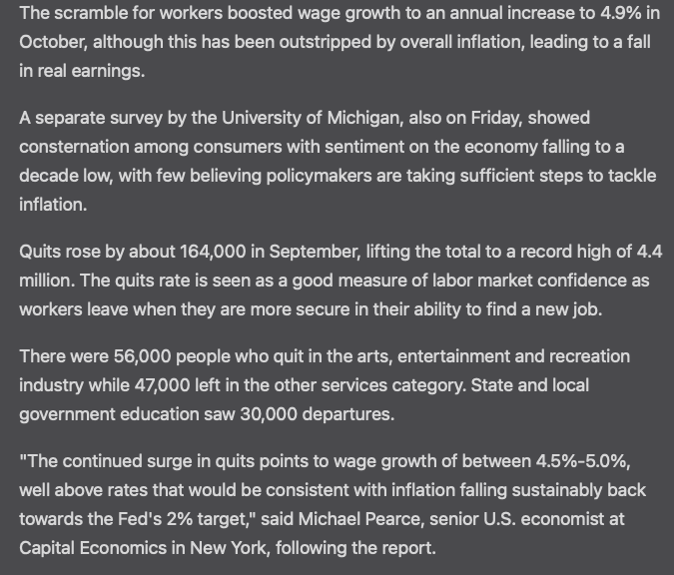

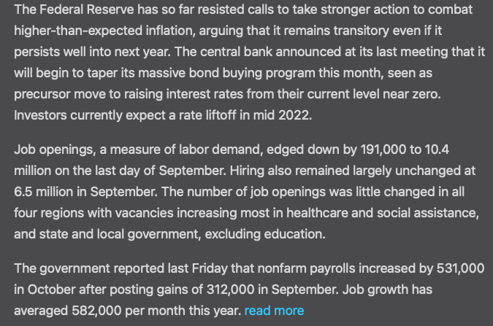

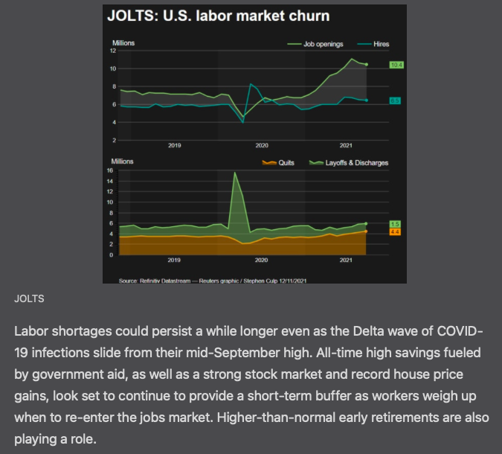

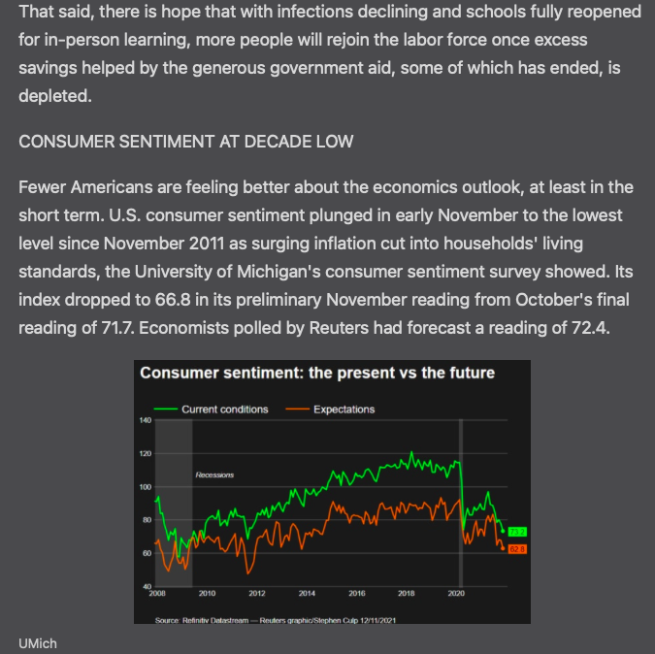
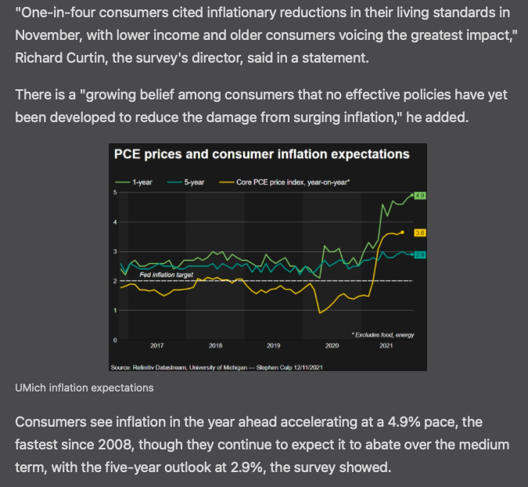

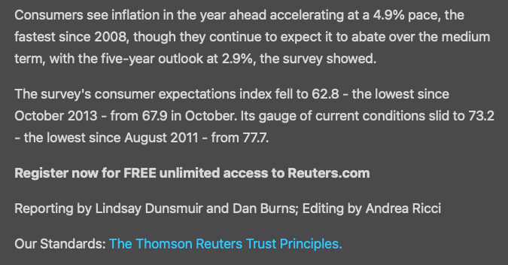

Mark Scheme

Student Name
Section |  |  |  | Date Written |  |  |  | Marks | /14
Word count |  |  |  | Article Date
 | A. Diagrams |  | B. Terminology |  | C. Application and analysis |  | D. Key concept |  | E. Evaluation
0 | The work does not reach a standard described by the descriptors below. |  | The work does not reach a standard described by the descriptors below. |  | The work does not reach a standard described by the descriptors below. |  | Either the work does not reach a standard described by the descriptors below or the key concept identified has already been used in another commentary. |  | The work does not reach a standard described by the descriptors below.
1 | Relevant diagram(s) are included but not explained, or the explanations are incorrect. |  | Economic terminology relevant to the article is included in the commentary. |  | Relevant economic theory is applied to the article with limited analysis. |  | A key concept is identified and there has been an attempt to link it to the article. |  | Judgments are made that are supported by limited reasoning.
2 | Relevant, accurate and correctly labelled diagram(s) are included, with a limited explanation. |  | Economic terminology relevant to the article is used appropriately throughout the commentary. |  | Relevant economic theory is applied to the article throughout the commentary with appropriate economic analysis. |  | A key concept is identified and the link to the article is partially explained. |  | Judgments are made that are supported by appropriate reasoning.
3 | Relevant, accurate and correctly labelled diagrams are included, with a full explanation. |  |  |  | Relevant economic theory is applied to the article throughout the commentary with effective economic analysis. |  | A key concept is identified and the link to the article is fully explained. |  | Judgments are made that are supported by effective and balanced reasoning.
4
Comments:

jyr134

00000 – 0000
More Wine Tariffs Imposed on France and Germany by U.S.: The Wallstreet Journal
Date Written: December 16 2021
Date of Article: December 31 2020
Word count: 800
Section 3: International Economics
Economic Concept: Choice

The concept of choice has to do with the ideas of scarcity and opportunity cost; not all needs and wants can be met, therefore putting economic agents in a situation where they have to make a decision between goods or services. Tariffs are an example of choice being taken away from consumers in the sense that a certain amount of options are no longer available. Near the end of 2020, the US announced that they would be imposing a tariff upon French and German wine. This was a development in a long-standing trade war between the US and the EU surrounding unfair government subsidies to commercial aircraft manufacturers.
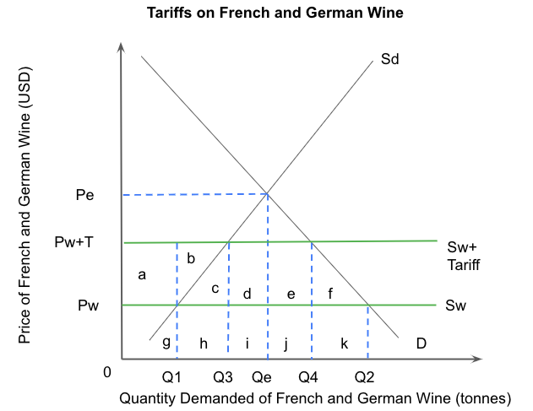
Figure 1.1 -- Tariffs on French and German Wine

Figure 1.1 illustrates the tariff placed upon French and German wine by the US. To be specific, tariffs shift the world supply curve upwards because the tax is being placed on foreign producers rather than domestic producers. In theory, before the tariff, Q2 tonnes of wine is being consumed at a price of Pw, with domestic production landing at Q1 and imports ranging from Q1-Q2. The tariff being placed on imported wine then shifts the world supply upwards by the amount of the tariff (in this case it would be by 25%), to the Sw+Tariff level. Therefore, the market prices increase as well, from Pw to Pw+T. Demand will then decrease from Q2 to Q1 due to prices rising and therefore a decrease in consumer choice. This tariff is beneficial to domestic producers because their revenue will increase. Their production increases from 0-Q1 to 0-Q3, in turn increasing their revenue from g to a+b+c+g+h. The remainder of supply comes from foreign producers, going from Q1-Q2 to Q3-Q4. Although their earnings are at Pw+T, the tariff they have to pay decreases their revenue from h+i+j+k to i+j. This allows the US government to receive a revenue of d+e. The tariff in place forces importers to pay a higher price for imported wine and this higher price is passed on to other parts of the supply chain, making its way down to the consumer in the end.

Tariffs are often used in the attempt to decrease dumping. This is the practice of exporters selling their goods for a price below that of production. Dumping is a predatory pricing strategy with the intention of gaining a strong international presence. The purpose of tariffs is essentially to eradicate the cost advantages of the prices of the dumped imports. Two main outcomes of tariffs are: lower consumer surplus as well as decreased efficiency. A welfare loss will be made due to decreased consumer surplus (from c+d+e+f to c+d+e), which is the difference between the price consumers are willing to pay and the price they actually pay. Consumers will now have less choice in what they can buy, with the imposition of the tariff, so what they are willing to pay may change. The imposition of the tariff requires domestic producers to produce Q1-Q3 units of wine, this is fairly inefficient compared to more efficient foreign producers. Domestic producers require more revenue than foreign producers; domestic producers do this for a revenue of c+h, whereas foreign producers could do this for a revenue of h. Domestic producers create another deadweight loss which is represented by c, this is the inefficiency of domestic producers.
Unfortunately, tariffs take away choice from economic agents. By introducing tariffs, there are fewer foreign options in an economy, so consumers must choose from a smaller pool of domestic goods. The imposition of a tariff on French and German wine is controversial because it is a retaliatory measure in a tit-for-tat trade war over aircraft manufacturing. A 25% tariff may be considered inappropriate in this specific example because it is one of many protectionist measures that has created tension between the US and the EU. In order to ease tension between the US and EU, it is important for the US government to evaluate their priorities. One option would be to reinstate bilateral trade negotiations between the US and EU. This could be done through reducing trade barriers on all goods and services and would achieve greater free trade. Taking this route would be beneficial for the US because often, protectionist policies can interfere with economic growth. The reduction of protectionist policies would increase efficiency and promote innovation because there are more foreign firms to compete with and comparative advantage would increase with decreasing protectionist measures which would lead to more efficient use of the world’s resources. Lastly, reestablishing bilateral agreements between the US and the EU would increase consumer choice seeing as they have both domestic and imported goods to choose from. In the long term, this could be beneficial for the US and EU because it will lower the prices of goods and services due to the increase of choices that consumers have.

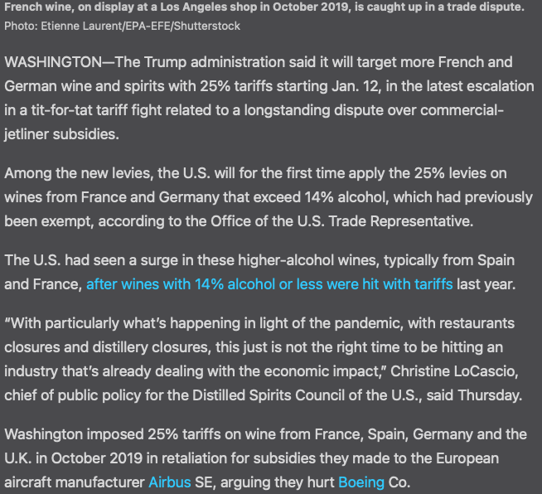
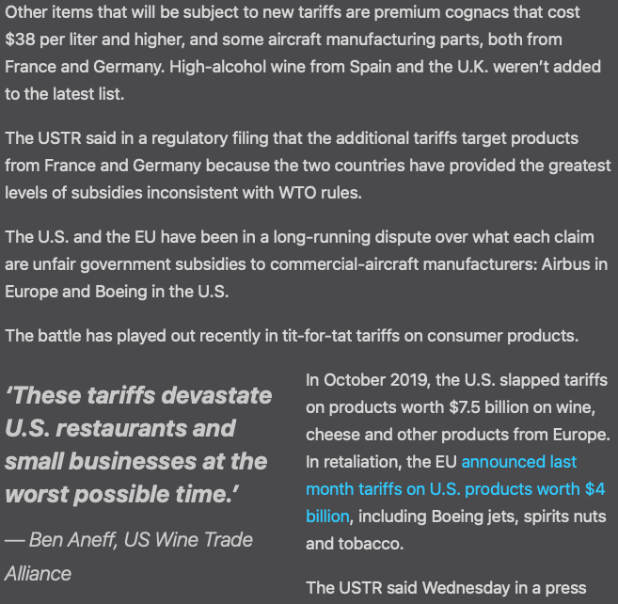
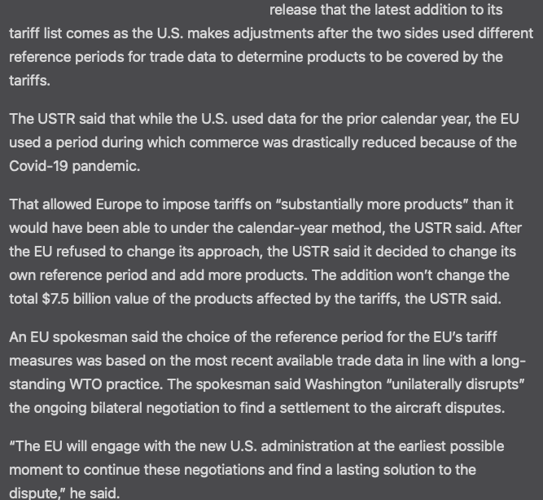
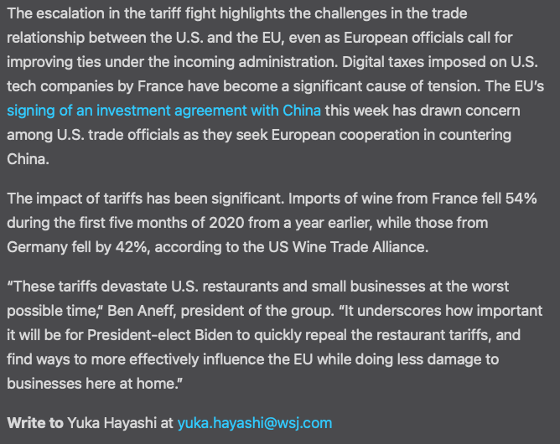

Mark Scheme

Student Name
Section |  |  |  | Date Written |  |  |  | Marks | /14
Word count |  |  |  | Article Date
 | A. Diagrams |  | B. Terminology |  | C. Application and analysis |  | D. Key concept |  | E. Evaluation
0 | The work does not reach a standard described by the descriptors below. |  | The work does not reach a standard described by the descriptors below. |  | The work does not reach a standard described by the descriptors below. |  | Either the work does not reach a standard described by the descriptors below or the key concept identified has already been used in another commentary. |  | The work does not reach a standard described by the descriptors below.
1 | Relevant diagram(s) are included but not explained, or the explanations are incorrect. |  | Economic terminology relevant to the article is included in the commentary. |  | Relevant economic theory is applied to the article with limited analysis. |  | A key concept is identified and there has been an attempt to link it to the article. |  | Judgments are made that are supported by limited reasoning.
2 | Relevant, accurate and correctly labelled diagram(s) are included, with a limited explanation. |  | Economic terminology relevant to the article is used appropriately throughout the commentary. |  | Relevant economic theory is applied to the article throughout the commentary with appropriate economic analysis. |  | A key concept is identified and the link to the article is partially explained. |  | Judgments are made that are supported by appropriate reasoning.
3 | Relevant, accurate and correctly labelled diagrams are included, with a full explanation. |  |  |  | Relevant economic theory is applied to the article throughout the commentary with effective economic analysis. |  | A key concept is identified and the link to the article is fully explained. |  | Judgments are made that are supported by effective and balanced reasoning.
4
Comments:

