**3.1 – International Trade**

**Free Trade**

1. Reasons for Free trade.
2. Why some nations need to trade
3. How a government can reduce exports through Trade Barriers.
4. Why a government might want to reduce imports through trade barriers.

**1) Why is Free Trade beneficial?**

* Choice __________________________________________________________________________________________________________________________________

* Retail Prices ______________________________________________________________________________________________________________________________
* Output/Economies of Scale __________________________________________________________________________________________________________________________________

**Cost**

**per unit**

**Output**

* Jobs __________________________________________________________________________________________________________________________________

**Wage**

**No. of**

**workers**

**2) Why do some nations need to trade?**

a) Why does Saudi Arabia sell oil to European Nations?

________________________________________________________________________________________________________________________________________

b) Why might the U.K. provide financial services to Brazil or Russia?

[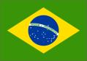](http://images.google.co.uk/imgres?imgurl=http://www.crwflags.com/art/countries1/brazil.gif&imgrefurl=http://www.crwflags.com/page0072.html&h=269&w=384&sz=8&tbnid=k9fMziFgdpoL4M:&tbnh=83&tbnw=119&hl=en&start=4&prev=/images?q=Brazil&svnum=10&hl=en&lr=)

_______________________________________________________________________________________________________________________________________________________________

c) Why does Hungary buy cars from Germany?

________________________________________________________________________________________________________________________________________

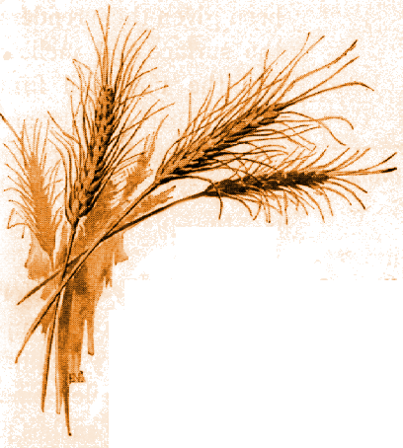

d) Why is it better for the U.S.A. to grow wheat and sell it to Ireland even though Ireland can grow their own?

_____________________________________________________________________________________________________________________________________________

e) Why is it important for an LEDC nation such as Botswana or Cameroon to trade with other nations?

________________________________________________________________________________________________________________________________________

f) In the table below summarize why nations trade using your answers from questions a)-e).

|  |  |
| --- | --- |
| A),B) |  |
| C) |  |
| D) |  |
| E) |  |

**Absolute and Comparative Advantage**

* To look at why different countries produce different goods and services.
* To understand what is meant by Absolute Advantage
* To understand what is meant by Comparative Advantage.

Do all countries produce the same goods and services?

_______________________________________________________

Why do **different** countries produce **different** goods and services or why are some nations more efficient than others at producing the same quantity of goods and services?



____________________________________________________________________________________________________________



______________________________________________________________________________________________________________



____________________________________________________________________________________________________________

______________________________________________________________________________________________________________

In order to illustrate why nations often specialise and produce different goods and services we will complete the example below.

**Comparative and Absolute Advantage**

In this example it is assumed that there are just two nations and that they both produce two types of product.

|  |  |  |
| --- | --- | --- |
|  | **Tonnes of Beef**  **(produced with x units of resources)** | **Tonnes of Wheat**  **(produced with x units of resources)** |
| **USA** | **100** | **50** |
| **FRANCE** | **20** | **100** |

Which country would you say had **absolute advantage** in the production of **beef and wheat**?

________________________________________________________________________________________________________________________________________

Draw a production possibility frontier to illustrate the benefits to both the nations of specializing in the product where they have absolute advantage.

**Beef**

**Wheat**

Why should both nations specialize?

_____________________________________________________________________________________________________________________________________

Sometimes we are faced with a situation where one country has absolute advantage in the production of both products.

|  |  |  |
| --- | --- | --- |
|  | **Tonnes of Beef**  **(produced with y units of resources)** | **Tonnes of Wheat**  **(produced with y units of resources)** |
| **USA** | **100** | **150** |
| **FRANCE** | **20** | **100** |

What would be your initial recommendation to the USA and France?

_________________________________________

How much better is the USA in producing **Beef** than France?

______________________________

How much better is the USA in producing **Wheat** then France?

______________________________

**Illustrate the above with a production possibility frontier.**

**Beef**

**Wheat**

**However** which nations have a comparative advantage in the production of **wheat** and which nations have a comparative advantage in the production of **beef**?

________________________________________________________________________________________________________________________________________

In the table below show the position of the two countries if they both specialise

|  |  |  |
| --- | --- | --- |
|  | **Tonnes of Beef**  **(produced with x units of resources)** | **Tonnes of Wheat**  **(produced with x units of resources)** |
| **USA** |  |  |
| **France** |  |  |

Now show the position of the two countries when they trade.

|  |  |  |
| --- | --- | --- |
|  | **Tonnes of Beef** | **Tonnes of Wheat** |
| **USA** |  |  |
| **France** |  |  |

If all countries specialise in a product where they have a relative or a comparative advantage then what will be the benefit?

Output/Economies of Scale

**____________________________________________________________________________________________________________________________________________________________________________________________________________**

* Availability of goods and services

**____________________________________________________________________________________________________________________________________________________________________________________________________________**

**Look at the example below.**

|  |  |  |
| --- | --- | --- |
|  | **Tonnes of Beef**  **(produced with y units of resources)** | **Tonnes of Wheat**  **(produced with y units of resources)** |
| **USA** | **50** | **100** |
| **FRANCE** | **25** | **50** |

**Explain using a production possibility frontier why the two nations are unlikely to trade.**

**Beef**

**Wheat**

**Absolute and Comparative Advantage – Lesson 2**

* In the previous lesson we looked at an example that related to absolute and comparative advantage. In this lesson we will look at :-

1. Another example of Comparative Advantage where a nations devote half their resources to producing one type of product and half its resources to producing another type of product.
2. An example of Comparative Advantage where we compare the costs of production of different goods in terms of hours of labour.
3. Look at the example below where we have two countries Russia and the USA. Imagine that the two countries just produce two products each, beer and oil.

|  |  |  |
| --- | --- | --- |
|  |  |  |
|  | 80 units | 160 units |
|  | 40 units | 40 units |

1. If each nation devotes a certain quantity of resources to the production of each product, which country will have an Absolute Advantage in the production of each product?

_________________________________________________________________________________________________________________________________

1. Explain using figures which nation will have a comparative advantage in the production of oil and which will have a comparative advantage in the production of beer.

Oil ____________________________________________________________________________________________________________________________

Beer_____________________________________________________________________________________________________________________________

1. Illustrate the above using a production possibility frontier

**Beer**

**Oil**

1. In the table below identify the position if both nations decide to specialise in the production of the product in which they have Comparative Advantage.

|  |  |  |
| --- | --- | --- |
|  | Beer | Oil |
| Russia |  |  |
| United States |  |  |

1. What exchange rate, in terms of units of oil and beer, would be mutually beneficial to both Russia and the United States?

**Beer**

**Beer**

**Oil**

**Oil**

1 unit of oil = _____________________ or 1 unit of beer = ______________________

1. Now show the position if the two nations trade.

|  |  |  |
| --- | --- | --- |
|  | Beer | Oil |
| Russia |  |  |
| United States |  |  |

1. Explain why both nations would benefit from such a trade.

________________________________________________________________________________________________________________________________________________________________________________________________________________________________________________________________________________

1. – The theory of comparative advantage is quite compelling but it has some limitations.

|  |  |
| --- | --- |
| Assumption | Explanation |
| Perfect Knowledge |  |
| Transport Costs |  |
| Two economies/Two products |  |
| Constant Returns to scale |  |
| Identical Goods |  |
| Free Trade |  |

World Trade Organisation

1. What is the WTO ?



__________________________________________________________________________________________

1. What is its main function?

________________________________________________________________________________________________________________________________________

1. What are the potential **benefits** of having the WTO?

* _________________________________________
* _________________________________________
* _________________________________________

1. When did the WTO come into **being**?

_________________________________________________________________

1. Which organisation did it succeed and when was that established?

________________________________________________________________________________________________________________________________________

1. By how much has world trade grown since 1950?

________________________________________________________________________________________________________________________________________

1. What issues have been discussed during the **negotiations or rounds**?

____________________________________________________________________________________________________________________________________________________________________________________________________________

1. What is **Dumping** ?

________________________________________________________________________________________________________________________________________

1. At which **Round** was the WTO created?

_________________________________________________________________

1. How does the WTO help world trade flow smoothly?



1. How many members are there in the WTO?

_________________________________________________________________

1. Using the flow chart below identify the structure of the WTO
2. How did the **WTO’s rules** come into force?

________________________________________________________________

1. What took place between **1947 and 1994**?

________________________________________________________________________________________________________________________________________

1. State how the WTO has an influence in the following areas ?

* Services

**____________________________________________________________________________________________________________________________________________________________________________________________________________**

# Intellectual Property

**____________________________________________________________________________________________________________________________________________________________________________________________________________**

# Restrictions on Free Trade – Trade Protection

1. - In general terms can you think of why a nation might wish to reduce the number of imports that are entering the country?

________________________________________________________________________________________________________________________________________________________________________________________________________________________________________________________________________________

1. **- How might a government reduce the amount of imports that enter the nation?**

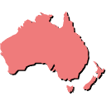

# 3) Tariff

* Look at the pictures below and explain what is meant by a **tariff**.



Japanes Mobile Phone - $50

Japanese Mobile Phone - $75

____________________________________________________________________________________________________________________________________________________________________________________________________________

* Use the diagram below to illustrate the impact of a tariff on the market for mobile phones.

## Price

**Quantity demanded/supplied**

# 4) Quota

* What do you understand by the term **Quota**?



____________________________________________________________________________________________________________________

**5000 U.S. monitors**

# Illustrate the impact of the quota on the diagram below. We assume that all the televisions are produced abroad in the U.K. market for televisions.

## Price of

**TVs**

**Quantity demanded/supplied**

# Now illustrate the impact of a quota in the market for televisions where there are both foreign and domestic producers.

## Price of

**TVs**

**Quantity demanded/supplied**

# http://t3.gstatic.com/images?q=tbn:ANd9GcSiI025YZEd-0kXvP-1LM55-6_F2ooMZgs2O06FlaMwhDhmeoB50g

* What is the impact of the quota on

**Consumers** _______________________________________________

**Domestic Firms** ___________________________________________

**Foreign Firms** ____________________________________________

# 5) Embargo



____________________________________________________________________________________________________________________________________________________________

# 6) Subsidies to domestic firms

* Draw a demand and supply diagram to show the impact that a government subsidy would have on a firm.

## Price

## Quantity Demanded/Supplied

* Why might the government **subsidize** a domestic firm and how would the subsidy act as a trade barrier?

____________________________________________________________________________________________________________________________________________________________________________________________________________________________________________________________________

### Voluntary Export Agreement

* What is a voluntary export agreement?

__________________________________________________________________________________________________________________________________

* Why might one country be prepared to restrict its level of exports?

__________________________________________________________________________________________________________________________________

* On the diagram below illustrate a voluntary export restraint of Japanese Cars in the U.S. market for cars.

Price

Quantity demanded and supplied

1. **Reasons for Trade Barriers (Protectionism)**

|  |  |
| --- | --- |
| **Reason** | Explanation |
| * Infant Industry |  |
| * Diversification of LEDC’s |  |
| * Domestic Employment |  |
| * Balance of Payments |  |
| * Strategic/political |  |
| * Government Revenue |  |
| * Product Standards |  |
| * Anti- Dumping |  |

* What is the **main argument** against using protectionist measures (tariffs, quotas etc.) ?

__________________________________________________________________________________________________________________________________________________________________________________________________________________

[](http://www.neonepiphany.com/26things/200307/md/time.jpg)

__________________________________________________________________________________________________________________________________________________________________

____________________________________________________________________________________________________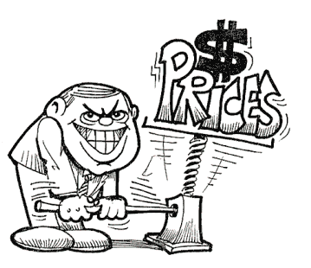_______________________________________________

_____________________________________________________________________________________________________________________________________________[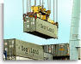](http://www.fl-ag.com/images/exports.jpg)_______________

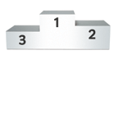

______________________________________________________________________________________________________________________________________________________

Higher Level Paper 3 Questions

On the **Higher Level Paper 3 you may be required to calculate, from diagrams, the impact of imposing a tariff, quota and subsidy on different stakeholders.**

* The graph below shows the market for steel in a nation.

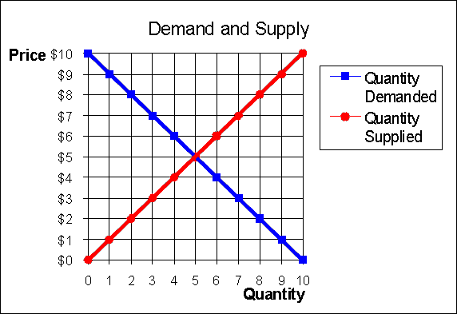

1. – Indicate the domestic equilibrium price and quantity demanded/supplied.

______________________

1. – The world price of steel is lower than the domestic price of steel at **$2 per tonne**. Add the world supply curve to your diagram.
2. – How much steel will now be supplied by domestic and foreign firms when there is free trade?

**Domestic Firms ________________________________________**

**Foreign Firms _________________________________________**

1. – Imagine now that the government imposes a tariff of **$1 per tonne**. Illustrate this on the diagram.
2. - Calculate the change in consumer spending, before and after the imposition of the tariff

**Consumer spending before tariff _______________________________________**

**Consumer spending after tariff ________________________________________**

1. – Calculate the government tax revenue after the tariff has been imposed.

**Government revenue** _________________________________________________

1. – Indicate the impact of the tariff on the following stakeholders.

|  |  |
| --- | --- |
| Domestic Firms |  |
| Foreign Firms |  |
| Consumers |  |
| Government |  |
| Resource Allocation |  |

* The graph below shows the market for cars in a nation.



1. – Indicate the domestic equilibrium price and quantity demanded/supplied.

______________________

1. – The world price of cars is lower than the domestic price of cars at **$2 per tonne**. Add the world supply curve to your diagram.
2. – How much steel will now be supplied by domestic and foreign firms when there is free trade?

**Domestic Firms ________________________________________**

**Foreign Firms _________________________________________**

1. – Imagine now that the government imposes a quota of **2 tonnes**. Illustrate this on the diagram.
2. - Calculate the change in consumer spending, before and after the imposition of the quota

**Consumer spending before quota _______________________________________**

**Consumer spending after quota ________________________________________**

1. – Calculate the revenue and sales of the domestic firms and foreign firms after the quota has been imposed.

**Domestic firm’s revenue** **and sales** ________________________________________________________________

**Foreign firm’s revenue and sales**

________________________________________________________________

1. – Indicate the impact of the quota on the following stakeholders.

|  |  |
| --- | --- |
| Domestic Firms |  |
| Foreign Firms |  |
| Consumers |  |
| Government |  |
| Resource Allocation |  |

* The graph below shows the market for sugar in a nation.



1. – Indicate the domestic equilibrium price and quantity demanded/supplied.

______________________

1. – The world price of sugar is lower than the domestic price of sugar at **$2 per tonne**. Add the world supply curve to your diagram.
2. – Imagine now that the government introduces a subsidy of $**2 per tonne**. Illustrate this on the diagram.
3. – Calculate the revenue and sales of the domestic firms and foreign firms after the subsidy has been imposed.

**Domestic firm’s revenue** **and sales** ________________________________________________________________

**Foreign firm’s revenue and sales**

________________________________________________________________

1. – Indicate the impact of the subsidy on the following stakeholders.

|  |  |
| --- | --- |
| Domestic Firms |  |
| Foreign Firms |  |
| Consumers |  |
| Government |  |
| Resource Allocation |  |