Fiscal Policy

Lesson Objectives
To understand what is meant by the term fiscal policy To identify the sources of government revenue
To differentiate between different types of government expenditure. To distinguish between a budget surplus and a budget deficit.
To look at the difference between expansionary and contractionary fiscal policy and illustrate both with a diagram.

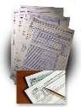
- What do you understand by the term “Fiscal Policy”?

- Using the graphic below, identify the main sources of government revenue.
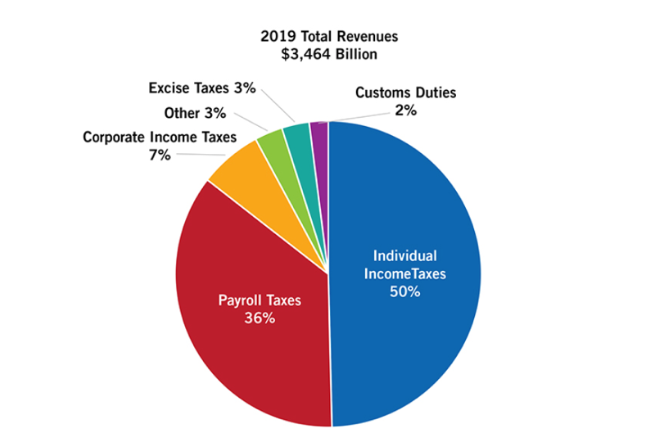
Source of government revenue
1
2
3
4
5
6
7
8

- What are the main items of government expenditure?

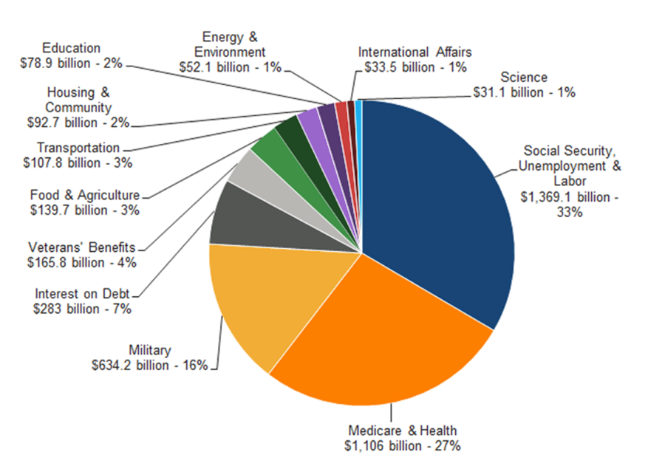
Item of expenditure
1
2
3
4
5
6
7

  - As well as the above areas of government expenditure (the names of which can vary from country to country, we can also classify government expenditure as either:-
Give some examples of each of the following in the table below:

Current expenditure Capital expenditure
Transfer payments

Current Expenditure
Example
Definition
Type

Capital Expenditure

Transfer payments

  - Each year the government prepares their budget for the next year. They have one of three options.

Balanced budget Budget surplus Budget deficit
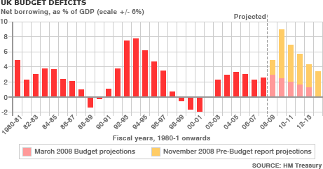

  - What do you notice about the U.K. government’s budget from the diagram above?

  - What is the national debt?

  - What is the relationship between the government’s yearly budget deficit/surplus and the national debt?

  - Find the USA’s National Debt Clock, what is the current level of the national debt, what percent of GDP does this represent?

  - Outline some of the advantages and disadvantages of the government having a large national debt.

Advantages | Disadvantages

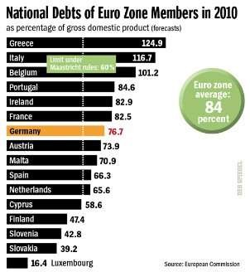
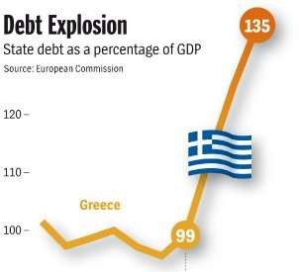

  - How do the governments borrow money?

  - Using the table below illustrate the difference between a contractionary fiscal policy and an expansionary fiscal policy.
Type of Fiscal Policy | Taxation | Government Spending
Contractionary
Expansionary

  - Why might the government pursue an expansionary fiscal policy?

  - On the diagram below illustrate the impact of such a policy on the economy.

Price Level

0 Real G.D.P.

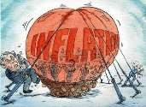
  - What are the potential disadvantages of an expansionary fiscal policy?

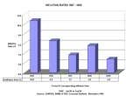
  - Explain what is meant by a contractionary fiscal policy and explain why the government may wish to pursue this objective.

  - Illustrate on the diagram below the potential impact of a contractionary fiscal policy on the macroeconomy:

Price Level

0

Real G.D.P.

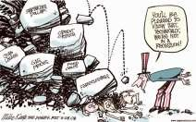
  - What are the drawbacks of a contractionary fiscal policy?

1.
2.
3.
4.

20. What will happen to government spending and revenues during the business cycle?

Period of the  business cycle | Government  Spending | Income  Tax | Government  Revenue | Deficit/  Surplus
Recession

Boom

  - The implementation of fiscal policy to achieve macroeconomic objectives may not be effective for several reasons.

Impact on aggregate demand

Impact on consumer/firm behaviour
Time lags
Political factors
Supply-side factors

  - However, one of the main criticisms leveled at fiscal policy (expansionary fiscal policy) is that it leads to ‘crowding out’.

If the government wishes to stimulate the economy using fiscal
policy they will have to run a .

Governments by selling
To finance the they will need to

The key to understanding this concept is that ‘savings’, of which there are a finite amount in the economy, are used to purchase government debt as opposed to being lent to the private sector (firms) in the form of loans or purchase of company shares/debt.
This action by the government leads to an increase in demand for

