“To What Extent Does Distance from the Central Business District of Houston, Texas, Affect Atmospheric Air Temperature?”

Extended Essay - Geography
Author: Felix Nicholls

Center Number: 002289
Candidate Number: 002289-0014
Session: May 2014

Word Count: 3862

Abstract

This paper investigates the research question, “To What Extent Does Distance from the Central Business of Houston, Texas, Affect Atmospheric Air Temperature?” The relationship between atmospheric air temperature (AAT) and distance from the CBD was analyzed mathematically, and in context to the atmospheric urban heat island effect. In order to evaluate the data from the investigation, a research hypothesis (H_{r}) was tested against a null hypothesis (H₀) regarding the mathematical analysis (the Spearman’s rank correlation coefficient (SRCC) critical-values test).

H_{r}: “The relationship between distance from Houston’s CBD and average AAT is inversely proportional.”

H₀: “µ < 0.354 for data from the stations to the northwest of the CBD. µ > -0.571 for data from stations to the southeast of the CBD ”

Data was gathered over the course of a 5-day period, using 22 weather stations from the website WeatherUnderground, along a transect study, which ran from the northwest of Houston to the southeast. The data could then be used as evidence to support H_{r} through visual analysis, or H₀ through mathematical analysis from the SRCC.
Although a correlation between AAT and distance from the CBD was found, through visual analysis, on 6 of the 25 results graphs, the mathematical analysis confirmed H₀ with 79% of the total data. Therefore, it was concluded that there is no relationship between distance from the CBD and AAT in Houston, Texas, and there is no presence of a UHI. By linking the results of the investigation to geographical UHI theory, it was found that this was the case predominantly due to the city’s low building density, and the factors that stem directly from this. In future studies, a more accurate method of data collection should be used, such as analysis of infrared satellite photographs.

Word count: 291
TABLE OF CONTENTS

ABSTRACT 2

INTRODUCTION 4

  - – GENERAL INTRODUCTION 4
  - – BACKGROUND INFORMATION AND GEOGRAPHICAL THEORY 4
  - – GEOGRAPHICAL CONTEXT 7
  - – OBJECTIVES 9

INVESTIGATION 10

2.1 – MET STATIONS 10
2.2 – HYPOTHESES 11
2.3 – METHODOLOGY 13

RESULTS 18

ANALYSIS 22

CONCLUSION 27

EVALUATION 28

APPENDIX 30

BIBLIOGRAPHY 45

Note:

*, †, ‡, §, **… - See Appendix

Introduction

  - – General Introduction

This paper presents the results of a study that examined the relationship between the urban heat island effect within Houston, Texas, and distance from its central business district (CBD). It is based upon temperature readings taken from meteorological (MET) stations throughout the city, and seeks to present an in-depth analysis of its subject matter, given the resources available to the author.
Although the relationship between distance from a CBD and atmospheric air temperature (AAT) has already been investigated in many different cities around the world and shown to follow a general trend, a study of this relationship has not been carried out before in Houston. Therefore, this paper aims to answer the question “to what extent does distance from the central business of Houston, Texas, affect atmospheric air temperature?” Its findings also present original, independent research.

  - – Background Information and Geographical Theory

Urban Heat Islands (UHIs) are modern climatological phenomena that occur all around the world, which are caused by the growth of urban environments. They are defined as “metropolitan (developed) areas* that are consistently hotter than their rural surroundings.” Two different types of UHI can be formed, each of which can result in a difference in temperature between rural and urban areas of up to 3°C throughout the day, and 12°C after sunset in rare cases: atmospheric urban heat islands (AUHIs) and surface urban heat islands (SUHIs). Although both types occur as a consequence of the expansion of urban areas, they are categorized as separate climatological occurrences due to the differences in the whereabouts of their appearances within the Earth’s atmosphere. An SUHI is created by a difference in temperature between urban and rural areas at ground level, whereas an AUHI is a difference in air temperature in the canopy layer (the layer of air between the ground and tree/building tops) between urban and rural areas. As such, both can occur in close proximity to each other simultaneously, and the presence of one type often gives rise to the creation of the other. Despite their differences, the occurrences of SUHIs and AUHIs are affected by the same factors:

Table 1.1: The characteristics of urban and rural environments that effect the formation of UHIs.
Characteristic That Effects the Formation of UHIs | Consequences for Rural Environments | Consequences for Urban Environments
Amount of vegetation | - Trees and plants create shade, which leads to decreased surface temperatures  - Evapotranspiration from vegetation reduces the air temperature  - Vegetation has a high water content, resulting in a high specific heat capacity that means it remains low in temperature | - Surfaces such as concrete and asphalt have high heat capacities, high levels of thermal emissivity and higher thermal conductivity than natural surfaces, creating higher air temperatures  - Synthetic surfaces do not undergo evapotranspiration, meaning that no cooling processes take place  - As the sun sets, large amounts of heat energy continue to radiate into the atmosphere, sustaining or increasing air temperature despite the cooling of the surroundings
Amount of CO₂ emissions | - Vegetation removes CO₂ gas from the atmosphere due to photosynthesis, resulting in a decrease in the greenhouse effect and a possible reduction in temperature | - Greenhouse gasses are released into the atmosphere by vehicles and buildings, reducing heat loss from the Earth’s atmosphere and increasing air temperature as a result of the greenhouse effect
Amount of buildings | - Small amount of synthetic surfaces helps to prevent air temperature from increasing | - Large amounts of synthetic materials used in the buildings, creating higher air temperatures
Density of buildings | - Small or low density buildings do not block wind, allowing areas to cool through convection | - Large, high density buildings act as wind-blocks, preventing cooling and allowing temperatures to rise
Amount of anthropogenic activity | - A low amount of human activity results in less heat energy being released into the atmosphere | - Objects such as cars and buildings, and large amounts of human activity results in thermal energy being released into the atmosphere in large quantities, with frequency

In the United States of America (USA), 82% of the population (roughly 260 million people) live in urbanized expanses that span approximately 106,386 square miles (275,538.5 square kilometers), or 2.66% of the total land area of the country. Due to their immense size, it can be expected (with table 1.1 in mind ) that the urbanized areas throughout the USA are likely to have a significant impact on the local weather, climate and surrounding environment, one of which is the formation of UHIs. It is important to understand how and why they are formed, due to the consequences that increased temperatures can have on the residents of urban regions:

- Increased temperatures may result in adverse health effects (1000 deaths a year are caused by heat extremes in the USA alone);
- Energy demands may rise, due to a growth in the use of air conditioning to deal with excess heat;
- Rising energy demands and air conditioning use can result in an increase in the amount of pollutant gasses (such as CO₂, CO and SO₂) that are released into the atmosphere;
- Higher-than-normal air temperatures can significantly reduce water quality.

As a result, a sound knowledge of the occurrence of UHIs could be crucial to healthier, more environmentally friendly and more comfortable living in the future.

  - – Geographical Context

Houston, Texas, is situated within the Greater Houston metropolitan zone (also known as the Houston-The Woodlands-Sugarland metropolitan area), which is located on the southeast coast of the USA, on the Western Gulf Coastal Plain - an area of grassland that borders with the Gulf of Mexico. The city is the 4th most populous in the USA (with 2,099,451 residents, as of the 2010 census), and is also the 9th largest city in the USA in terms of area (599.59 square miles).
Houston’s CBD is located within Downtown Houston, and is bounded by three major highways: the Interstate 10 (I-10), the U.S Highway 59 (US 59) and the Interstate 45 (I-45). From the CBD, much of Houston’s industry (primarily petrochemical-processing complexes) extends southeasterly, towards the coastline and the coastal towns of Galveston and Baytown. In a similar manner to the USA as a whole, Houston’s large urban expanses can be expected to have an adverse effect on the local climate, environment and weather.

Figure 1.1: A map showing the features of Houston
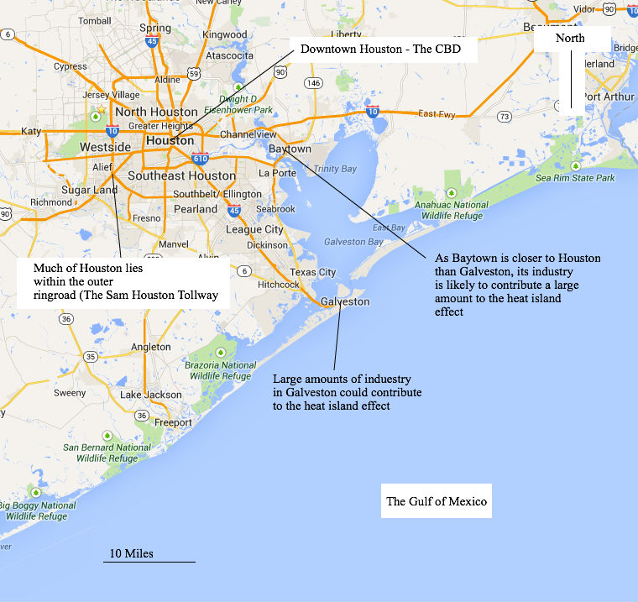

  - – Objectives

The objectives of this paper are to:

  - Investigate the relationship between AAT and distance from the CBD in the city of Houston, Texas, by testing the null research hypothesis with SRCC calculations;
  - Suggest whether or not there is a UHI present within the city;
  - Provide an explanation for the relationship that is shown by the investigation that is specific to Houston.

Investigation

2.1 – MET Stations

In order to collect reliable weather data from around Houston, the MET stations from the website Weather Underground (Wunderground) were used, since they recorded temperature data at regular time intervals, and have large and easily accessible data bases that are open for public use. Since the stations measure atmospheric air temperature, this means that they are suitable to use to test for the presence of an AUHI in Houston.
The investigation took place over a five-day period in 2013, from Monday 29th July, to Friday 2nd August. This week was the warmest on average of Houston’s 2013-summer season. Since the creation UHIs is influenced by the unnatural thermal properties of many of the synthetic materials that can be found within cities (see table 1.1), the hottest week in Houston is most likely to create a UHI.

2.2 – Hypotheses

In order to answer the research question, a research hypothesis will be suggested, and tested using a null hypothesis:

Research hypothesis (H_{r}):

“The relationship between distance from Houston’s CBD and average AAT is inversely proportional.”

This pattern is shown in many major cities around the world, most of which are smaller than Houston. The results of the investigation will be explained according to the theory from table 1.1.
In order to test the research hypothesis using statistical analysis, a null hypothesis will be used, based upon values of the Spearman’s Rank Correlation Coefficient (SRCC). The SRCC was chosen to analyze correlation in preference to other mathematical techniques because it can be applied to both linear and non-linear relationships.

Figure 3.2: The formula for calculating an SRCC value †

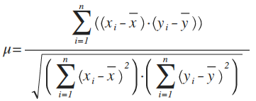

Null hypothesis (H₀):

“µ < 0.354 for data from the stations to the northwest of the CBD. µ > -0.571 for data from stations to the southeast of the CBD.”

There are 15 MET stations on the negative x-axis (to the northwest of the CBD), which results in 15 daily average readings. For 15 pairs of variables, the critical SRCC value is 0.354. For the 7 MET stations on the positive x-axis (to the southeast of the CBD), the critical SRCC value is -0.571. The critical values chosen represent the point at which the probability of a set of results occurring by chance is equal to 0.1%. Above this value, the probability of the results occurring by chance increases.
If a large proportion of the results graphs support H₀ rather than H_{r}, then the research hypothesis can be discarded as false. All graphs will be analyzed mathematically, by having the SRCC calculations applied to the positive and negative sections of their x-axes. All but four appear solely in the appendix.

2.3 – Methodology

- In order to investigate the relationship discussed in the research question, a transect study was used, so that the patterns in the relationship could be assessed across as large a section of Houston as possible. Given the confines that arose as a consequence of the locations of the MET stations, there was only one linear segment of the city that could have a straight transect mapped over it.

Figure 2.1: The transect used for the investigation – the temperatures shown by the figure stations have no significance for the investigation. Not all MET stations are displayed at this scale
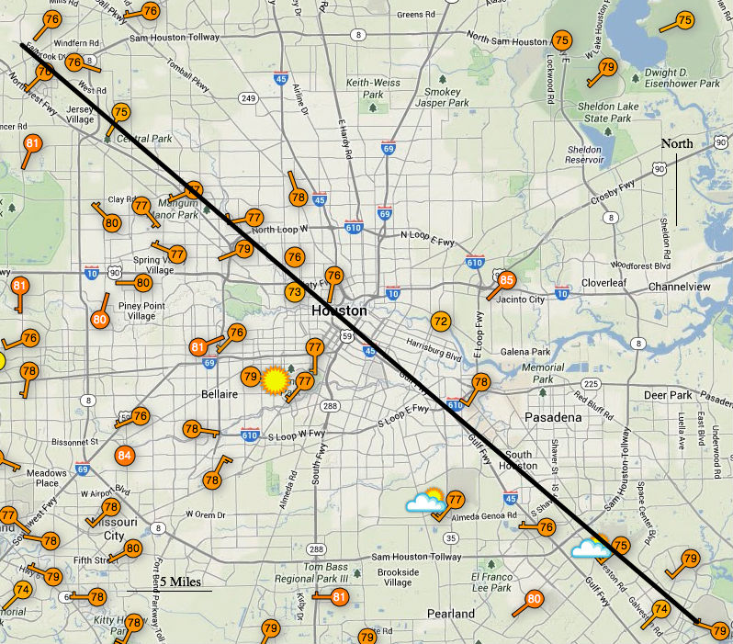

- Any stations that lay on, or within close proximity to, the transect were used for the investigation, in order to increase its validity by increasing sample size. All stations to the northwest of the CBD are said to have negative distance from it, and all stations to the southeast have positive distance. This naming convention was put in place in order to make the results graphs easier to interpret visually. The imbalance of MET stations to the northwest and southeast of the CBD was a weakness of the investigation that could not be altered by the author of this paper.

Figure 2.2: The MET stations, northwest of the CBD, that were used for the investigation, in relation to the transect - negative distance from the CBD
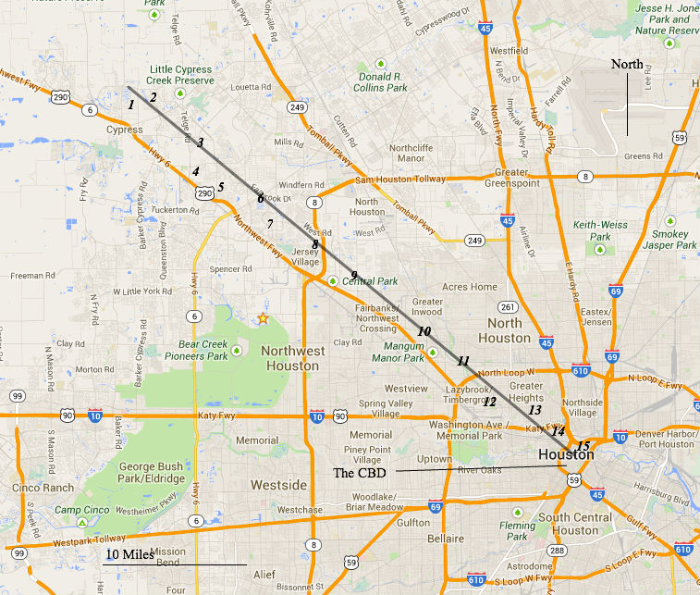

Figure 2.3: The MET stations, southeast of the CBD, that were used for the investigation, in relation to the transect - positive distance from the CBD
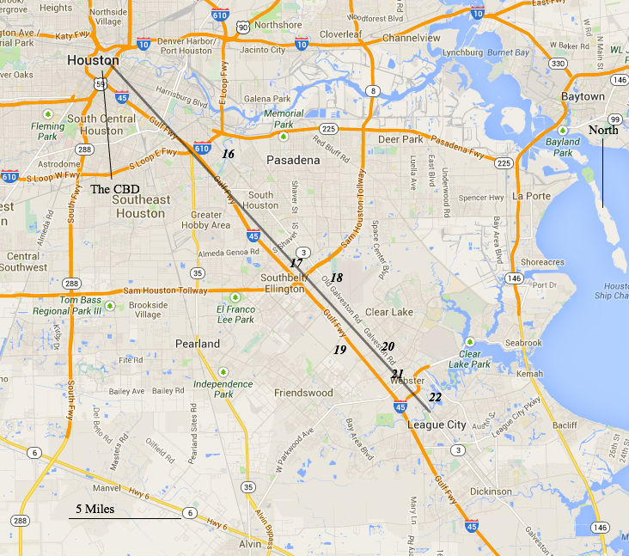

Table 2.1: The MET stations used throughout the study
MET Station Number (from figures 2.2 & 2.3) | MET Station I.D | Distance from the CBD (km)
1 | KTXCYPRE33 | -42.0
2 | KTXDRYCR1 | -40.1
3 | KTXCYPRE26 | -37.3
4 | MD8059 | -35.2
5 | KTXCYPRE11 | -33.1
6 | KTXHOUST178 | -30.2
7 | KTXHOUST291 | -28.0
8 | KTXHOUST61 | -26.8
9 | KTXHOUST218 | -20.6
10 | KTXHOUST42 | -14.3
11 | KTXHOUST101 | -10.8
12 | KTXHOUST143 | -8.4
13 | KTXHOUST275 | -5.7
14 | MUR126 | -4.1
15 | KTXHOUST284 | -2.3
16 | KTXHOUST282 | 11.0
17 | KHOU | 13.5
18 | MD5074 | 20.0
19 | KEFD | 25.3
20 | KTXHOUST136 | 31.2
21 | KTXWEBST5 | 31.3
22 | KTXNASSA2 | 35.4

- Data was collected from the MET stations for each day during the week of investigation. Every data point for each day was collected from each MET station - see appendix for the full data tables.

- The temperature readings were averaged in two different ways:

  - Hourly averages for each day throughout the week were calculated. Since 22 stations were used, this created 22 sets of 24 hourly averages for each station per day, resulting in 2640 average data points in total (5 x 22 x 24). This allowed the results graphs to display the relationship between AAT and distance from the CBD 5 times for each hour of the day, resulting in a greater number of tests for the research and null hypotheses and allowed the validity of the investigation to increase.

  - All of the data from each station throughout the week of investigation was averaged to a single temperature. This allowed the general relationship between distance and temperature to be displayed in one graph.

- An SRCC value for the northwesterly and southeasterly sections of the axes for each graph was calculated, in order to provide data to test H₀. The negative and positive sections of the x-axis on each graph were treated as different data sets, in order to calculate a value for each side independently of one-another and test H₀ more thoroughly.

Results

Table 3.1: The AAT readings for the week of investigation‡
MET Station Number | Distance from the CBD (km) (“-” represents a northwesterly direction from the CBD) | Weekly Average AAT (°F)
1 | -42.0 | 85.6
2 | -40.1 | 84.8
3 | -37.3 | 87.1
4 | -35.2 | 86.4
5 | -33.1 | 89.2
6 | -30.2 | 88.0
7 | -28.0 | 87.0
8 | -26.8 | 87.4
9 | -20.6 | 86.6
10 | -14.3 | 88.0
11 | -10.8 | 87.4
12 | -8.4 | 85.2
13 | -5.7 | 87.0
14 | -4.1 | 87.5
15 | -2.3 | 86.6
16 | 11.0 | 86.7
17 | 13.5 | 85.1
18 | 20.0 | 85.2
19 | 25.3 | 85.9
20 | 31.2 | 85.1
21 | 31.3 | 85.1
22 | 35.4 | 85.3

Figure 3.3: The relationship between average AAT throughout the week of investigation, and distance from the CBD§

SRCC value for negative values (x < 0) on the x-axis (µ₋): 0.123 (3 decimal places)
SRCC value for positive values (x > 0) on the x-axis (µ₊): -0.558 (3 decimal places)

Figure 3.4: The relationship between average AAT at 17:00PM, and distance from the CBD

µ₋ = -0.308
µ₊ = -0.736
Figure 3.5: The relationship between average AAT at 1:00AM, and distance from the CBD

µ₋ = 0.369
µ₊ = 0.069

Figure 3.6: The relationship between average AAT at 23:59PM, and distance from the CBD

µ₋ = 0.441
µ₊ = 0.076
Table 3.2: The µ₋ and µ₊ values of the hourly average graphs

Key:

- Green cells denote data that supports H_{r}
- Red cells denote data that does not support H_{r}

Hour (including graphs from the appendix) | µ₋ value | µ₊ value
1:00 | 0.369 | 0.069
2:00 | 0.640 | 0.066
3:00 | 0.737 | 0.242
4:00 | 0.758 | 0.291
5:00 | 0.715 | 0.413
6:00 | 0.664 | 0.801
7:00 | 0.752 | 0.409
8:00 | 0.700 | 0.040
9:00 | 0.524 | -0.216
10:00 | 0.524 | -0.216
11:00 | 0.318 | 0.263
12:00 | 0.049 | -0.013
13:00 | 0.015 | -0.164
14:00 | -0.041 | -0.407
15:00 | -0.213 | -0.491
16:00 | -0.279 | -0.348
17:00 | -0.308 | -0.736
18:00 | -0.395 | -0.615
19:00 | -0.464 | -0.371
20:00 | -0.397 | -0.248
21:00 | -0.554 | -0.228
22:00 | -0.268 | -0.267
23:00 | 0.180 | -0.004
23:59 | 0.441 | 0.076

Analysis

38 of a possible 48 ‘µ’ values (≈ 79.1%) support the null hypothesis. The mathematical data therefore strongly implies that there is no relationship between the distance from Houston’s CBD and AAT, and that there is no UHI in Houston.
Visual analysis of figures 3.3 – 3.6 suggests a relationship similar to the relationship discussed in H_{r}, since their curves of best-fit follow the general trend expected to be shown. The curves of best fit for figures 3.6 & 3.5 both reach their maximum point at station 15, the closest MET station to the CBD. However, this cannot be used to conclude that the research hypothesis is true, due to the fact that this sample size contains only 2 graphs (which represent only 8% of the graphical data in total). From visual analysis of the curves of best fit from the graphs in the appendix, this same trend is only shown in 4 more. Thus, a total of 6 of the 25 graphs support the research hypothesis due to the maximum point of their curves of best fit; a 24% success rate for H_{r}. This is not a large enough percentage to conclude reliably that H_{r} is true.
A further 7 graphs support H_{r} due to the shape of their curves of best fit (which match the shape that would be expected were H_{r} true). However, this is not a large enough sample of evidence to allow a reliable conclusion to be made. Although many of the graphs’ curves of best fit do peak near to the 0 mark on the x-axis (figure 3.5 for example), the correlation of their data according to the SRCC analysis suggests that this is not significant-enough to be accepted as viable supporting evidence for H_{r}.
There are five possible explanations as to why distance from the CBD in Houston and average AAT, display the pattern that was shown by the investigation:

1 – Vegetation Cover:

From table 1.1, one of the reasons that a heat island didn’t occur could be the amount of vegetation cover in the city. Although Houston is the 4th largest city in the world in terms of area, the density of its population is relatively low (1,505 people per square kilometer). This means that there is undeveloped, vegetated land in many areas across the city, as figure 4.1 shows:

Figure 4.1: A map showing the low building density and large amounts of vegetation in Houston, Texas
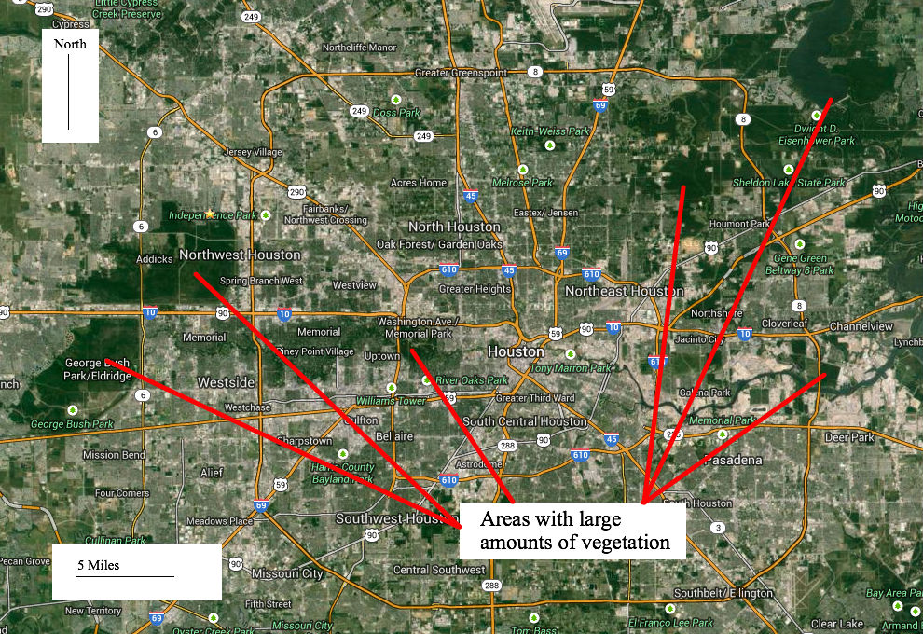

Large amounts of vegetation around the city reduces the average temperature by increasing the rate of evapotranspiration, which requires energy, in the form of heat, that is taken by plants from the Sun and the surroundings before it can be absorbed by synthetic surfaces. As roughly 90% of a plant’s mass is water, which has a specific heat capacity much higher than that of the synthetic materials from which the city is constructed, it takes much more thermal energy to raise their temperature than it does to raise the temperature of man-made infrastructure. This reduces the rate of heating, making a heat island less likely to occur.

2 – Building Density:

Another factor from table 1.1 that affects atmospheric air temperature is the density of the buildings. Although the building density in Houston is greatest in downtown, the surrounding areas are of a much lower density (in terms of both population and building). As such, there may not be a great-enough concentration of high-density buildings to accumulate heat energy, or to block enough wind to prevent natural cooling of the city. However, UHIs regularly appear in smaller cities around the world, which are more densely populated than Houston. This suggests that Houston’s low density and low amounts of high-density are key factors in the absence of a UHI.

3 – Anthropogenic Activity:

The city of Houston is notorious for its car culture, as well as being the global head quarters for many of the world’s oil and gas companies. As such, the level of anthropogenic activity within the city can be expected to be very high. However, the majority of the petrochemical industry lies to the southeast of the city than the transect, further south than the length of the transect. Although the traffic levels in and around the CBD are very high throughout the working week, the extra thermal energy produced by factories and petrochemical-processing plants further to the southeast could counteract the high concentration of thermal energy in and around the CBD by supplying enough waste heat energy to make the total amount of heat energy throughout the city roughly homogeneous in all areas. However, this is unlikely, which suggests that anthropomorphic activities around the city play a relatively small role in its average temperature.

Figure 4.2: A map showing the location of Houston’s main industrial areas with respect to the transect
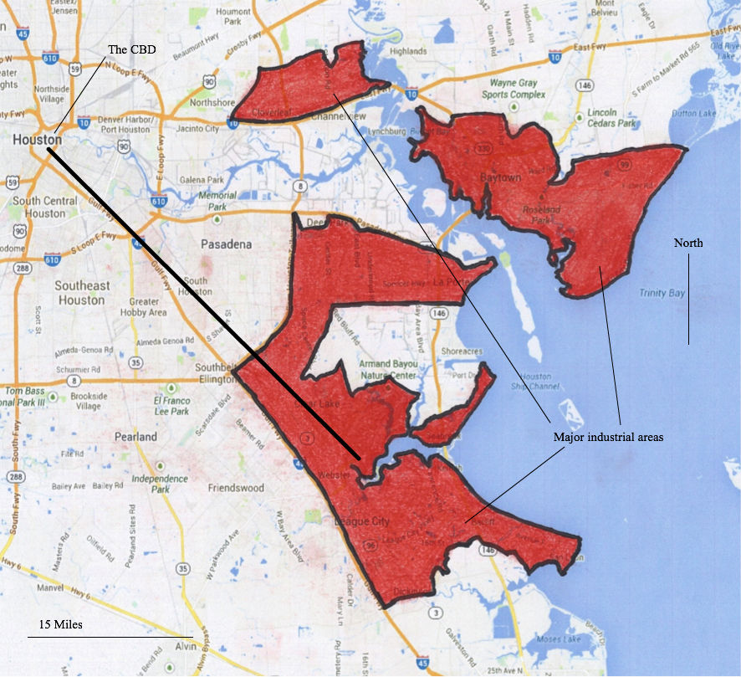

As figure 4.2 shows, much of the industry is unaccounted for by the transect, which means that the investigation couldn’t have taken the anthropogenic activity from these sites directly into account in the results (thermal energy from these areas may have made a difference to the results by dispersing into the area of investigation, but the areas of the atmosphere where it was most concentrated were not included in the investigation).

4 – Greenhouse Gas Emissions

Since industry and car usage are so common in Houston, the levels of greenhouse gas emissions are very high. Texas was responsible for 11.1% of all the USA’s CO₂ emissions in 2012, more than any other state. Of this 11.1%, the Houston metropolitan area provided 5.6%. However, the lack of zoning laws throughout the city results in industrial areas becoming merged with areas of housing (besides the large petrochemical works, which are designated their own area of the Gulf Coast – see figure 4.2). This results in greenhouse gases being emitted from all over Houston, especially in the suburbs, where the concentration of housing decreases and the concentration of industry increases. This would offset a UHI, if it were to form, by supplying thermal energy to the edges of the city and reducing the temperature difference between different areas.

5 – The Geographical Situation of the City

Being a coastal city, Houston could be affected by sea breezes. As these cold, high-pressure bodies of air move inland, they cool the surrounding areas. Since Houston is low density, the lack of buildings to act as wind blocks allows the sea breezes to penetrate further than they otherwise might in a denser city. This could result in Houston being cooled, and prevent a UHI from forming.

Conclusion

From the analysis of the results, it can be concluded that distance from the CBD does not affect the average AAT. The mathematical analysis of the results provided large amount of evidence to suggest that H₀ was true (and thus the research hypothesis was false). Visual analysis of the graphs could not be used to test the null hypothesis, but as only 24% of them supported H_{r}, visual analysis did not provide enough evidence for H_{r} to refute the mathematical evidence for H₀.
Therefore, it can be concluded that the distance from the CBD of Houston, Texas, and atmospheric air temperature are un-related, and the city does not contain an AUHI. However, due to the limitations of the investigation that arise from the transect nature of the study, the validity of this conclusion is questionable [see evaluation].
As is obvious from the evaluation, the lack of a relationship between AAT and the distance from Houston’s CBD is likely to be caused by the city’s generally low density buildings, which reduce the heating effects caused by industry and anthropogenic activity, and increase the cooling effects due to the increased amount of vegetation. The lack of heating effects could also be due to the fact that Houston does not have zoning laws, and industry is spread across the entire city, and is not concentrated in any single area.

Evaluation

Strengths of the investigation:

- This investigation reached a reliable and valid conclusion by following a scientific method, and using large amounts of data that was collected from readily available sources.

- All MET Stations which lay on or in the vicinity of the transect were used for the investigation, meaning that it gathered, and made use of, as much data as possible. This increased the validity of the results and of the conclusion, by providing more evidence to prove/disprove the research and null hypotheses.

- The results were analyzed both graphically and mathematically, which allowed them to be interpreted from two different viewpoints.

Weaknesses of the investigation:

- The main limitation to this study was the location of the MET stations. Since I had no control over their locations, and I could not change them, the data collection for this paper was constrained to the places that had weather stations, meaning that only a limited amount of the city could be tested. Given a larger budget, I could have placed my own weather stations around the city, in places that I wanted to investigate. This would have increased both the amount of data I collected, and the area of Houston that I was testing.

- Since this paper was based upon a transect study, the results gained may not be true for all parts of the city of Houston, and only the areas that have been tested along the transect. Although the location of the MET stations was the limiting factor that forced the investigation to be carried out in this manner, if it were to be repeated, ideally it would be repeated using data that stemmed from all areas of the city, or at least more transects, in order to gain a greater range of results, and test the research hypothesis in more detail.

- Due to the fact that the investigation was only carried out over a 5-day time-period, the results cannot provide conclusive proof for/against the existence of an atmospheric urban heat island in Houston, because its presence may not be continuous throughout the entire year: UHI’s from in areas that are consistently hotter than their surroundings, but not necessarily permanently so. In order to improve, data would be collected over a much longer time period (possibly even over a whole year), in order to gain as much data as possible before analyzing it. However this was not possible for this investigation, due to the fact that 5 days worth of data took 26 hours to process.

- The length of the transect used for the investigation was a factor which reduced the strength of its conclusion. This is because it could have been encompassed entirely within a heat island. It is a distinct possibility that no relationship was shown due to the fact that the entire area covered by the transect was within a very large AUHI. Although the locations of the MET stations was once again the deciding factor in the length of the transect, if more had existed, then the length of the transect could not only have increased, which could have possibly yielded a different conclusion, but the number of MET stations involved within the study would have increased as well, giving larger amounts of data with which a conclusion could have been formed.

- Not all of the MET stations recorded data in consistent intervals. As the results tables in the appendix show, there were several extended periods where two of the MET stations did not record any data whatsoever. Although 20 of the 22 MET stations recorded a large amount of temperature readings, there was still potential for the results graphs to display relationships that were not true. In order to improve this in future, one could provide their own MET stations for the investigation, so that even more data can be used and the effect of missing data on the analysis can be reduced even further. Another possible solution is not to collect data using MET stations at all, and use another method, such as thermal imagery, taken from satellites. However, this is a potentially very expensive and impractical method, although it would yield much more reliable, more easily interpretable results.

Appendix

* - The U.S. Census Bureau defines an urban area as: “An area that has a population of at least 50,000 and population density of at least 1,000 people per square mile, that is surrounded by areas or blocks (suburbs) that have an overall population density of at least 500 people per square mile.”

† -

- n = Number of points on the graph;
- x_{i} = Each x value from the graph;
- $\overline{x}$ = Average x value for the whole graph;
- y_{i} = Each y value from the graph;
- $\overline{y}\text{ =}$ The average y value for the whole graph.

‡ - Results tables for the MET stations during each day of the week of investigation (cells are left blank where no data for that specific time was available):

Monday:
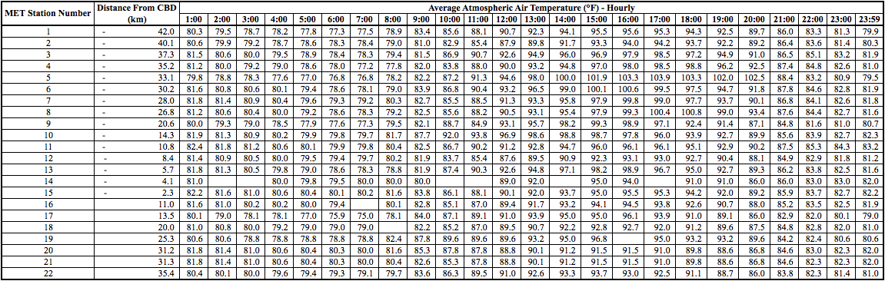

Tuesday:
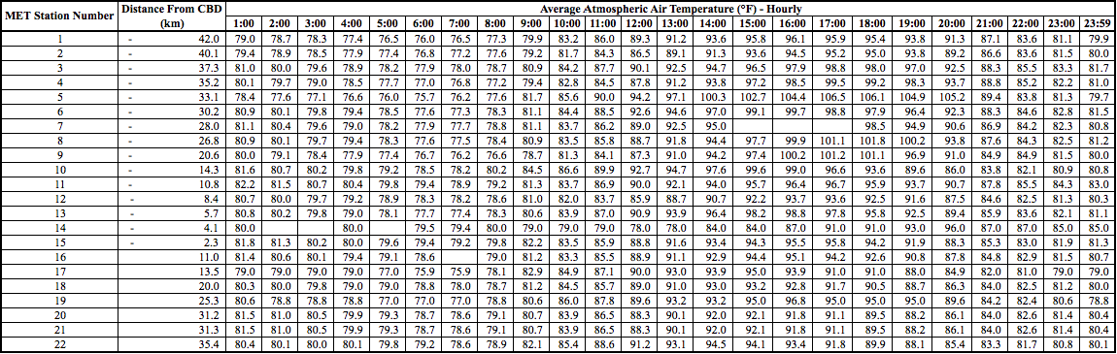

Wednesday:
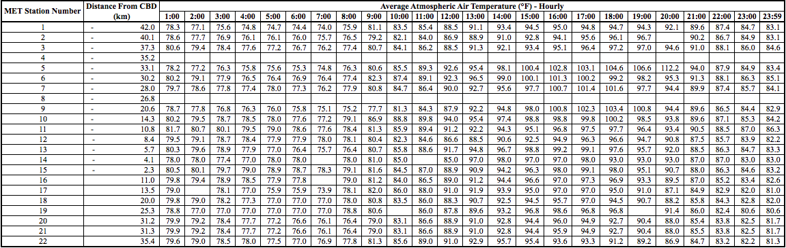

Thursday:
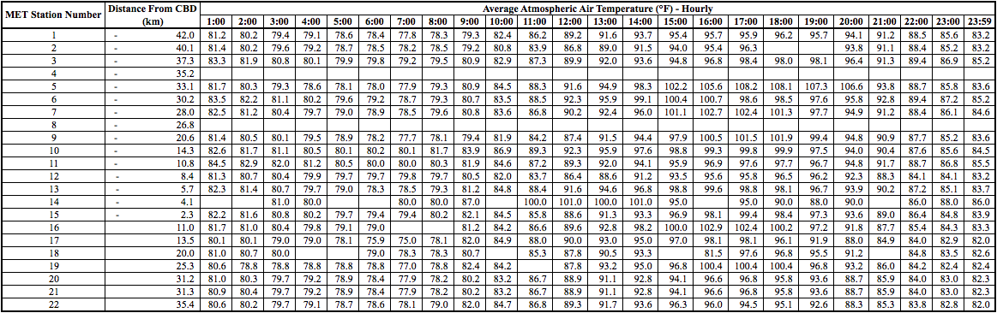

Friday:
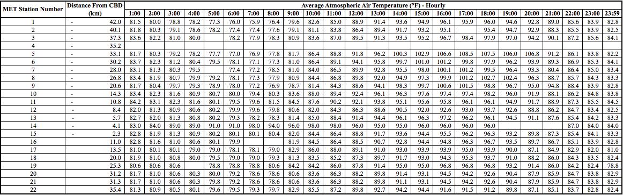

§ - Graphs of average AAT at each hour throughout the days of the week of investigation:

The relationship between distance from the CBD and AAT at 1:00AM (Monday through Friday)

- SRCC value for –x values (µ₋) = 0.369
- SRCC value for +x values (µ₊) = 0.0693
The relationship between distance from the CBD and AAT at 2:00AM (Monday through Friday)

µ₋ = 0.640
µ₊ = 0.0662

The relationship between distance from the CBD and AAT at 3:00AM (Monday through Friday)

µ₋ = 0.737
µ₊ = 0.242

The relationship between distance from the CBD and AAT at 4:00AM (Monday through Friday)

µ₋ = 0.758
µ₊ = 0.291

The relationship between distance from the CBD and AAT at 5:00AM (Monday through Friday)

µ₋ = 0.715
µ₊ = 0.413

The relationship between distance from the CBD and AAT at 6:00AM (Monday through Friday)

µ₋ = 0.664
µ₊ = 0.801

The relationship between distance from the CBD and AAT at 7:00AM (Monday through Friday)

µ₋ = 0.752
µ₊ = 0.409

The relationship between distance from the CBD and AAT at 8:00AM (Monday through Friday)

µ₋ = 0.700
µ₊ = 0.0398

The relationship between distance from the CBD and AAT at 9:00AM (Monday through Friday)

µ₋ = 0.524
µ₊ = -0.216

The relationship between distance from the CBD and AAT at 10:00AM (Monday through Friday)

µ₋ = 0.524
µ₊ = -0.216

The relationship between distance from the CBD and AAT at 11:00AM (Monday through Friday)

µ₋ = 0.318
µ₊ = 0.263

The relationship between distance from the CBD and AAT at 12:00PM (Monday through Friday)

µ₋ = 0.0485
µ₊ = -0.0125

The relationship between distance from the CBD and AAT at 13:00PM (Monday through Friday)

µ₋ = 0.0151
µ₊ = -0.164

The relationship between distance from the CBD and AAT at 14:00PM (Monday through Friday)

µ₋ = -0.0405
µ₊ = -0.406

The relationship between distance from the CBD and AAT at 15:00PM (Monday through Friday)

µ₋ = -0.213
µ₊ = -0.491

The relationship between distance from the CBD and AAT at 16:00PM (Monday through Friday)

µ₋ = -0.279
µ₊ = -0.348

The relationship between distance from the CBD and AAT at 17:00PM (Monday through Friday)

µ₋ = -0.308
µ₊ = -0.736

The relationship between distance from the CBD and AAT at 18:00PM (Monday through Friday)

µ₋ = -0.395
µ₊ = -0.615

The relationship between distance from the CBD and AAT at 19:00PM (Monday through Friday)

µ₋ = -0.464
µ₊ = -0.371

The relationship between distance from the CBD and AAT at 20:00PM (Monday through Friday)

µ₋ = -0.397
µ₊ = -0.248

The relationship between distance from the CBD and AAT at 21:00PM (Monday through Friday)

µ₋ = -0.554
µ₊ = -0.228

The relationship between distance from the CBD and AAT at 22:00PM (Monday through Friday)

µ₋ = -0.268
µ₊ = -0.267

The relationship between distance from the CBD and AAT at 23:00PM (Monday through Friday)

µ₋ = 0.180
µ₊ = -0.00371

The relationship between distance from the CBD and AAT at 23:59PM (Monday through Friday)

µ₋ = 0.441
µ₊ = 0.0758

Bibliography

² The United States Environmental Protection Agency, Heat Island Impacts,
<http://www.epa.gov/hiri/impacts/index.htm> (March 2013)

³ The United States Environmental Protection Agency, Heat Island Effect,
<http://www.epa.gov/hiri/> (March 2013)

⁴ Information adapted from: The United States Environmental Protection Agency,
Reducing Urban Heat Islands: Compendium of Strategies,
<http://www.epa.gov/heatisld/resources/compendium.htm> (March 2013)

⁵ The Central Intelligence Agency, The World Factbook,
<https://www.cia.gov/library/publications/the-world-factbook/geos/xx.html> (April 2013)

⁶ Wendell Cox, New US Urban Data Released,
< http://www.newgeography.com/content/002747-new-us-urban-area-data-released> (April 2012)

⁷ Stanley A. Changnon, Kenneth E. Kunkel and Beth C. Reinke, Impacts and Responses to the 1995 Heat Wave: A Call to Action,
<http://journals.ametsoc.org/doi/pdf/10.1175/1520-0477%281996%29077%3C1497%3AIARTTH%3E2.0.CO%3B2> (page 1499)

⁸ The United States Environmental Protection Agency, Heat Island Impacts,
<http://www.epa.gov/hiri/impacts/index.htm> (March 2013)

⁹ The United States Census Bureau, State and Country Quick Facts, Houston, Texas,
< http://quickfacts.census.gov/qfd/states/48/4835000.html> (January 2013)

¹⁰ Adapted from: Google Maps,
<http://maps.google.com/> (August 2013)

¹¹ Weather Underground, WunderMap Beta,
<http://www.wunderground.com/wundermap/beta/?overview=new> (August 2013)

¹² Wikipedia, Spearman’s Rank Correlation Coefficient,
<http://en.wikipedia.org/wiki/Spearman's_rank_correlation_coefficient> (October 2013)

¹³ The University of York Mathematics Department, Upper Critical Values of the Spearman’s Rank Correlation Coefficient,
<http://www.york.ac.uk/depts/maths/tables/spearman.pdf> (page 1) (October 2010)

¹⁴ The University of York Mathematics Department, Upper Critical Values of the Spearman’s Rank Correlation Coefficient,
<http://www.york.ac.uk/depts/maths/tables/spearman.pdf> (page 1) (October 2010)

¹⁵ Adapted from: Weather Underground, WunderMap Beta,
<http://www.wunderground.com/wundermap/beta/?overview=new> (August 2013)

¹⁶ Adapted from: Google Maps,
<http://maps.google.com/> (August 2013)

¹⁷ Adapted from: Google Maps,
<http://maps.google.com/> (August 2013)

¹⁸ The United States Census Bureau, State and Country Quick Facts, Houston, Texas,
< http://quickfacts.census.gov/qfd/states/48/4835000.html> (January 2013)

¹⁹ Adapted from: Google Maps,
<http://maps.google.com/> (August 2013)

²⁰ Adapted from: Google Maps,
<http://maps.google.com/> (August 2013)

²¹ EPA Greenhouse Gas Emissions Data, 2012 Greenhouse Gas Emissions From Large Facilities,
<http://ghgdata.epa.gov/ghgp/main.do> (January 2013)

The value µ represents the SRCC value of each axis of each graph.
The United States Environmental Protection Agency, Heat Island Impacts, <http://www.epa.gov/hiri/impacts/index.htm> (March 2013)
Ibid, (March 2013)
Information adapted from: The United States Environmental Protection Agency, Reducing Urban Heat Islands: Compendium of Strategies, <http://www.epa.gov/heatisld/resources/compendium.htm> (March 2013)
The Central Intelligence Agency, The World Factbook, <https://www.cia.gov/library/publications/the-world-factbook/geos/xx.html> (April 2013)
Wendell Cox, New US Urban Data Released, < http://www.newgeography.com/content/002747-new-us-urban-area-data-released> (April 2012)
Stanley A. Changnon, Kenneth E. Kunkel and Beth C. Reinke, Impacts and Responses to the 1995 Heat Wave: A Call to Action, <http://journals.ametsoc.org/doi/pdf/10.1175/1520-0477%281996%29077%3C1497%3AIARTTH%3E2.0.CO%3B2> (page 1499)
The United States Environmental Protection Agency, Heat Island Impacts, <http://www.epa.gov/hiri/impacts/index.htm> (March 2013)
The United States Census Bureau, State and Country Quick Facts, Houston, Texas, < http://quickfacts.census.gov/qfd/states/48/4835000.html> (January 2013)
Adapted from: Google Maps, <http://maps.google.com/> (August 2013)
Weather Underground, WunderMap Beta, <http://www.wunderground.com/wundermap/beta/?overview=new> (August 2013)
Wikipedia, Spearman’s Rank Correlation Coefficient, <http://en.wikipedia.org/wiki/Spearman's_rank_correlation_coefficient> (October 2013)
The University of York Mathematics Department, Upper Critical Values of the Spearman’s Rank Correlation Coefficient, <http://www.york.ac.uk/depts/maths/tables/spearman.pdf> (page 1) (October 2010)
Ibid, (October 2010)
Adapted from: Weather Underground, WunderMap Beta, <http://www.wunderground.com/wundermap/beta/?overview=new> (August 2013)
Adapted from: Google Maps, <http://maps.google.com/> (August 2013)
Adapted from: Google Maps, <http://maps.google.com/> (August 2013)
The United States Census Bureau, State and Country Quick Facts, Houston, Texas, < http://quickfacts.census.gov/qfd/states/48/4835000.html> (January 2013)
Adapted from: Google Maps, <http://maps.google.com/> (August 2013)
Figure adapted from: Google Maps, <http://maps.google.com/> (August 2013)
EPA Greenhouse Gas Emissions Data, 2012 Greenhouse Gas Emissions From Large Facilities, <http://ghgdata.epa.gov/ghgp/main.do> (January 2013)

