MICROECONOMICS

[Centre Number] – [Candidate Number]
'Do-nothing document': Australian electric vehicle strategy lets emissions keep rising
Source: The Guardian
Date Written: 8 March 2021
Date of Article: 4 February 2021
Word Count: 800
Section 1 – Microeconomics
Concept: Intervention
https://www.theguardian.com/environment/2021/feb/05/do-nothing-document-australian-electric-vehicle-strategy-allows-emissions-to-keep-rising

Article
'Do-nothing document': Australian electric vehicle strategy lets emissions keep rising
The Morrison government has ruled out subsidies to encourage people to buy electric or hybrid vehicles, and assumes they will be adopted at a pace that would lead to greenhouse gas emissions from transport increasing over the next decade.
A “future fuels strategy” discussion paper released on Friday is largely consistent with a leaked draft in December. It does not include policies to make it more affordable to buy electric vehicles (EVs) or a phase-out date for the sale of new fossil fuel cars, as some other countries have announced.
The government said its focus would be installing EV charging and hydrogen car refuelling stations where needed, encouraging businesses that wanted to include more low-emissions cars in their fleets and giving Australians “access to the right information to help them make informed choices’’.
The paper notes the government’s emissions projections in December forecast that battery EVs would make up 26% of new car sales by 2030.
The projections report found that pace of adoption would be associated with a 6% increase in transport emissions over the decade to 2030, a time in which the government is committed to cutting emissions and scientists and some global leaders, including US president Joe Biden, are urging much deeper cuts than currently planned.
The emissions reduction minister, Angus Taylor, said the government’s policy was based on the principle people should be empowered to make decisions about new technologies. “Australians should be able to choose the type of car they drive,” he said.
The policy was sharply criticised by advocates and analysts who argue a rapid uptake of EVs is necessary for Australia to play its part in combating the climate crisis.
Richie Merzian, the climate and energy program director at the Australia Institute, said: “This is a climate policy that will ensure emissions continue to rise.”
The Electric Vehicle Council said the discussion paper was a “flaccid, do-nothing document” that would prevent Australians getting access to the range of EVs available in other countries.
The council’s chief executive, Behyad Jafari, compared Australia’s approach with what he said were accelerating incentive programs for EVs in other countries. He cited the British Conservative government’s allocation of more than $1bn in subsidies for EV buyers and charging stations as it attempts to phase out new fossil fuel cars by 2030.
He said a rapid transition to EVs would lead to cleaner air, cut emissions and free the country from “our insecure dependence on foreign oil imports”.
“Global leaders from Biden to Boris [Johnson] are rushing to accelerate their transition to electric vehicles, but Angus Taylor reckons he knows something they don’t,” Jafari said.
EVs make up only 0.75% of new car sales in Australia, less than nearly all comparable countries, and it is one of few nations without emissions or fuel efficiency standards for passenger cars.
The government announced plans for a national EV strategy in February 2019, before the last federal election. That was replaced last year with a broader approach that also covers hydrogen fuel-cell and biofuel powered vehicles.
It has rejected introducing fuel efficiency standards, which would involve setting a target to lower the average emissions from the national vehicle fleet, despite a departmental analysis in December 2016 finding the benefits in savings on fuel and reduced emissions would outweigh the costs under all scenarios examined.
Taylor said on Friday modelling had showed a fuel efficiency standard of 105 grams of CO2 per kilometre, which Labor had proposed before the last election following the 2016 departmental analysis, would increase the cost of cars by $4,863 and “force people out of the cars they love and into EVs”. He did not mention the finding that the overall benefits would outweigh the costs.
The minister confirmed a budget pledge of $74.5m to be mostly spent on the rollout of charging infrastructure, but said the discussion paper showed direct subsidies would not be value-for-money for taxpayers as they were an expensive way to cut emissions. He said the cost would be reduced if commercial fleets switched to using cleaner cars as it would help build a second-hand market.
Taylor said the paper also showed plug-in hybrid cars would have immediate emissions reduction benefits above EVs in most parts of Australia due to the high-level of emissions from Australia’s electricity grid.
But Simon Holmes à Court, a senior adviser to the Climate and Energy College at Melbourne University and clean energy commentator, said this was a flawed analysis as it assumed a vehicle life of only five years, rather than a typical 15 years.
It also did not factor in that people often charged EVs from their own rooftop solar panels, and that the three biggest EV charging networks in the country offered 100% zero emissions power, he said.
“You have to work hard to make electric vehicle emissions look bad, and Angus Taylor has put in those hard yards,” Holmes à Court said.
Taylor said Australians were “already making the choice to switch to new vehicle technologies where it makes the most economic sense”, with hybrid sales doubling last year.
“We are optimistic about how quickly the technology cost will reduce for other electric vehicles compared to traditional cars, making it an easier choice for consumers,” he said.
Labor’s climate change spokesman, Chris Bowen, said years of government inaction had left Australia with the lowest uptake of EVs in the developed world and car makers “no longer bothering to send their most affordable” cars to the country.
He said Taylor and Scott Morrison had spent the whole last election campaign claiming EVs would “end the weekend”. “They’re asking voters to trust them when their ideology and neglect has made EVs more expensive for years,” he said.
The Greens leader Adam Bandt said the government’s policy was “no carrot and no stick”. “This hands-off approach will make it harder for Australia to reduce emissions,” he said.
Australia has become increasingly isolated on its approach to the climate crisis. More than 100 countries having supported a mid-century net zero emissions target as expected under the Paris agreement, but the Morrison government has resisted setting goal.
The prime minister, Scott Morrison, this week said he wanted to meet net zero emissions “preferably by 2050” through low-emissions technology, not by imposing new costs, but has not explained how the government’s technology approach could get there.
Several major car companies plan to phase out fossil fuel models. GM, which has been accused of not acting to address its emissions, recently announced it would be all-electric by 2035.
The government has invited submissions on the future fuels discussion paper until 2 April, with a final policy promised mid-year.
As 2022 begins, there’s a new year resolution we’d like you to consider. We’d like to invite you to join more than 1.5 million people in 180 countries who have taken the step to support us financially – keeping us open to all, and fiercely independent.
In 2021, this support sustained investigative work into offshore wealth, spyware, the 6 January insurrection, the corporate actors behind the climate crisis and the abuses of Big Tech. It enabled diligent, fact-checked, authoritative journalism to thrive in an era of falsehood, sensation, hype and breathtaking misinformation and misconception.
In 2022, we’ll be no less active, with the US midterms, the ongoing fight for racial justice, the next round in the struggle against the pandemic and a World Cup.
With no shareholders or billionaire owner, we can set our own agenda and provide trustworthy journalism that’s free from commercial and political influence, offering a counterweight to the spread of misinformation. When it’s never mattered more, we can investigate and challenge without fear or favour.
Unlike many others, Guardian journalism is available for everyone to read, regardless of what they can afford to pay. We do this because we believe in information equality. While others commoditise information, we seek to democratise it. Greater numbers of people can keep track of global events, understand their impact, and become inspired to take meaningful action.

Commentary
With the goal of reducing environmental impact and fixing the market failure of electric vehicles, governments intervene in the transportation market in various ways impacting the market and its stakeholders differently. Therefore when the Australian “government ruled out subsidies” for electric vehicles (EV) in their “future fuels strategy”, negative projections were made. I will analyze this article through the lens of intervention.
The main advantage of EVs over fuel cars is their lower amount of carbon footprint. Not only does each EV bring private benefit to its consumer but also an external benefit to society by preventing harmful emissions. Thus, EVs have a positive externality of consumption – consumption with a positive spillover effect on a third party. Thus, social benefits are higher than private benefits, making it a market failure, which is a misallocation of resources.
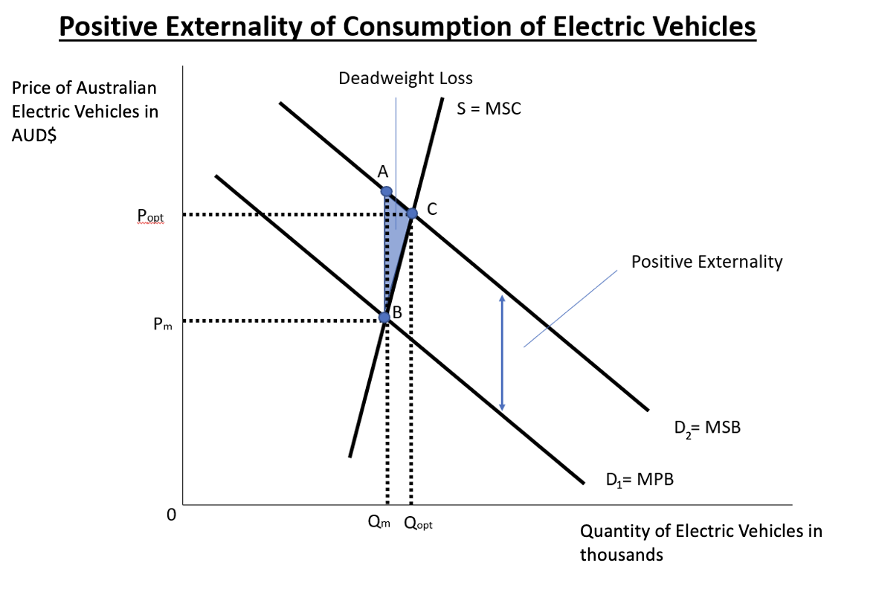
The current demand can be represented as the curve D1 which equals Marginal Private Benefits (MPB) of consumption. The marginal social benefits (MSB) of consumption can be demonstrated by D2, which includes the positive externality, making it significantly higher than the MPB curve. The current market operates at Qm which is below the social optimum of Qopt, where benefits are maximized and MSB=MSC. Thus, there is an underallocation of resources in the market as there are not enough EVs being bought, resulting in a market failure. As a result, there is a deadweight loss ABC which represents all the lost gains from trade.
The main method of intervention utilized by the Australian government is through awareness campaigns. The “future energy strategy” paper mainly focused on providing “access to the right information to help [consumers] make informed choices”. The aim of these campaigns is to impact the preferences of consumers over time and shift the current MPB demand curve to the right where it will equal the MSB. Awareness campaigns can certainly have their effect in the long-term by educating consumers, however, they might not be the most effective in the short-term.
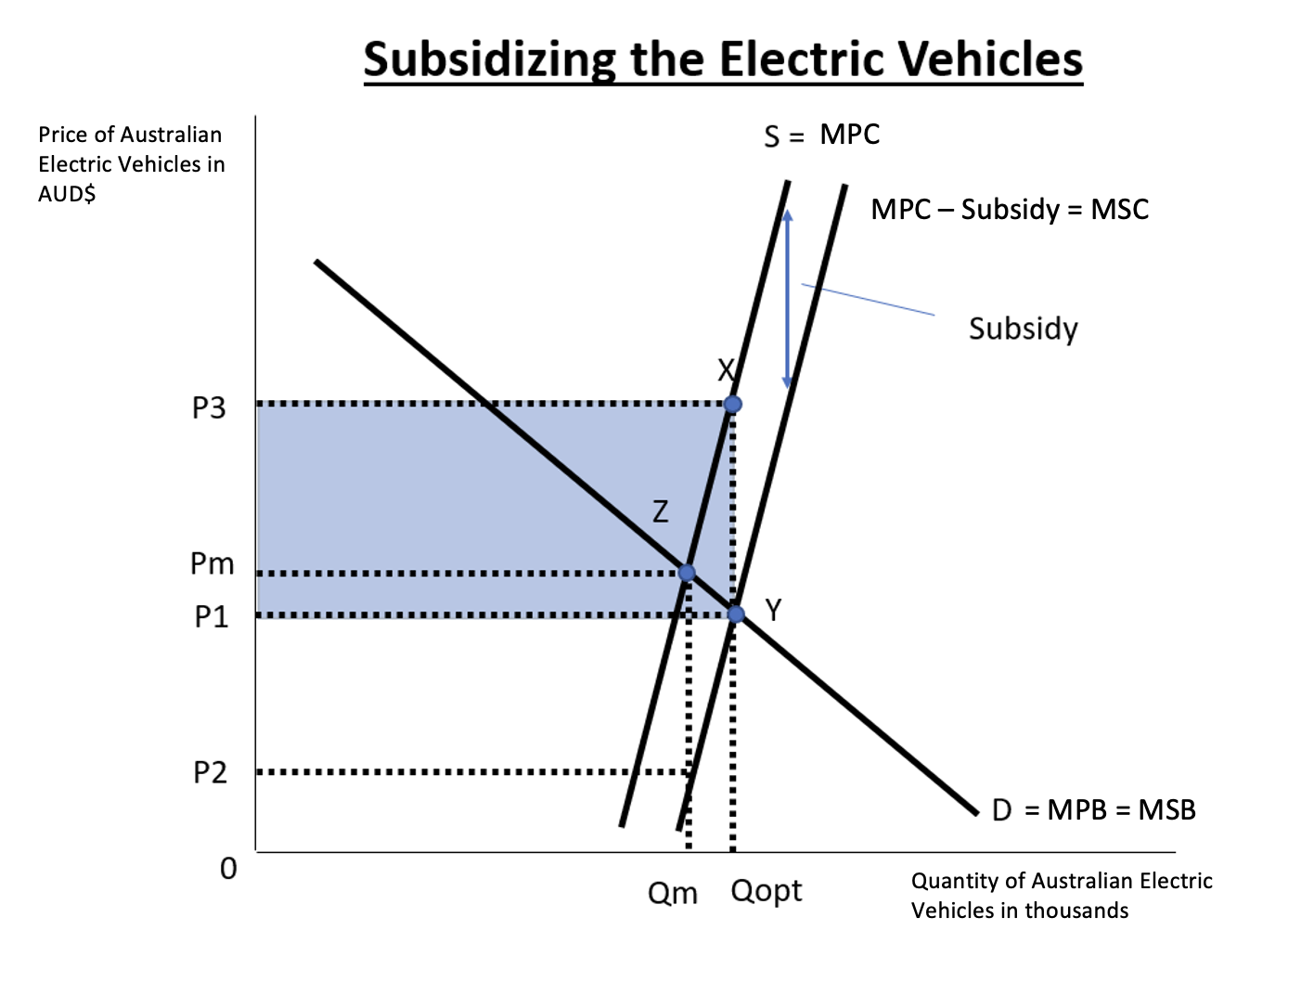One way to fix the market failure would be through a Pigouvian subsidy – a payment made by the government to intervene with the market and internalize the positive externality to decrease the deadweight loss. It lowers the marginal private cost of each unit produced by the firm by the amount of the subsidy and thus allows for more units to be produced at a lower price. This can be modeled by the supply curve being shifted downwards by the amount of the subsidy and a new equilibrium is reached at Qopt and P1. The revenue of suppliers has increased from 0PmZQm to 0P3XQopt, of which only 0P1YQopt is paid through the consumers and the rest (highlighted in blue) is covered by the subsidy. The price paid by the consumer has decreased to P1 and the price received by the producer has increased to P3 allowing for a higher quantity of EVs.
An assumption of this solution is the producers of EVs manage to use the subsidies effectively to compete with fuel cars, whereas in reality, it may take more time and resources. Additionally, as with any type of intervention, there could be unforeseen consequences, such as the potential overallocation of resources. This may occur if the subsidy is larger than the positive externality and results in deadweight loss due to wasteful trades that should not happen. Furthermore, since the market for cars tends to be supply-inelastic due to high barriers of entry, and the demand is elastic because of substitutes, the supplier will likely get the greater benefit of the subsidy. In such a case, the price paid by consumers for EVs might not decrease enough to make a noticeable difference in consumption. Another disadvantage of the subsidies is the opportunity cost – the government can spend the money on other priorities such as infrastructure or healthcare. Moreover, the government may be forced to increase tax rates to generate more tax revenue, limiting the growth of the economy. However, if the Morrison government prioritizes reducing their carbon footprint, government intervention by subsidizing producerswould be the most suitable solution. It is more effective in the short-term than awareness campaigns, and will in a long-term promote sustainable development.
In conclusion, if the Australian government would like to reduce their carbon emissions in a short amount of time, subsidies are their best option. There is always the question of intervening or allowing the market forces to fix the market failure, however, for immediate results, an intervention in the form of subsidies would be greatly beneficial in addressing the market failure, as it would create incentivite for clean vehicle production. By subsidizing the electric car brands, the Morrison Government can intervene in the market successfully by internalizing the positive externality, thus accelerating the integration of electric vehicles into the transportation industry and preserving the planet in the process.

Student Name
Section |  |  |  | Date Written |  |  |  | Marks | /14
Word count |  |  |  | Article Date
 | A. Diagrams |  | B. Terminology |  | C. Application and analysis |  | D. Key concept |  | E. Evaluation
0 | The work does not reach a standard described by the descriptors below. |  | The work does not reach a standard described by the descriptors below. |  | The work does not reach a standard described by the descriptors below. |  | Either the work does not reach a standard described by the descriptors below or the key concept identified has already been used in another commentary. |  | The work does not reach a standard described by the descriptors below.
1 | Relevant diagram(s) are included but not explained, or the explanations are incorrect. |  | Economic terminology relevant to the article is included in the commentary. |  | Relevant economic theory is applied to the article with limited analysis. |  | A key concept is identified and there has been an attempt to link it to the article. |  | Judgments are made that are supported by limited reasoning.
2 | Relevant, accurate and correctly labelled diagram(s) are included, with a limited explanation. |  | Economic terminology relevant to the article is used appropriately throughout the commentary. |  | Relevant economic theory is applied to the article throughout the commentary with appropriate economic analysis. |  | A key concept is identified and the link to the article is partially explained. |  | Judgments are made that are supported by appropriate reasoning.
3 | Relevant, accurate and correctly labelled diagrams are included, with a full explanation. |  |  |  | Relevant economic theory is applied to the article throughout the commentary with effective economic analysis. |  | A key concept is identified and the link to the article is fully explained. |  | Judgments are made that are supported by effective and balanced reasoning.
4
Comments:

MACROECONOMICS

[Centre Number] – [Candidate Number]
Fed's 'transitory' inflation plot thickens again with rate at 30-year high Source: Reuters
Source: Reuters
Date Written: 8 March 2021
Date of Article: November 11, 2021
Word Count: 796
Section 1 – Macroeconomics
Concept: Equity
https://www.reuters.com/business/feds-transitory-inflation-plot-thickens-again-with-rate-30-year- high-2021-11-11/

Article
Fed's 'transitory' inflation plot thickens again with rate at 30-year high
WASHINGTON, Nov 11 (Reuters) - Inflation pushed more broadly through the economy in October again challenging the Federal Reserve's outlook for only "transitory" price increases, offsetting recent wage hikes in a blow to consumers, and prompting investors to boost bets the central bank will raise interest rates sooner than expected.
Yields on two-year Treasury notes , a proxy for the outlook for the overnight interest rate set by the Fed, jumped 6 basis points, the most in three weeks and among the largest daily increases in the last year and a half, to 0.485% on Wednesday after the release of data showing consumer prices rose by 6.2% in October versus the year before.
That was the largest one-year jump in prices in 30 years and applied across staples like food, energy and rent, as well as to items like automobiles where the Fed has expected the pace of price increases to ease alongside pandemic-driven "bottlenecks" in global supply chains.
But those "bottlenecks" remain overrun by strong U.S. consumer demand, and inflation measures meant to diminish the impact of one-time spikes in goods and services are also rising.
Both a Cleveland Fed "trimmed mean" index of consumer prices and one that tracks the median level of price increases surged in a sign that price pressures were rising across a more extensive set of goods and services.
Still, one Fed policymaker on Wednesday said the central bank should still remain patient.
"We need to wait to see how this percolates through the economy," before changing monetary policy in response to it, San Francisco Fed president Mary Daly said on Bloomberg TV .
Markets had a shorter leash. Pricing in futures contracts tied to the target federal funds rate showed investors boosting odds the Fed will by September raise rates twice by a cumulative 0.50 percentage point. Expectations for a third quarter-point rate increase in December increased to nearly 50% compared to less than 30% on Tuesday.
"The risks stemming from inflation have become increasingly top of mind to Federal Reserve policymakers, since excessive accommodation for too long, or essentially running the economy hot, could well hold unintended market consequences that further erode confidence and eventually impair the recovery," said Rick Rieder, chief investment officer for global fixed income at investment giant Blackrock.
With demand, supply and wage pressures expected to continue, "near-term inflation readings may be intimidating to 'inflation fighters'...which could press central bankers to at least discuss a faster reaction-function."
NOT 'LINEAR'
For both the Fed and the Biden administration, what was an adamant faith in transitory inflation has been tempered.
"We know that the recovery from the pandemic will not be linear," Biden's Council of Economic Advisers said on Twitter in a nod to prices rising still faster than anticipated. The CEA "will continue to monitor the data as they come in," the office said.
The price rises also have had the disconcerting effect of outpacing wage increases that the Fed and White House hoped would flow to lower-paid workers in the hotel, restaurant and other industries hardest hit during the pandemic shutdowns last year and the cautious return to in-person services since then.
On a month-to-month basis inflation almost fully offset the strong wage increases seen in the leisure and hospitality industry in October, noted Nick Bunker, research director for North America at job site Indeed.
Overall, real hourly wages fell 1.2% in October compared with the year before, with the nearly 5% wage gain of the past 12 months more than offset by the 6.2% rise in prices.
That continues reversing what had been a steady rise in workers' purchasing power since around 2013, with the benefits of low inflation boosting "real" wages after several years of stagnation following the 2007-2009 financial crisis and recession.
The Fed has said it is reluctant to raise interest rates until more people have returned to jobs after being sidelined during the pandemic, even if inflation runs above its formal 2% target "for some time."
The jobs-first strategy is a change from the previous approach which tried to use higher unemployment as a way to keep prices under control - in effect imposing the cost of inflation-fighting onto those rendered jobless during economic slowdowns.
The Fed still hopes inflation will ease, over time, without the need to ratchet interest rates higher to cool the economy, and risk slowing or reversing job growth in the process.
But the longer inflation data run beyond expectations, the tougher that will be.
"With annual inflation now topping 6%, is this sufficient to force the Fed’s hand? This long, long transitory period has to heap pressure on the Fed," said Seema Shah, chief strategist at Principal Global Investors.

Commentary
As the US economy is recovering from the recession caused by COVID-19, inflation has become a major issue. Inflation is a sustained rise in the average price level and a fall in the value of money within an economy over a period of time. The article discusses how “consumer prices rose by 6.2%” since last October and whether the government should take more drastic action to address this ‘transitory’ inflation. I will be analyzing the article through the concept of equity, as surges in prices reduce purchasing power affecting low-income households the most.
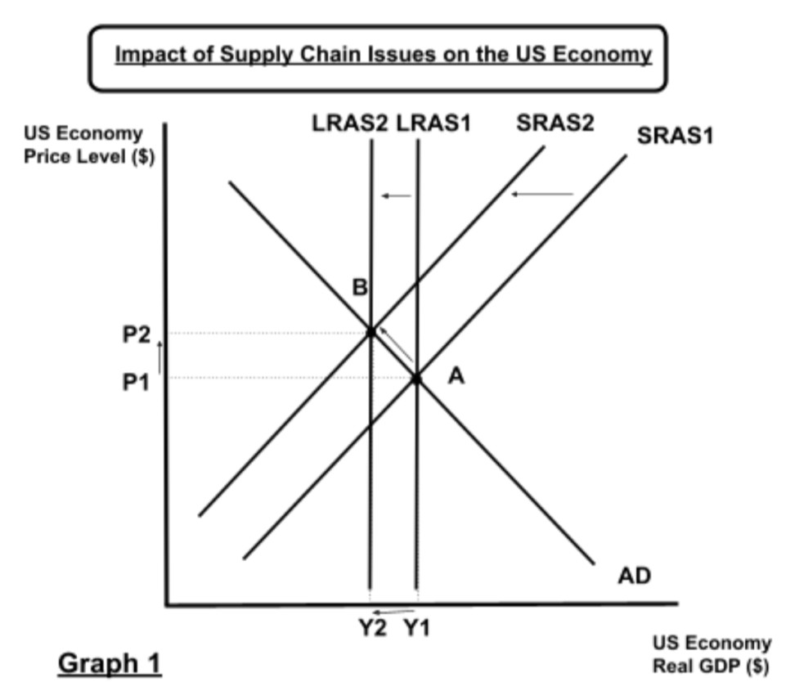
Though an increased consumer demand played a role, the main driver is the higher production costs that have increased due to two main reasons. Firstly, ever since the pandemic, the global supply chain has been disrupted. There are problems within the container market, shipping routes, seaports, and other components of production. Such supply-chain issues created shortages and backlogs, increasing the transportation costs for firms significantly. The second reason is labor costs. The labor force has shrunk during the pandemic, as people are unable to work, are underemployed, or are on early retirement, making the labor market unable to meet the increased demand for workers from firms. As a result, it is more expensive for firms to hire from a smaller labor force, increasing production costs further.
Increased production costs mean the firms can not supply as much, which can be modeled by a shift of SRAS1 to SRAS2 on Graph 1. Due to the shortage of supply within the economy, the price level of goods and services rises under the pressure of high consumer demand, from P1 to P2. Thus, the market shifts from equilibrium and it can be represented by a movement along the AD curve from point A to B. Over time, there might be a long-term fall in production capacity, as firms can not produce as many goods and services, illustrated by a leftward shift from LRAS1 to LRAS2.
Higher prices erode the purchasing power of consumers, however, it does not impact everyone the same. As low-income households have a higher propensity to consume, they are likely to be more burdened by the change in prices. Higher prices have been applied across expenses like food, energy, rent, and used automobiles. These are necessities that low-income households spend the majority of their income on, making them susceptible to the impact of elevated prices. On the other hand, the wealthy have a lower marginal propensity to consume, as they save or invest a high proportion of their income, so the inflation does not affect them to the same degree. Thus, inflation is likely to increase the inequality of income, decreasing the level of equity in the country. With its Gini coefficient at 41.1, the US does not have the most well-distributed income, and inflation is likely to worsen the situation further.
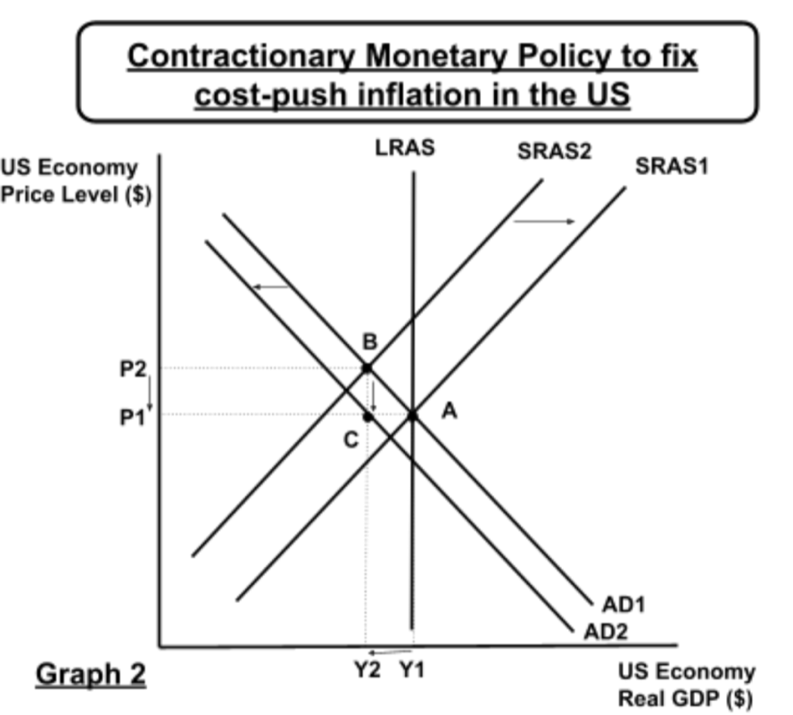
As for solutions, this inflation is often called “transitory”, meaning it might not exist in the long term. Over time the supply-chain issues will be resolved and supply costs would go down. Thus the firms will be able to supply more goods and services again, which can be represented by a shift from SRAS2 back to SRAS1. This is essentially why the federal reserve system is not taking action at the moment, as they are waiting for the market to fix itself. However, such a high inflation rate may get the central bank to act sooner than expected.
One way to fix cost-push inflation would be through a contractionary monetary policy. The article mentions how the “yields on two-year Treasury notes... jumped 6 basis points” already and the government may want to increase this interest rate further to encourage saving. As it is more profitable for consumers and commercial banks to invest in government bonds, they are less likely to consume or borrow. Thus, the central bank is able to take expenditure out of the economy. Additionally, the overnight lending rate for banks can be increased to discourage commercial banks from lending out as much money, decreasing the money supply further. This is likely to result in less consumption, decreasing the consumer demand represented by a shift from AD1 to AD2.
The main issue with this solution is the risk of shrinking the economy back down due to lower demand. When comparing the new equilibrium of C to the pre-pandemic equilibrium of A, though the price level is now lower, so is the output of the economy, which can be represented by a change from Y1 to Y2. Such drastic change is likely to slow the recovery of the economy, potentially increase unemployment, and worsen the equity gaps even further. Therefore the policy needs to be implemented gradually and at an incremental rate, especially when just coming out of a recession.
References:
Friesen, Garth. “No End in Sight for the Covid-Led Global Supply Chain Disruption.” Forbes, Forbes Magazine, 6 Sept. 2021, https://www.forbes.com/sites/garthfriesen/2021/09/03/no-end-in-sight-for-the-covid-led-glo bal-supply-chain-disruption/?sh=39ba0dfe3491.
Gini Coefficient by Country 2021, https://worldpopulationreview.com/country-rankings/gini-coefficient-by-country.

Student Name
Section |  |  |  | Date Written |  |  |  | Marks | /14
Word count |  |  |  | Article Date
 | A. Diagrams |  | B. Terminology |  | C. Application and analysis |  | D. Key concept |  | E. Evaluation
0 | The work does not reach a standard described by the descriptors below. |  | The work does not reach a standard described by the descriptors below. |  | The work does not reach a standard described by the descriptors below. |  | Either the work does not reach a standard described by the descriptors below or the key concept identified has already been used in another commentary. |  | The work does not reach a standard described by the descriptors below.
1 | Relevant diagram(s) are included but not explained, or the explanations are incorrect. |  | Economic terminology relevant to the article is included in the commentary. |  | Relevant economic theory is applied to the article with limited analysis. |  | A key concept is identified and there has been an attempt to link it to the article. |  | Judgments are made that are supported by limited reasoning.
2 | Relevant, accurate and correctly labelled diagram(s) are included, with a limited explanation. |  | Economic terminology relevant to the article is used appropriately throughout the commentary. |  | Relevant economic theory is applied to the article throughout the commentary with appropriate economic analysis. |  | A key concept is identified and the link to the article is partially explained. |  | Judgments are made that are supported by appropriate reasoning.
3 | Relevant, accurate and correctly labelled diagrams are included, with a full explanation. |  |  |  | Relevant economic theory is applied to the article throughout the commentary with effective economic analysis. |  | A key concept is identified and the link to the article is fully explained. |  | Judgments are made that are supported by effective and balanced reasoning.
4
Comments:

INTERNATIONAL ECONOMICS

[Centre Number] – [Candidate Number]
Chinese Telecom Gear Hit With EU Trade Tariffs in Pricing Row
Source: Bloomberg
Date Written: December 28, 2021
Date of Article: November 17, 2021
Word Count: 800
Section 3 – International Economics
Concept: Efficiency
https://www.bloomberg.com/news/articles/2021-11-17/chinese-telecom-gear-hit-with-eu-trade-tariffs-in-pricing-row

Article
Chinese Telecom Gear Hit With EU Trade Tariffs in Pricing Row
Chinese exporters will pay anti-dumping duties of up to 44% EU says higher prices for European buyers are justified
The European Union imposed tariffs of as much as 44% on optical-fiber cables from China, affecting the supply of next-generation telecommunications equipment used by Deutsche Telekom AG and others.
Chinese exporters of core broadband gear for future 5G networks will face EU tariffs to counter unfair price undercutting known as dumping, according an EU legal document published on the authority’s website on Wednesday. Regulators said below-cost pricing risked driving EU producers out of the European market and there were plenty of alternative suppliers in Europe and elsewhere to replace the Chinese goods.
The tariffs will enter into force the day after the document is published in the EU’s Official Journal. They include a 44% duty on EU imports from companies the EU says are controlled by the Chinese state: FiberHome Telecommunication Technologies Co. Ltd. and Nanjing Wasin Fujikura Optical Communication Ltd.
The EU probe of optical-fiber cables imported from China stems from the first-ever dumping complaint by Europacable, an association that represents European producers including Prysmian SpA, Nexans SA and Leoni AG. The industry previously sounded an alarm that Chinese imports jumped 150% between 2016 and 2019, taking some 15% of the EU market, which is worth about 1 billion euros ($1.1 billion) a year.
The European Commission said “it was inevitable that anti-dumping duties would have cost implications” for companies that bought cables from China, bit added that “this was due to the unfair export behavior” of suppliers and that cables accounted for only a minor share of the total roll-out cost of digital networks, less than 5% for 5G networks. Deutsche Telekom and Spanish distributor Comercial Electro Industrial SA opposed the tariffs, the EU said.

Commentary
With the global rise in demand for 5G networks, the market for optical-fiber cables from China has seen significant growth over the last few years. The article discusses how the “Chinese imports jumped 150% between 2016 and 2019, taking some 15% of the EU market”. This was achieved through dumping, which is when a country exports a product at a price lower than the cost of production or significantly lower than the price in their domestic market. Thus to counter this unfair pricing, the European Union has imposed tariffs (taxes on imports) up to 44%. Though done with the goal of preventing dumping and helping domestic suppliers, such change raises a question of efficiency and whether such drastic measures against dumping are ideal for the economy.
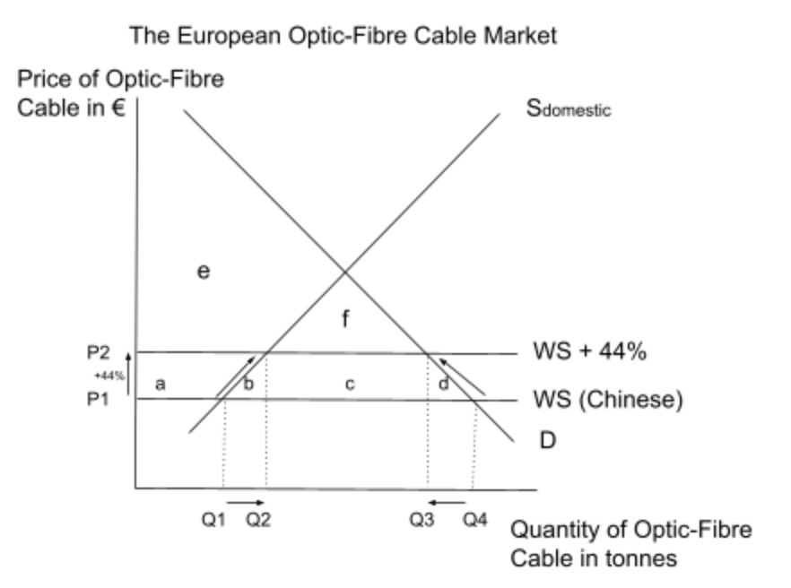
Due to the export subsidies offered by the Chinese government, the Chinese suppliers have lower marginal costs than the European suppliers so an unlimited supply of Chinese imports is assumed (denoted by the perfectly elastic WS curve). At price level P1, Q4 is the quantity demanded for optical-fiber cables, but only Q1 is supplied by domestic European suppliers. The majority is supplied through Chinese imports equalling Q4-Q1. However, an introduction of the tariff would raise the opportunity cost for Chinese firms that are now unable to supply at the same price. Consequently, the demand for imports goes down, and the domestic supply increases. This can be modeled by movements from Q4 to Q3 and from Q1 to Q2. At P2 (P1+tariff), Q2 is supplied by the domestic firms leaving the import number to only Q3-Q2, meaning it has gone down by (Q2-Q1)+(Q4-Q3).
Efficiency can be discussed by considering the impact of the change on the social surplus. Due to the increased amount of quantity sold, the local suppliers are able to generate more revenue and therefore there is a larger producer surplus. This increase in the producer surplus can be denoted as a on the diagram. Thus, the tariff supports domestic suppliers and allows them to expand their productions possibilities over time, in order to compete with foreign imports. Additionally, with the tariff, the government is able to collect tax revenue which can be denoted as c on the diagram.
On the other hand hand, the consumers can not purchase at the old price of P1, and the consumer surplus, therefore, decreases from a+b+c+d+e+f to e+f. Furthermore, there is a welfare loss of b and d due to the tariff reducing the efficiency of the economy: domestic producers that would not supply before are producing now and the efficient foreign supply is not being imported anymore.
Additionally, this change creates uncertainty for the companies like Deutsche Telekom that depended on these imports for their supply of telecommunication equipment. With the increased prices of imports due to the tariffs, the production costs rise significantly for the domestic companies importing optical-fiber cables. They now can not supply as much which can be represented by a shift of the supply curve to the left. Thus the price increases from P1 to P2 and quantity decreases from Q2 to Q1. On this diagram, the welfare loss due to the inefficiency of this change is represented by a+b. An important assumption of this model is that the demand is not inelastic, because in this case, the quantity demanded would not lower by much, despite the increase in price due to the tariff.
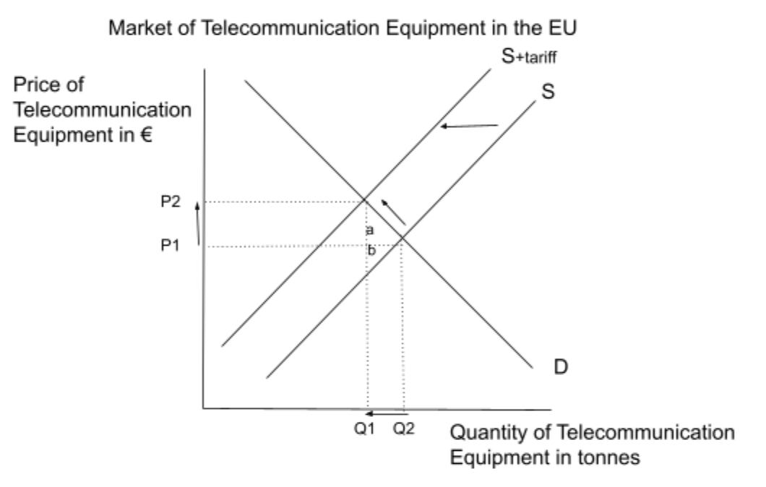
In conclusion, the introduction of tariffs against dumping was a quick and effective way to address the dumping issue with Chinese exports. It protects domestic suppliers of optical-fiber cables, brings government revenue, encourages fair trade, and its effects are immediate. However, it may not be the best decision for the economy in the short term in terms of efficiency, as it has caused a lot of welfare loss and lost gains from trade. Not only do the firms buying the imports have to bear higher prices, but the consumers of these telecommunication firms may face higher prices as well. Moreover, China may retaliate in response to these tariffs leading to trade issues in the future. In the long-term, the domestic firms may expand their production possibilities to have the same opportunity cost as the foreign exporters and thus increase the efficiency of the economy.
The best approach would be to work within the WTO to resolve trade disputes and minimize dumping in order to achieve free and fair trade for an efficient global allocation of resources. Through WTO and trade agreements, domestic subsidies for dumping can be reduced so there is an even playing field on the international market and no tariffs are required to begin with. However, given the situation, tariffs are a relatively efficient tool to reduce dumping in the optical-fiber cable industry in Europe, as it protects domestic suppliers and strives towards fair trade.

Student Name
Section |  |  |  | Date Written |  |  |  | Marks | /14
Word count |  |  |  | Article Date
 | A. Diagrams |  | B. Terminology |  | C. Application and analysis |  | D. Key concept |  | E. Evaluation
0 | The work does not reach a standard described by the descriptors below. |  | The work does not reach a standard described by the descriptors below. |  | The work does not reach a standard described by the descriptors below. |  | Either the work does not reach a standard described by the descriptors below or the key concept identified has already been used in another commentary. |  | The work does not reach a standard described by the descriptors below.
1 | Relevant diagram(s) are included but not explained, or the explanations are incorrect. |  | Economic terminology relevant to the article is included in the commentary. |  | Relevant economic theory is applied to the article with limited analysis. |  | A key concept is identified and there has been an attempt to link it to the article. |  | Judgments are made that are supported by limited reasoning.
2 | Relevant, accurate and correctly labelled diagram(s) are included, with a limited explanation. |  | Economic terminology relevant to the article is used appropriately throughout the commentary. |  | Relevant economic theory is applied to the article throughout the commentary with appropriate economic analysis. |  | A key concept is identified and the link to the article is partially explained. |  | Judgments are made that are supported by appropriate reasoning.
3 | Relevant, accurate and correctly labelled diagrams are included, with a full explanation. |  |  |  | Relevant economic theory is applied to the article throughout the commentary with effective economic analysis. |  | A key concept is identified and the link to the article is fully explained. |  | Judgments are made that are supported by effective and balanced reasoning.
4
Comments:

