Geography end of year 10 exams

Outline of topics for exams- paper 1- Knowledge based exam

Population
- Growth of population
- Population density and distribution (Canada)
- Over and under population (Bangladesh and Australia)
- Changing population structure (DTM and population pyramids)
- Dependent populations (Ageing: Japan, Youthful: Gambia)
- Population control (China and Singapore)
- The impact of HIV and AIDS (Botswana)
- Migration (International: Mexico- USA, Internal: China)

Examples of questions
The size of the population in an area may change as a result of natural increase. For an area which you have studied, explain why the rate of natural population growth is high. (7 marks)
Overpopulation occurs when there are too many people living in an area for the resources which are available. What problems are caused by overpopulation? You should refer to a country or area which you have studied. (7 marks)
What policies can be used by governments to influence rates of natural population growth? You should refer to at least one example which you have studied. (7 marks)
Explain why the governments of some countries may be concerned by a rapid growth of population. You may refer to examples which you have studied. (7 marks)
What strategies are being used to try to reduce the spread of disease in developing countries? You may refer to examples which you have studied. (7 marks)
The migration of people can be explained in terms of the pull and push factors which influenced their decision to migrate. Examples of types of migration include: international and internal migration, forced and voluntary migration, permanent and seasonal migration. Choose any example of migration and name the areas between which people moved. Explain why many people made the decision to migrate. You should refer both to pull and to push factors. (7 marks)
Give reasons why it is difficult for governments of developing countries to achieve a reduction in the rate of population growth. (6 marks)
For a residential area in a named settlement you either know or have studied, describe the changes which have been caused by either an inward or an outward movement of people. Include in your answer changes in housing, services and amenities. (6 marks)
Explain why governments of developing countries often find it difficult to lower their birth rates. (6 marks)
Describe the likely effects of an ageing population in an MEDC such as Norway. (5 marks)
Describe the different ways by which the dependent population is supported in developed and developing countries. (5 marks)
Describe the positive and negative effects which the migration of large numbers of people may have on the area to which they move. (5 marks)
Italy, a developed country in Europe, has an ageing population. There are twice as many people aged 60 years and over than children aged below 10 years. What problems may this cause for the country? (5 marks)
Many migrants from other countries move to cities in Australia, such as Sydney and Melbourne. Describe the effects of international migration on cities such as these. (4 marks)
Suggest reasons why a greater number of women in developed countries now have their children later in life. (4 marks)
Settlement
- Factors affecting site and situation of settlements (links to skills paper)
- The shape of settlements- nucleated, linear and dispersed (links to skills paper)
- Hierarchy of settlements (links to skills paper)
- Land use patterns in MEDCs (Houston)
- The problems and management of urban sprawl (Houston and London)
- Changing land use in a city (London)
- Development on the rural/ urban fringe (Houston)
- Growth of cities in LICs (Mumbai)

Examples of questions
The area surrounding towns and cities is known as the rural-urban fringe. What problems are likely to occur in the rural-urban fringe as a result of the growth of towns and cities? You should refer to an example which you have studied. (7 marks)
Many settlements have grown over the years into large urban areas. These include towns and cities with main functions such as: - ports, - industrial towns, - tourist resorts, - administrative centres. - capital cities. For a named example of a large settlement which you have studied, identify its main function and explain the reasons for its growth. (7 marks)
In all large urban areas attempts have been made to solve the problems faced by the people who live there. These include problems such as: traffic congestion, squatter settlements, housing shortages, urban sprawl. Choose either one of these problems or any other problem faced by people who live in urban areas. For a named urban area, describe the attempts which have been made to solve the problem which you have chosen. (7 marks)
Describe what has been done to improve the quality of life in squatter settlements in developing countries. You may refer to examples which you have studied to illustrate your answer. (7 marks)
In all large urban areas there have been changes in land use in recent years. These include the development of: road networks, residential areas, industrial areas, leisure and shopping facilities. For a named urban area, identify a recent change in land use. Describe the advantages and disadvantages of this development for people who live in the urban area which you have named. (7 marks)
Why does the growth of squatter settlements often result in problems for both the squatters and the area around the squatter settlement? (7 marks)
Describe measures to reduce the problem of traffic congestion in towns and cities. You should refer to examples in your answer. (6 marks)

Explain why traffic congestion is a problem in many large urban areas. (5 marks)
The area surrounding towns and cities is known as the rural-urban fringe. Why do many town and city authorities control the developments which may take place in the rural-urban fringe? (5 marks)

Tectonics
- The structure of the earth
- Plate boundaries
- Types of volcanoes (Shield- Iceland, Composite- Montserrat)
- Cause/ effects and management of volcanoes (Montserrat)
- Why do people live near volcanoes (Iceland and Montserrat)
- Measurement of earthquakes
- Cause/ effects and management of an earthquake (Haiti)
- Why do people live in an earthquake zone? (Haiti and California)

Examples of questions
In many parts of the world the natural environment presents hazards to people. Choose an example of one of the following: a volcanic eruption, an earthquake, a drought. For a named area, describe the causes of the example which you have chosen and its impacts on the people living there (7 marks).
In many parts of the world the natural environment presents hazards to people. Choose an example of one of the following: - a volcanic eruption - a tropical storm - a drought. For a named area, describe the short-term and long-term effects of the example which you have chosen on people living in the area (7 marks).
Explain why people choose to live close to active volcanoes. You may refer to examples which you have studied (7 marks).
Why may volcanic areas offer opportunities as well as problems for people living there? (7 marks).
Explain why MEDCs, such as the USA, normally recover more quickly from natural disasters than LEDCs. (5 marks)
Explain why many people continue to live in areas at risk from natural hazards. (5 marks)
Explain how volcanoes are formed at destructive plate boundaries. You may use a labelled diagram in your answer. (5 marks)
Long-term effects may occur in the weeks or months after a large earthquake. Explain why these long-term effects might be difficult to deal with. (5 marks)
Short-term effects of earthquakes on people include loss of life and injuries, as well as damage to buildings and communications. What may be done before an earthquake occurs to reduce these short-term effects? (4 marks)

Coasts
- Waves
- Coastal erosion (cases study- The Jurassic coast- Dorset)
- Coastal transportation and deposition
- Mangroves (case study- The Sundarbans, Bangladesh)
- Coral Reefs (case study- The Great Barrier Reef, Australia)
- Sand Dunes
- Opportunities on coastlines (Sundarbans, Great Barrier reef)
- Threats to coastlines (Sundarbans and cyclone Alia, Great Barrier reef, )
- Management of coastlines (The Holderness coastline)

Examples of questions
Describe the ways in which coastal areas can provide opportunities for the people who live there. You should give examples from an area you have studied. (7 marks)
Explain how the natural features of headlands are formed as a result of wave processes. You may use labelled diagrams in your answer. (7 marks)
Explain how and why coastal sand dunes have formed in a named area which you have
studied. You may use a labeled diagram or diagrams in your answer. [7]

For an area you have studied, describe the benefits and problems of living near the coast. [7]

For a named coastal area which you have studied, describe the impacts of a tropical storm.[7]

Explain how fragile areas like coral reefs can be managed (7)

Rivers
- Landforms from source to mouth
- Flooding (case study-Tewkesbury, Bangladesh, Buffalo Bayou)
- Opportunities on Rivers (Bangladesh or Mississippi)
- Management of Rivers (Buffalo Bayou, Bangladesh or Twesksbury)

In many parts of the world the natural environment presents hazards to people. Choose an example of one of the following: a flood, a tropical storm, a drought. For a named area, describe the causes of the hazard which you have chosen. [7]
Choose a named example of one of the following: an area of mountains, a fast-flowing river, a flood plain. Describe the ways in which your chosen type of natural environment can provide opportunities for the people who live there. [7]
Flooding occurs on the flood plains and deltas of some rivers.
For a river which you have studied, explain what has been done to reduce flooding. [7]
Describe the advantages and difficulties for people of living on a river delta. You should refer to a delta which you have studied. [7]
Explain how and why a delta is formed. You should refer to an example you have studied and include labeled diagrams. [7]
Explain how a river changes from source to mouth (7)

Describe the advantages and difficulties for people of living close to a river (5)

Describe and explain how an oxbow lake is formed. You should use label diagrams. (5)

Explain how and why a delta has formed in a named area which you have studied. You should use a labelled diagram or diagrams in your answer. (7)

Explain the change in the shape and characteristics of a river as it travels from source to mouth (7)

Weather and climate
- Tropical Rainforests: Amazon (particularly Ecuador)
- Problems and Opportunities in Desert: The Mojave Desert, Western USA
- Hurricane Harvey, Houston 2017

For a named tropical desert, explain how and why the natural environment is threatened by human activities. [7]
The weather often causes problems for people. These include problems caused by:
flooding,
drought,
tropical storms.
Choose either one of these hazards or any other hazard faced by people as a result of the
weather or climate. Describe the problems experienced by people living in areas at risk from
your chosen hazard.
Many areas of natural vegetation are at risk from human activities. Name either an area of tropical rain forest or tropical desert which you have studied and explain why and how it is at
risk from human activities. [7]
For an area of tropical desert which you have studied, describe and explain the characteristics of its natural vegetation. [7]
Name an area which you have studied where tropical storms occur. Describe the problems which they cause for people living in your chosen area.[7]
For a named area of tropical desert which you have studied, describe and explain the characteristics of its climate.[7]
For a named area of tropical rainforest which you have studied, describe and explain the characteristics of its climate.[7]
For a named area of tropical rainforest which you have studied, describe the ways in
which it benefits people.[7]

The thermometers used at the meteorological station are kept in a Stevenson Screen. Explain how this ensures that reliable readings are obtained. (4)

Give reasons for the climate of an area of tropical rainforest such as Kisangani. ? (5)

Explain how the natural vegetation of tropical desert areas can survive in the hot, dry climate. (5)

Another type of natural environment is tropical rain forest.
Describe the impact of human activity on a tropical rain forest ecosystem which you have studied. (7)

Explain why the effects of tropical storms of the same strength are likely to be greater in an LEDC than an MEDC. Refer to examples which you have studied. (7)

An earthquake is an example of a natural hazard. Choose an example of one of the following: a) a tropical storm, b) a drought. For a named area, describe the causes and effects of your chosen hazard. (7)

For a named area which you have studied, describe the impacts of a tropical storm. (7)

Name an area of tropical rainforest which you have studied and explain why deforestation is taking place there. (7)

Exam tips: Paper 1 (knowledge based paper)

Tip 1:
One mark indicates one separate point.
If the questions is worth 5 marks and you give 3 pieces of information you can only get a maximum of 3 marks from 5. Always use the box on the bottom right of the question as guidance. It will look like this [5]

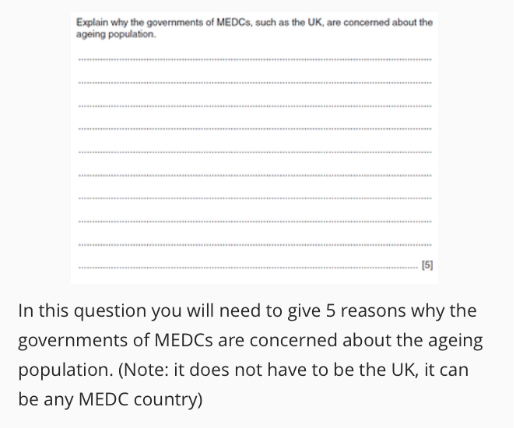

Tip 2:
If it is relevant to draw a quick diagram you should.
Certain questions especially in Physical Geography such as the units on Rivers and Coasts will ask you to explain the formation of a certain feature. Sometimes they will say with the aid of a diagram, but sometimes they will not. Even if they do not specifically ask for one (and you have the time) you can quickly sketch on in on the left hand side of the question in the blank space there. You never know it might help you get all the marks!
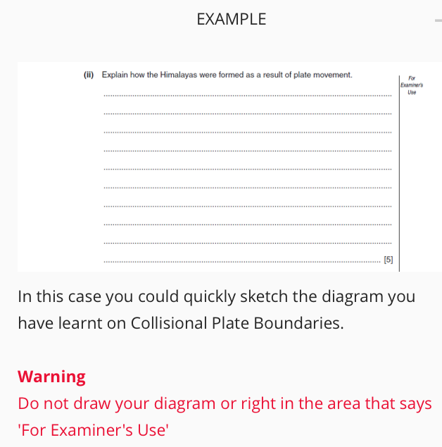

Tip 3:
'C' style questions test case study knowledge.
To be able to answer the 'C' style question worth 7 marks in Paper 1 you will need a lot of case study material over the IGCSE course. This is the only question which take the quality of your writing into account.
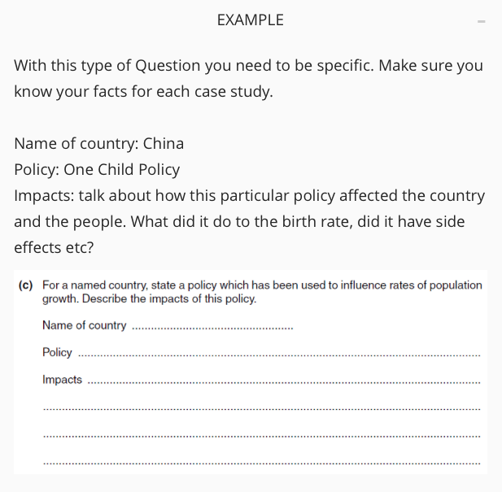

Tip 4:
Always read the question carefully and follow instructions to the letter.
The easiest way to lose marks in your Geography IGCSE is to not answer the specific question. If anything is written in 'bold' it is important and you need to pay attention to it. If the question says use figures or evidence, do so!

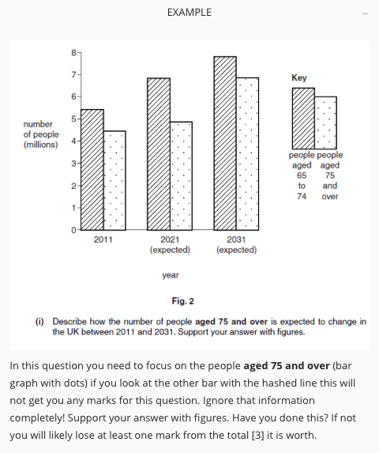

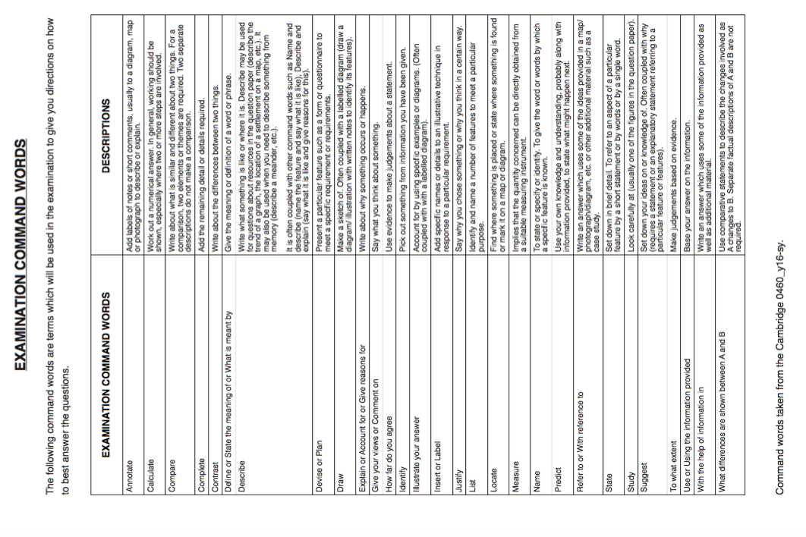

Paper 2: Skills paper

Tip 1:
This is the skills based paper. You will need to bring the following equipment to your
examination.
- Black pen
- Pencil (with a sharpener and eraser)
- Ruler (30cm)
- Protractor
- A pair of compasses
- Calculator
- Piece of string
Tip 2:
You always need to use the map extract.
When you are answering the questions you need to ensure that you are using the map extract to
answer the question not only the outline map in the question paper.
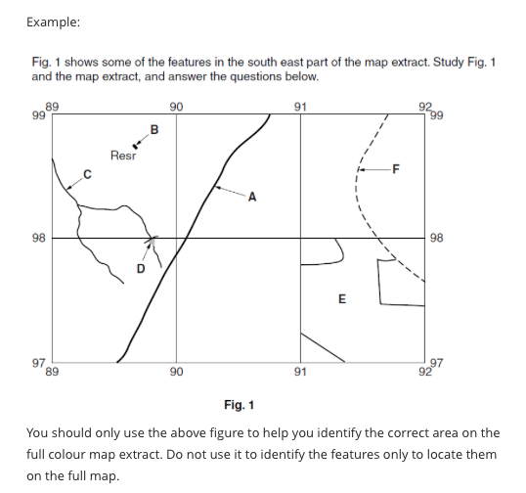

Tip 3:
You need to provide evidence
When the question requests it you need to provide actual map information
(evidence to get all marks). Do not forget this as failure to include it will lose
you marks.

Map evidence can include things like:
- Naming a location
- Providing a grid reference
- Identifying specific features round in the location
- Interpreting land use and the lie of the land (relief)

