Evaluation of Dragons Den/ shark Tank pitches
Bambooee
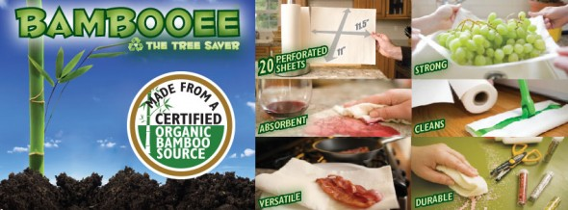

https://www.youtube.com/watch?v=4k4Oewvp7fA
- What is good about the product?

- How do you think it is related to the SDG?

- What was good about the pitch?

- What aspects of the pitch could be improved and how?

- What makes a successful pitch?

- How will you use the ideas from today in your pitch?

Obeo Food Waste Box

https://www.youtube.com/watch?v=mGqEkLuliZU&feature=emb_logo
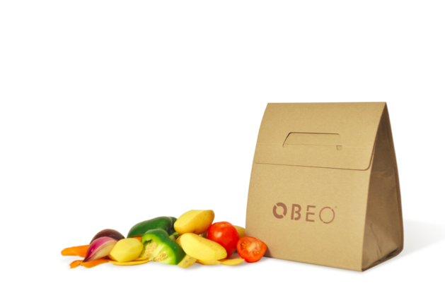

- What is good about the product?

- How do you think it is related to the SDG?

- What was good about the pitch?

- What aspects of the pitch could be improved and how?

- What makes a successful pitch?

- How will you use the ideas from today in your pitch?

The whole leaf company
https://www.youtube.com/watch?time_continue=240&v=1ZtnPPZBhUk&feature=emb_logo

- What is good about the product?

- How do you think it is related to the SDG?

- What was good about the pitch?

- What aspects of the pitch could be improved and how?

- What makes a successful pitch?

- How will you use the ideas from today in your pitch?

