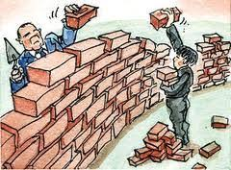

Evaluating Trade Barrier Effects

Impact on: | 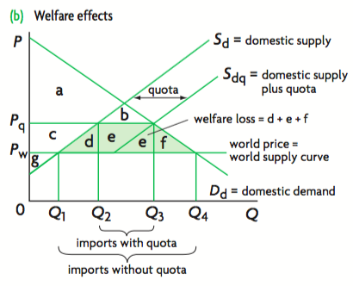  Tariffs | Quotas  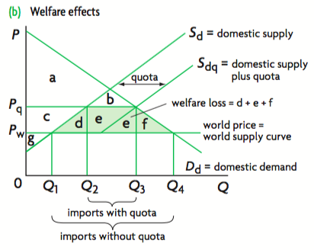 | Production subsidies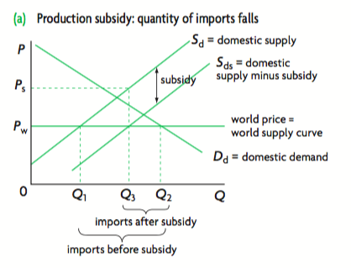 | Administrative barriers
Consumers
Producers
Employment (workers)
Government
Taxpayers
Income distribution
Efficiency in production
Society as a whole
Foreign producers
Global resource allocation

